My List is an area in the Direct Input (DI) system where you can set up a list of the people whose information you edit regularly.
Note: You will only need to do this if you have an Admin login onto DI. Those with Supervisor logins will see a list of all the people they manage as soon as they access DI.

Adding an Individual to My List
The first step is to log onto DI and choose People Admin from Main Menu in the Oracle Applications Home Page.
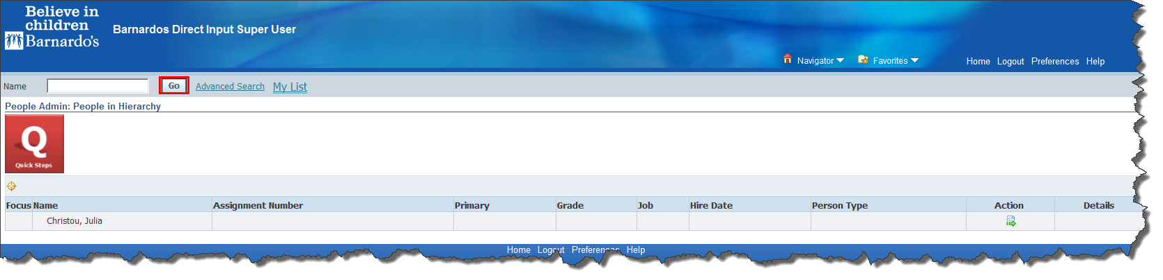
- Type the person’s last name in the Name field
- Click on the Go button
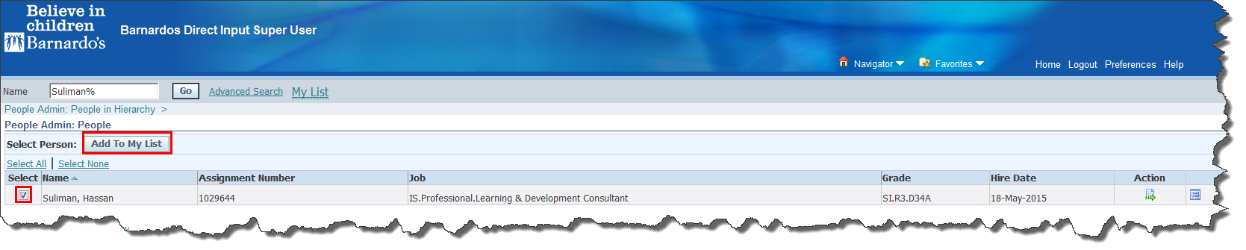
- Click in the tick-box to the left of the person’s name to select it.
- Click on the Add To My List button.
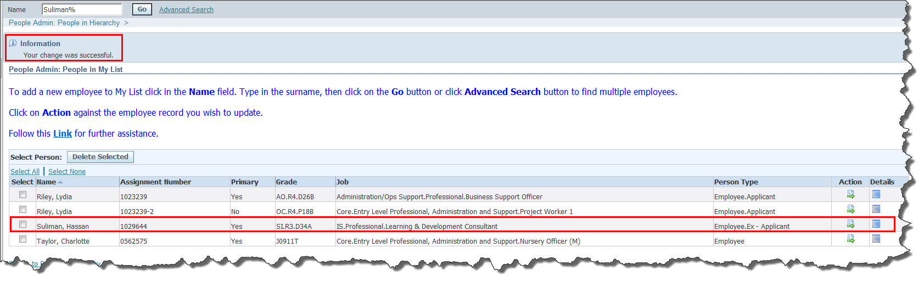
- Repeat the above steps for all of the individuals you wish to add to your list.
- When you subsequently hover over the My List link, you will be able to see a preview of your My List, before clicking to access it.
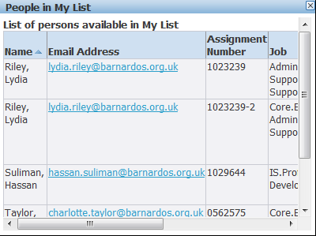
- Click x in the top corner to close it.

Deleting an Individual from My List
This may need to be done as people leave a department or service and are no longer required on your list of employees.
The first step is to log onto DI and choose People Admin from the Main Menu.
- Click on the My List link
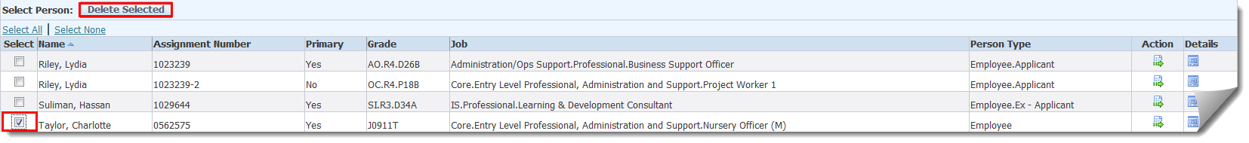
- Click in the tick-box to the left of the person’s name to select it.
- Click on the Delete Selected button. Using Advanced Search
If you have a number of people to add to your list, and they all come under the same cost centre, you can use Advanced Search to add them more quickly.
The first step is to log onto DI and choose People Admin from the Main Menu.
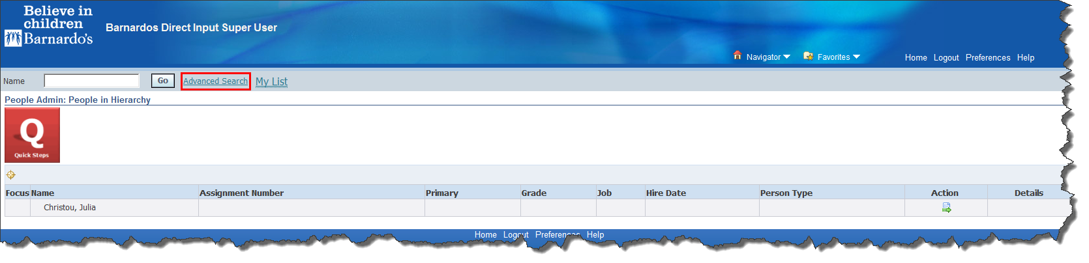Click on the Advanced Search link
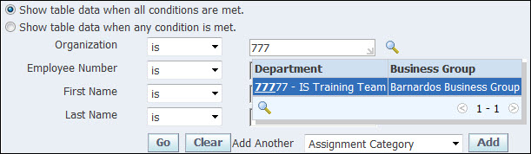
- Click in the Organization field.
- Type the cost centre (e.g. 77777).
- As you type, available matches appear below the field, in this example there is only one match but if there were more they would all be listed.
- Highlight and click the correct option.
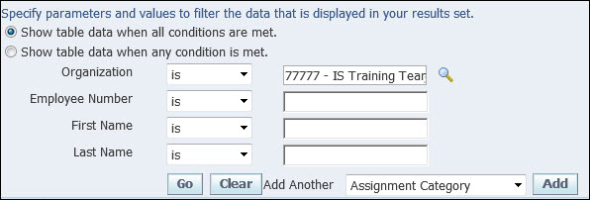
- Click on the Go button.
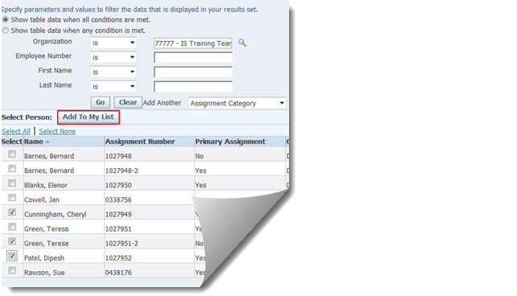
- Click in the tick-boxes to the left of the names to select them.
- Click on the Add To My List button.
Note: The screen will only show the first 10 people found in the cost centre. If there are more than 10 people in the cost centre you now need to click on the Next 10 link, tick any people you wish to add to your list and click on the Add To My List button. Repeat this for as many pages as have been found.

