The Allowance Allocation function in Direct Input (DI) allows you to allocate only 10 types of allowances mentioned in the first screen shot below, such as office at home or additional duties allowances.
Note: Allowances entered through DI can be amended through DI again. For Allowances which are not in the list below please contact your local People teams for any amendments.

Adding an Allowance Allocation
- Log onto DI.  - Open the Fast Path folder.  - Click on Allowance Allocation from the available list of actions. | 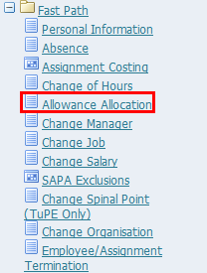
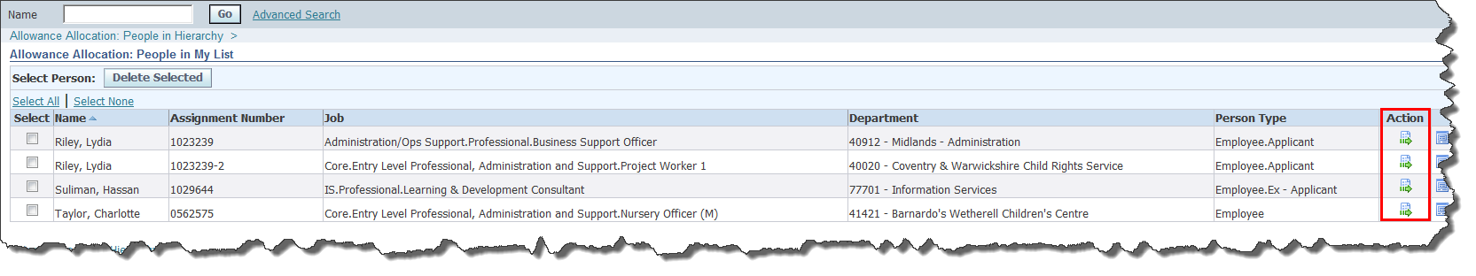
- Either search for an employee using the search field, click on My List and select an employee or, if you line manage an employee, they will visible in the lower part of the screen
- Once you have located the employee, click on the Action button .
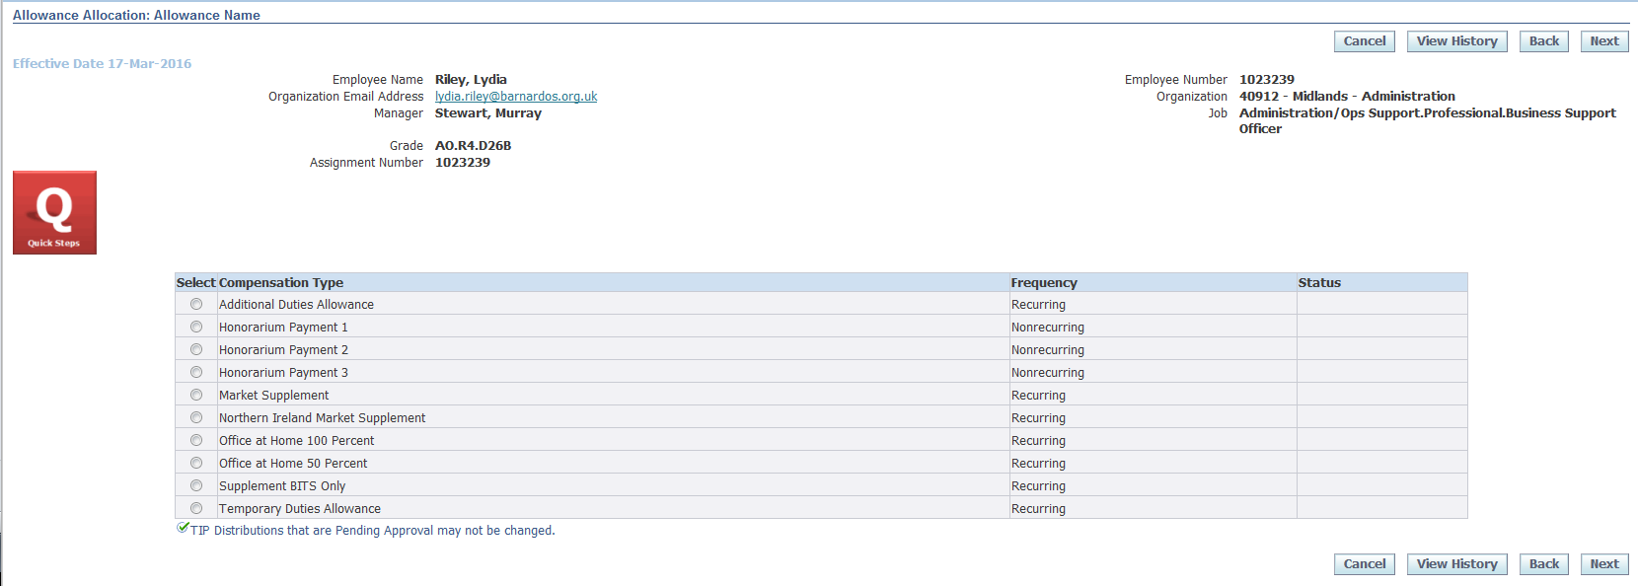
Note: Some of the allocations are recurring and some are non-recurring (i.e. one-off payments), as indicated in the Frequency column. The Status column shows the status of any existing allowances of that type that have been entered via DI. You can only add allowances if the Status column is blank.
The Status column only shows those allowances entered via DI. If any allowances have been entered by the People section they will only show up via the View History button, so you must also check these as detailed below.
- Click on the View History button.
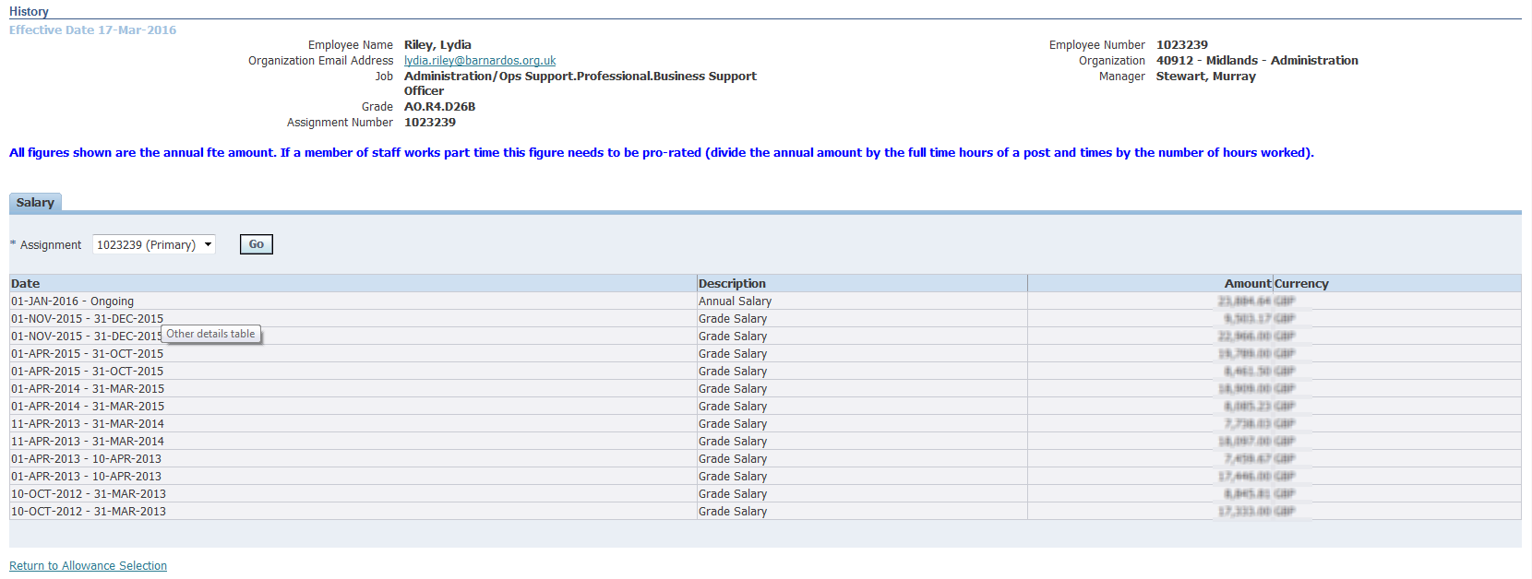
- Check whether the allowance type you wish to edit has already been allocated
Note: If the allowance you wish to allocate is already allocated, contact your local People team.
- Click on the Return to Allowance Selection link to return you to the previous screen.
- Providing that the allowance to be allocated has a blank in the Status column and does not appear in the history screen, you can continue to allocate it.
- Select the allowance type that you wish to allocate.
- Click on the Next button.
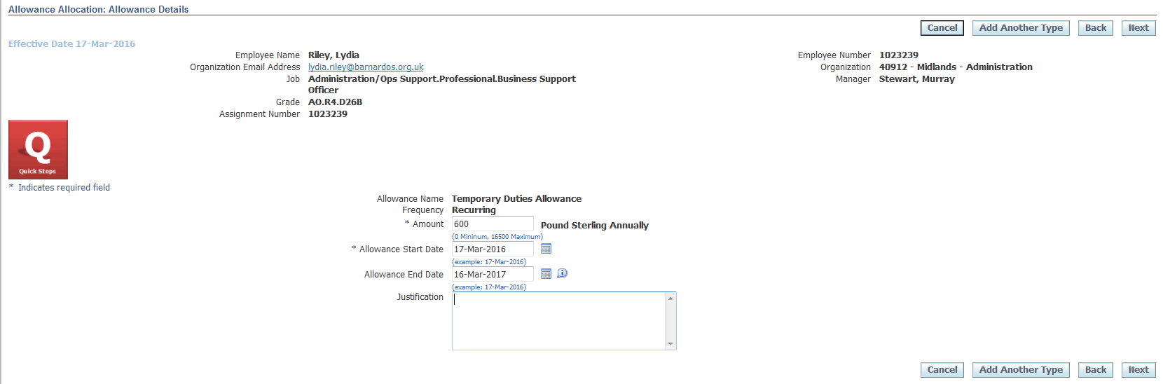
- Enter the amount of the allowance in the Amount field.
Note: for recurring allocations, this figure should be the Annual Full Time Equivalent amount (i.e. 12 times the monthly amount for a full time worker) even if the allocation is for less than a year or the person is actually part time. The system will work out the correct amount for the time period and number of hours actually worked.
For example, if you are entering an allocation of £10 per month for someone that works 1 day per week, you would need to enter £600 in the Amount field (£10 per month x 12 months x 5 days). The system will then pro-rata this amount according to the hours worked and the duration of the allocation.
- Enter the start date for the allowance in the Allowance Start Date field.
- If the allowance is for a specific period of time, enter the end date in the Allowance End Date field.
- Describe the justification for the allowance in the Justification text field.
Note: At this point, if you are allocating more than one allowance to this individual, you can click on the Add Another Type button.
- Click on the Next button.
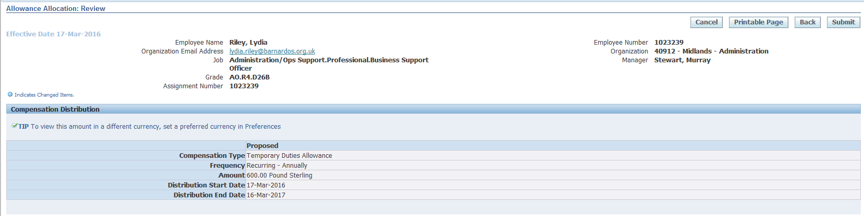
- Click on the Submit button.
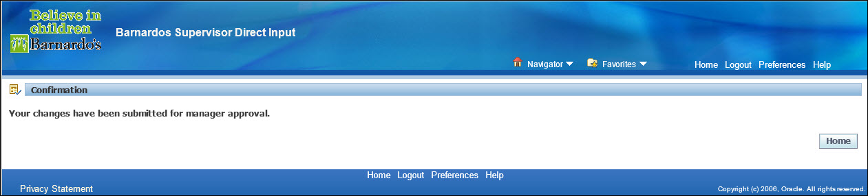
- Click Home to return to the Oracle Applications Home Page.

