Amending an Allowance Allocation
- Select the allowance type that you wish to amend after checking the status.
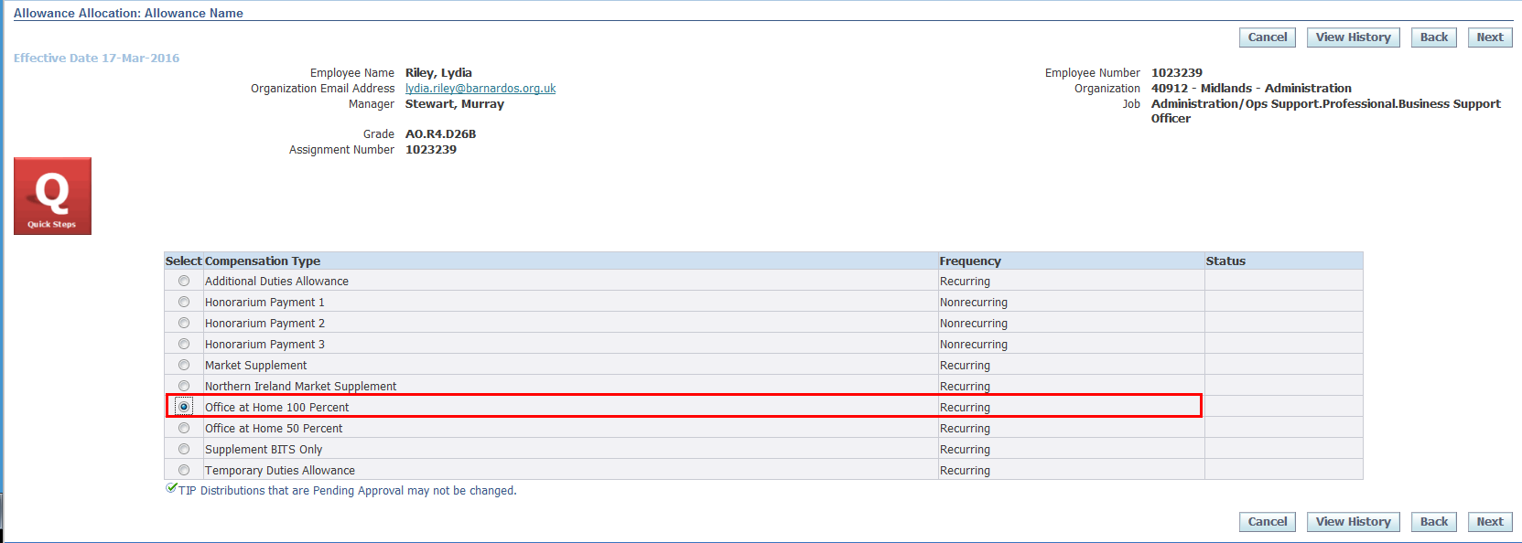
Note: Only Allowances which are currently ongoing and entered through DI can be amended through DI. For Allowances which are not any of the 10 types mentioned above please contact your local People team for amendments.
- Click on the Next button.
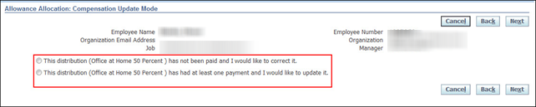
- Select the relevant option from the compensation update mode.
- The first option can be used to correct a wrongly entered allowance. Selecting this option will allow you to re-enter all details the same way you enter a new allowance.
- The second option should be used for open-ended allowances. Only the end date should be entered in this case. The amount and start date should always remain the same.
- Click Next to amend the allowance details. In this example the Allowance Start Date has been changed.
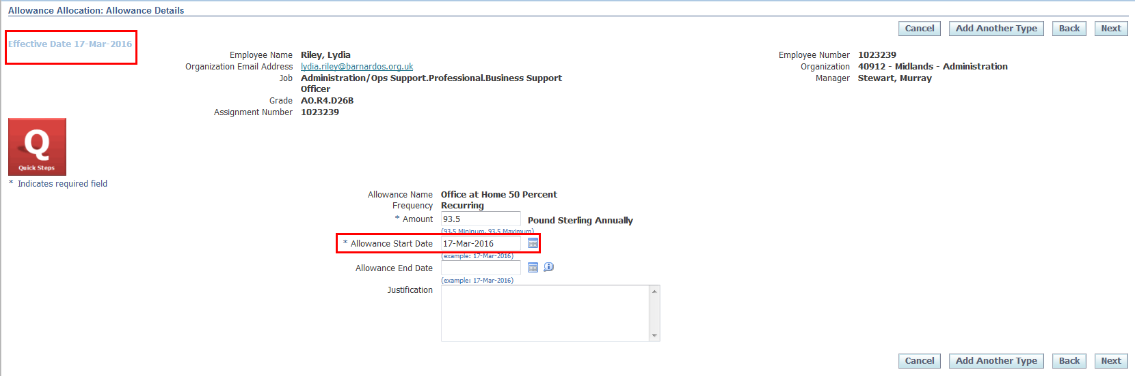
- Click Next.
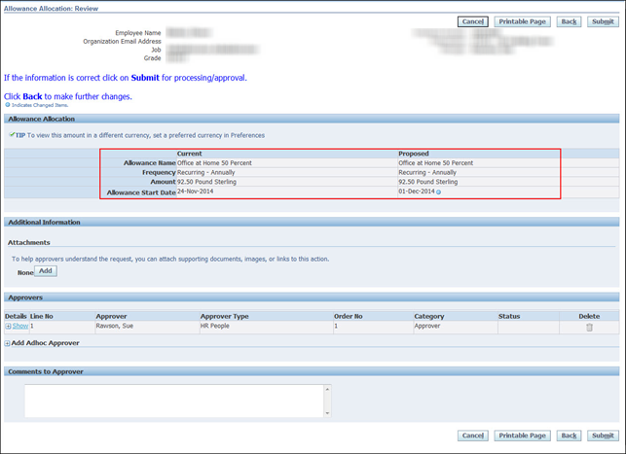
- The review screen will show both the current and proposed changes.
- Review the changes and if correct, click Submit.
Note: Any fields that have been updated will be indicated with a blue circle in the Proposed column.
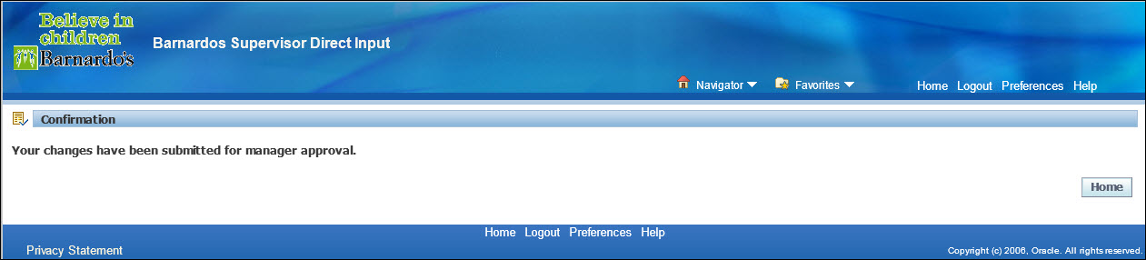
- Click Home to return to the Oracle Applications Home page or Navigator to go to another responsibility.
- Once approved, notification will be sent to HR and payroll.

