Through the Direct Input (DI) system you are able to change an employee’s salary. This action is for all employees on Barnardo’s Terms and Conditions only. For TUPE employees select Change Spinal Point (TUPE Only) in Direct Input.
Note: If the salary change is because of a change of Job. Please action the Change Job in Direct Input first.
- Log into Direct Input

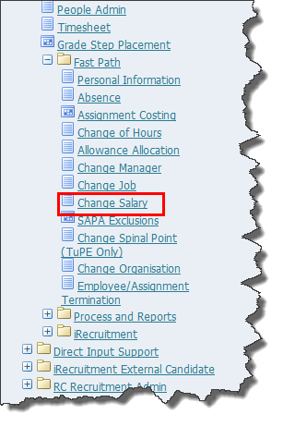
- From the Fast Path menu select Change Salary.

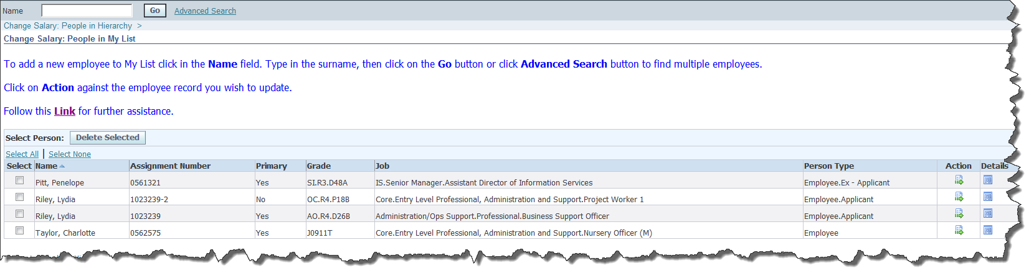
Note: Either search for an employee using the search field, click on My List and select and employee or, if you line manage an employee, they will be visible in the lower part of your screen.

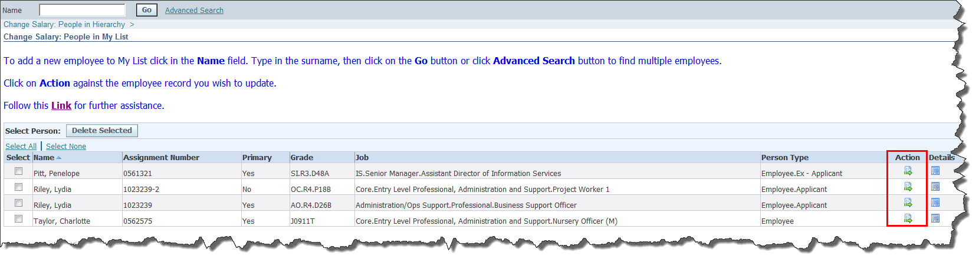
- Select the Action button next to the required employee.

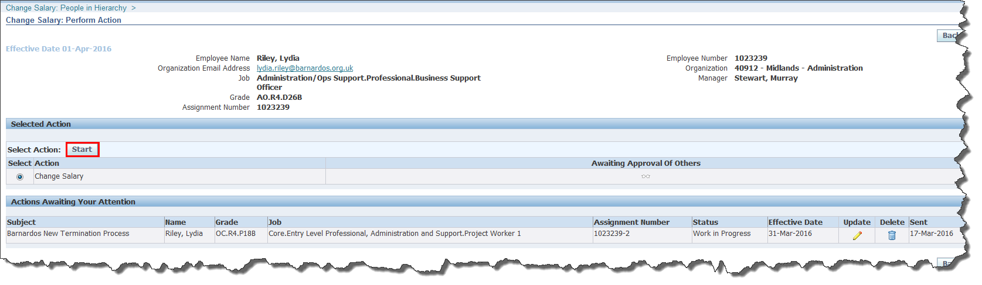
The Change salary: Perform Action screen will display.

- Select the Start button.

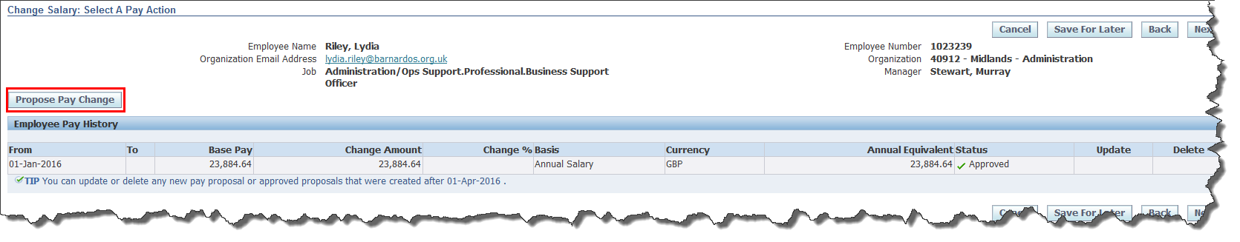
The Change Salary: Select A Pay Action screen will display.

- Select the Propose Pay Change button.

TIP: Use the Back button to go back to the previous screen or the Save for Later button to save the action for another time.
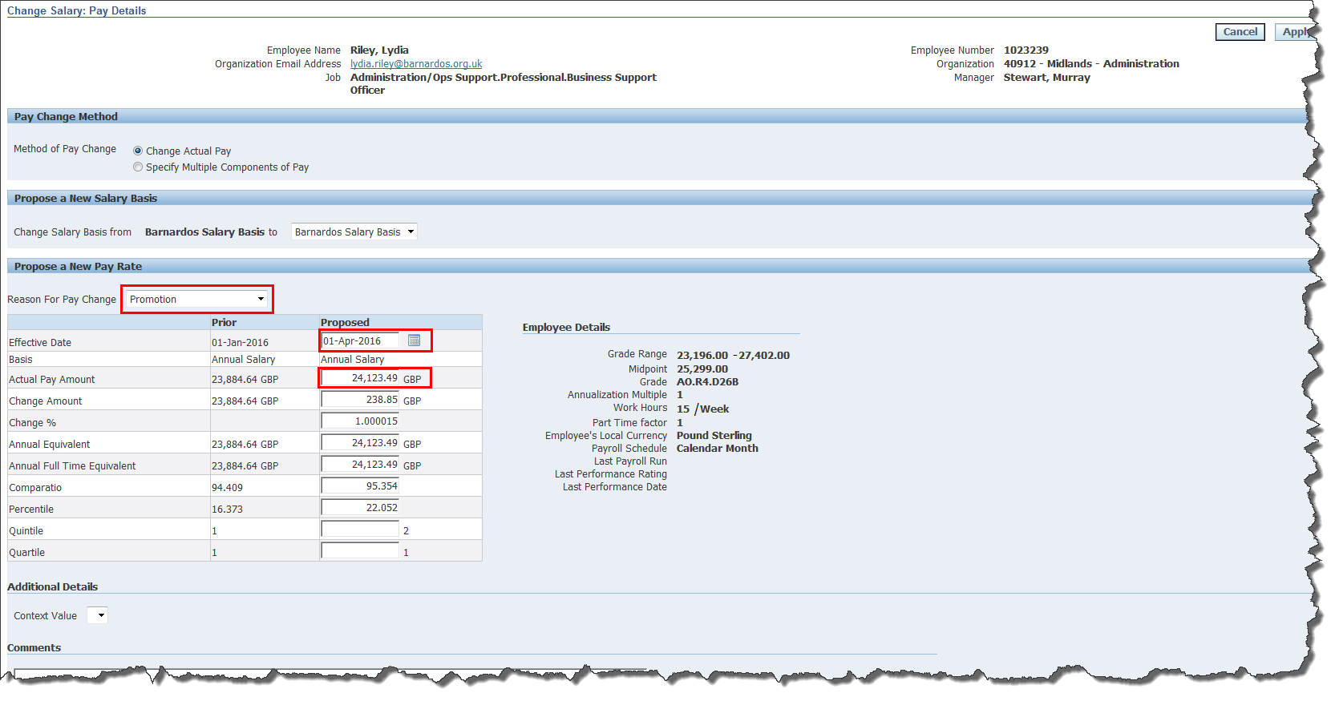
The Change Salary: Pay Details screen will display.
Note: The Barnardo’s Salary Basis field will default to Barnardo’s Salary Basis.
- In the Reason for Change field select the required option.
- In the Effective Date field enter the date.
TIP: You can use the calendar to the right of the Effective Date field to select a date.
- In the Actual Pay Amount enter the salary in GBP.
Note: The rest of the fields will populate once the Actual Pay Amount has been entered.
- Select the Apply button.

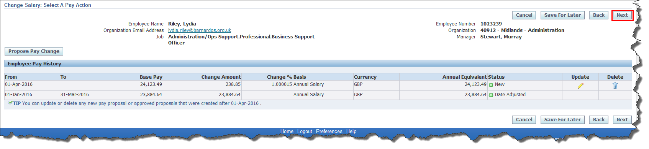
The Change Salary: Select a Pay Action screen will display.
Note: The new proposed salary will be displayed. You can update or delete any pay proposal or approved proposals that were created after 1 April 2016. Salary history will be displayed.
TIP: Use the Back button to go back to the previous screen or the Save for Later button to save the action for another time.
- Select the Next button.
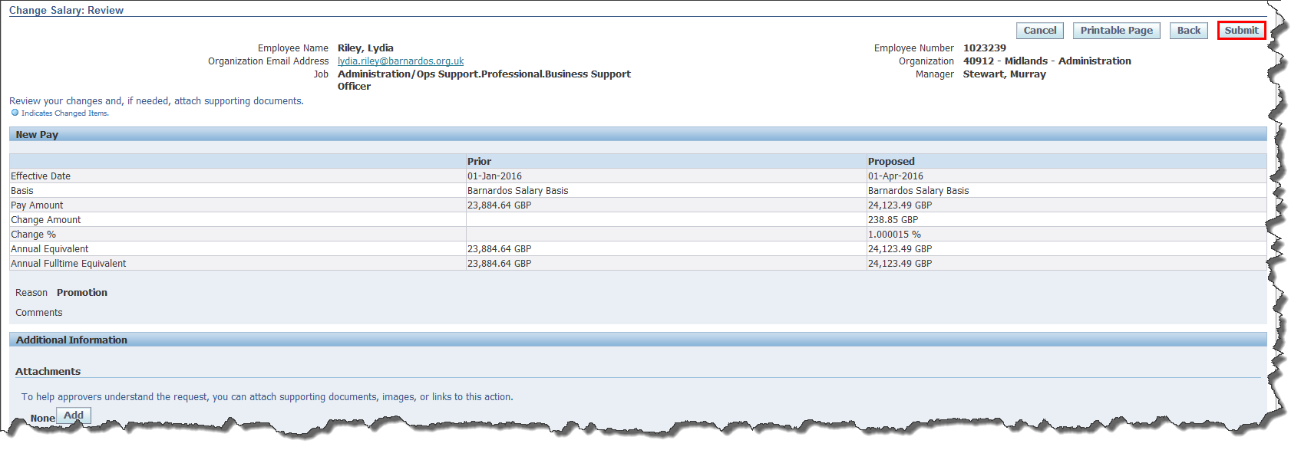
- Select the Submit button.

A Confirmation screen will appear displaying that changes have been submitted for manager approval.

