You can query the Direct Input (DI) system to find out details of the grade and pay of any of the people whose details you have permission to edit. In the case of Supervisor logins, this will be the people who report to you. In the case of Admin logins this will be the people in the Cost Centre(s) assigned to you.

Executing a Grade Query
- Log onto DI.
- Select Grade Step Placement – Query Only from the available items in the Navigator.
Note: The Grade Step Placement – Query only function has a different style of interface from the rest of DI.
- Oracle Forms will open.  - You first thing you need to select is the ‘Effective Date’.  - No - if you want to query the person’s current grade.  - Yes - if you want to query what the person’s grade was at a particular date in the past, choose and enter the date required in the next screen that appears (not shown here). | 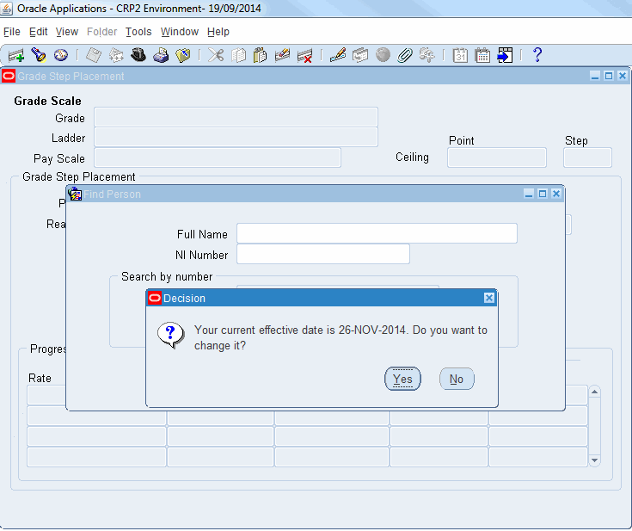
- Enter the name of the person in the Full Name field.  - Press the Tab key on the keyboard or select Find. | 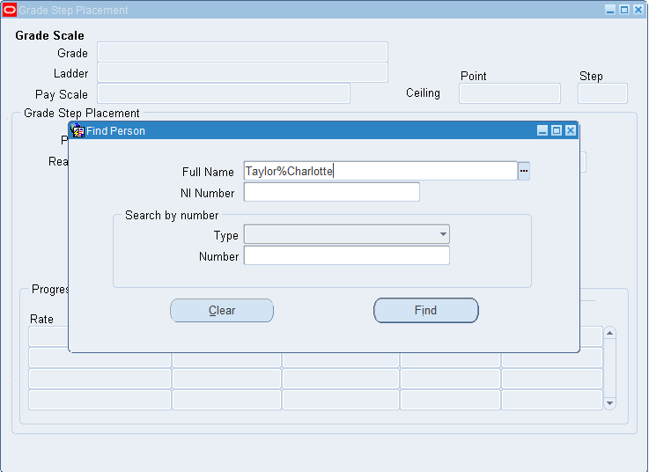
- Select the correct name from the list.  - Click on the OK button. | 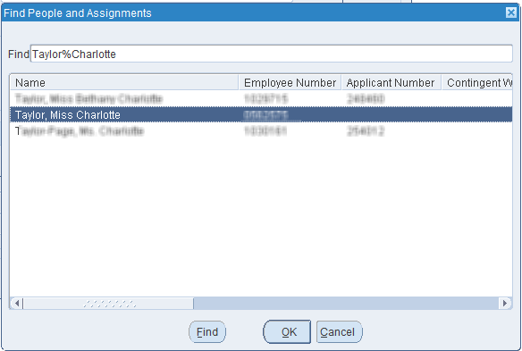
- The Grade Step Placement screen for the requested employee will open. | 