Click the links below to get to the relevant action.
Recording a Termination of Employment | Adding Termination Details
Terminating a Supervisor or Manager | Recording a Termination/end of Assignment

Important information about Terminations
The termination process in Direct Input (DI) can be used in the following two instances:
- Termination of Employment: When an employee is leaving Barnardo’s, the primary assignment should be selected and the procedure for Termination of Employment outlined in this guide should be followed.
- Termination of an Assignment: When a single assignment for an employee with multiple assignments needs to be ended, the particular assignment number which needs ending should be selected and the procedure for Termination of an Assignment outlined in this guide should be followed.
Note: If an employee has more than one job in Barnardo’s (i.e. has multiple assignments), terminating the primary assignment will terminate all of that person’s assignments.

Recording a Termination of Employment
- Log onto Direct Input.  - Select People Admin from the available items in the Navigator. | 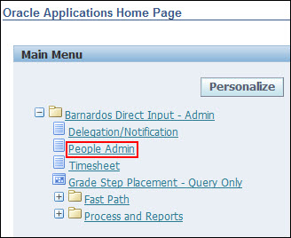
Locate the person whose employment is to be terminated by searching or from My List.
If the person has more than one assignment:-
- ‘Yes’ will be in the Primary Assignment column to indicate a Primary Assignment;
- ‘No’ will be in the Primary Assignment for non-primary assignments.
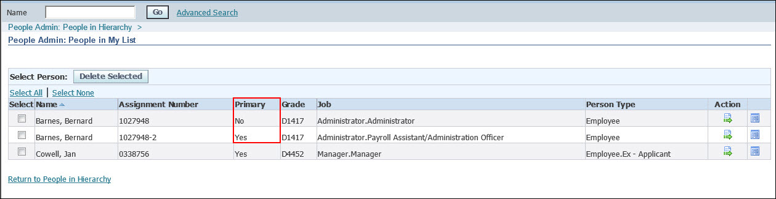
- If you are terminating an employee who is leaving Barnardo’s who has more than one assignment always select the primary assignment and click Action.
- If you are terminating an assignment only select the one that is to end and click Action.
- Select Employee/  Assignment Termination from the available list of actions  - Click Start | 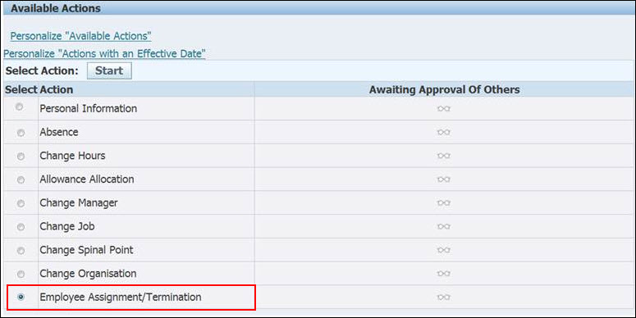
- Select the Effective Date using the calendar button.
Note: The effective date is the actual date of termination (i.e. the last day that the person will be paid), which is not necessarily their last day at work, due to using up annual leave.
- Click Continue.
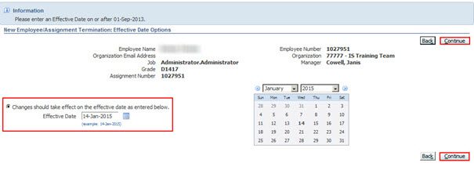

Adding Termination Details
Note: This screen is only used when an employee is leaving Barnardo’s.  - The Notification date should be the date when termination was advised. Note that the system will change it to the Termination date.  - The Reason field is mandatory and must be completed.  - Select a reason from the drop down menu.  - Enter any relevant notes in the Comments field |  | 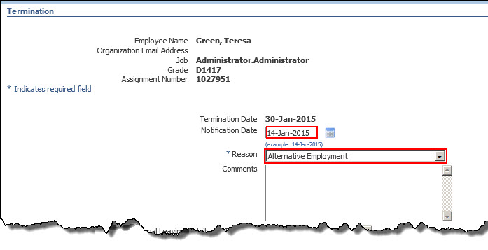
- Choose Additional Leaving Reasons from the Additional Leaving Reasons drop-down menu.  - A new set of fields are displayed |  | 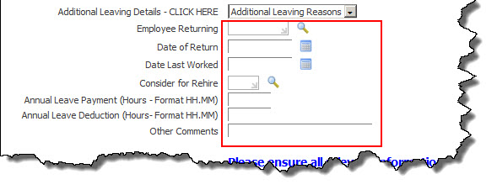
Complete the additional fields as appropriate, e.g.  - Employee Returning – This field is to be used if the employee is returning within 3 months and is a Yes or No option.  - Date of Return – This is the date the employee is returning to Barnardo’s.  - Date Last Worked – This is the last date the person is physically in office. This may be the same as the Effective Date or earlier if the person has taken annual leave just before the termination date. This field should be completed in either case.  - Other Comments – Used to explain any additional payments or deductions relating to annual leave, or any other payments that should be made. |  | 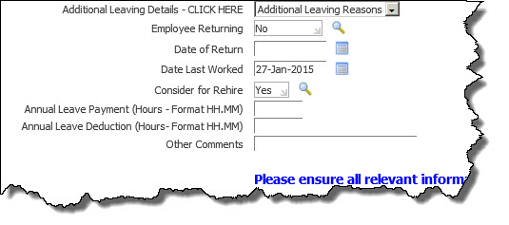
- Consider for Rehire – This is a list of values, but it only contains “Yes” and “No”. It is quicker to type the required entry rather than use the search button to select it.
- Annual Leave Payment (Hours) – Any annual leave outstanding to be paid. The format is in minutes e.g. If 7 hours 15 minutes (07:15) are outstanding, 07:15 hours should be entered in this field.
- Annual Leave Deduction (Hours) – Any annual leave to be deducted from the final salary payment. The format is in minutes e.g. If 7 hours 15 minutes (07:15) are outstanding, 07:15 hours should be entered in this field.
- Click Next and check all the details you have entered on the Review Screen.  - Click Submit. | 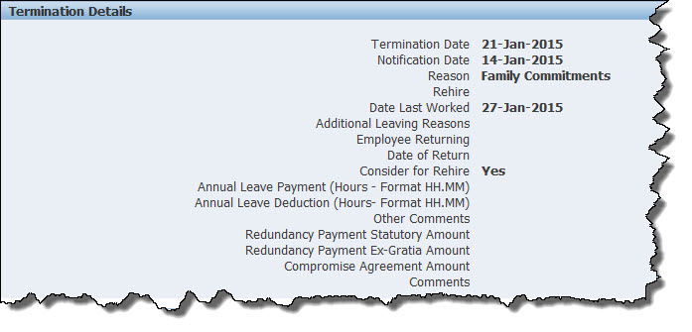

Note: If the person whose employment is being terminated is a supervisor, there will be further screens to complete before you get to this screen.
This is dealt with in Terminating a Supervisor below.

- A confirmation screen appears.  - If you have completed your work in Direct Input, close this screen and exit from Oracle.  - If you have more Direct Input tasks, click on the Home button or Navigator menu. | 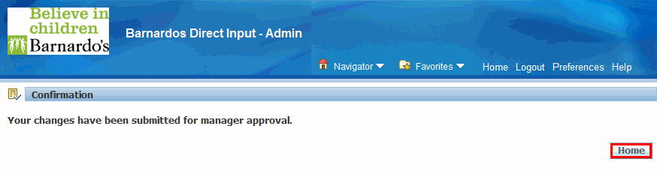

Terminating a Supervisor or Manager
If the person whose employment is being terminated is a supervisor or manager; then the process is the same as detailed above. However, after Adding Termination Details you will arrive at the screen below.
This screen lists the manager’s direct reports. You can either assign all of them to a single new manager, or assign them each individually:
To assign all reports to the same new manager:
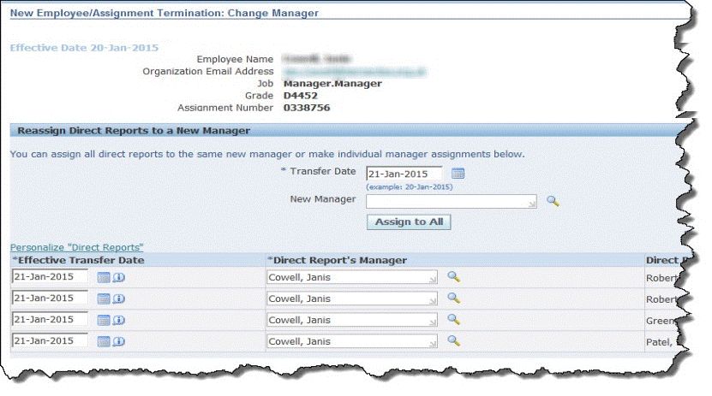
- Enter the transfer date using the calendar button to the right of the Transfer Date field. | 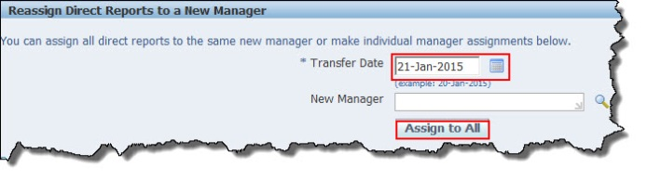
- Choose the new manager using the search button to the right of the New Manager field.
- Click on the Assign to All button.
- All reports will change to the new manager. | 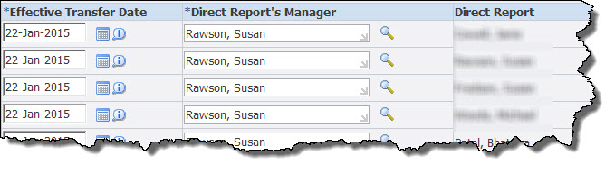
- Click Next. | 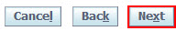

To assign the reports individually, for each row in the list of direct reports:
- Enter the transfer date using the calendar button to the right of the Effective Transfer Date field. |  | 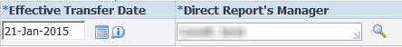
- Choose the new manager with the search button to the right of the Direct Report’s Manager field.
- When you have completed reassigning the reports, click Next.
- The Review window is displayed
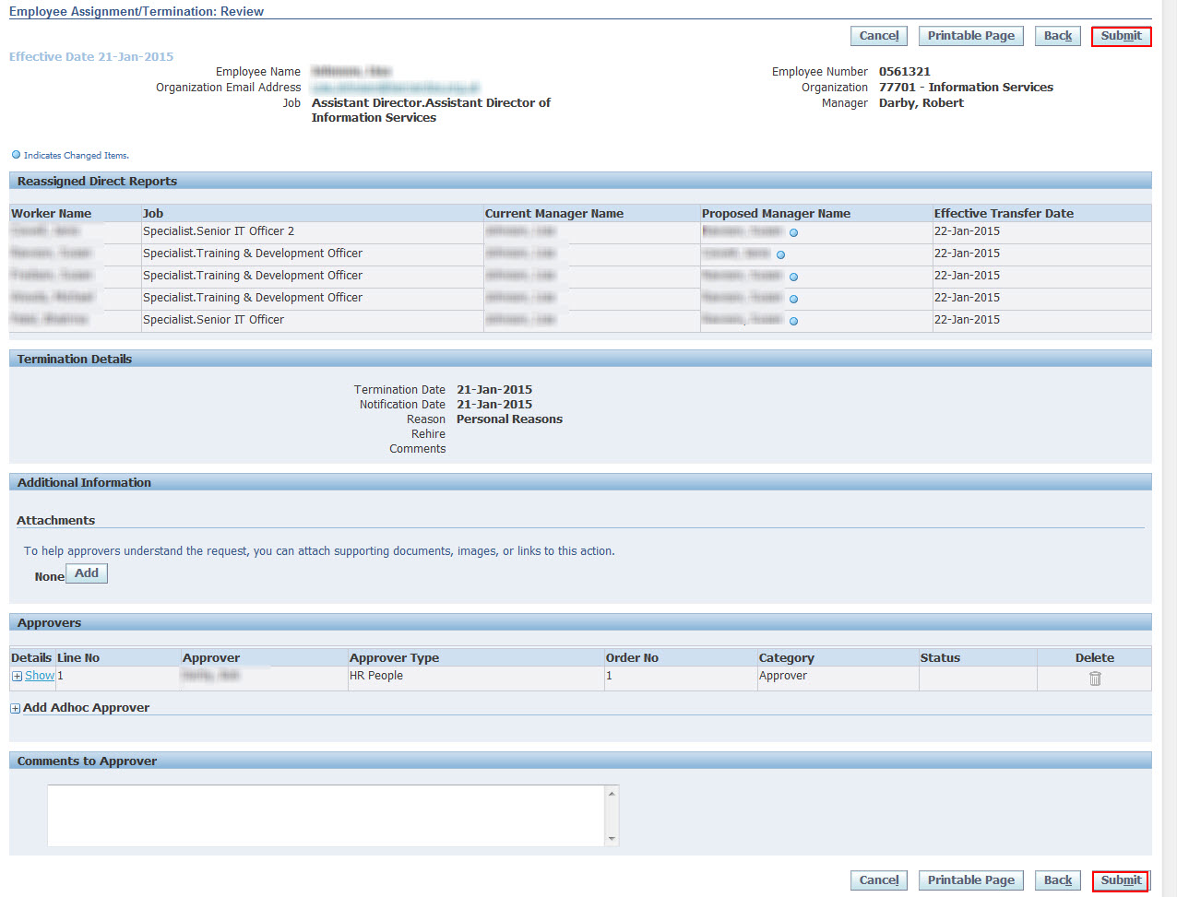
- Click Submit.
- A confirmation screen appears.
- If you have completed your work in Direct Input, close this screen and exit from Oracle.
- If you have more Direct Input tasks, click on the Home button or Navigator menu.

Recording a Termination/End of an Assignment
If the person has more than one assignment:-
- ‘Yes’ will be in the Primary Assignment column to indicate a Primary Assignment;
- ‘No’ will be in the Primary Assignment for non-primary assignments.
Note: You can end any of the assignments for an employee who has more than one, except the assignment that is indicated as the primary. It is important to remember that if you end the primary assignment this will terminate the employee. If the assignment which needs to be ended is a primary assignment, email the regional people team to change it to a non - primary assignment.
- Click the action button for the non-primary assignment that needs to be ended for that person.
- Select Employee/
Assignment Termination from the available list of actions.
- Click Start.
- Select the Effective Date using the calendar button.  NOTE: the Effective Date is the last day that the person will be paid for this selected assignment only.  - Click the Continue button. | 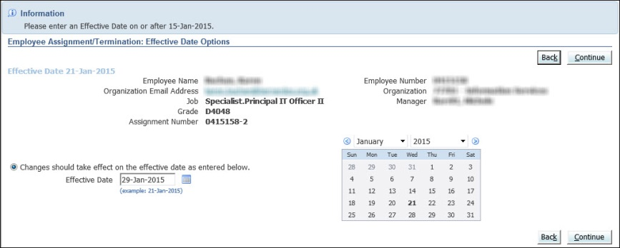

Note: The warning at the top of the window will confirm that if you go any further with the process, it will end this assignment only.
- The Organization, Job, Position, Grade and Statutory Information fields give the detailed information of this assignment for the person.  - This is just for information. | 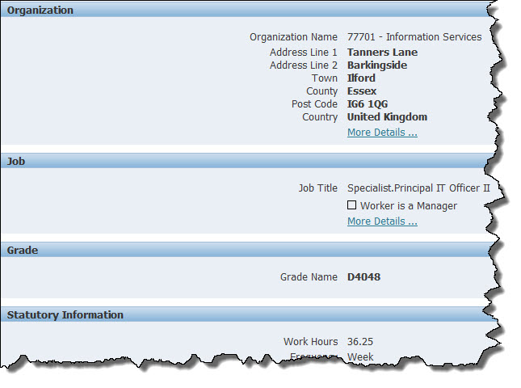
- Assignment Status – This field shows the current status of the assignment as active and the field below is a mandatory one.  - Always ensure that ‘END’ is selected from the drop down list.  - Click Next. | 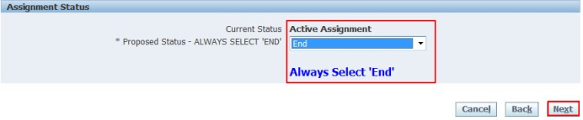
- Check the information on the Review screen is correct.
- Click Submit.
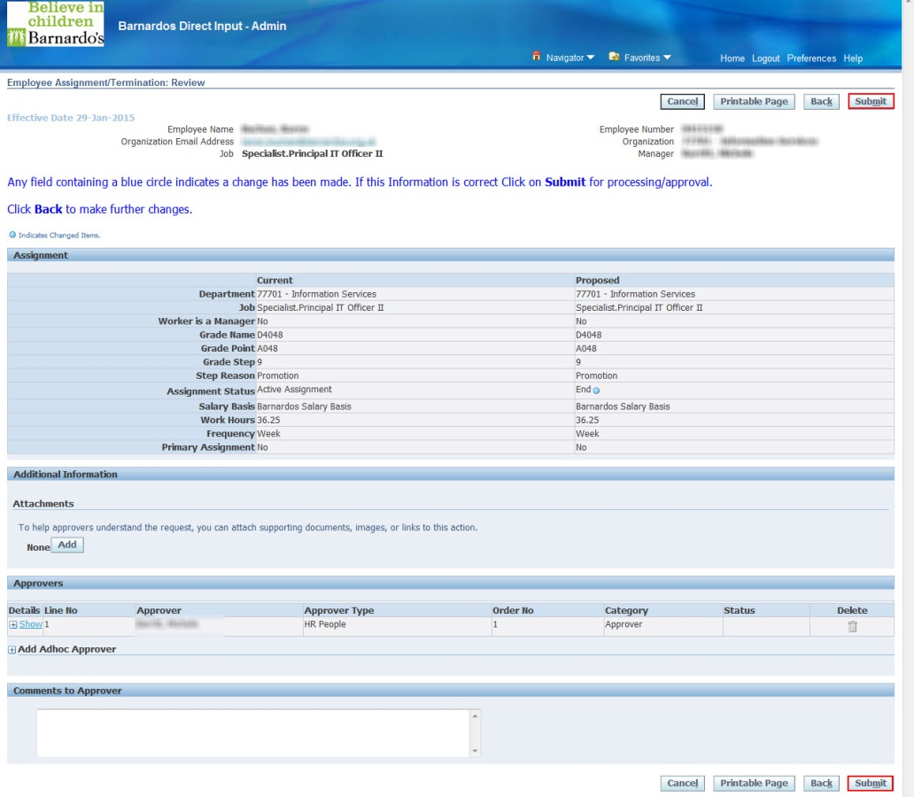
- If you have completed your work in Direct Input, close this screen and exit from Oracle.
- If you have more Direct Input tasks, click Home or Navigator to choose an alternative option.

