Exporting report into Excel
Run the report in the usual way. If you do not know how to run a standard report, refer to the user guide Running & Printing Reports.
- Click on the View Output button in the main report screen.  - In the output screen click on the Tools menu.  - Select the Copy file. | 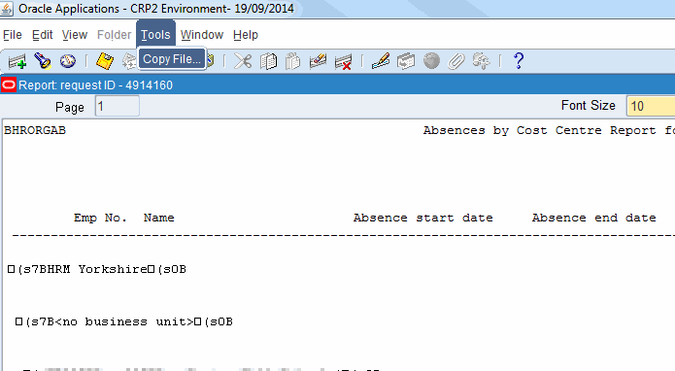
- A new window will be launched.  - Click on the File menu.  - Click on Save As… | 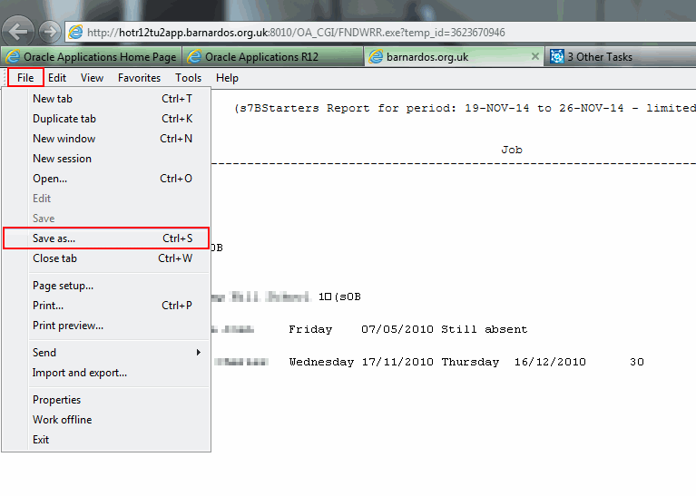
- Give the file a suitable name.  - Ensure that Save as type is ‘Text File’.  - Click on Save.  - Close Oracle. | 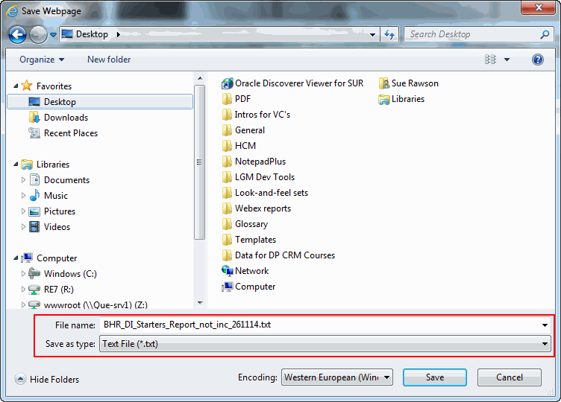
- Open Excel.  - Click on File, Open.  - Ensure the Files of type is changed to All Files. | 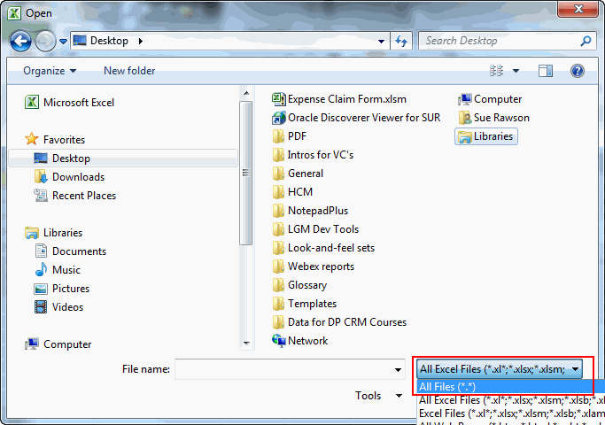
- Select the report.  - Click on Open. | 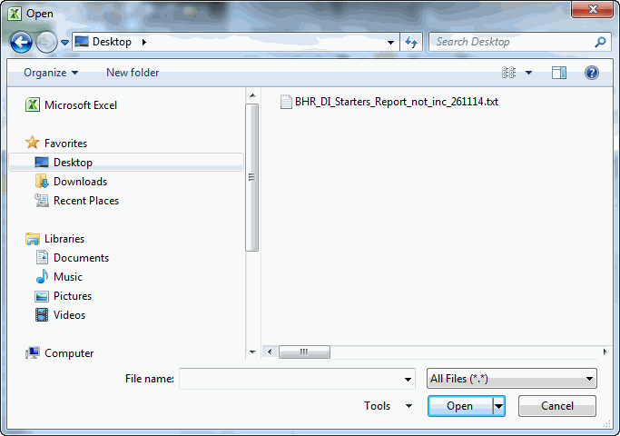
- Select the Fixed width and click on Next. | 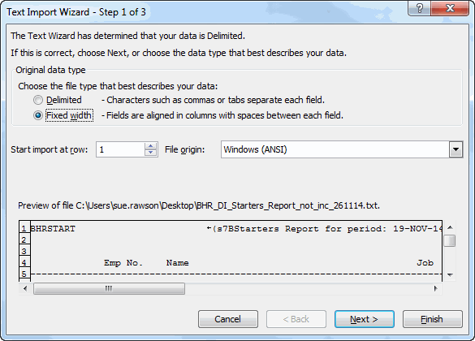
- Click and drag the arrowed line to a place where a break is required (ie where a new Excel column is needed).  - If no new column is needed, click and drag the line downwards and it will be deleted.  - Use the scroll bar to move forward and back to move/delete all the breaks.  - Click on Finish when completed. | 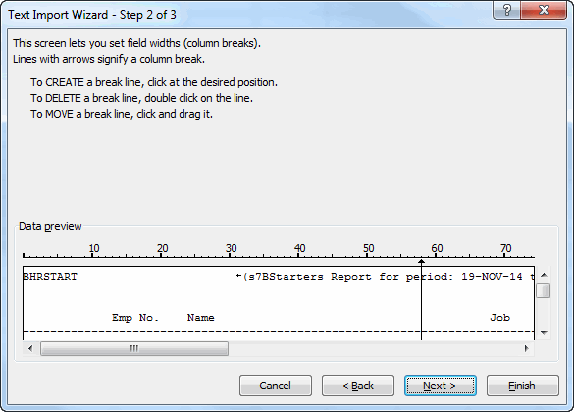
- The report will now appear in Excel.  - The report can now be saved into Livelink if required. | 