What information can you modify?
The DI system will allow you to modify any of the following items of information.
- Timesheets
- Personal Information - Name, Address, Phone numbers and email address, Emergency contact details, Marital Status, On Call Allowance, Sleep In Allowance and Work Schedule.
- Employment Information – Absences, Leavers/Terminations, Location, Manager, Hours, Post, Organisation, Spinal Point and Allowances

On-Screen Help
On many of the screens in DI we have inserted help text such as the example below:
Note: Text is coloured blue to differentiate it from the other text on the screen, and normally contains links to user guides.

- In addition, to the right of some fields you will find a Tip button in the shape of a small blue speech bubble enclosing an “i”, as in the example on the right. | 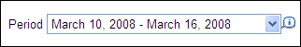
- Clicking on this tip icon, will pop up a tip screen similar to the on on the right. | 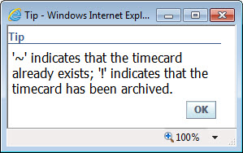

Obtaining a Login
In order to access the Direct Input (DI) system you will need a login and to be assigned one or more “responsibilities”. The latter define what permissions you have within the DI system. If you do not already have a login, you should request one via the IS Service Desk using FirstPoint.
Note: If you already use Oracle for another function (e.g. Finance) then you do not need to get a new login. All Oracle functions are accessed through the same login. However, you will need to have the appropriate DI responsibility assigned to your existing login. You should request this via email to Direct Input Support.

Logging In
Follow the instructions below:
- Go to Start  - Select All Programs  - Select the Barnardos Websites folder  - Select Oracle E-Business Suite [Live] | 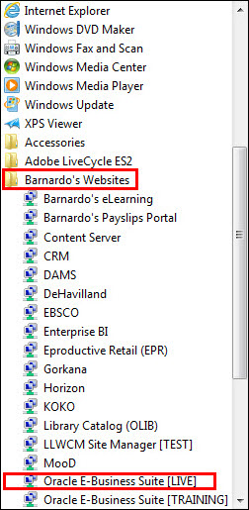
- Alternatively type “Oracle” in the Search programs and files field
- Select Oracle E-Business Suite [Live] | 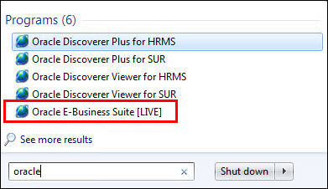
- The first time you login you will need to set up single sign on. See user guide Oracle Single Sign on for help with this
- The Oracle Applications Home Page will be launched.
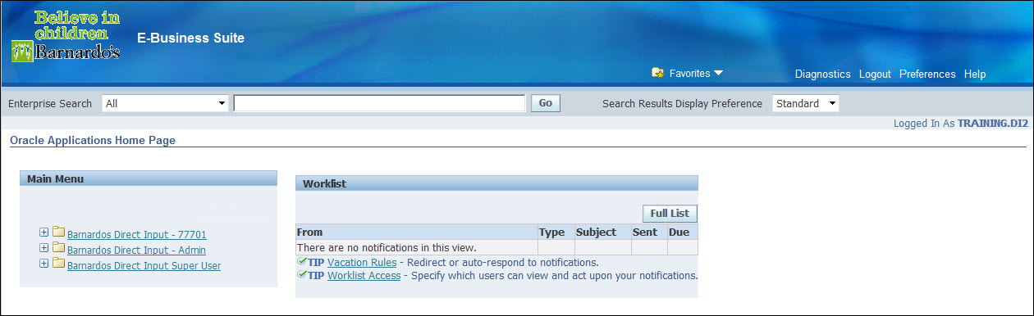

Which DI responsibility do you have?
There are two DI responsibility types. They differ only in the groups of people whose details you are allowed to modify. They will be shown in the left hand panel.
- Barnardos Direct Input - Admin – If you have an this type of responsibility you will be allowed to modify the details of any staff that fall within the cost centre assigned to your access. If you manage any staff, you will also be able to modify their details.
Note: If your service has more than one cost centre, the name of the responsibility will include the service name, e.g. Barnardos Direct Input – Short Breaks. You will be able to edit the details of any staff that fall within all of these cost centres.
- Barnardos Supervisor Direct Input – if you have this type of responsibility you will be able to modify the details only for staff that you manage. You will normally be given this type of login if your main task on DI will be approving changes entered by someone else (see “Approving Changes” below).

- From the Main Menu, click the + to the right of the relevant folder to access the related functions | 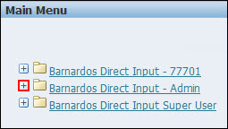
- Available functions will be listed – details of how to use each function are covered in separate user guides | 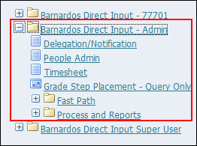

NOTE: If you have been assigned Barnardo’s Supervisor Direct Input responsibility as part of the the roll out of i-Recruitment an additional item called iRecruitment Home will appear at the bottom of the navigation panel in the Oracle Applications Home Page.

Navigator
The Navigator menu is available everywhere but the Home Page.

- Click the drop down arrow to access your other responsibilities  - Hover your mouse over the  responsibility to select one of the available fucntions | 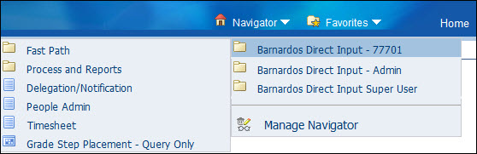

Favorites
- Using Oracle Favorites can save time accessing your most used screens
- For information on adding and editing Favorites, see the user guide called Working with Favorites.

Setting up your “My List”
If you have a Supervisor responsibility you can skip this step, as all of the staff that report to you will be listed on the first screen that you see in DI. However, if you have an Admin responsibility you will need to select the people whose details you wish to modify from a list. This process is covered in the separate user guide entitled Adding People to My List.

Approving Changes
With any change that involves pay (i.e. Timesheets, Change of Hours, Change Post, Change Spinal Point, Termination and Allowances) any changes entered must be approved. This process is detailed in the separate user guides entitled Approving Timesheets and Other Changes
Important Note for Managers/Supervisors
If you are responsible for approving changes entered by someone else it is vital that you log on to DI regularly in order to deal with any changes that are awaiting your approval or not paid. If you fail to do this, it will probably result in someone being paid incorrectly!
If you are going on leave you should set up a Vacation Rule to redirect your approvals to someone else before you leave, so that any notifications can be dealt with in your absence. This is covered in the separate user guide entitled “Vacation Rules”.
Timesheets must be approved within 10 days of submitting or the approval will be “escalated” up to the manager of the current approver.

Who Approves Changes?
Changes that requires approval must be approved by the manager of the person whose HR record is being updated (often this will NOT be the manager of the person entering the changes). An automated email will be sent to the approver for each change that requires approval.
Changes that do not require approval (e.g. change of name, address etc.) are actioned immediately and no email is sent.

Common Direct Input Processes
There are a number of different actions that you can perform via Direct Input (DI), and many of the steps are common to all of these. This user guide gives an overview of the common steps. Details of each action are covered in separate user guides.

People Admin vs Fast Path
A number of the actions that you can perform with DI are in the Fast Path group. In fact, you can also reach these via the People Admin option as well, e.g.
People Admin | Fast Path
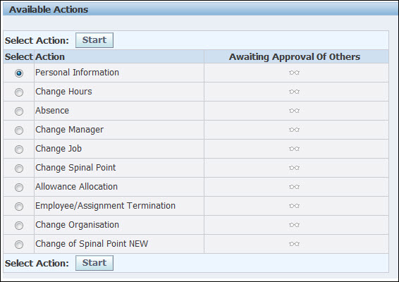 | 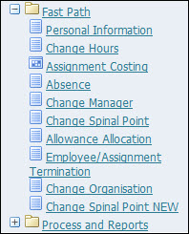

It does not matter which way you access the action, via Fast Path or People Admin.

Starting an Action
The first step in most actions that you can carry out in DI is to select the relevant person.
- From the Oracle Applications Home Page, click on the function you wish to perform
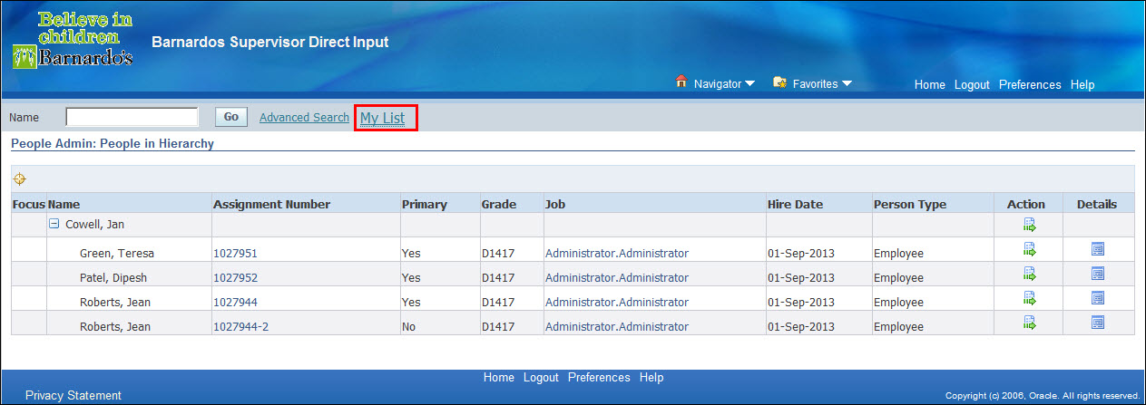
If you have a Supervisor login you will see a list of the people whose details you can edit (as in the example above). If you have an Admin login you will need to click on the My List link towards the top of the page. The user guide entitled Adding People to My List covers setting up your My List page with the list of people whose information you can edit.
- Once you have found the person whose details you wish to edit, click on the icon in the Action column for that person
From this point, each action leads to different screens. These are covered in detail in the separate user guides for the relevant action.

Corrections, Changes and Effective Dates
With a number of DI functions, you will be asked if you want to correct the information or to add new information, e.g.
Which of these you should choose depends upon whether you are correcting an error (e.g. if a surname has been entered incorrectly) or if the information has actually changed (e.g. if the person has changed their surname).
You will often also be asked if you wish to change the “Effective Date”, e.g.
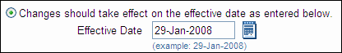
The effective date is the date from which the change you are making should start. This allows you to back date a change that happened in the past (such as a change of surname) or forward date a change that will happen in the future (such as a termination).
Note: It is very important that the correct effective date is used. Using the wrong effective date could result in a number of errors, including possible under or over payment of salary.
If you are making a correction, you will not be allowed to change the effective date (as it is assumed that the current information is incorrect and has been since it was entered). You will only be allowed to change the effective date when you have chosen to enter new information.

Common Controls
There are a number of controls that you will come across in various places in the DI system. Mostly these are fairly self-explanatory (The “Submit” button, for example). This section describes how to use the more complex controls.

The Calendar Button
In fields date fields you can type the date into the field, using the format dd-mmm-yyyy (e.g. 01-JAN-2008). Alternatively you can click on the Calendar button, shown to the right of the field in the above example. This opens a popup calendar:
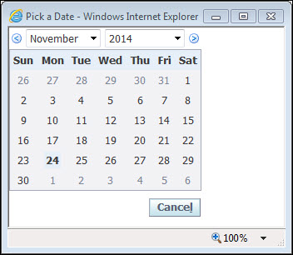
You can change the month and year using the drop-down lists at the top, then click on a day in the month displayed to select it.

The Search (Magnifying Glass) Button
In fields where you can select from a large list a Search button in the shape of a small magnifying glass will be displayed to the right of the field, as in the above example. This button pops up a search screen allowing you to search for items from a list. The example used here shows the search popup used to select a user name. This occurs in a number of places in DI, such as when setting up vacation rules or redirecting an approval.
Tip: It is useful to type into the field before clicking on the Search button. This will display any matching records in the popup search screen. In the example above, the letters “wo” have been entered into the field before the Search button was clicked. The result is shown below, where the Search popup shows a list of all names starting with these two letters. Note that you do not need a % sign on the end (e.g. wo%) for this to work, although it will still work if you include it.
You can display all of the items on the list by typing % in the field before starting the search. If you use this with a long list (such as the list of user names) the resulting list is too long. However, for shorter lists (such as the “Reason” list when changing Spinal Point) this is very useful in order to see what the options are.
If you are familiar with wildcard searching you can use the % sign as a wildcard to make your search more flexible in a number of ways, such as %ford, phil%ips etc.

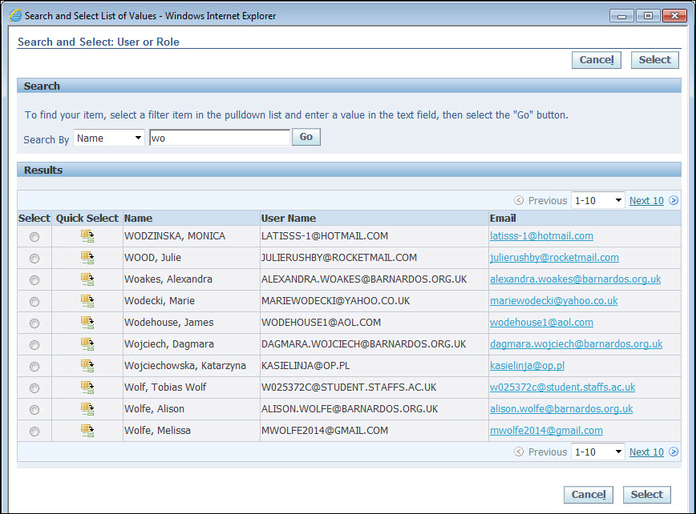
- Click on the button in the Quick Select column to select an item from the list

Forgot Your Uswername or Password?
- Click the Login assistance link | 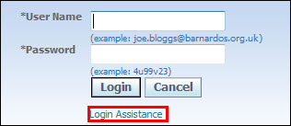
- Type in your username or email, depending on which one you want reset  - Click on the button to the right of the username or email | 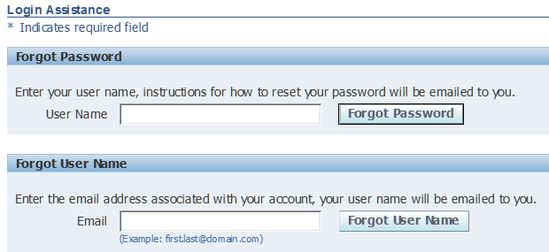
- A confirmation screen is then displayed confirming your request and advising you that an email will be sent to your email address
- Select OK to return to the Login screen

