The Absence function should be used to record when a person is absent from work. Absence should be recorded as it happens or at least once a week. You should start an absence record as soon as the absence starts, i.e. do not wait for the person to return to work.
Once the person returns to work, you should update the absence record as detailed in Updating an Absence Record below.
Note: When an employee starts maternity leave this is NOT recorded as an absence. You should record this as a change of hours. See the user guide entitled Change of Hours for details.

Starting an Absence Record
- Log onto DI.  - Select People Admin from the available items in the Navigator. | 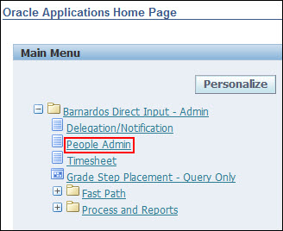
- If you have an Admin login, go to My List.  - Click on the action button for that person.  - Select Absence from the available list of actions  - Click the Start button. | 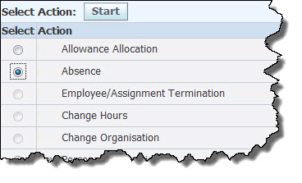

Absence History
- The absence summary screen lists a history of all previous absences from the latest to the oldest, displaying 10 items on the screen.
- Use the Next 10 and Previous 10 links to move from page to page.
- Click on the Details button to view the details of a specific absence.
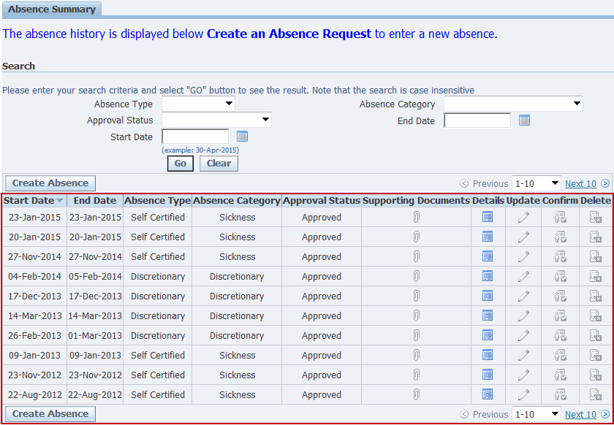
- The Search at the top of the screen can be used to find Absences based on various criteria, including Start and End date.
- Select from any of the drop down lists, or type in dates and click on the Go button to filter out Absence based on the search criteria.
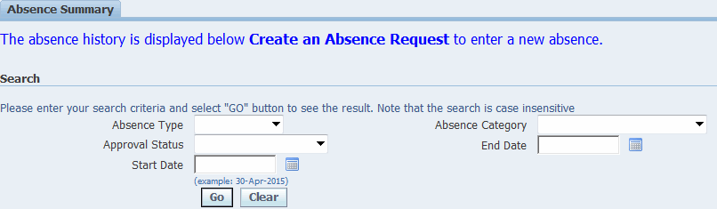

Creating a New Absence
- Click Create Absence button.
- Choose an Absence Type from the drop-down list
- Choose an Absence Reason from the drop down list.
- Choose the first day that the person was absent from work using the button to the right of the Start Date field.
- If the person is still absent from work, you must leave the End Date and Working Days fields blank. Then skip to Submitting the Absence below.

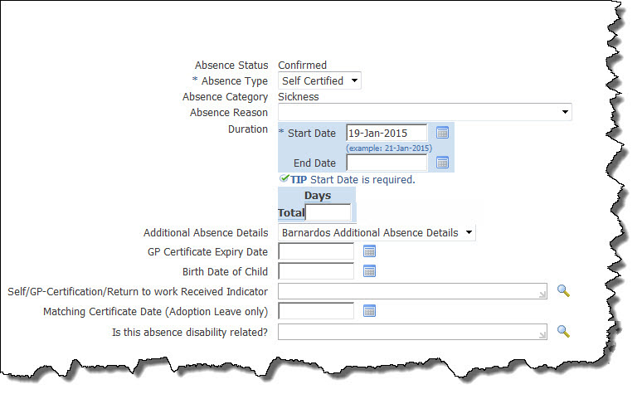

Note: If a change needs to be made after the End Date has been entered and the absence has been submitted, you should contact the Direct Input Support Team.
However, if the person has already returned to work:
- Choose the last date that the person was absent from work (NOT the day the person returned to work) using the button to the right of the End Date field. | 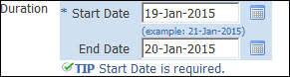
- Enter the number of working days the person was absent from work in the Days field. Be careful not to include days that the person does not normally work. Please make sure that this is in line with the Work Schedule/ Availability Schedule of the person which is recorded on Oracle HCM. | 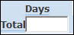
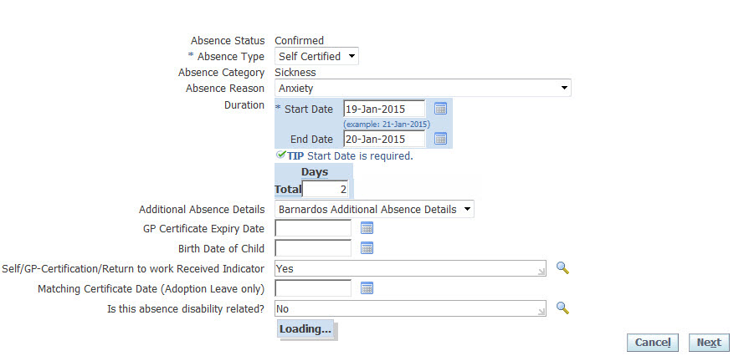
Note: If the Availability Schedule is not correct, refer to the user guide on Personal Information for more details on how to Update/Correct the Work Schedule on DI.

Note: Ideally, the return to work interview will take place immediately the person returns to work, allowing the Self/GP-Certification/Return to work Received Indicator field to be updated to Yes. However, once an end date has been entered onto an absence record, the record can no longer be updated.
Consequently, it is important that the return to work interview happens as quickly as possible so that this field can be updated at the same time that the end date is recorded.
- Matching Certificate Date (Adoption Leave only) – If the absence is for adoption leave enter the date on the certificate indicating when the adoption is to commence.
- Is this absence disability related? – For medical absences, enter a Yes if the absence is related to a disability and No if it is not.

Submitting the Absence Record
- Click Next.
- Click Submit.
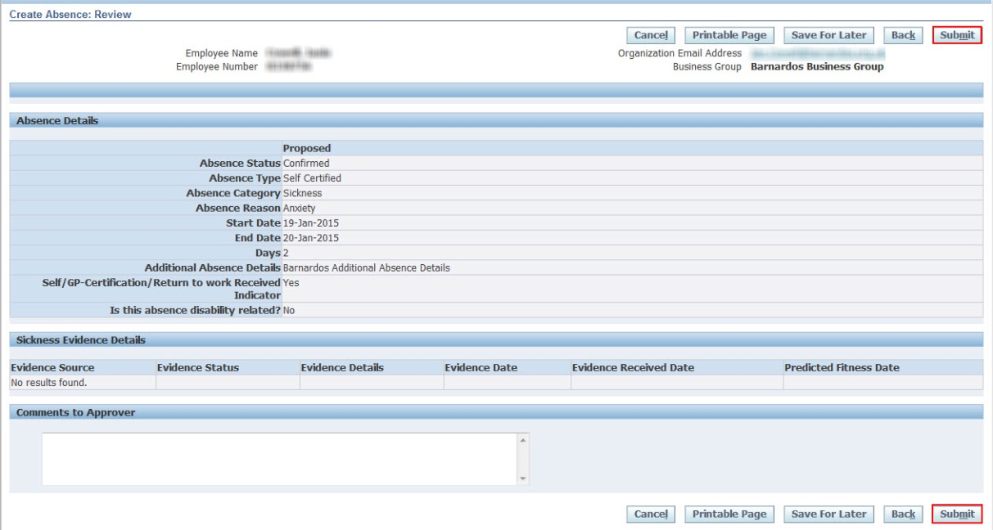
- The Absence Summary screen will be displayed with the new absence listed.
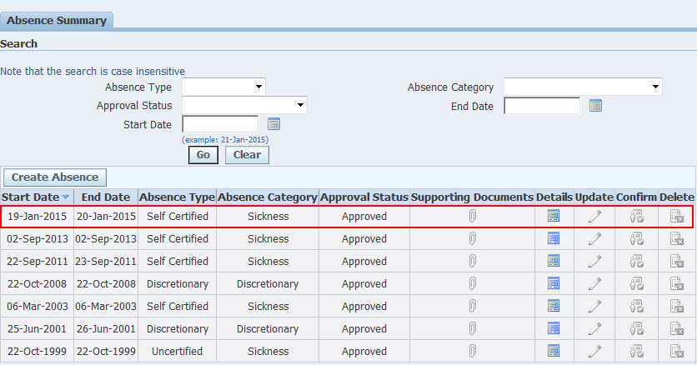

Click Home to return to the Oracle Applications Home Page or Navigator to access another responsibility.

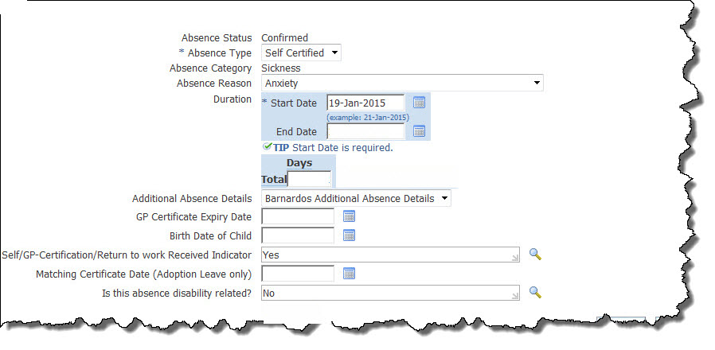Updating an Absence Record
This process is normally used to complete an absence record after the person has returned to work. The first step is to locate the absence record that you wish to update:
- Follow the steps above to locate the record to be updated.
- Click on the update button in the Update column.

Note: You cannot change the absence type of an existing absence record. If you need to do this (e.g. when a Self Certified absence extends past one week and has been replaced by a GP Certificate it will be GP Certified) you must delete the existing Self Certified record (using the delete button to the right of the record) and then create a new absence with the correct GP Certified absence type.

- Enter the last day that the person was absent from work (NOT the day the person returned to work) using the button to the right of the End Date field. | 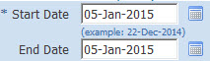
- Enter the number of working days the person was absent from work in the Days field.  Be careful not to include days that the person does not normally work. You must make sure that this is in line with the Work Schedule/ Availability Schedule of the person which is recorded on Oracle HCM. | 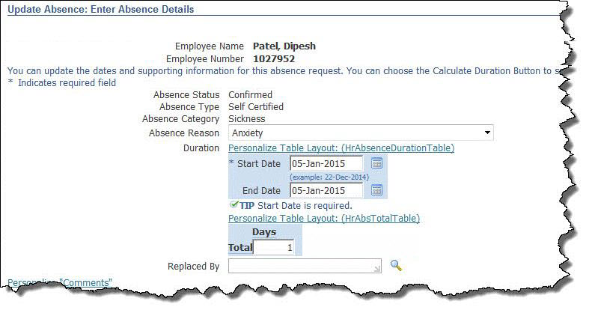
Note: If the Availability Schedule is not correct, please refer to the guide on Personal Information for more details on how to Update/Correct Work Schedule on DI.
- If the absence is medical (i.e. Self Certified or GP Certified) or to do with adoption leave, the following extra fields will appear at the bottom of the form.
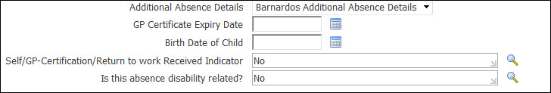
- GP Certificate Expiry Date – Used for GP Certified absences only. This is the date that the member of staff should refrain from work, as indicated by date on the GP on the certificate.
IMPORTANT NOTE: When a new GP certificate is received (for an existing GP certified absence) the absence should not be closed and a new one opened. Update the GP Certificate expiry date field to reflect the new GP Certificate end date.
- Self-Certification/Return to work Received Indicator – Used for Self-certified absences only. You should initially enter No in this field if the person is still absent. When the absence record is updated to add the End Date, then this field should be updated to Yes if the return to work interview has taken place.
NOTE: Ideally, the return to work interview will take place immediately the person returns to work, allowing the above field to be updated to Yes. However, once an end date has been entered onto an absence record, the record can no longer be updated.
Consequently, it is important that the return to work interview happens as quickly as possible so that this field can be updated at the same time that the end date is recorded.
- Matching Certificate Date (Adoption Leave only) – If the absence is for adoption leave enter the date on the certificate indicating when the adoption is to commence.
- Is this absence disability related? – For medical absences, enter a Yes if the absence is related to a disability and No if it is not.
- Click Next.
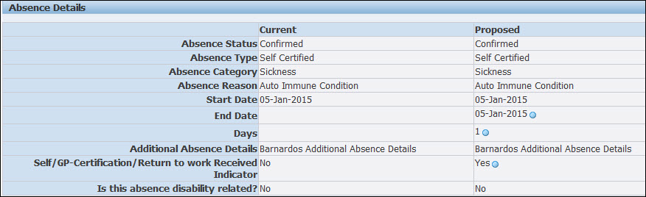
Note: The fields that you have updated will be indicated with a blue circle in the Proposed column.
- Click Submit. | 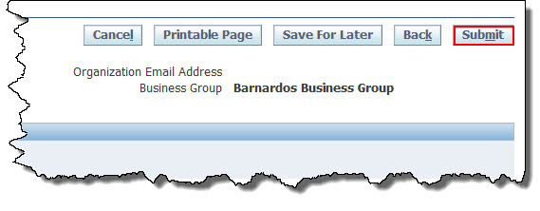
- The Absence Summary screen will be displayed with the absence listed with the updated information.
Important Points:
- Phased return to works should not be record onto the employee’s absence record. The absence should be ended on the employees last day absent before the phased return to work begins. As long as the phased return to work is 4 weeks or less the employee is entitled to full pay so there will be no need to record as an absence entry.
- Annual leave will continue to accrue during periods of sickness absence. Members of staff who fall sick during the course of their annual leave and provide a doctor’s certificate confirming their sickness shall be regarded as being sick from the date of their doctor’s certificate and shall be entitled to take the balance of the holiday at a later date after their return.
- Employees should not do day swap, as in work overtime or take flexi to cover a sickness period.

