This user guide covers how to run a single report in Oracle, then how to find it again and view it on the screen and finally, how to print it (if required).

Running a report
- On the main Oracle Applications Home Page, open the Direct Input folder.  - Open the Process and Reports folder.  - Click on Submit Process. | 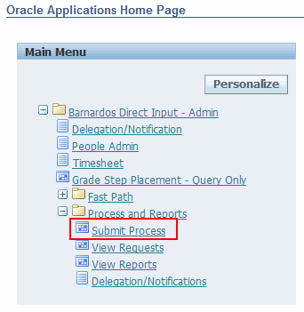
- The Submit New Request dialogue box will appear.  - Single Request will be selected by default.  - Click on OK. | 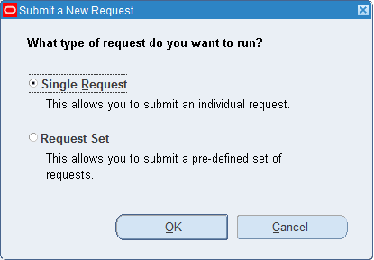
- Click on the Ellipse button at the right hand end of the Name field. | 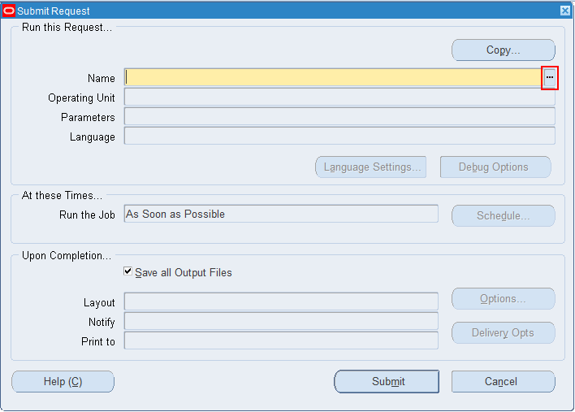
- Select a report from the list of options. | 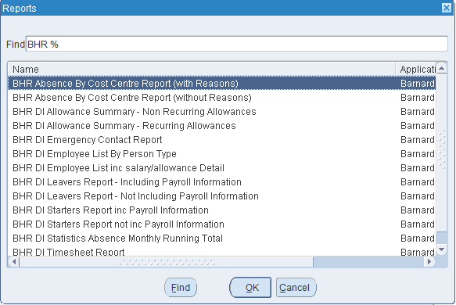
- Enter any parameter information as required.  NOTE: The parameters will differ depending on the report you select in the previous step.  - Click on OK. | 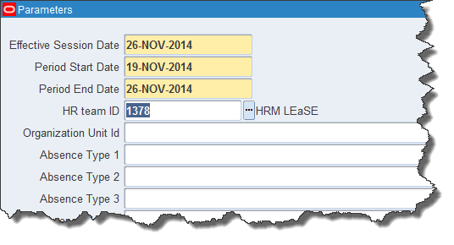
- The relevant report is now in the report Name field.  - The relevant parameters are in the Parameters field.  - Ensure the Print to field has the correct printer in it (if not, click inside the field, then on the ellipse button and select the correct printer from the list of options.  - Click on the Submit button. | 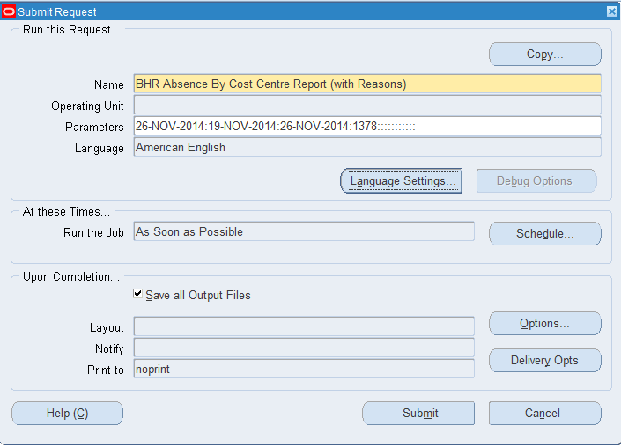
- A Decision dialogue box will pop up.  - Take a note of the Request ID number, just in case you need it.  - Yes –if you want to run another report (in addition to the one you have just submitted).  NOTE: if you click Yes, you will be taken through the steps above.  - No – if you want to locate the report you have just submitted, | 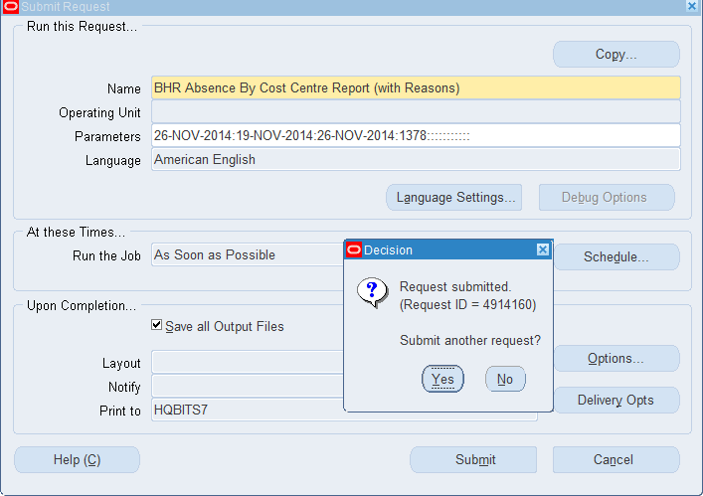
- If you click No, the reports window will automatically close and you will be taken to the Navigator window where you can view and print your reports. | 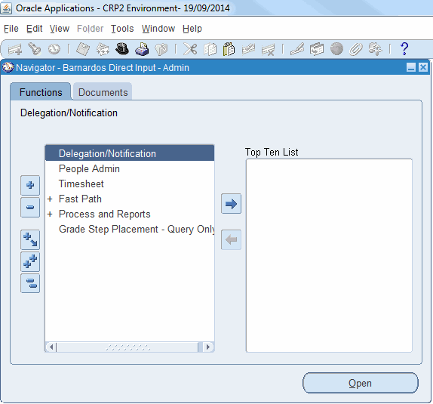

Viewing a Report

- Once any report has been submitted, you need to view it and possibly print it.  - Double click on the + next to Process and Reports.  - Double click on View Requests. | 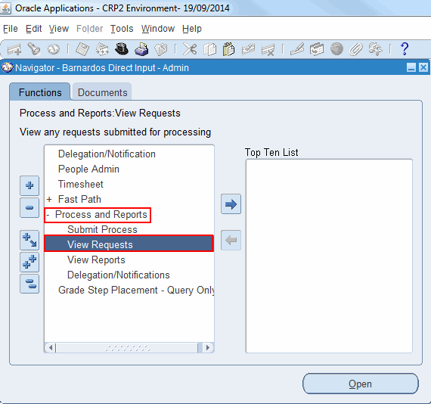
- The Find Requests window will open.  - Select an item from the radio buttons in the top left.  - My Completed Requests – will find only reports that have been completed.  - My Requests in Progress – will find only reports that are still in the process of being built.  - All My Requests – will find all reports requested by you.  - Specific Requests – require a Request ID number and will find only that report. | 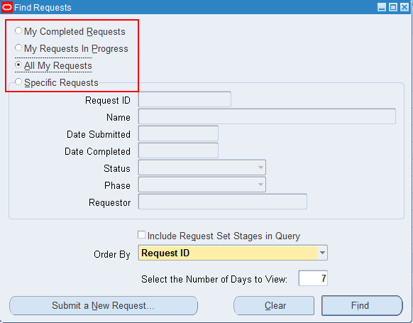
- If you have noted down the Request ID number, select Specific Requests.  - Type the number into the Request ID field.  - Click on Find  NOTE: if you do not have the Request ID number, you will have to find All Reports which may be a long list. | 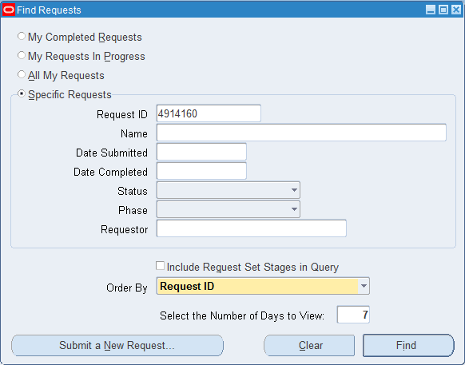
- The report will now appear.  NOTE: the Phase column says this report is Completed. If it has not completed, click on the Refresh Data button.  - To view the report, click on the View Output button. | 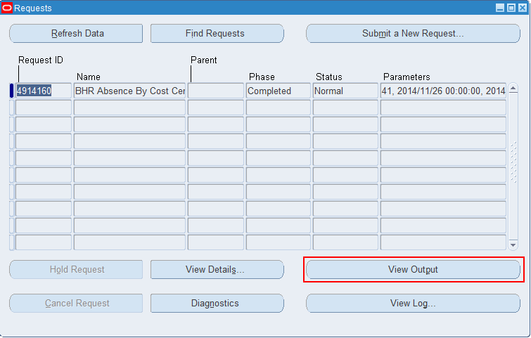
- The viewing screen will open.  - Use the Next and Previous buttons to move through any forms. | 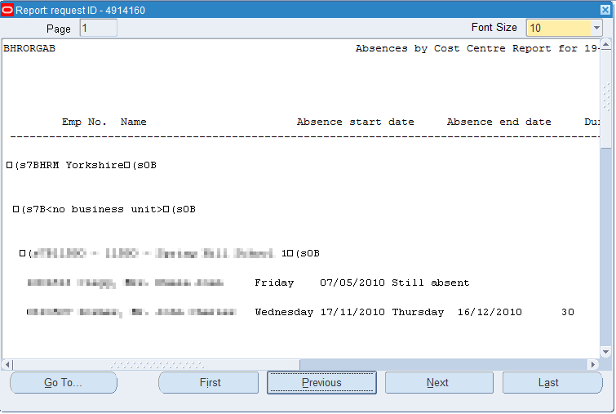

Printing a report

- Close the viewing window to return to the main reports window.  - Ensure you have the correct report selected.  NOTE: You can check this by looking at the column to the left of the Request ID number – if it is blue, this is the report that will print.  - Click on Tools from the main oracle tool bar.  - Select Reprint/Republish. | 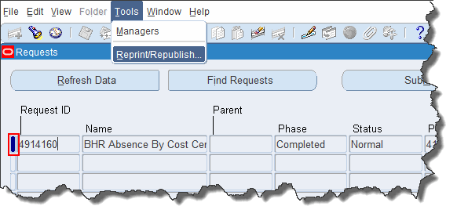
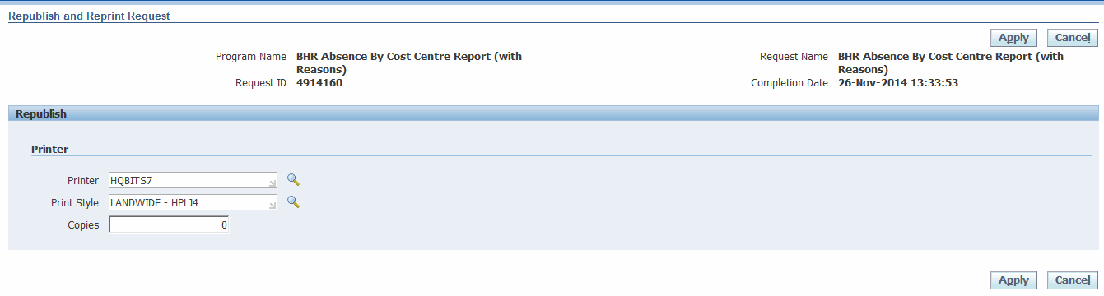
- The Reprint Options dialogue window will be launched.
- Ensure you are printing to the correct printer. If not, use the Search button to search and locate your own printer.
- In the Copies field enter the number of copies that you want printed (this must be a minimum of 1).
- Click Apply.

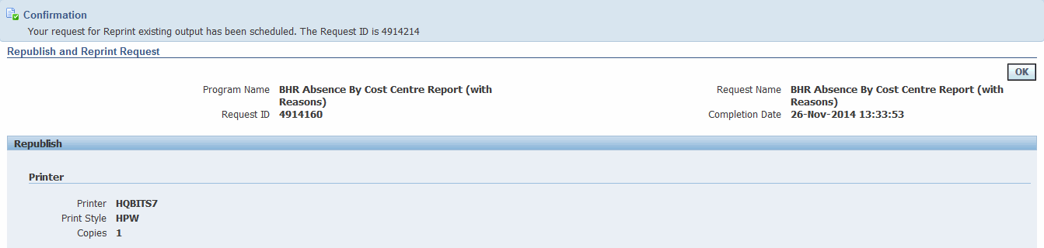
- A confirmation window will appear.
- Click OK.

