You can now search for existing timesheets once they have been created. Timesheets will be archived on Oracle after a certain time period, but you can find them again using the search facility.
- Click on Timesheet in the Oracle Application Home Page. | 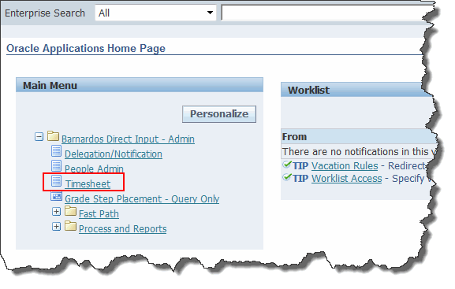
To find the employee whose Timesheets you want to view either:-  - Click on My List (if you have added them to your own personal list of employees) OR  - Click in the search field and type in their surname. | 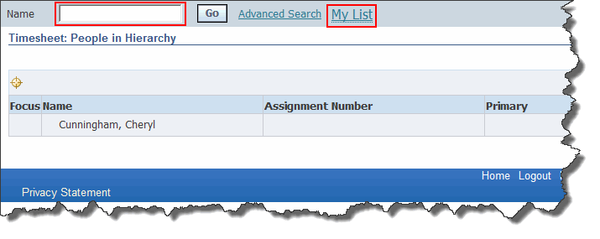
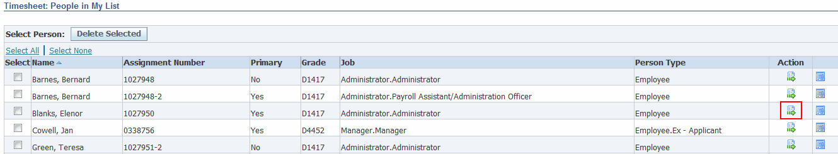
- Once you have found the correct employee, click on the Action button to the right of their name.
- The Search panel will now appear at the top of the form.  - Click on the Calendar button for the From Date field (or alternatively you could just type the date into the field using the date format in the example given). | 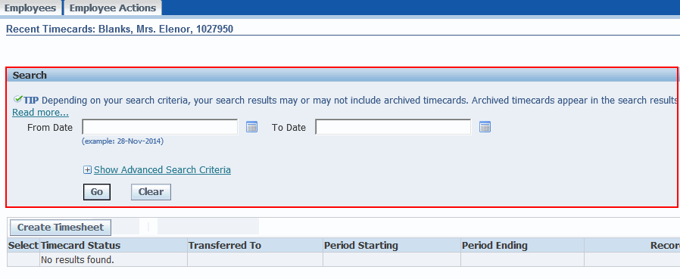
- If you are using the calendar, select an appropriate date by clicking on it. | 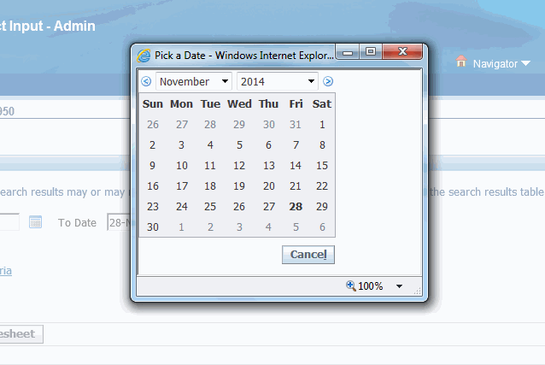
- Repeat these steps in the To Date field.  - Click on the Go button. | 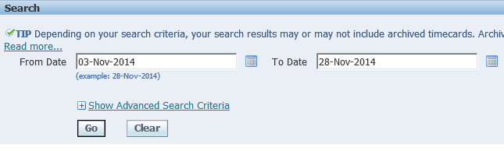
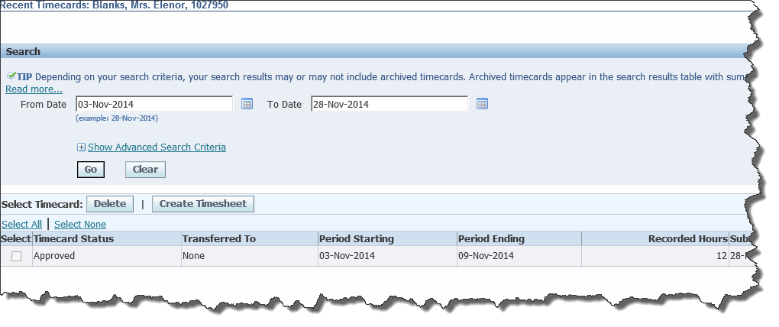
- The results of your search will appear in the bottom portion of the form.

