The Direct Input (DI) system allows you to add and update a number of items of personal information. This guide covers all of these.

Click on a link below to move to that section of the guide.
Accessing Personal Information | Updating Employee Basic Details
Phone Numbers – Except Home | Main Address
Additional Address | Emergency Contacts

Accessing Personal Information
To access an employee’s Personal Information:-  - Open the Fast Path folder.  - Click on Personal Information. | 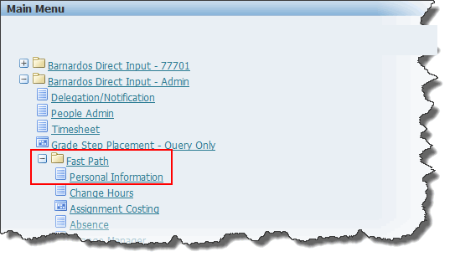
The Personal Information: People in Hierarchy screen is launched.
- Anyone you directly line manage will be in the list on this screen.
- To find someone you don’t line manage, click in the Name field, type in their surname and find them.
- Alternatively, you can use the Advanced Search link to find them.
- To update their Personal Information, click on the Action button to the right of their name.
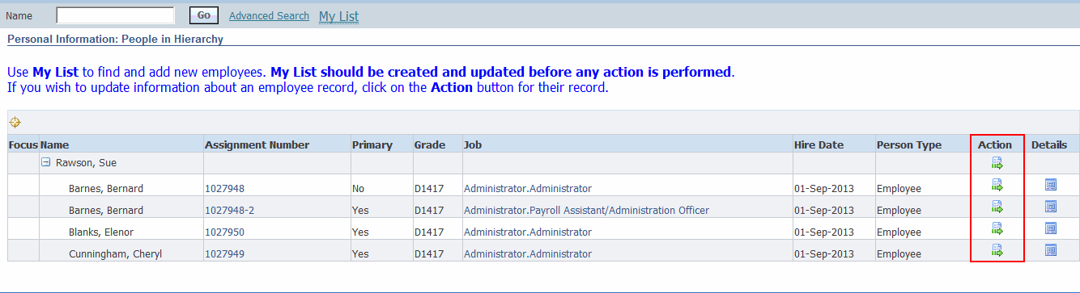
- The Personal Information screen is launched.  - This screen is divided into sections covering the Basic details, Phone, Addresses and Emergency Contact information, all of which can be updated. | 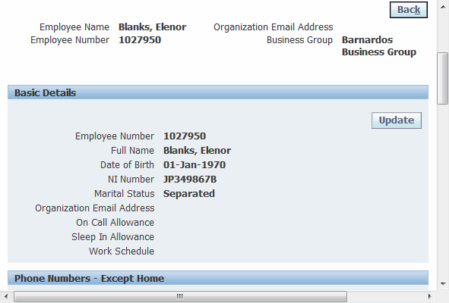

Updating Employee Basic Details
- Click on the Update button. | 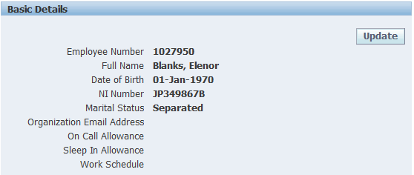
- Choose to either correct the current information or enter new information. For advice on what each of these items means, click here.
- Select one of the options then click on Next.  - Update the information as required.  - Click on the Next button. |  | 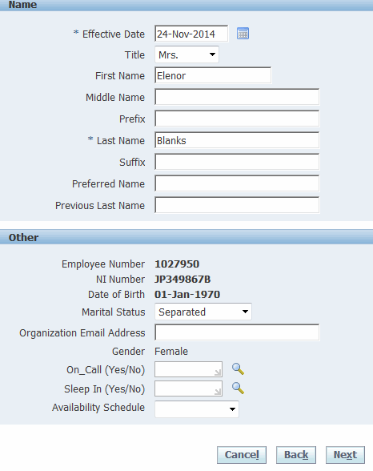

- Check the details on the Summary screen.
- If you need to change anything, always click on the Back button in Oracle and never on the Browser back button .
HINT: any item with a blue circle to the right of it indicates a change!!
- Click on the Submit button to submit all changes.
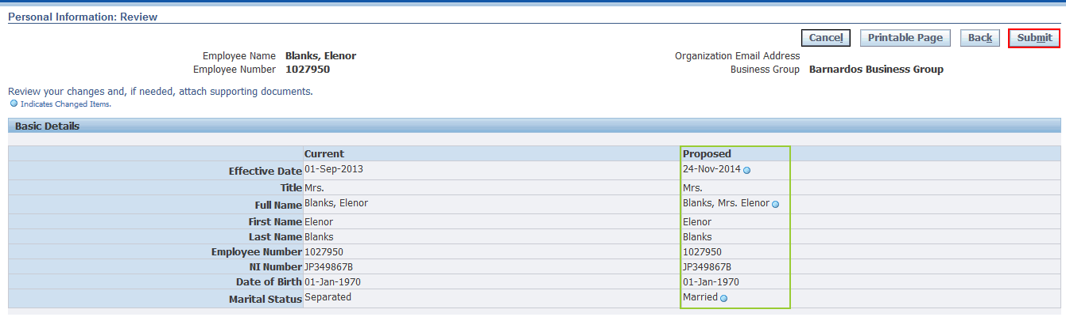
- Any changes will be applied.
- Click on the Return to Overview button to return to the Personal Information page (if you wish to update other sections).
Note: The Overview Page will only display First Name and Last Name even if you have entered other names.
- Click on the Home link to return to the main Oracle Applications Home Page or use Navigator or Favorites to carry out other actions.

Phone Numbers – Except Home
This should be used to add and update any phone numbers EXCEPT the person’s main home phone number, which is recorded in the Main Address area.

Adding a new Phone number
- In the Phone Numbers – Except Home section, click on the Add button.
- Click on the drop down arrow in the Type field and select the type of phone this number is for:-  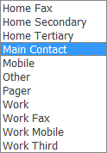  - Type in the new number.  - Click on Add Another Row to add a second number.  - Click on the Next button when all numbers have been added. | 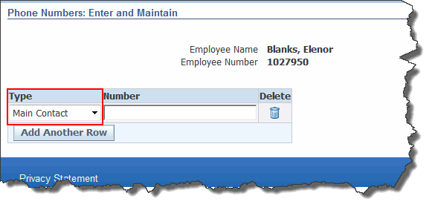
- Check the details on the Summary screen.
- If you need to change anything, always click on the Back button in Oracle and never on the Browser back button .
HINT: any item with a blue circle to the right of it indicates a change!!
- Click on the Submit button to submit all changes.
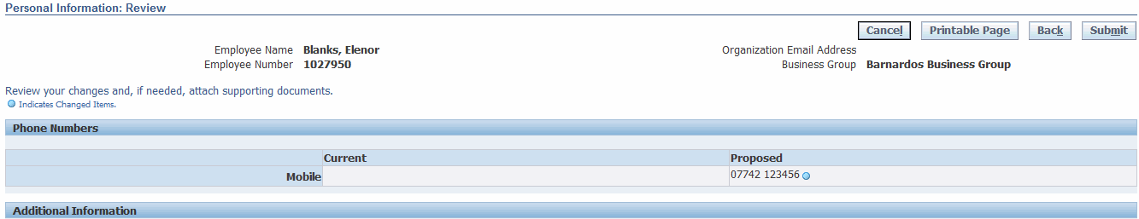
- Any changes will be applied.
- Click on the Return to Overview button to return to the Personal Information page (if you wish to update other sections).
- Click on the Home link to return to the main Oracle Applications Home Page.

Updating an existing Phone number
- In the Phone Numbers – Except Home section, click on the Update button.

- Update an existing phone numbers by re-typing the number.  - Delete an existing number using the button in the Delete column of the appropriate row.  - Click on Add Another Row to add a second number.  - Click on the Next button when all numbers have been added. | 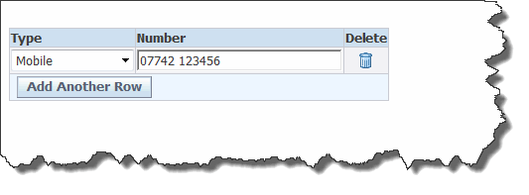
- Check the details on the Summary screen.
- If you need to change anything, always click on the Back button in Oracle and never on the Browser back button .
HINT: any item with a blue circle to the right of it indicates a change!!
- Click on the Submit button to submit all changes.
- Any changes will be applied.
- Click on the Return to Overview button to return to the Personal Information page (if you wish to update other sections).
- Click on the Home link to return to the main Oracle Applications Home Page.

Main Address

Correcting or Amending an Address
- Click on the Update button
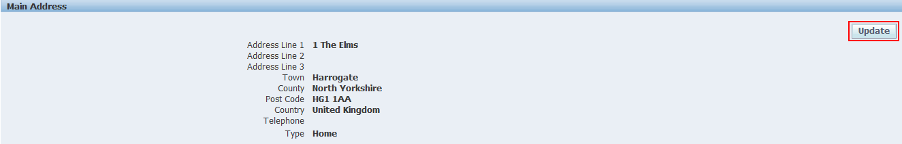
- Choose Correct or amend this address.  - Click on the Next button. | 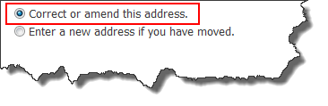
- Make any changes to the existing address or telephone number.  - Click on the Next button. | 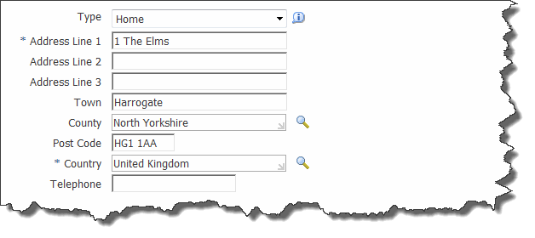
- Check the details on the Summary screen.
- If you need to change anything, always click on the Back button in Oracle and never on the Browser back button .
HINT: any item with a blue circle to the right of it indicates a change!!
- Click on the Submit button to submit all changes.
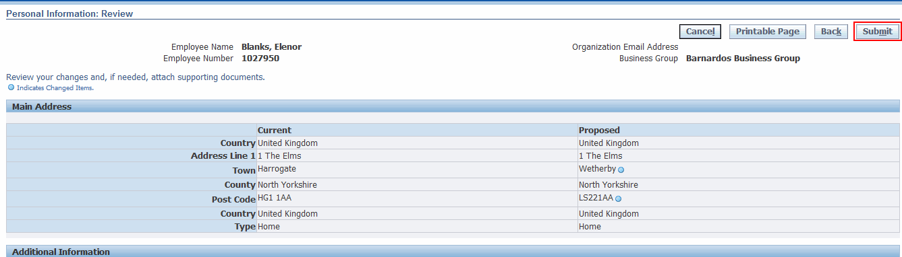
- Any changes will be applied.
- Click on the Return to Overview button to return to the Personal Information page (if you wish to update other sections).
- Click on the Home link to return to the main Oracle Applications Home Page.

Entering a new Address
- Click on the Update button
- Choose Enter a new address if you have moved.  - Click on the Next button. | 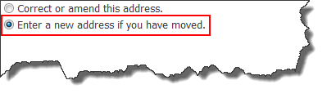
- Ensure the Effective Date is set to the date the move of house took place.  - Select the Type of address and complete the address information.  - Click on the Next button. | 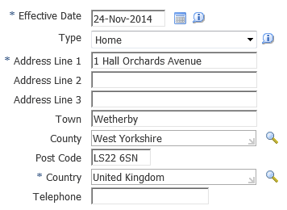
- Check the details on the Summary screen.
- If you need to change anything, always click on the Back button in Oracle and never on the Browser back button .
HINT: any item with a blue circle to the right of it indicates a change!!
- Click on the Submit button to submit all changes.
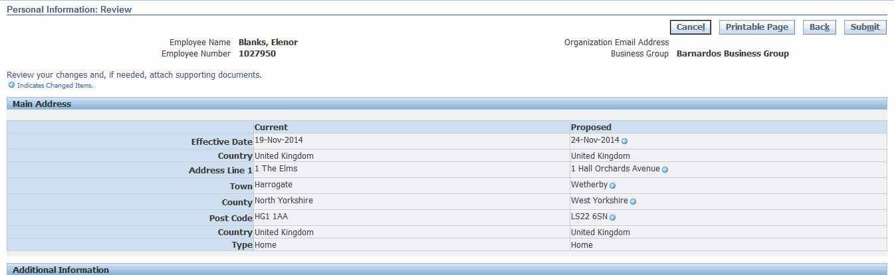
- Any changes will be applied.
- Click on the Return to Overview button to return to the Personal Information page (if you wish to update other sections).
- Click on the Home link to return to the main Oracle Applications Home Page.

Additional Address
You can add or update additional addresses for any person in DI. If there are any additional addresses already in DI, these will be listed below the main address, each with their own Update button. Below the last one (or below the main address if no additional addresses have been entered) will be an empty row with an Add button.

- Click on the Add or Update button as appropriate.  - Enter or edit the information for the additional address as required.  - Note: You must choose Secondary in the Type field. You cannot save the additional address with the type Home.  - Click on the Next button | 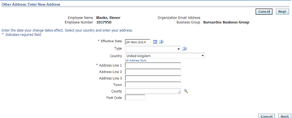
- Check the details on the Summary screen.
- If you need to change anything, always click on the Back button in Oracle and never on the Browser back button .
HINT: any item with a blue circle to the right of it indicates a change!!
- Click on the Submit button to submit all changes.
- Any changes will be applied.
- Click on the Return to Overview button to return to the Personal Information page (if you wish to update other sections).
- Click on the Home link to return to the main Oracle Applications Home Page.

Emergency Contacts
NOTE: All staff records must have at least one Emergency Contact listed.
- To add a new Emergency Contact, click on the Add button.
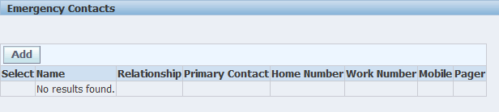
- Add information about the Emergency contact in the General Information section, including their relationship with the Barnardo’s employee.  - Add a contact telephone number in the Phone Numbers section.  - Click on the Next button. | 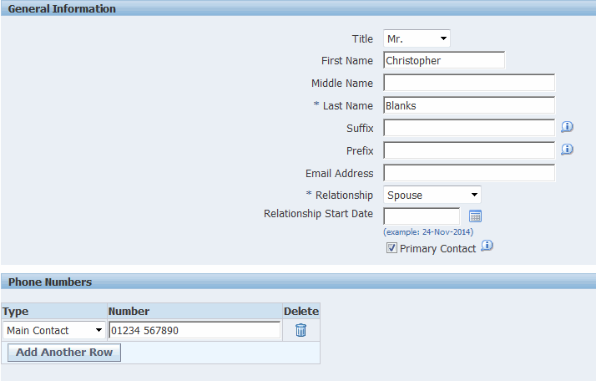
- Check the details on the Summary screen.
- If you need to change anything, always click on the Back button in Oracle and never on the Browser back button .
HINT: any item with a blue circle to the right of it indicates a change!!
- Click on the Submit button to submit all changes.
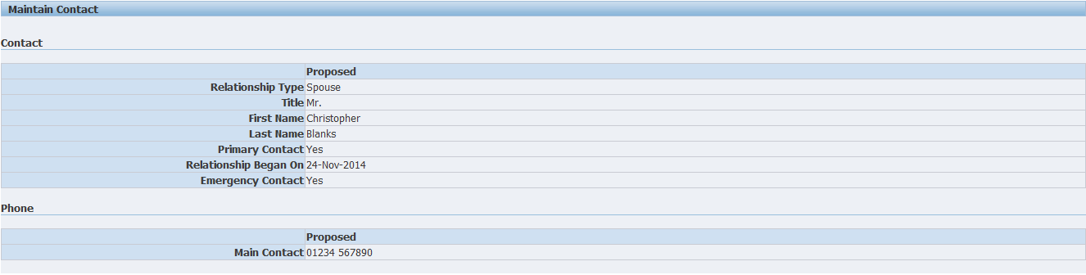
- Any changes will be applied.
- Click on the Return to Overview button to return to the Personal Information page (if you wish to update other sections).
- Click on the Home link to return to the main Oracle Applications Home Page.
- Click the radio button in the Select column then the Update button to update an existing emergency contact.
- Click the radio button in the Select column then the Remove button to remove an emergency contact.
- Add a new emergency contact by clicking the Add button.
