All Timesheets created will remain in DI and can be viewed at any time, even after they have been approved.

Viewing a Timesheet
- Log onto DI.
- Open the Direct Input Folder and select Timesheet from the list.
- If you have an Admin login, go to My List.
- Click on the button for that person.
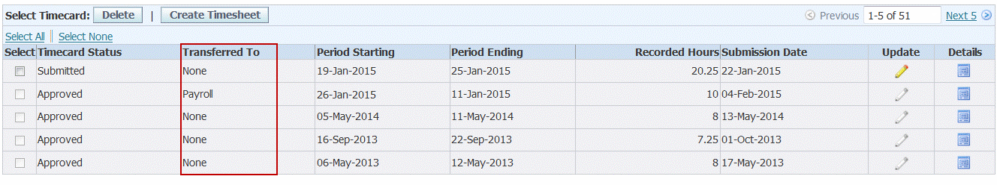
- You can use this view to check the progress of a Timesheet. The entry in the Status column will change from Submitted to Approve when it has been approved.
- Also note that the Transferred To column will indicate when an approved timesheet has been transferred to Payroll.
- Click on the button in the Details column for the relevant Timesheet.
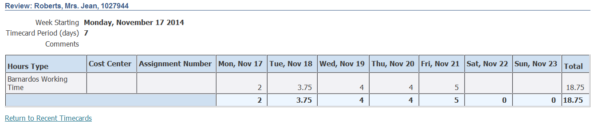

Printing a Timesheet
- View the Timesheet that you wish to print, as detailed above.  - Choose Page Setup from the File menu. | 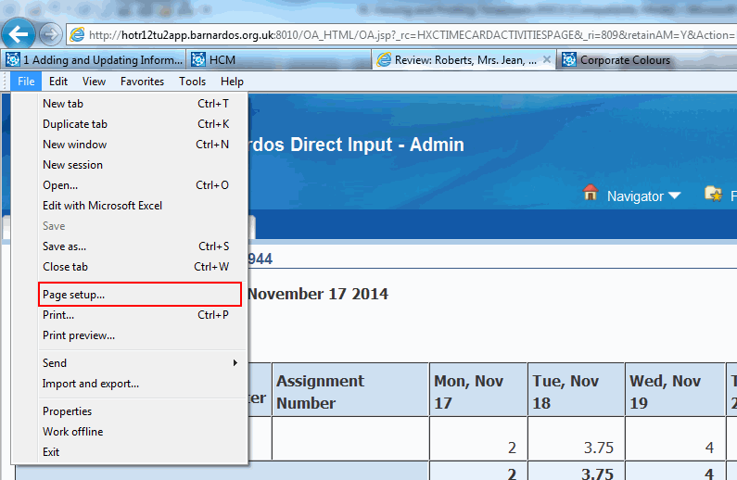
- Select Landscape in the Orientation area.  - Click on the OK button. | 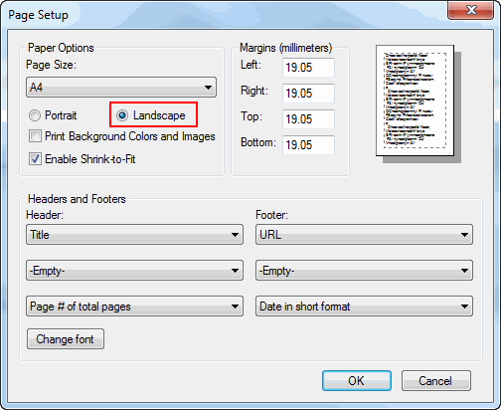
- Click on File and Print or the button on the Commands toolbar.
- To print another timesheet for the same employee, click on Return to Recent Timecards and then view the next one you wish to print.

