The Change Job function on Direct Input (DI) allows you to change the assignment information when a person is:-
- changing their job;
- has had a change of grade as a job evaluation;
- or their primary organization (cost code) is changing.
Note: you only have permission to change job information for your project/section cost codes. If an employee is changing job or moving to another organisation please contact your local HR/People team.

Changing Job Details
- Select People Admin from the available items in the Navigator. | 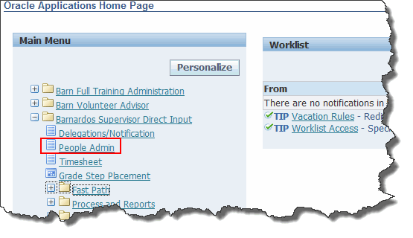
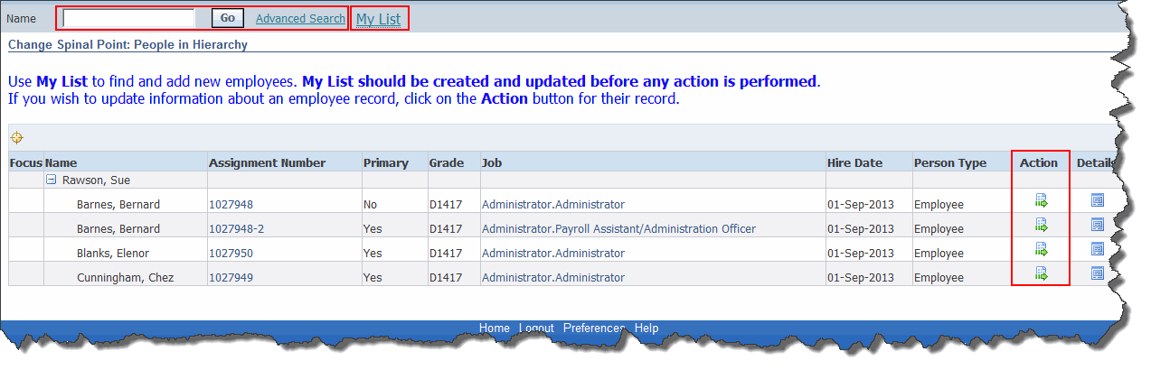
- If you have an Admin login, go to My List.
- If you manage the employee, they will be listed in the panel at the bottom of the screen.
- However you find the employee, click on the Action button to change their job.
- Select Change Job from the list of actions  - Click on the Start button. |  | 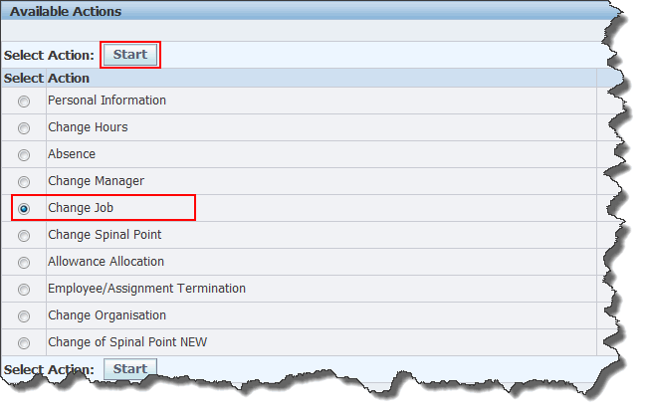
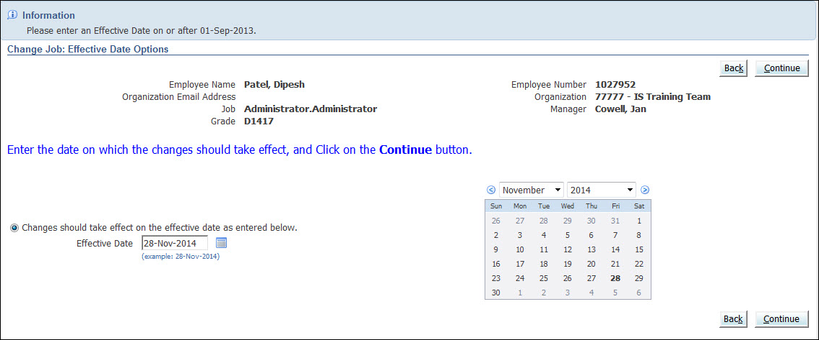
- Select the date from which the change should be effective using the button to the right of the Effective Date field.
- Click Continue.
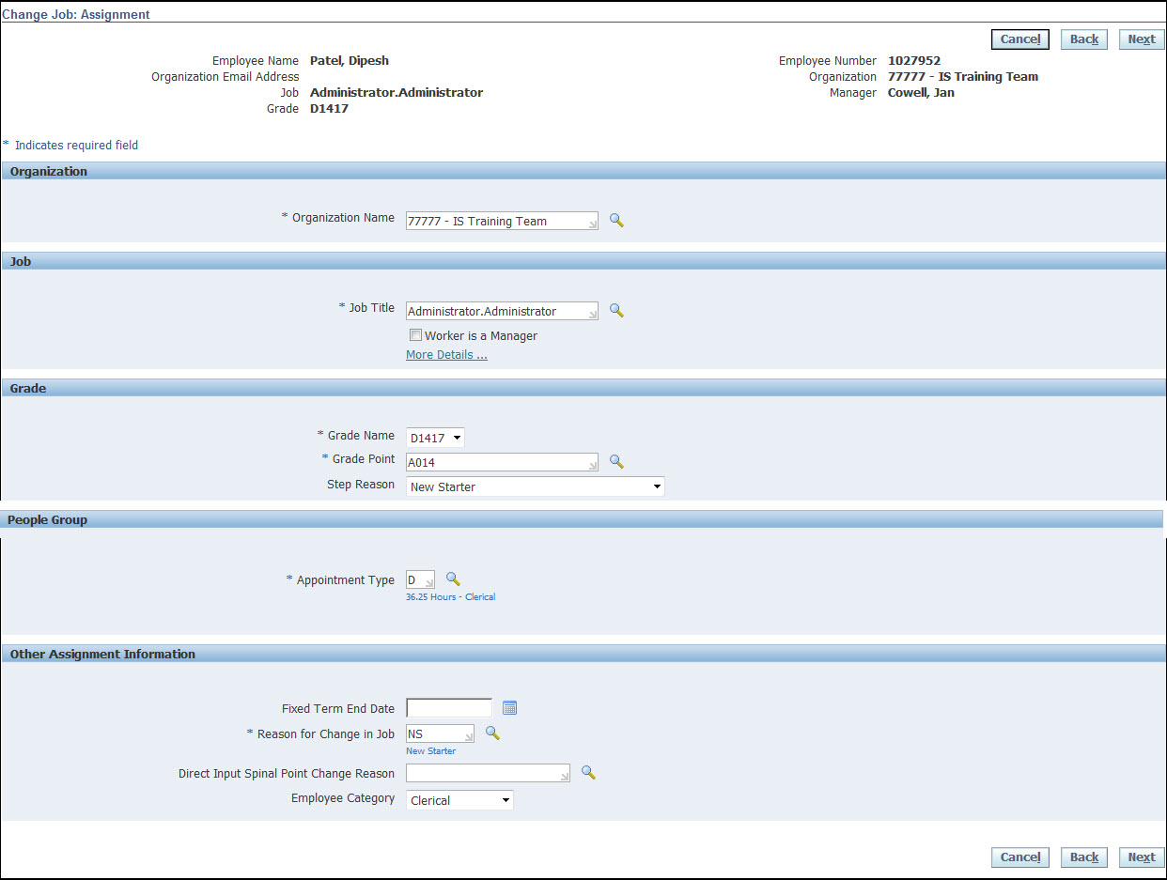
Note: Make changes on this page in order down the page, as many of the fields are linked to the choices made in the fields above them.

Change Job: Organisation section
- To change the Organization (i.e. the department/cost centre that the person works in), click on the search button to the right of the Organization field. | 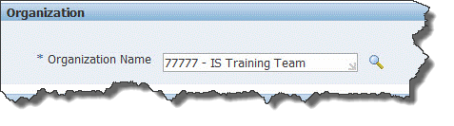
- To change the selected person’s job, delete the current job title. Type a % in the empty field and click on the search button to the right of the Job Title field.  - Tick the Worker is a Manager tick-box beneath the Job Title field if required. | 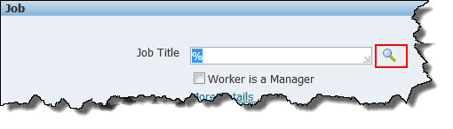
- A list of job titles will now be available for the organization you have selected.  - Note: Do not select jobs which have are suffixed with (M). These job titles are no longer used.  - Select the job title given to you by the Direct Input Team. | 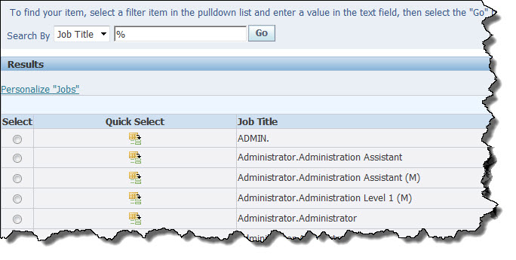
- Notice that once the correct job title has been selected, the Job Title Field and the Grade Name will automatically be populated based on the job code selected.  - The Grade Point will automatically default to the bottom of the scale. If this is changed then a Step Reason needs to be added. | 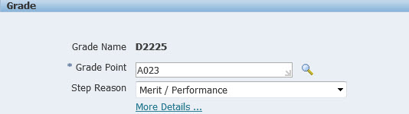
- To enter a Step Reason click the down arrow and select from the list of options | 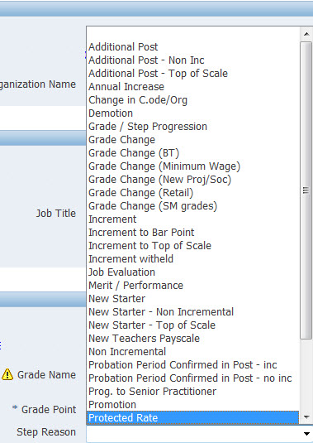
- The Appointment Type field should match the Grade Name prefix and reflect the full time hours for the job. To change the value displayed, replace the current value with % and click on the search button, then select the correct value from the list displayed. | 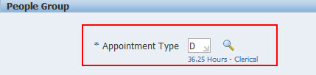
- If the job is for a fixed term, enter the end date using the calendar button to the right of the End Date field, otherwise leave blank. | 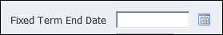
- Type % in the Reason for Change in Job field then click the search button to the right of the field to select a suitable reason.
- If the job is not full time, choose the appropriate category from the Employee Category drop-down list. | 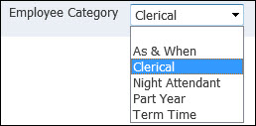
- Click Next. | 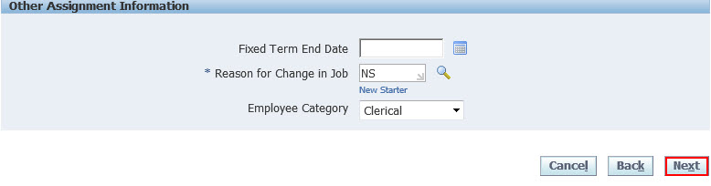

Change Location
If necessary, change the person’s location.
- Enter % into the Location field then click the search button to find the relevant location.
- Click Next.
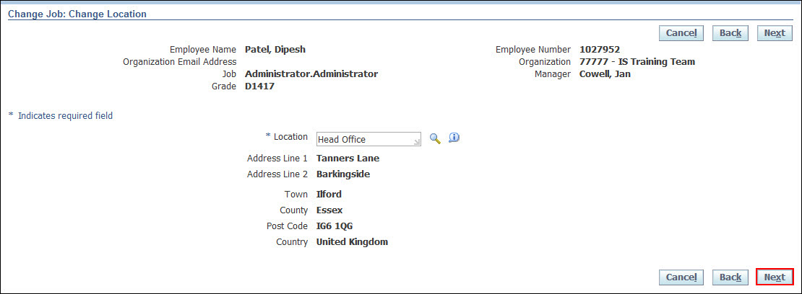

Change Job: Change Manager
This screen allows you to edit:
- The selected person’s manager (i.e. the person they report to).
- The selected person’s direct reports (i.e. the people that report directly to them).
Note: This screen works in exactly the same way as described in the separate user guide entitled Change Manager.
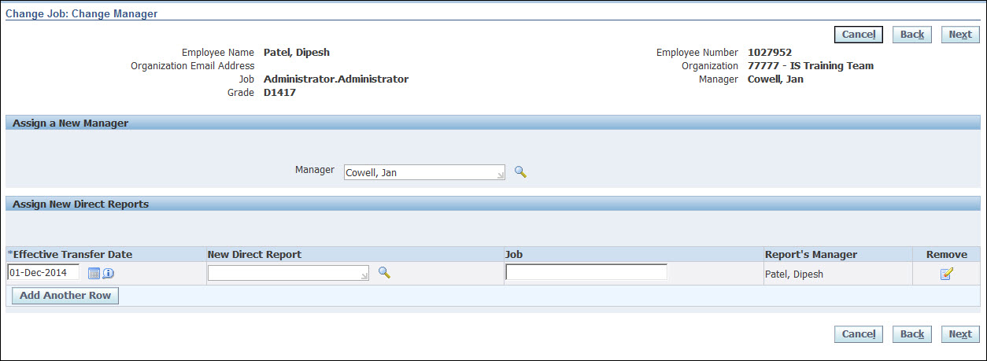
- When you have completed all the necessary edits, click Next.

Change Job: Work Schedule
- If the new job has different work hours, edit the contents of the Work Hours field.
- If this is a fixed term job enter the Fixed Term End Date.  - Click into Reason for Change in Job field. To change the value displayed, replace the current value with % and click on the search button, then select the correct value from the list displayed. | 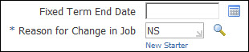

Enter or Change Assignment Category
- If necessary, choose a new Assignment Category
Note: Only choose from the following four options:
FullTime – Fixed Term;
FullTime- Permanent;
PartTime – Fixed Term;
PartTime – Permanent
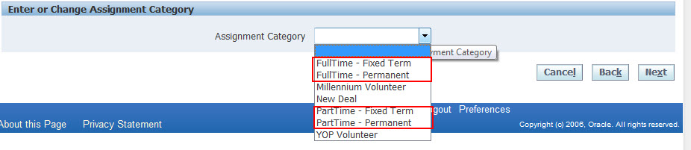
- Click Next.

Change Job: Review

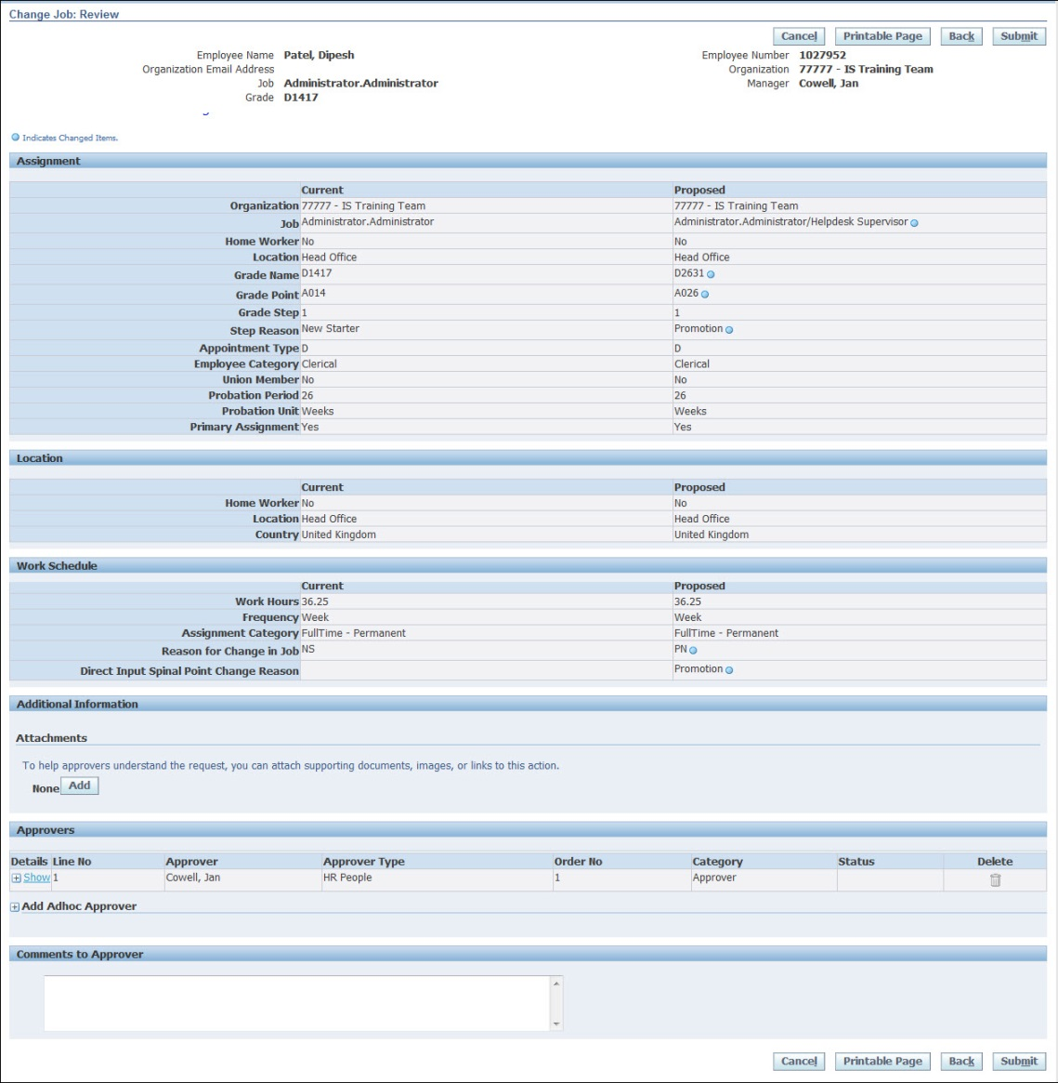
Note: The fields that you have updated will be indicated with a blue circle in the Proposed column.
- If all of the information is correct, click the Submit button. (If it is incorrect and you need to make a change, click the Back button).
- Click Home to return to the Oracle Applications Home Page or use the Navigator to go to another DI screen. | 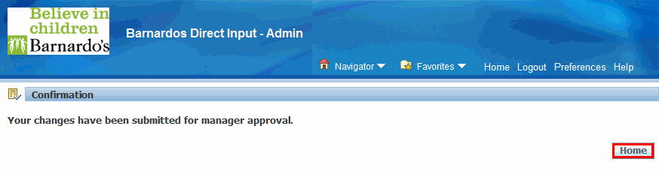

Important Reminder: When a job change notification is received by a supervisor for approval, the supervisor must ensure that the Correct Spinal Point within the grade range is entered in the field named Grade Point (e.g. A018) before clicking the Approve Button.
Please bear in mind that if the correct spinal point is not correct, the person will be automatically put on the Lowest Spinal Point within the grade range proposed.

