The Change Manager function on Direct Input (DI) allows you to change the following information for the people whose details you have permission to edit:
- Their manager (i.e. the person they report to).
- Their direct reports (i.e. the people that report directly to them).

Changing Manager Details
- Log onto DI.
- Select People Admin from the available items in the Navigator.
- If you have an Admin login, go to My List.
- Click on the action button for that person.
- Select Change Manager from the available list of actions.
- Click Start.
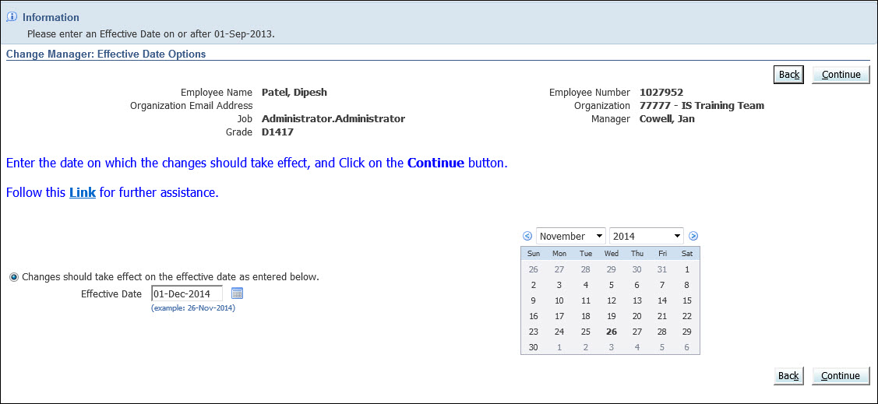
- Select the date from which the change should be effective using the button to the right of the Effective Date field.
- Click Continue.
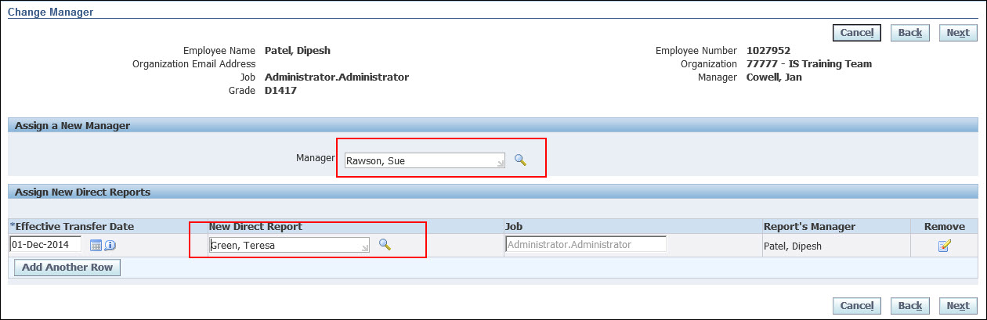
- If you wish to change the selected person’s manager (i.e. the person they report to) select a new manager with the search button to the right of the Manager field.
- If you wish to add or remove the selected person’s direct reports (i.e. the people that report directly to them), use the table at the bottom of the page:
  - If any direct reports already exist you can remove them by clicking on the button in the Remove column.
  - If no direct report already exists there will be one empty row showing. You can add a report using the search button to the right of the New Direct Report field in this row.
  - If you need a new row for an extra direct report, click on the Add Another Row button.
Note: You can assign each direct report a separate effective date if this is needed. The new manager field uses the effective date you specified in the previous step.
- When you have completed all the edits you require, click on the Next button.
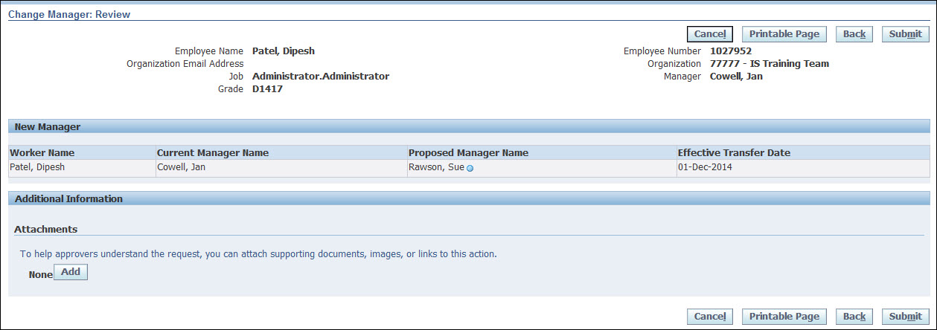
Note: The fields that you have updated will be indicated with a blue circle in the Proposed column.
- Click Submit.
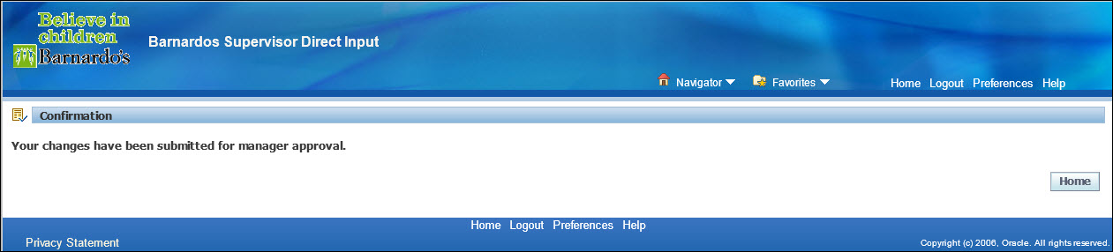
- Click Home to return to the Oracle Applications Home Page.

