The Change Organisation is used when an employee is moving to a new organisation/cost code and their job remains the same.

Changing Organisation Details
- Log onto DI.  - Open the Fast Path folder.  - Click on Change Organisation from the available list of actions. | 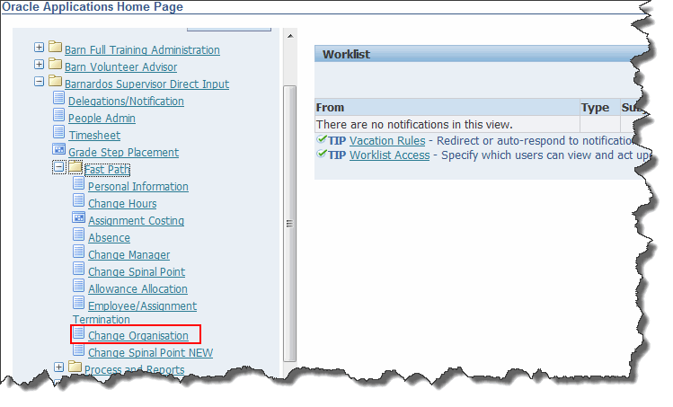
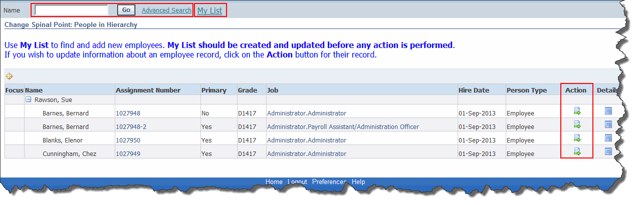
- Either search for an employee using the search field, click on My List and select an employee or, if you line manage an employee, they will visible in the lower part of the screen
- Once you have located the employee, click on the Action button .
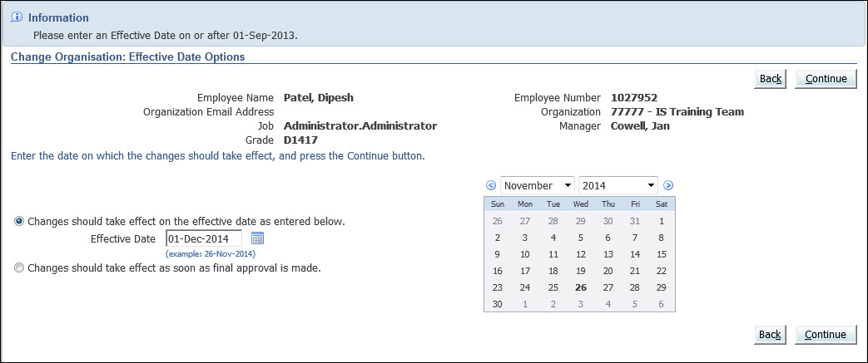
- Select the date from which the change should be effective using the button to the right of the Effective Date field.
- Click Continue.
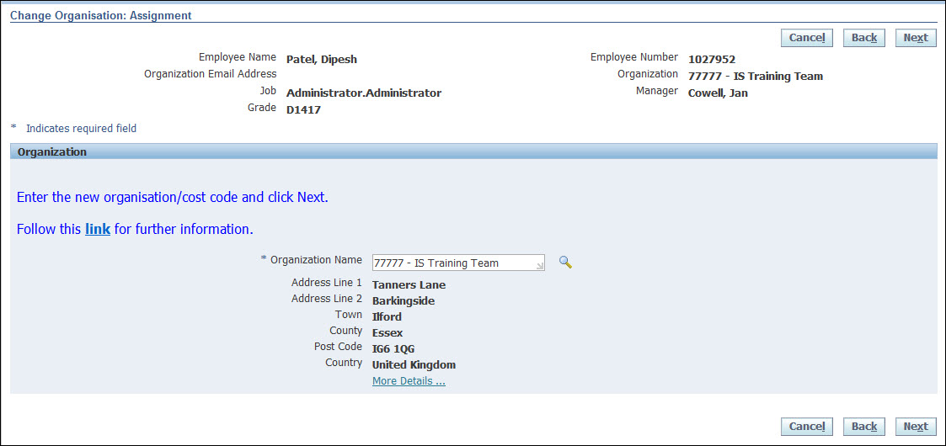
- To change the Organization (i.e. the department/cost centre that the person works in), use the search button to the right of the Organization field.
- Click the Next button.
- To change the Organization (i.e. the department/cost centre that the person works in), use the search button to the right of the Organization field.
- Click the Next button.
- If necessary, change the person’s location using the button to the right of the Location field.  - Click on the Next button. |  | 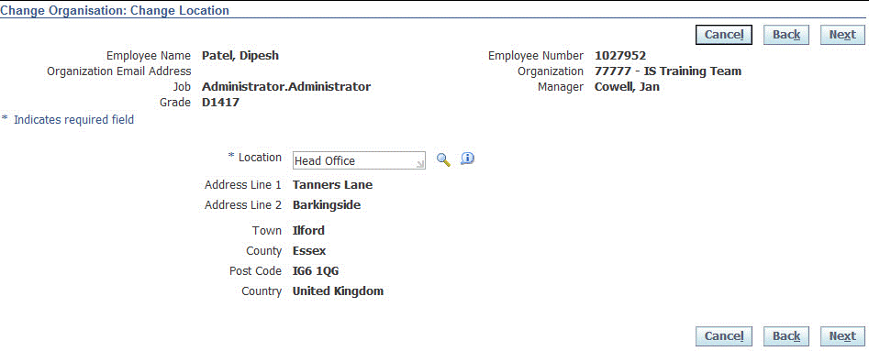
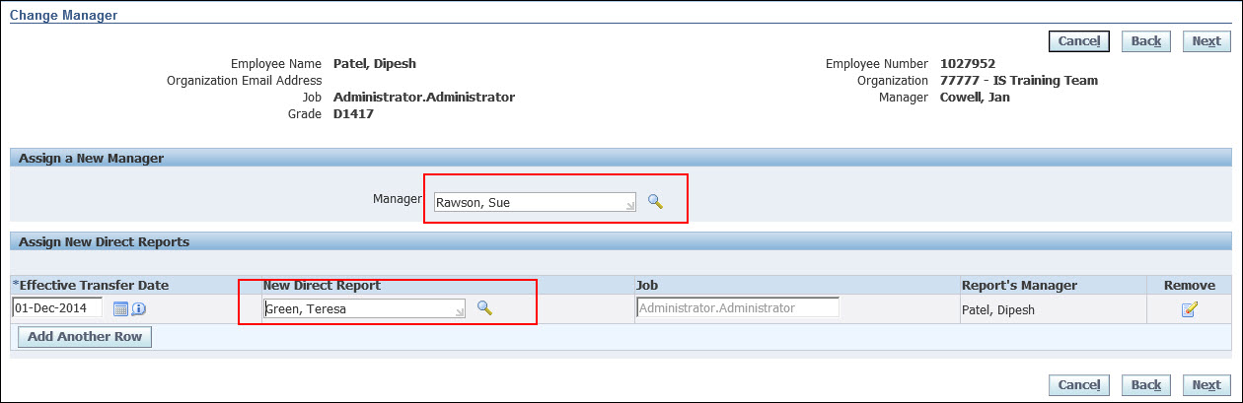
This screen allows you to edit:
- The selected person’s manager (i.e. the person they report to).
- The selected person’s direct reports (i.e. the people that report directly to them).
Note: This screen works in exactly the same way as described in the separate user guide entitled Change Manager.

- When you have completed all the necessary edits, click Next.
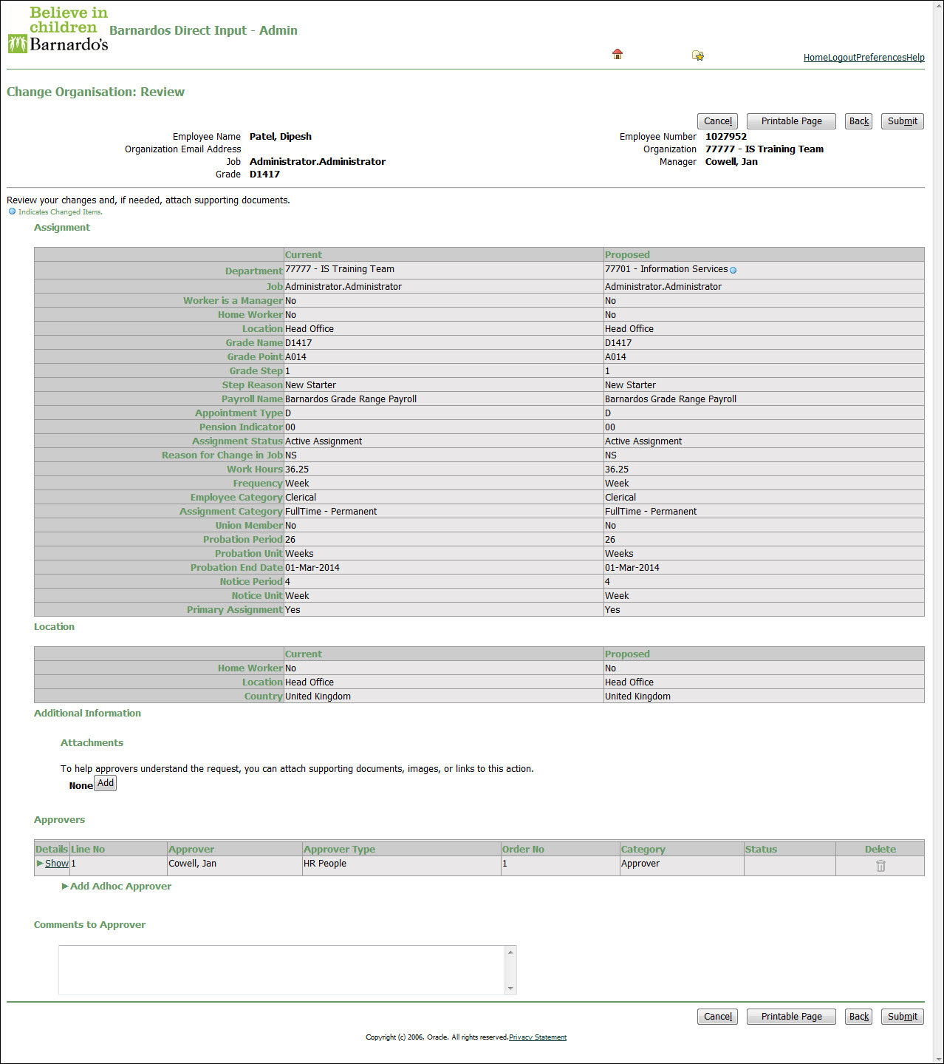
Note: The fields that you have updated will be indicated with a blue circle in the Proposed column.
- Click Submit, if all the information is correct. (If it is incorrect and you need to make a change, click the Back button).
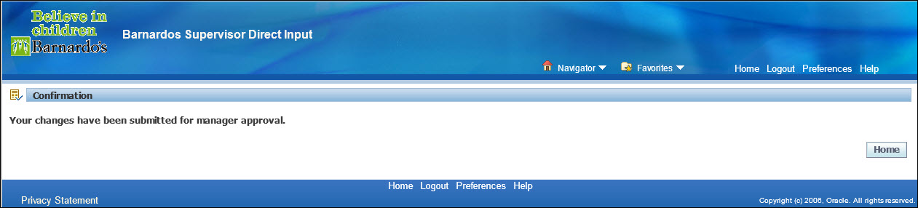
- Click Home to return to the Oracle Applications Home Page or Navigator to change to another responsibility.

