The change of hours function is used to change the normal working hours of an employee for their existing post.
Note: This function should be used when someone goes on maternity leave (reduce their hours to zero) or unpaid leave for more than 2 weeks. However, for all other absence from work, you should create an absence record rather than a change of hours. See the user guide entitled Recording Absences for details.
If the change of hours permanently affects the cost code split for the person, you should send an email to Jeremy Morgan in HO payroll and copy Direct Input Support into the email. For temporary cost code splits please contact your local finance team.
- Permanent is more than 3 months.
- Temporary is less than 3 months.
This function is also used for extension of a FIXED TERM employee’s current contract. In this case, Fixed Term Contract End Date should be updated with the proposed extension of contract date.
The first steps are:
- Log onto DI.
- Select People Admin from the available items in the Navigator.
- If you have an Admin login, go to My List.
- Click on the button for that person.
- Select Change Hours.
Note: If the employee is also changing their normal working days then you should update the work schedule information, under Personal Information. Please refer to the guide on Personal Information for more details.
- Choose the date the change of hours should take effect from with the calendar button to the right of the Effective Date field.
- Click the Continue button.
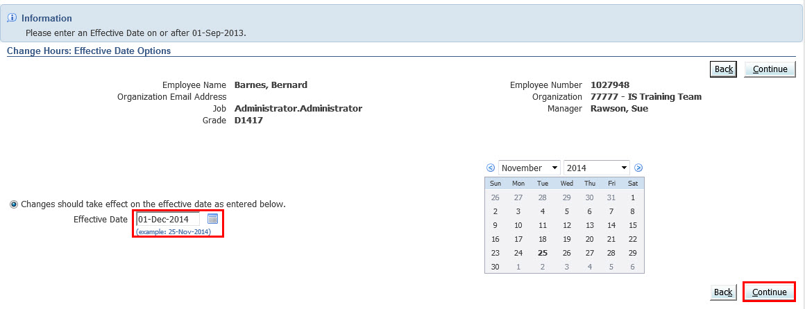
Note: It is important that the correct date is entered here as the person will be paid for their changed hours from this date. Entering the wrong date could result in under or over payment.
- Enter the new working hours into the Work Hours field.
- Fixed Term Contract End Date should be updated with any proposed extension of contract when an employee is fixed term.
- Choose a reason with the search button to the right of the Reason for Change in Position field.
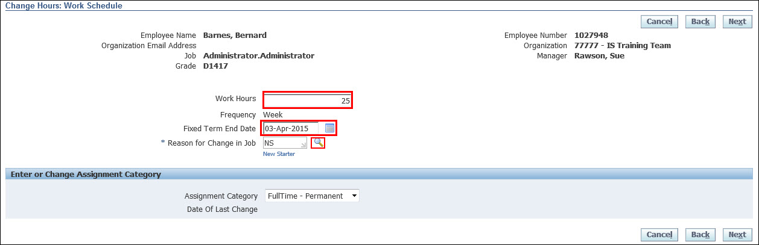
- The Assignment Category field should be checked and updated every time a change of hours is proposed and the correct status selected to match the working hours and the contract type. Only the following four options should be selected:
FullTime - Fixed Term
FullTime - Permanent
PartTime - Fixed Term
PartTime - Permanent

- Click on the Next button.
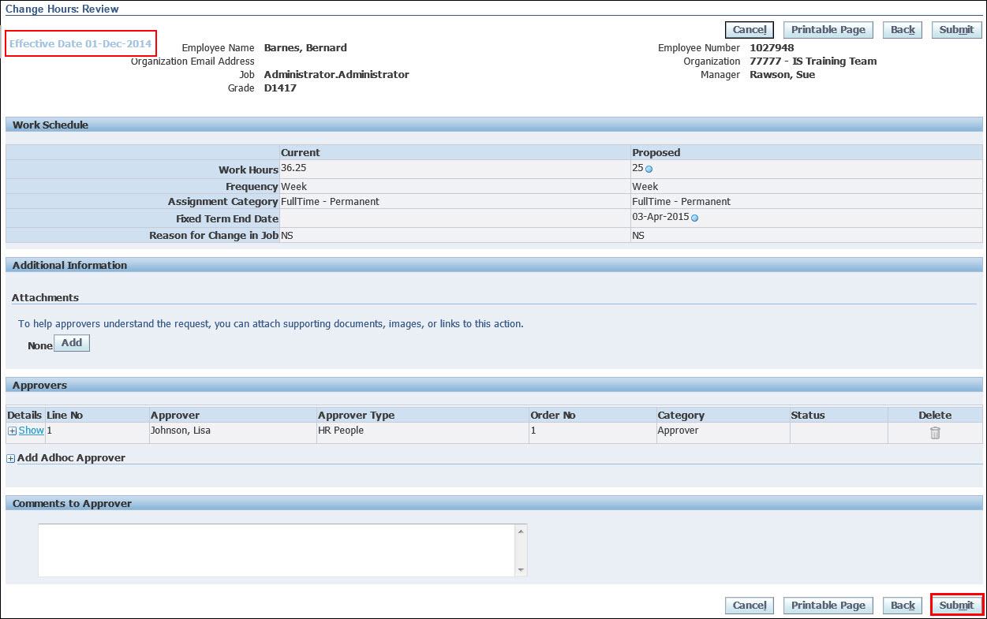
Note: The Effective Date is shown on the top left of the screen but the text is feint. Additionally, the fields that you have updated will be indicated with a blue circle in the Proposed column.
- Click on the Submit button.
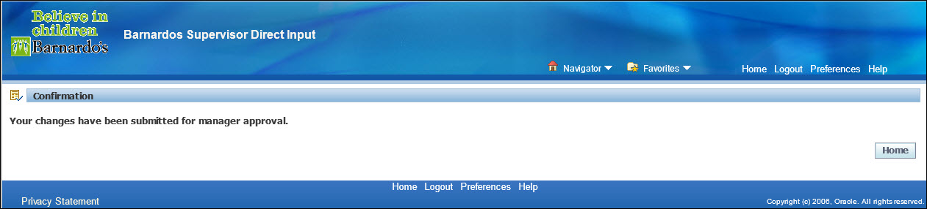

Click Home to return to the Oracle Applications Home Page or Navigator menu to access another responsibility.

