Each grade on the Barnardo’s pay system has a range of possible salaries (spinal points). Normally, a person will start at the lowest spinal point for a grade and receive an automatic increment every year until they reach the highest spinal point for their grade.
The Spinal Point function allows you to increment a person’s spinal point manually (e.g. in response to job evaluation, promotion etc.)
Note: Never use this function to apply the normal annual spinal point increment; that is carried out automatically. If you are not sure which spinal point the person is currently on see the user guide entitled Grade and Pay Queries.

Making a Spinal Point Increment
- Log onto DI.  - Open the Fast Path folder.  - Click on Change of Spinal Point from the available list of actions. | 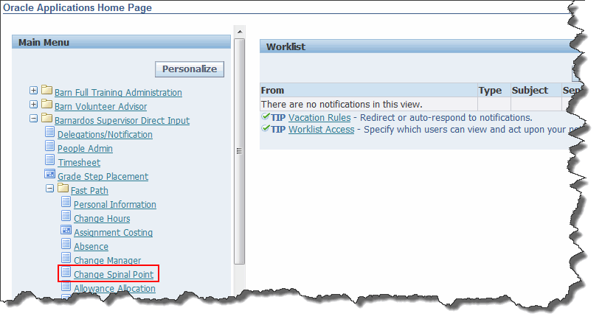
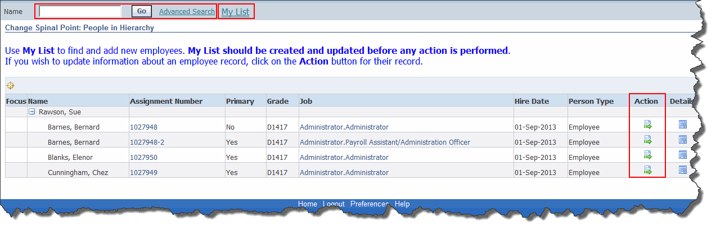
- Either search for an employee using the search field, click on My List and select an employee or, if you line manage an employee, they will visible in the lower part of the screen.
- Once you have located the employee, click on the Action button .
- Change the Effective Date to the date the Spinal Point change should become effective.  - Click on the Continue button. | 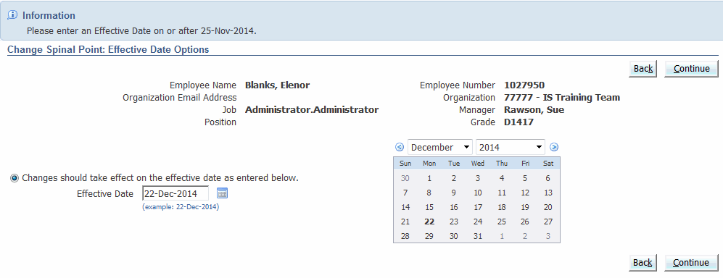
- Click in the Grade Point field and delete the final number.  - A list of values for that grade point is now visible.  - Select the correct point. | 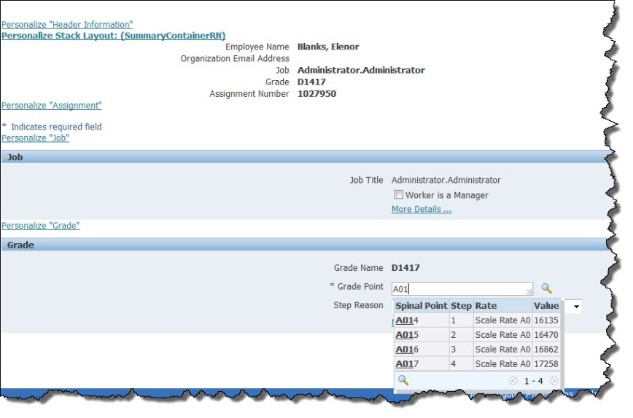
- Click in the Step Reason field.  - Select the correct option form the picklist. | 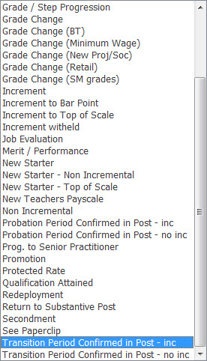
- Click on the Next button. | 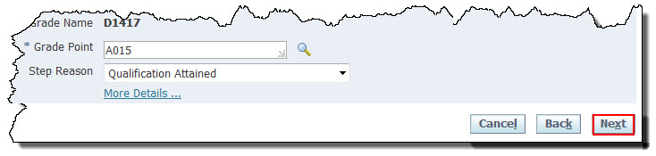

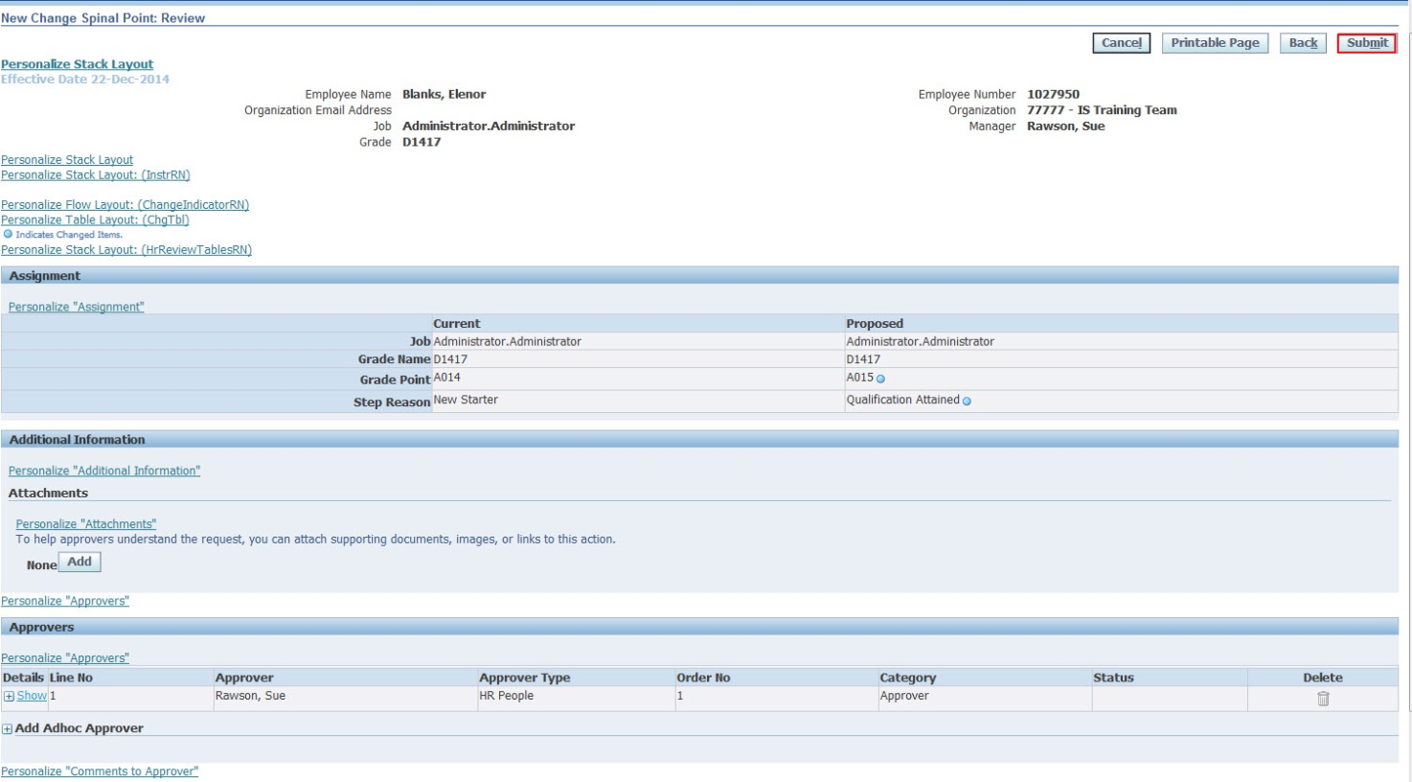
Note: The fields that you have updated will be indicated with a blue circle in the Proposed column.
- Click Submit.  - Confirmation that your change has been submitted for approval is shown.  - Click Home or use Navigator or Favorites to carry out further actions. | 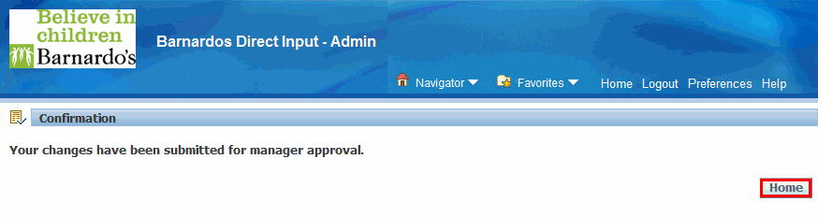

Important Reminder: If the person is to be given more than one increment, then the Supervisor has to make sure that Correct Spinal Point is entered in the Grade Point field (e.g. A015).
See the user guide on Approving Timesheets and other changes to learn more about approvals.

