Timesheets (also known as Timecards) need to be created in order to record the hours worked under the following circumstances:
- All working time for “as and when” staff.
- Any approved overtime or time in excess of the normal working hours for salaried staff (where these are being paid, i.e. not taken as time in lieu).
Note: DO NOT create a time sheet for salaried staff UNLESS they are being paid for excess hours.

Creating a Timesheet
- Log onto DI.
- Select Timesheet from the Navigator.
- If you have an Admin login, go to My List.
- Click on the button for that person.
- The Recent Timecards screen is launched.
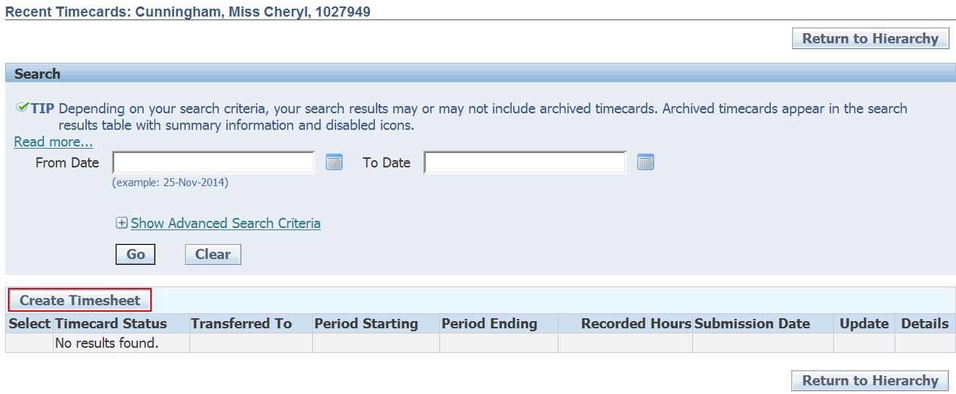
- You can perform a search for existing and archived timesheets from this screen.
- Click on the Create Timesheet button to create a new timesheet.

- The Time Entry screen is launched which allows you to enter the working hours for this employee.  - Choose the correct week from the Period drop-down list.  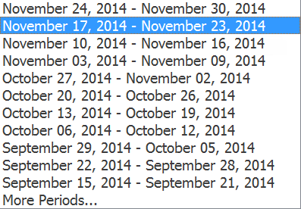 | 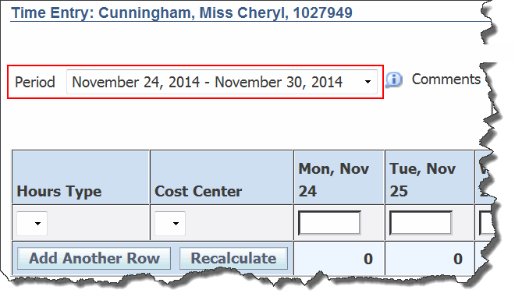
Note: You can complete timesheets for the past as well as the current week. If the week you want is not shown, click on More Periods… at the top of the list. You should not create timesheets for future weeks as the employee hours may change or the employee may not be able to work them as agreed.
Hours Type – this list will be different depending on the role of the Employee (ie As and When, Full Time etc.)  - Choose Barnardo’s Working Time.  NOTE: there are currently 6 different types of timesheet lists.  The list will differ depending on the role of the employee (ie Part Time, As and When etc.)  If you are in any doubt about using an item other than Barnardo’s Working Time, contact your local People team. | 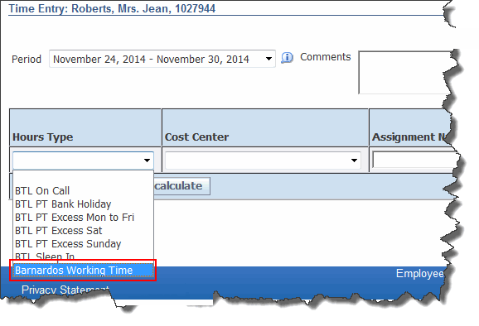
Note: These are the ONLY exceptions. Please use Barnardo’s Working Time for all other entries, even if there appears to be a more suitable option on the list. The link for timesheet conversions for Barnardo’s Working Time is Timesheet Conversion.
- Cost Centre – leave this field blank when the hours are being recorded against the primary assignment for that person. If the hours are being recorded against a different cost centre you should select it from the list.  - Assignment Number – if the hours are being recorded against an assignment other than that person’s primary assignment, enter the appropriate assignment number here. | 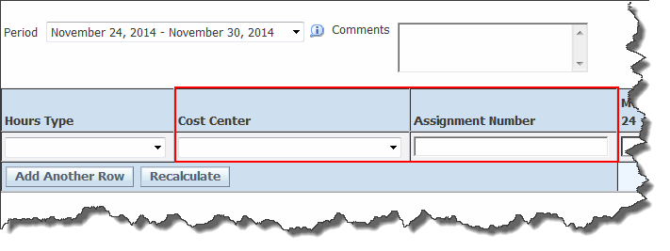
Note: A person’s primary assignment number (or personnel number) will be a seven digit number, e.g. 1234567. If someone has more than one assignment they will have extra assignment numbers, e.g. 1234567-1, 1234567-2 etc. It is these extra assignment numbers that must be entered here when appropriate.
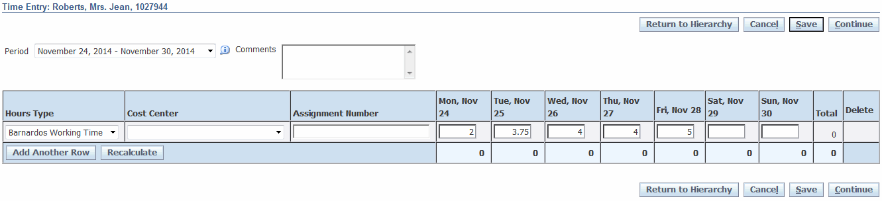
- Hours – You should enter the hours worked in the other fields on this row. The maximum hours that can be entered in one day is 16.
- If you need to enter another row (for a different Hours Type worked in the same week), click on the Add New Row button. This will actually add two new rows, but DI will ignore any that you do not fill in.
- Complete as many rows as you need in the same way as above.
- Click on the Recalculate button to update the totals.
- Once all the hours have been recorded for the selected week:-  - Click on Save to save the timesheet BUT NOT send it for approval. You would use this option if you needed to return to the timesheet and make amendments to it before sending it for approval.  - Click on the Continue button to send the timesheet for approval immediately. | 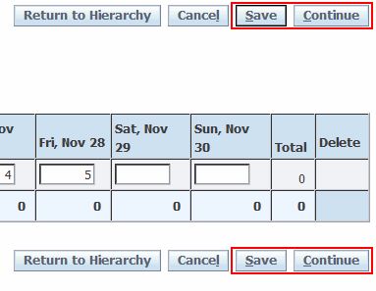
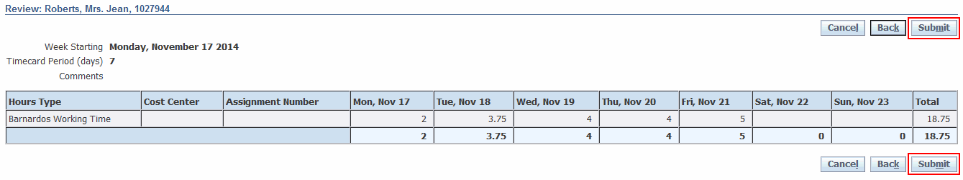
- Click on the Submit button to send the timesheet for approval.
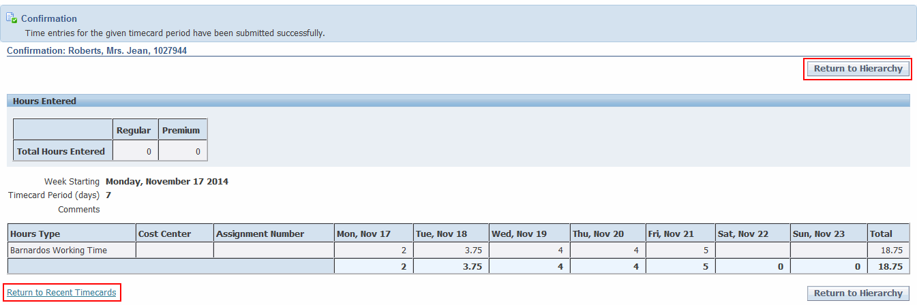
- A Confirmation screen will appear. DI will now send a notification and an email to the approver alerting them that there is a timesheet awaiting their approval.
- To complete another timesheet for this employee, click on the Return to Recent Timecards link.
- To return to the People in Hierarchy screen and select another employee to create a time sheet for, click on the Return to Hierarchy button.
- To return to the main Navigator, click on the Home link at the top right of the screen.

