How to access b-Learning at Barnardo’s
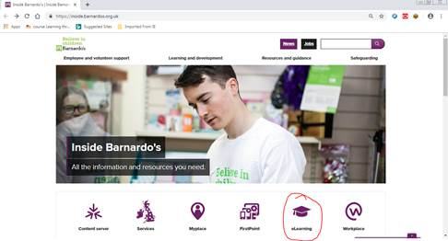
Go to the Inside.Barnardo’s home page and click on the link that says ‘b-Learning’ (shown circled in red below):

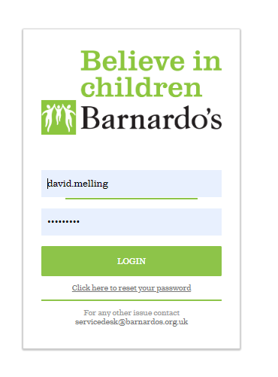

At the login screen, your username and password should auto-complete if you wait a few seconds for the system to catch-up.
If, however, you do not automatically login
to the eLearning platform, please enter your username (firstname.lastname) and your password.

If you have forgotten your password, click on the link underneath the green ‘LOGIN’ box and an email will be sent to you inviting you to set-up a password.

Once you have successfully logged-in you will be taken to the eLearning homepage where
you can see what’s on offer and new The BU resources including TED Talks, leadership
resources and learning animations.

