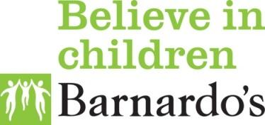
How to use these
Barnardo’s documents

Make a copy/ duplicate of this document. You can do this in Google Suite or by downloading as a PDF/ word document

Edit the areas of the document highlighted in yellow to suit your specific needs. For example: Dates, titles, place names

Delete this page

Use as instructed on the Inside Barnardo’s website

We have more materials for supporting service design with young people. These are available on the Barnardo’s website. [add link to intro page on Inside Barnardo’s]

We like to learn. If you’d like to feedback on these materials, get in touch at servicedesign@barnardos.org.uk.

Care journeys

Information sheet

About the care journeys project

Barnardo’s is working in Plymouth over the next 7 years on an exciting new project.

We want to make sure that 19-21 year olds with care experience do as or more ‘well’ than their peers who have not been in care.

This project is called Care Journeys and we like to think of it as a laboratory - 7 years to work with young people and professionals to try out new ideas.

Any good experiment starts by understanding how things work now. And this is what we’re planning to do over the next 4 months.

We’d like to meet with care experienced young people to understand, in their words, how they have found the changes to their care that happen between the ages of 16-25.

We know for lots of young people these changes happen too quickly and may not be managed well. We also know that some young people have experiences about things that worked for them, or ideas about how things could work better.

We want to hear from you and understand your experiences so together we can come up with ways to make this much better.
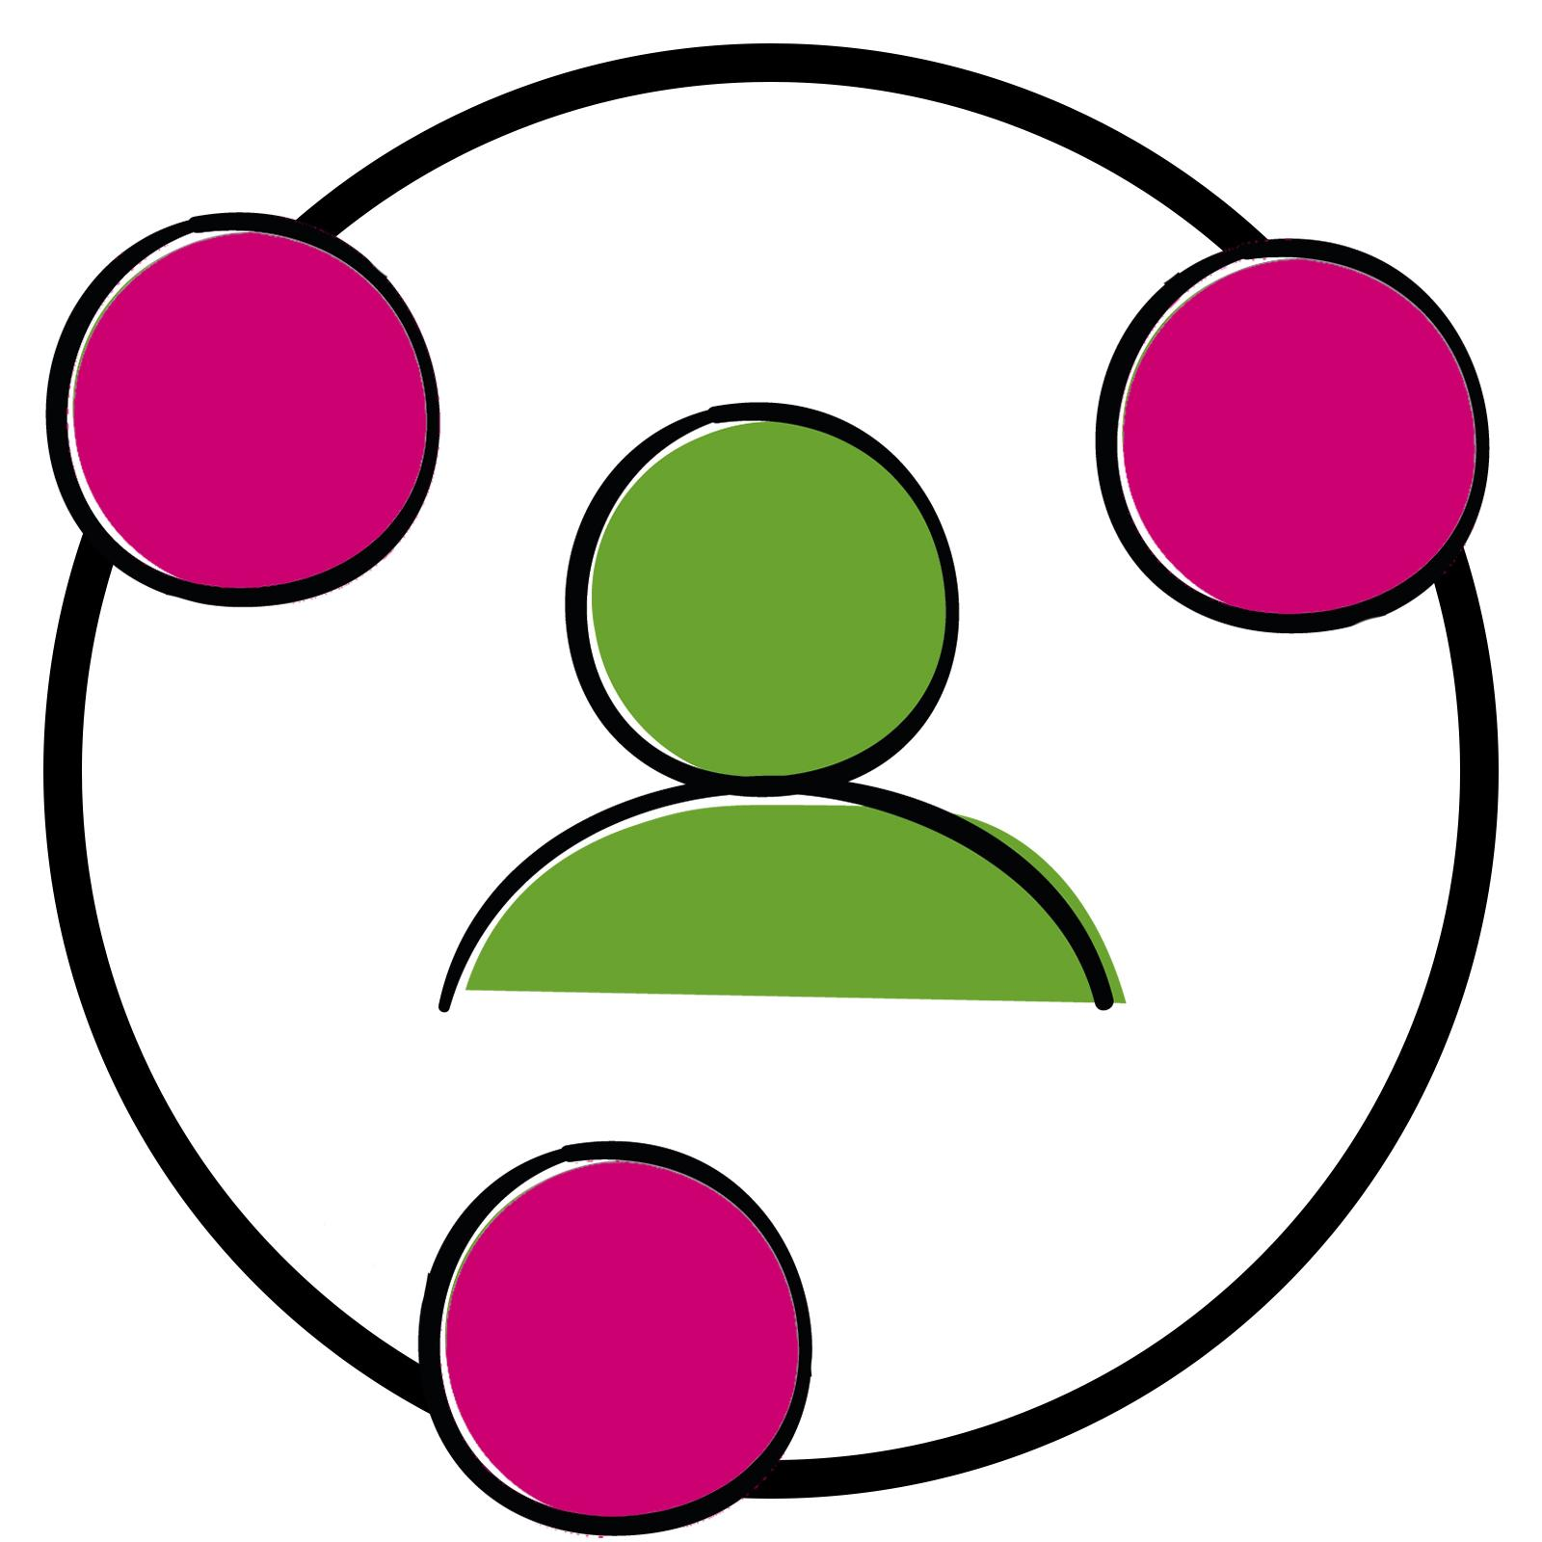

What would happen if I am part of the project?

You would meet with two people in our team for an interview/discussion with around 5 other young people.

You would be sharing thoughts and ideas with us for about 45 minutes.

We’d meet at the Barnardo’s office on King Street (123 King Road).

Do I have to say yes to being part of this project?

No! It’s totally up to you. No one will be upset if you say no.

You can also change your mind at any point for any reason. And you don’t have to answer any questions you don’t want to. You being comfortable is most important.

You don’t have to tell us your reason for not taking part, if you don’t want to.

If you say no, it won’t affect any services you receive from us.

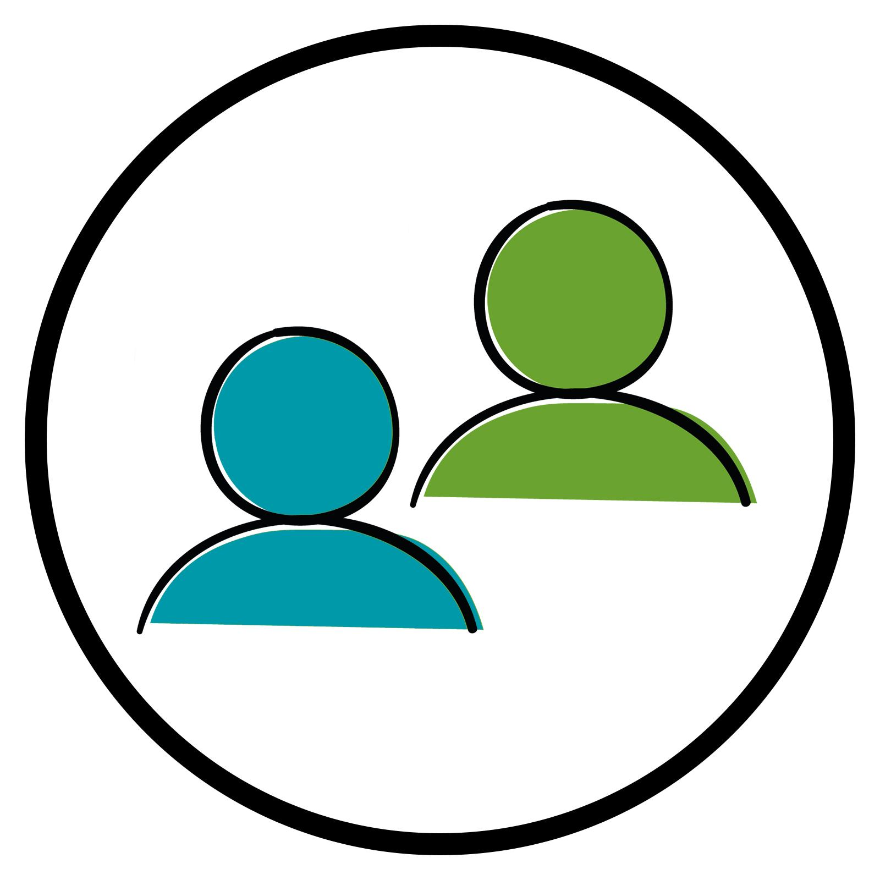

Who might I meet?

You might meet one or more of these people. They are all on our team.

 | 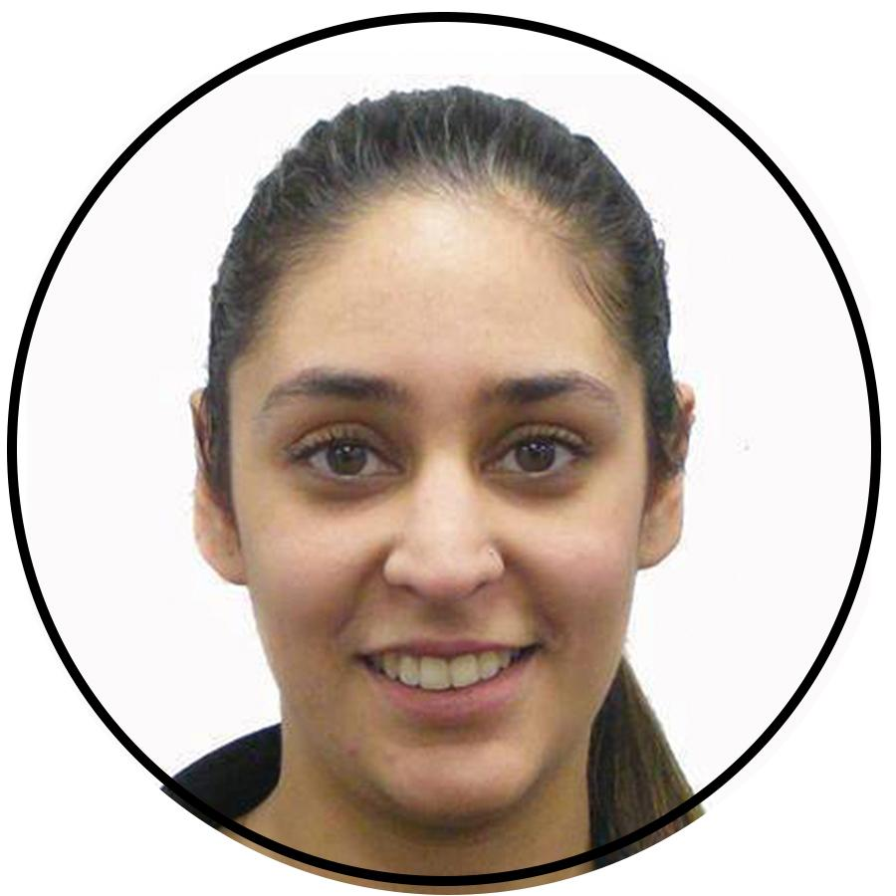
Amy Ricketts  A designer at Barnardo’s | Sohila Sawhney  A researcher at Barnardo’s | Caitlin Connors  A researcher at Barnardo’s
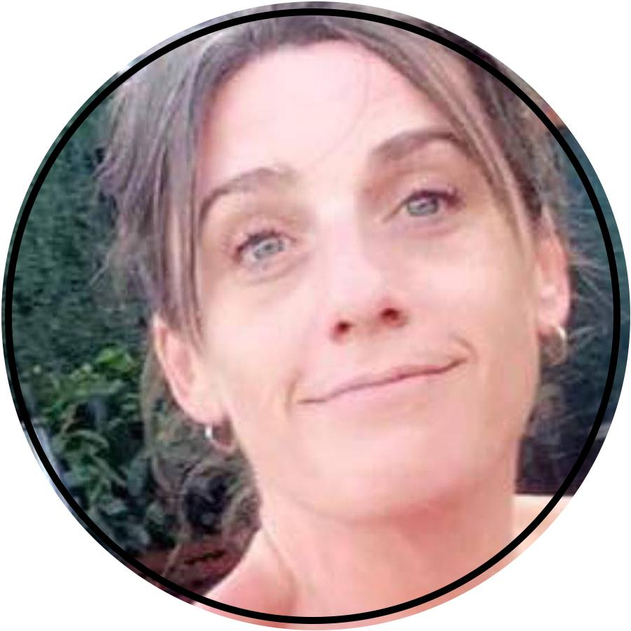 | 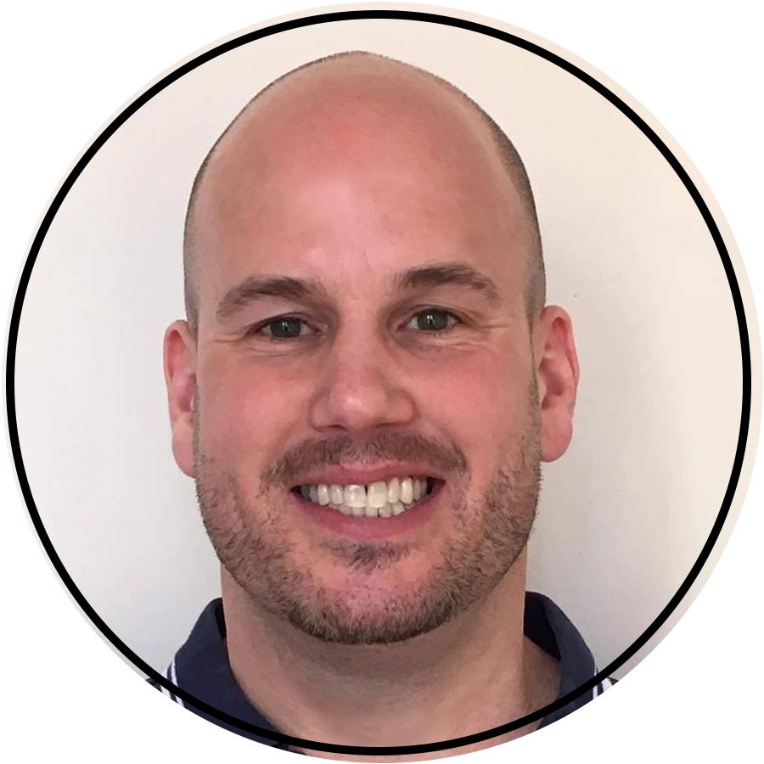
Cairin Laird  A Barnardo’s worker who supports young people | Jason Owens  A Barnardo’s worker who supports young people
If it makes you more comfortable, you are welcome to have someone you trust in the room with you (like a worker).

What will I get for taking part?

To say thank you for having shared your story and giving us your time, you will be given a £20.00 gift voucher.

Other young people we have spoken to said they found it helpful to chat through things with our team.

Is anyone going to be taking notes?

ONLY if you say it’s ok, the interviewers will record the session by taking some notes, taking a voice recording, or maybe taking photographs of the things we do together.

You can chat with us to decide if you’re ok with us taking notes or recordings.
It’s ok to take part but not have any notes or recordings taken if that’s what you want.

Will anyone know what I say in the discussion?

Only the people whose pictures you see above will know what you have said.

They will probably tell other people what they’ve learned from talking to you and people like you, but they won’t share your name.

The only time that we’d share what you say with people not in the room or in our team is if you say something that makes us worried that you or someone else might be in danger of harm.

If this happens, we will have to tell someone who can help. We would talk with you first.

What happens with the things
I share after the session?

We will think about what you and other young people said, and write up a report to help people understand how to make things better. We’ll send you a short document after the sessions about what we’ve learned to get your thoughts.
In our report, we’ll include quotes from what you and other people shared - with no names - and use that to help others think about how to improve our services.

Barnardo’s will delete the research data 2 years after the project ends. In the meantime we keep recordings and notes in a safe, secure place where no one can access them without permission.

If you would like to delete your personal data or have a complaint, you can contact
_________________________________

Email: _________________________________
Phone:_________________________________

