This guide will help you setup access to Office 365 on your Android device

Essentials
- Unenroll and uninstall the Citrix XenMobile Apps (Secure Mail, Secure Web and Secure Hub) by following the guide here.
- If you’re using a Corporate Android device, enrol into Intune by following the guide here.
- Check the version of Android on your device to make sure it’s compatible with the Office 365 Apps. How to check and update your Android version? As of January 2021 your device will need to be running a minimum of Android 8.

My device is ready

Personal Android
- Install the Company Portal App from the Google Play Store. You do not need to enrol.
- Install the required Office 365 Apps from the Google Play Store. Usually this will include Microsoft Outlook and other Apps such as Microsoft Word and Microsoft Excel.

Corporate (Intune Enrolled) Android
- Install the required Office 365 Apps from the Google Play Store (use the Google Play Store in the Work Profile if this has been setup on your device). Usually this will include Microsoft Outlook and other Apps such as Microsoft Word and Microsoft Excel.

My device is running an older version of Android
You’ll still be able to access Office 365 from your device but will need to use the Web version instead. Open this link in the browser on your device. You do not need to proceed with the remaining steps in this guide.

Setup

- Open the Microsoft Outlook App and select ADD ACCOUNT

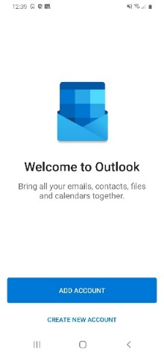
- Enter your Barnardo’s email address and select CONTINUE

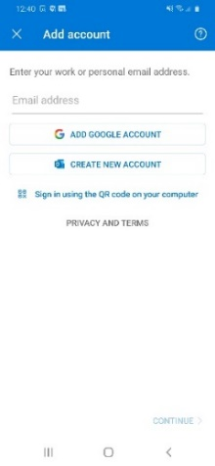
- Enter your OKTA username and password and select Sign In

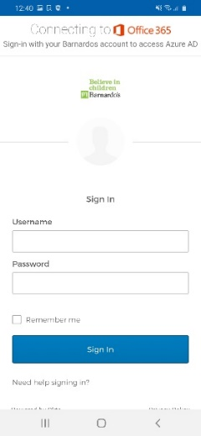

- Respond to the OKTA MFA prompt (this can be either an SMS message, phone call, push notification or code from the OKTA Verify App on your device)

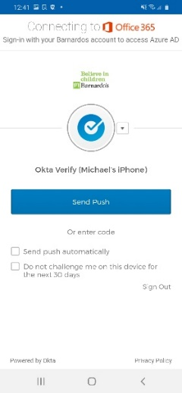

- Select Register

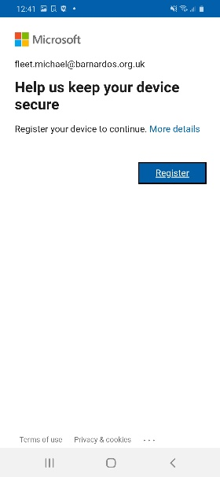

- Select MAYBE LATER

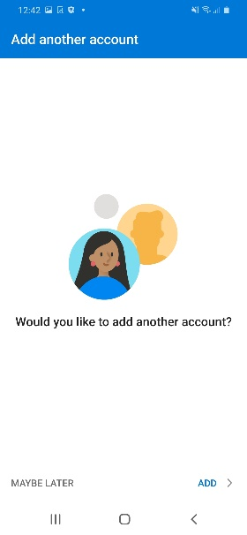

- Either skip or run through the tutorial

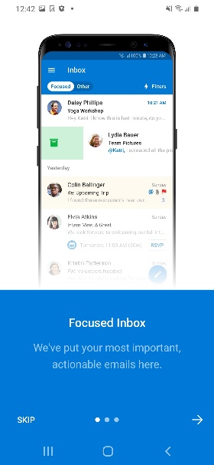

- Select CONTINUE

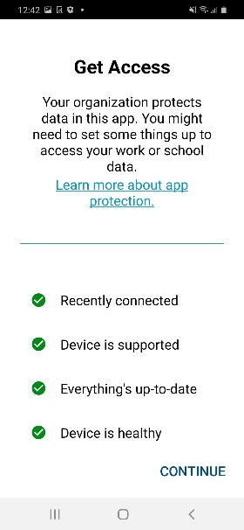

- Enter a PIN of at least 6 digits and select Send

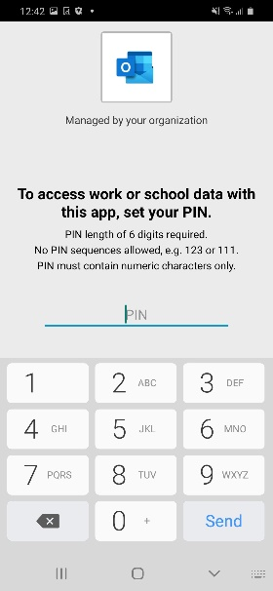

- Confirm the PIN and select Send

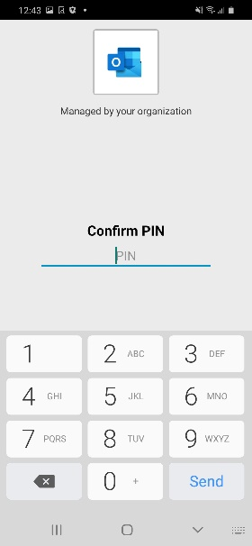

- The Microsoft Outlook App will now be setup, and you can now access your email and calendar on your device

- Open any other Microsoft Office 365 Apps to setup for BYOD

