This guide will help you setup access to Office 365 on your iOS device

Essentials
- Unenroll and uninstall the Citrix XenMobile Apps (Secure Mail, Secure Web and Secure Hub) by following the guide here.
- If you’re using a Corporate iOS device, enrol into Intune by following the guide here.
- Check the version of iOS on your device to make sure it’s compatible with the Office 365 Apps. How to check and update your iOS version? As of January 2021 your device will need to be running a minimum of iOS 13.

My device is ready

Personal iOS
- Install the Microsoft Authenticator App from the Apple App Store.
- Install the required Office 365 Apps from the Apple App Store. Usually this will include Microsoft Outlook and other Apps such as Microsoft Word and Microsoft Excel.

Corporate (Intune Enrolled) iOS
- Install the required Office 365 Apps from the Apple App Store. Usually this will include Microsoft Outlook and other Apps such as Microsoft Word and Microsoft Excel.

My device is running an older version of iOS
You’ll still be able to access Office 365 from your device but will need to use the Web version instead. Open this link in the browser on your device. You do not need to proceed with the remaining steps in this guide.

Setup

- Open the Microsoft Outlook App, enter your Barnardo’s email address and select ADD ACCOUNT

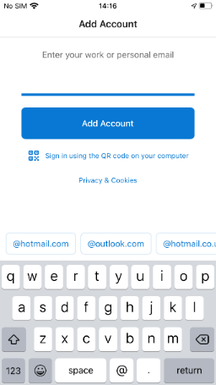
- Select Open Authenticator

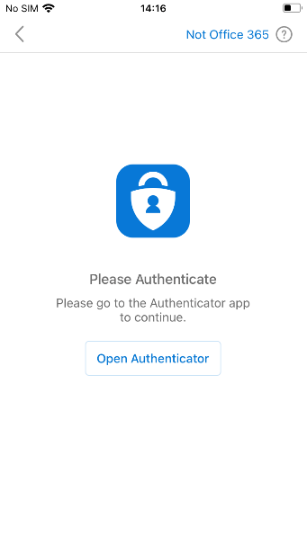
- Enter your OKTA username and password and select Sign In

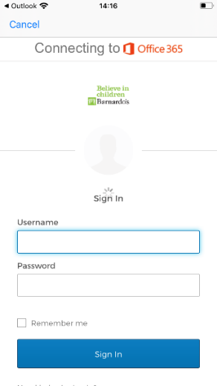

- Respond to the OKTA MFA prompt (this can be either an SMS message, phone call, push notification or code from the OKTA Verify App on your device)

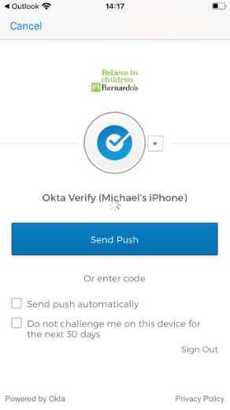

- Select Register

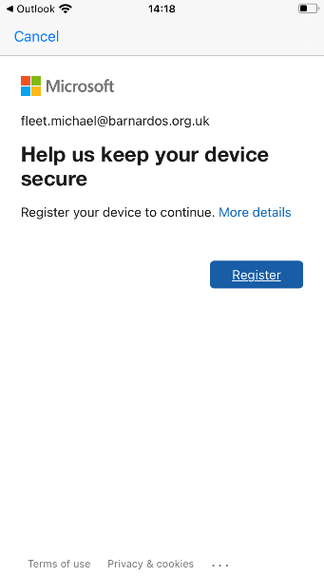

- Select OK

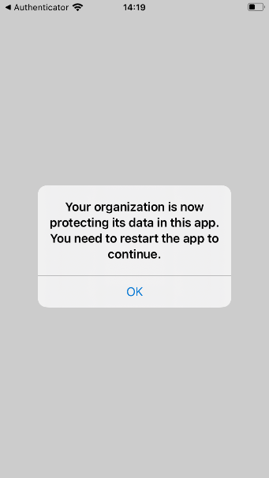

- Open the Microsoft Outlook App again and select OK

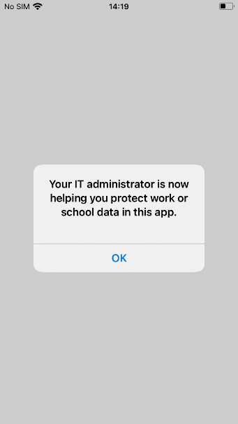

- Enter a 6 digit PIN

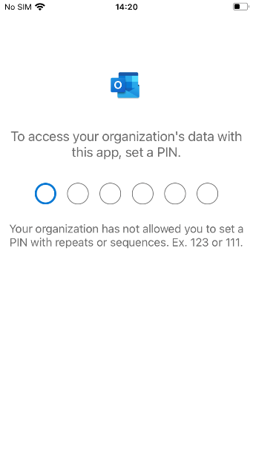

- Confirm the PIN

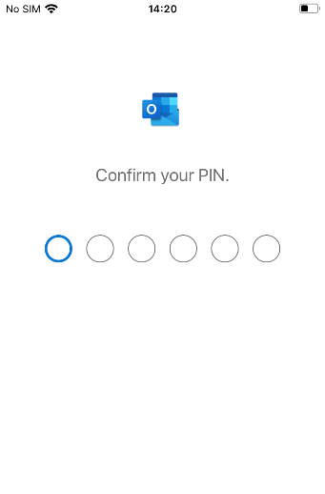
- Confirm whether you would like to enable Outlook App notifications

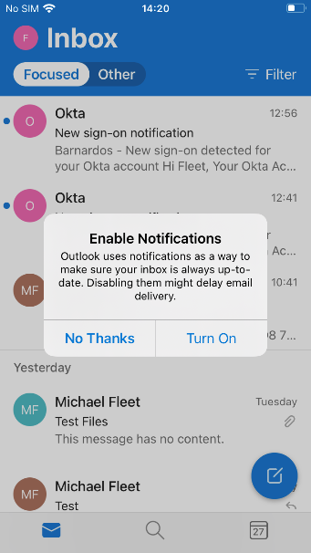

- The Microsoft Outlook App will now be setup, and you can now access your email and calendar on your device

- Open any other Microsoft Office 365 Apps to setup for BYOD

