A guide to Accessibility Tools for Hearing in Windows 10 and Office 365

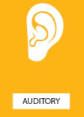

Contents
About this guide three
Tools to help across the board four
Zoom feature four
Reuse files….. five
Smart Lookup seven
Editor………….. eight
Accessibility MailTip twelve
Ease of Access tools within Settings thirteen
Hearing fourteen
Windows 10 Tools fourteen
Audio fourteen
Hear all sounds in one channel sixteen
Visual clues sixteen
Make notifications stick around longer seventeen
Closed captions eighteen
Change caption font eighteen
Change caption background nineteen
Dim window content nineteen
Office365 tools twenty
Useful keyboard shortcuts for Hearing accessibility tools: twenty
Creating accessible documents twenty-one
Check document accessibility twenty-one
Real time presentation subtitles twenty-two
Glossary twenty-three

About this guide
There are many tools that Microsoft has created to improve accessibility for its users. Some of these are within Windows 10 on your device, some are through Office 365 applications.
Examples of products include:
- On-Screen Keyboard: enables people to use a pointer in place of a keyboard to type text.
- Voice-recognition software: converts spoken words into typed text.
- Programs or settings that make your device easier to hear, display captions or set visual alerts.

The Windows 10 features are accessed via your Ease of Access site in the Settings menu. See page 13 for help with this.

Barnardo's recognises the social model of disability which means that it acknowledges that disabled people are not disabled by their impairments or conditions but by, for example, physical, environmental, attitudinal and technological barriers and structures. it is hoped that this guide helps in removing some of those barriers.

Tools to help across the board
Office 365 has some new tools that can benefit everyone. Next to each tool you will see the icon of the app(s) in which you can use the feature.
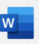
Zoom feature:
O365 Word, Excel, and PowerPoint documents have two methods of zooming to increase font size when you are reading.
Either by using the Zoom slider in bottom right of a document:
Or
Via View group along the top ribbon:
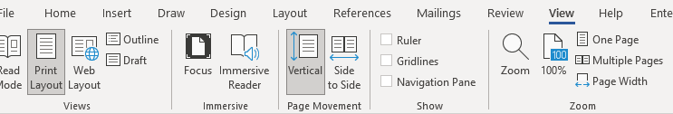
Clicking onto Page Width will adjust your Word document to the entire width of your window.
Excel and PowerPoint have less choice but you can still set your zoom percentage and customise to go larger than 200 per cent.
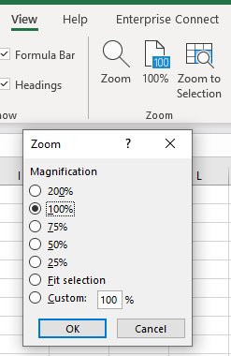

Reuse files
A useful Word tool called Reuse Files is a feature that allows you to search for documents and re-use parts of them. You can insert a block of text or other content from a different file without leaving the document you're currently working on. In PowerPoint it is ‘Reuse Slides’.
Click on Reuse Files in your Home command bar or Insert command bar.
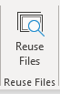

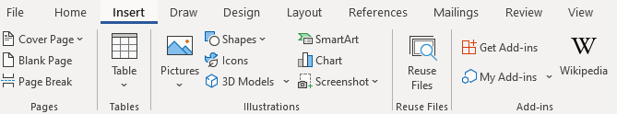

It will present a search bar plus some ‘suggestions for you’.
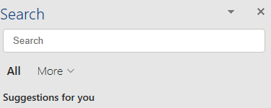

Clicking onto the More arrow allows you to narrow down the source of the information you wish to find. For example, if you only want in-house documents, choose Files; if you only want pictures, choose Media.
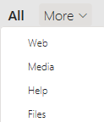

The function is intelligent enough to work out what you are working on and tries to offer results built on similarity of subject. For example, choosing Web whilst working on an accessibility document will give you various internet pages related to accessibility. Choosing Media presents you with accessibility images and logos, and Files brings up relevant documents (Word, PowerPoint, Excel) already stored on SharePoint or OneDrive.
If not relevant enough, use the Search field to look for a subject you want.
Files: If you find a document you wish to copy from, click into it and a plus sign will appear to ‘insert content’. Scroll to anything you wish to reuse, make sure the plus sign is over it and click. The selected text will be put into your current document wherever the cursor is.
However, you can click on the ellipsis (3 dots) next to the file’s name to choose other options:
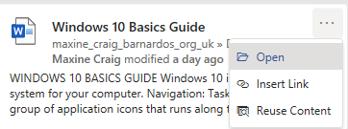
- Open: opens the document in a new window (as long as you have access to it)
- Insert link: inputs a hyperlink to the document’s location
- Reuse content: opens the file in the Search sidebar for you to scroll through content (same result as clicking into the file and using the plus sign)
Web: You can either click onto the suggested web name (in blue) or link (green) and it should open the page in a new tab on your internet window, or you can use the ellipsis (3 dots).
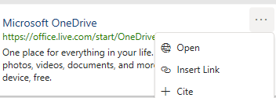
- Open: opens the webpage in a new tab if you have Chrome or Edge open
- Insert link: inserts the webpage link using its name
- Cite: inserts the webpage name plus the file path (where the page is on the internet)

Media: Select a picture you want by clicking onto the plus sign when you hover over the image.

Smart Lookup
Using the Smart Lookup pane lets you get search results without leaving the application you are in and provides definitions, topics, articles, and related searches from the web. The Search bar at the top of your document performs the same way so use that if you have no Smart Lookup.
When you select a word or phrase, right-click it, then choose Smart Lookup from the menu that appears. Note: it may appear as Search “…..” instead in Word and PowerPoint but this produces the same results that are displayed in the pane that appears on the right side of the screen.
You can also get to Smart Lookup/ Search any time by going to References command bar and choosing Search or Smart Lookup (depending on what shows there).
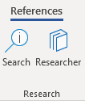

As with Reuse Files, you can narrow your search down by choosing Files, Web or Media.
Files: If you find a file/document you wish to copy from, click into it and a plus sign will appear to ‘insert content’. Scroll to anything you wish to reuse, make sure the plus sign is over it and click. If you want more or less than is being covered by the plus sign, you can also left click on your mouse and drag your cursor over what you want to select, then click the plus sign. The selected text will be put into your current document.
However, you can click on the ellipsis (3 dots) next file’s name to choose other options:
- Open: opens the document in a new window (as long as you have access to it)
- Insert link: inputs a hyperlink to the document’s location
- Reuse content: opens the file in the Search sidebar for you to scroll through content (same result as clicking into the file and using the plus sign)

Web: You can either click onto the suggested web link or name and it should open the page in a new tab on your internet window, or you can use the ellipsis (3 dots).
- Open: opens the webpage in a new tab if you have Chrome or Edge open
- Insert link: inserts the webpage link using its name
- Cite: inserts the webpage title plus the file path (where the page is on the internet)

Media: Select a picture you want by clicking onto the plus sign when you hover over the image.

Editor
Editor helps you to improve your writing in Word and Outlook Online by identifying words and phrases that might need more refinement. Editor analyses text as you type and makes suggestions when it finds misspellings and opportunities for improving.
When Editor is enabled, improved spelling and grammar suggestions will be automatically available to you. Editor is there to help you, but it will not prevent you from continuing with your document if you choose not to take its advice.

In Word, you can find Editor on the Home command bar and the Review command bar.
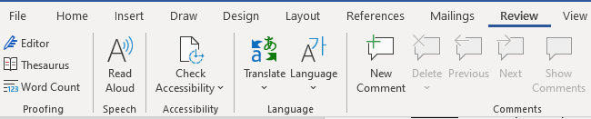
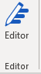

Click onto Editor and a pane will open on the right to tell you how many spelling and grammar errors there are and any refinement issues it has detected for clarity, conciseness, formality, punctuation and vocabulary.
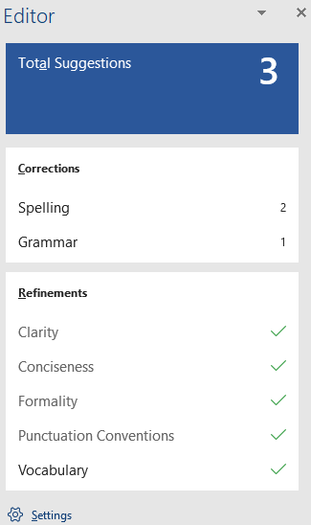

Click onto any of these sections that show a number, and Editor will give you alternatives or tell you what the correction is.
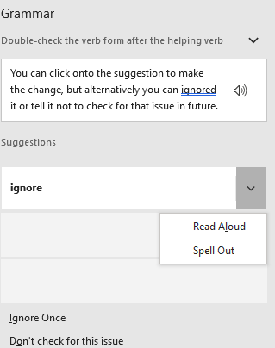

You can click onto the suggestion to make the change, but alternatively you can ignore it or tell it not to check for that issue in future.
Editor in Outlook Online
For Outlook Online, you will find Editor in the lower taskbar of a new blank email. (Unfortunately, Editor is not currently available on Outlook Desktop app.)
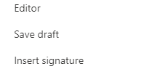
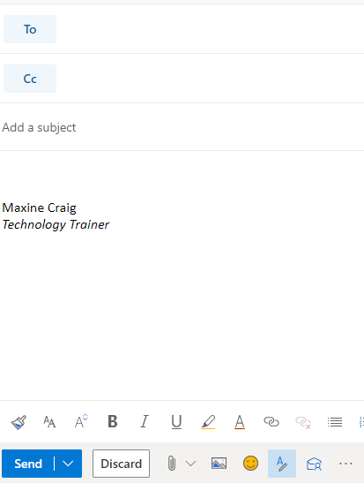

You initially have to go into the ellipsis to find it, but if you want easier access to it you can go into Settings (the cog in top right of Outlook Online), choose View all Outlook Settings > Customise actions, then scroll down to Toolbar section. Tick the Editor box to add it to the lower toolbar as displayed below.
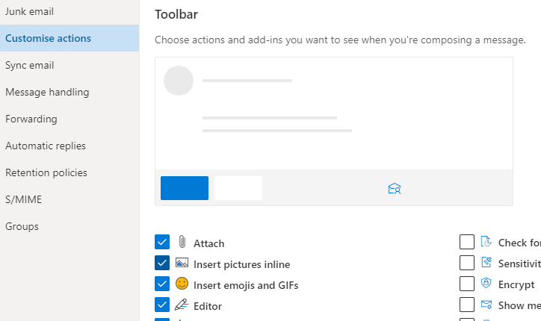

Editor here works differently. It does not display a box of suggestions but highlights errors as you type. If you click onto the word underlined, it gives you the options for improving your text.
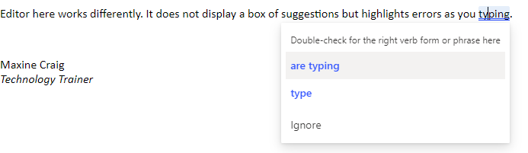
When you click on the Editor icon, you can set your controls to choose what it checks, from spelling and grammar to clarity, conciseness, inclusiveness, formality and punctuation and vocabulary.
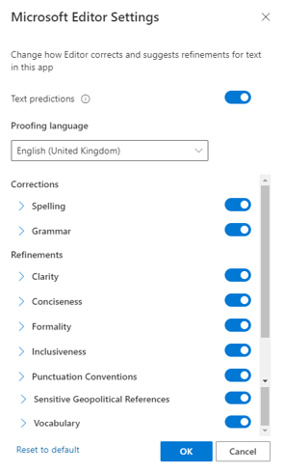

You can also turn off ‘Text predictions’ in this Editor box if you prefer not to have this function. Text prediction anticipates your next words and suggests words or phrases as you type. For example, it has added ‘than’ after the words ‘much better’ have been typed below. You can either ignore and continue to type or use the Tab key to accept the suggestion.
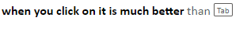

Accessibility MailTip

A MailTip in Outlook on the Web informs co-workers of your preference for accessible content. This prompt reminds them to run Accessibility Checker before sending an email to you and fix any issues that might make the content difficult for people with disabilities to read or understand..
Go to Settings (the cog icon in top right of Outlook Online) and choose ‘view all Outlook settings’ at the bottom of the Settings pane.

Then select General from the list of the left and then Accessibility from within the General options.
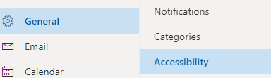

Tick the Accessible Content box.
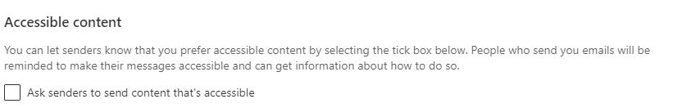

Ease of Access tools within Settings
There are a few ways you can reach the Ease of Access settings available on your Windows 10 computer/laptop.
- Press Windows logo key plus U key, which will take you straight into the Ease of Access site
OR
- Press Windows key plus I key to take you to Settings, where you can then choose the Ease of Access site

If you prefer not to use shortcuts:
- Click on the Start menu in bottom left corner or press Windows logo key to access Start menu
then select Settings
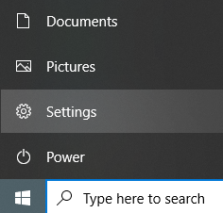
Or
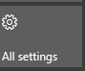
- Click onto the Notifications icon in bottom right of your screen, then select All Settings from the displayed tiles

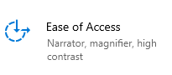
Then select Ease of Access

On the left of the Ease of Access site, you will get a list divided into Vision, Hearing, and Interaction.
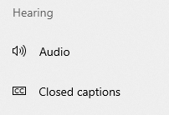

Hearing
For those who are hard of hearing, have hearing loss or are deaf, Microsoft has some specialised features can provide help, including closed captioning and mono sound.
Explore Microsoft's hearing accessibility guide
If you cannot access this hyperlink, the full URL is:
https://support.microsoft.com/en-gb/windows/guide-for-people-who-are-deaf-or-hard-of-hearing-47647fe6-73bc-2afa-85ba-0b233198e6c4

Windows 10 Tools
Within Windows 10 Ease of Access site, there are two options for Hearing: Audio and Closed Captions
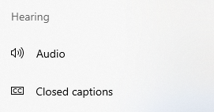

Audio
You can make your device easier to hear or use without sound. Use the slider to amend the volume on your device.
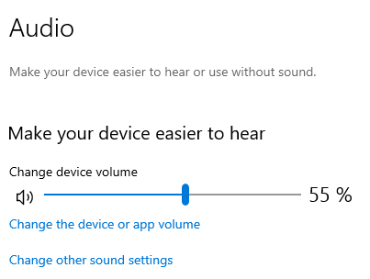
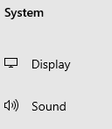
If you click onto the ‘change the device or app volume’ link, it will take you out of the Ease of Access site and into the Sound section of System site within Settings. This lets you choose your sound output and input devices if you have more than the laptop speakers or microphone.

Clicking onto the ‘change other sound settings’ is more in-depth and brings up a box with four tabs in which you can make further amendments to sound devices and the sound themes in Windows for events like calendar reminder, message notifications, etc.
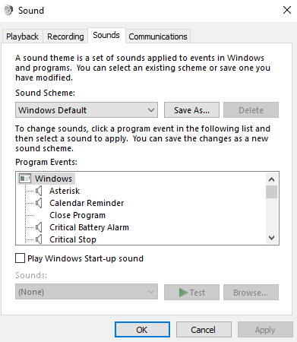
Within the Communication tab, you can adjust the volume for when you receive or make phone calls.
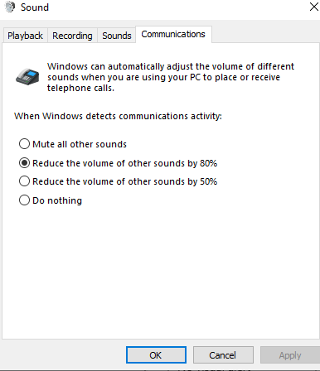

Hear all sounds in one channel
Windows let you convert stereo sound into a single channel so you can hear everything, even if you are using just one headphone.
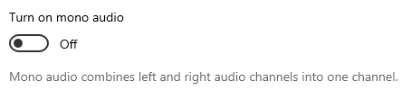

Visual clues
If you have trouble hearing audio alerts and prefer to get visual clues, you can have your PC display them visually.
Under ‘Show audio alerts visually’, still within Audio settings, choose how you want audio alerts displayed.
You can choose to have the title bar of the active window, the active window, or the entire screen flash when a notification arrives, instead of relying on sound alone.
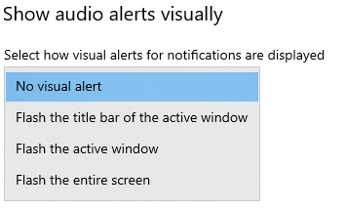

Make notifications stick around longer
By default, Windows notifications disappear five seconds after they appear. If you want more time to read them, you can increase how long they're displayed. Maximum is 5 minutes.
To change this time, you will need to go into the Vision section of Ease of Access and choose Display.
You will see the following box where you can change the notification display time from 5 seconds to between 7 seconds or 5 minutes.
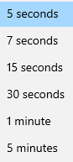
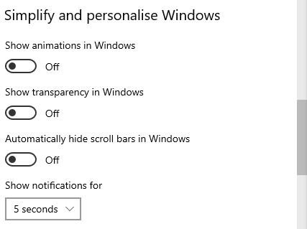

Closed captions
You can make your device easier to use without sound by displaying audio as text using captions. There are several drop-down boxes to adapt the captions as best for you.
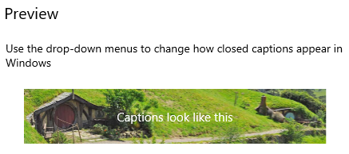

Change caption font
When you make changes to the following aspects of your captions, the preview will display the ‘captions look like this’ in your new colour, font, etc. It is a good way of testing first.
You can change the caption colour, transparency, style, size, and effects.
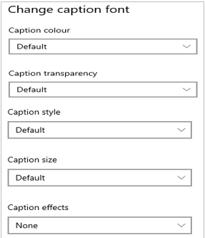

Change caption colour: choose from white, black, red, green, blue, yellow, magenta, and cyan
Change caption transparency: choose from opaque, translucent, semi-transparent and transparent
Change caption style: choose from two serif styles, two sans serif styles, casual, cursive, small capitals
Change caption size: choose percentages of 50, 100, 150 and 200.
Change caption effects: choose from raised, depressed, uniform, drop shadow or none.

Change caption background
You can make changes to the background display.
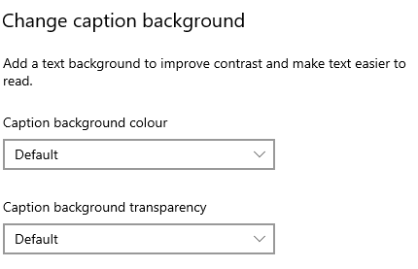
Text background colour options are black, white, red, green, blue, yellow, magenta, cyan.
Background transparency options are opaque, translucent, semi-transparent, and transparent.
So, for example, choosing a red text background and opaque produces this:

Dim window content
Finally, you can also change the background when your caption display using the ‘dim window content’ drop-down boxes.
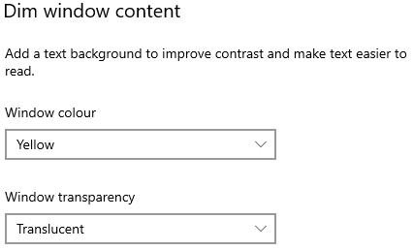
As with caption colours, the Window colour options are black, white, red, green, blue, yellow, magenta, cyan.
The transparency options are opaque, translucent, semi-transparent and transparent.
For example, changing the window options to yellow and translucent produces this:

Office365 tools

In PowerPoint, you can add closed captions or subtitles to videos and audio
files in your presentations. Adding closed captions makes your presentation accessible to a
larger audience, including people with hearing disabilities and those who speak languages
other than the one in your video.
However, as this is a long process please click onto the link below to access Microsoft’s pages for this.
How to add closed captions or subtitles to PowerPoint
If you cannot access this hyperlink, this is the full URL:
https://support.microsoft.com/en-gb/office/add-closed-captions-or-subtitles-to-media-in-powerpoint-df091537-fb22-4507-898f-2358ddc0df18?ui=en-us&rs=en-gb&ad=gb

Useful keyboard shortcuts for Hearing accessibility tools:

Function | Shortcut keys
Open Ease of Access Centre | Windows logo key plus U key
Open Settings | Windows plus I key

Creating accessible documents
Whilst you may not have accessibility needs yourself, you should always bear in mind that some of your recipients could have.

Check document accessibility
Click Review and choose Check Accessibility.
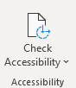

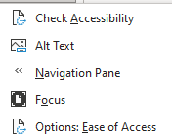
If you click onto the drop-down arrow, you’ll see the options which include Focus to display your document in a more focused way. Focus will put a black surrounding on your document and removes everything else, including the Word commands along the top. Just press ESC to remove Focus.

Results for the Check Accessibility option are presented in three types:
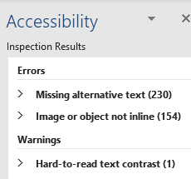

Errors – these cannot be read by screen readers
Warnings – these would be difficult to read
Tips – might cause problems

Real time presentation subtitles
You can provide translated subtitles to your presentations on the Slide Show ribbon tab by selecting Subtitle Settings.
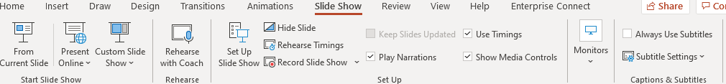
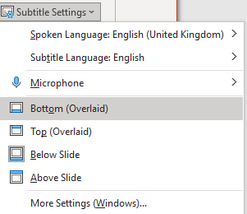
- Use Spoken Language to see the voice languages that PowerPoint can recognise and select the one you want. This is the language that you will be speaking while presenting.
- Use Subtitle Language to see which languages PowerPoint can display on-screen as captions or subtitles and select the one you want. This is the language of the text that will be shown to your audience. Choosing the same language as your Spoken Language allows you to provide closed captioning. This is especially relevant for accessibility for the deaf and hard of hearing.
You can turn subtitles on and off using the Subtitle toggle that appears in the bottom left of each slide when you are in ‘slideshow’ mode.

Glossary
Device: whatever you are using to access your work on – desktop PC, laptop or smartphone.
File Explorer: the ‘folder’ icon that displays along your bottom taskbar; the one you have been using to find your documents, downloads, pictures and desktop.
Windows Key: this is a bottom-left key on your keyboard with the Windows icon on it.
Application: the different programmes within O365 are called applications, e.g. Outlook, Word, PowerPoint, Teams. Often these are called Apps for short.
Icon: the ‘logos’ of the different applications (e.g. Word is a blue W, Excel is a green E, OneDrive is a blue cloud) or web browsers (e.g. Chrome is a coloured circle)
Desktop apps: applications that are available on your laptop/computer by clicking onto the icon. They may be on your bottom taskbar, or in your Start menu. You don’t have to be online to see and access them.
Window: In computer terms, a window is an area on the screen that displays information about a programme. You can have multiple windows open, displaying different websites, documents and applications.
Windows 10: the operating system of your device. Where Windows has a capital W, it means this system and not a window on which you can see your documents, websites, etc.
URL: short for Uniform Resource Locator, this is your web address. It shows the location of a document or website on the internet, including your OneDrive.
Microsoft 365 and Office 365: this is essentially the same thing and both names are used for the applications such as OneDrive, Outlook, Teams, Word, PowerPoint, Excel and OneNote.

