A guide to Accessibility Tools for Learning Disabilities in Windows 10 and Office 365

Contents
About this guide four
Tools to help across the board five
Zoom feature five
Reuse files…… six
Smart Lookup eight
Editor………….. nine
Accessibility MailTip thirteen
Ease of Access tools within Settings fourteen
Learning fifteen
Windows 10 Tools fifteen
Text suggestions fifteen
Managing distractions sixteen
Turn off animations sixteen
Turn off background images sixteen
Make notifications stick around longer seventeen
Get visual alerts for sound seventeen
Clean up taskbar clutter eighteen
Focus Assist nineteen
Office 365 Tools twenty-two
Improve comprehension and reading with Immersive Reader twenty-two
Immersive Reader in Word twenty-two
Accessing Immersive Reader twenty-two
Using Immersive Reader twenty-two
Immersive Reader in Outlook Online twenty-four
Accessing Immersive Reader twenty-four
Using Immersive Reader twenty-five
Immersive Reader in MS Edge twenty-seven
Accessing Immersive Reader twenty-seven
Using Immersive Reader twenty-eight
Improve writing quality with Editor thirty-one
Read Aloud thirty-one
Dictate - Type with your voice thirty-two
Creating accessible documents thirty-three
Check document accessibility thirty-three
Real time presentation subtitles thirty-four
Glossary thirty-five

About this guide
There are many tools that Microsoft has created to improve accessibility for its users. Some of these are within Windows 10 on your device, some are through Office 365 applications.
Examples of products include:
- On-Screen Keyboard: enables people to use a pointer in place of a keyboard to type text.
- Editor: helps you to improve your writing in Word and Outlook Online by identifying words and phrases that might need more refinement. Editor analyses text as you type and makes suggestions when it finds misspellings and opportunities for improving.
- Immersive Reader which helps with reading comprehension and can highlight different types of words for you.

The Windows 10 features are accessed via your Ease of Access site in the Settings menu. See page 14 for help with this.

Barnardo's recognises the social model of disability which means that it acknowledges that disabled people are not disabled by their impairments or conditions but by, for example, physical, environmental, attitudinal and technological barriers and structures. it is hoped that this guide helps in removing some of those barriers.

Tools to help across the board
Office 365 has some new tools that can benefit everyone. Next to each tool you will see the icon of the app(s) in which you can use the feature.
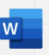
Zoom feature:
O365 Word, Excel, and PowerPoint documents have two methods of zooming to increase font size when you are reading.
Either by using the Zoom slider in bottom right of a document:
Or
Via View group along the top ribbon:
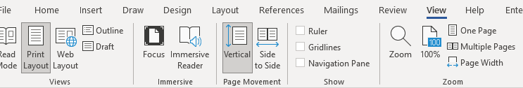
Clicking onto Page Width will adjust your Word document to the entire width of your window.
Excel and PowerPoint have less choice but you can still set your zoom percentage and customise to go larger than 200 per cent.
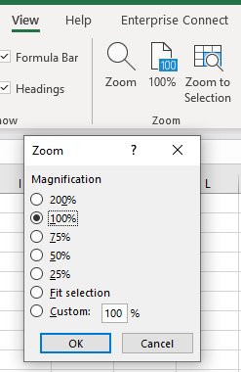

Reuse files
A useful Word tool called Reuse Files is a feature that allows you to search for documents and re-use parts of them. You can insert a block of text or other content from a different file without leaving the document you're currently working on. In PowerPoint it is ‘Reuse Slides’.
Click on Reuse Files in your Home command bar or Insert command bar.
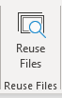

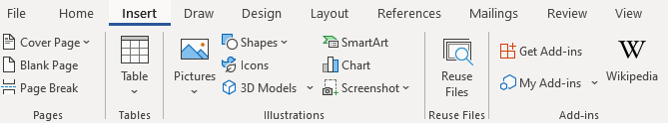

It will present a search bar plus some ‘suggestions for you’.
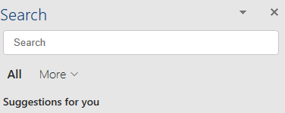
Clicking onto the More arrow allows you to narrow down the source of the information you wish to find. For example, if you only want in-house documents, choose Files; if you only want pictures, choose Media.
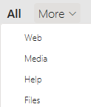
The function is intelligent enough to work out what you are working on and tries to offer results built on similarity of subject. For example, choosing Web whilst working on an accessibility document will give you various internet pages related to accessibility. Choosing Media presents you with accessibility images and logos, and Files brings up relevant documents (Word, PowerPoint, Excel) already stored on SharePoint or OneDrive.
If not relevant enough, use the Search field to look for a subject you want.
Files: If you find a file/document you wish to copy from, click into it and a plus sign will appear to ‘insert content’. Scroll to anything you wish to reuse, make sure the plus sign is over it and click. The selected text will be put into your current document.
However, you can click on the ellipsis (3 dots) next to the file’s name to choose other options:
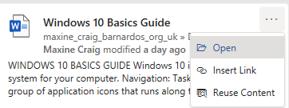
- Open: opens the document in a new window (as long as you have access to it)
- Insert link: inputs a hyperlink to the document’s location
- Reuse content: opens the file in the Search sidebar for you to scroll through content (same result as clicking into the file and using the plus sign)
Web: You can either click onto the suggested web name (in blue) or link (green) and it should open the page in a new tab on your internet window, or you can use the ellipsis (3 dots).
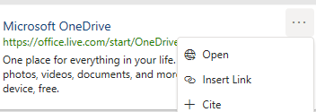
- Open: opens the webpage in a new tab if you have Chrome or Edge open
- Insert link: inserts the webpage link using its name
- Cite: inserts the webpage name plus the file path (where the page is on the internet)

Media: Select a picture you want by clicking onto the plus sign when you hover over the image.

Smart Lookup
Using the Smart Lookup pane lets you get search results without leaving the application you are in and provides definitions, topics, articles, and top related searches from the web. The Search bar at the top of your document performs the same way.
When you select a word or phrase, right-click it, then choose Smart Lookup from the menu that appears. Note: it may appear as Search “…..” instead in Word and PowerPoint but this produces the same results that are displayed in the pane that appears on the right side of the screen.
You can also get to Smart Lookup/ Search any time by going to References command bar and choosing Search or Smart Lookup (depending on what shows there).
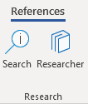
As with Reuse Files, you can narrow your search down by choosing Files, Web or Media.
Files: If you find a file/document you wish to copy from, click into it and a plus sign will appear to ‘insert content’. Scroll to anything you wish to reuse, make sure the plus sign is over it and click. If you want more or less than is being covered by the plus sign, you can also left click on your mouse and drag your cursor over what you want to select, then click the plus sign. The selected text will be put into your current document.
However, you can click on the ellipsis (3 dots) next file’s name to choose other options:
- Open: opens the document in a new window (as long as you have access to it)
- Insert link: inputs a hyperlink to the document’s location
- Reuse content: opens the file in the Search sidebar for you to scroll through content (same result as clicking into the file and using the plus sign)

Web: You can either click onto the suggested web link or name and it should open the page in a new tab on your internet window, or you can use the ellipsis (3 dots).
- Open: opens the webpage in a new tab if you have Chrome or Edge open
- Insert link: inserts the webpage link using its name
- Cite: inserts the webpage title plus the file path (where the page is on the internet)

Media: Select a picture you want by clicking onto the plus sign when you hover over the image.

Editor
Editor helps you to improve your writing in Word and Outlook Online by identifying words and phrases that might need more refinement. Editor analyses text as you type and makes suggestions when it finds misspellings and opportunities for improving.
When Editor is enabled, improved spelling and grammar suggestions will be automatically available to you. Editor is there to help you, but it will not prevent you from continuing with your document if you choose not to take its advice.

In Word, you can find Editor on the Home command bar and the Review command bar.
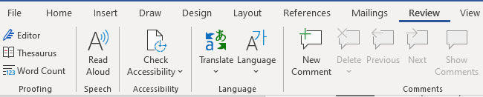
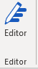

Click onto Editor and a pane will open on the right to tell you how many spelling and grammar errors there are and any refinement issues it has detected for clarity, conciseness, formality, punctuation and vocabulary.
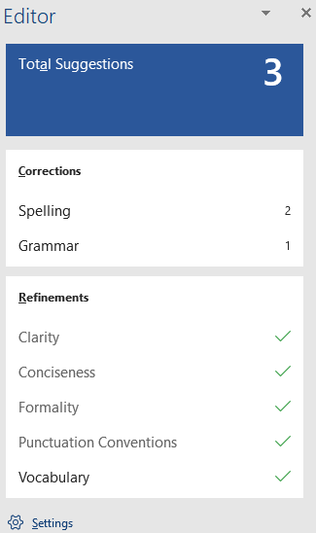
Click onto any of these sections that show a number, and Editor will give you alternatives or tell you what the correction is.

You can press onto the ‘read aloud’ icon to get the issue read to you, and if you press on the drop-down arrow in the suggestion, you can choose between ‘read aloud’ or ‘spell out’.
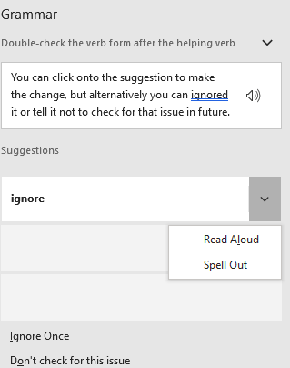
You can click onto the suggestion to make the change, but alternatively you can ignore it or tell it not to check for that issue in future.
Editor in Outlook Online
For Outlook Online, you will find Editor in the lower taskbar of a new blank email. (Unfortunately, Editor is not currently available on Outlook Desktop app.)
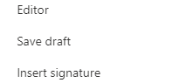
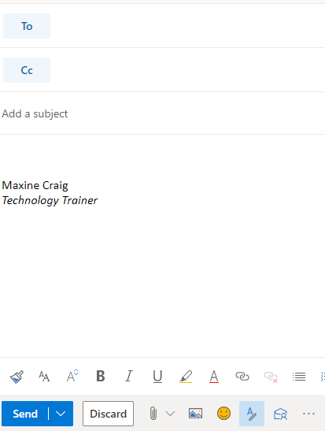

You initially have to go into the ellipsis to find it, but if you want easier access to it you can go into Settings (the cog in top right of Outlook Online), choose View all Outlook Settings > Customise actions, then scroll down to Toolbar section. Tick the Editor box to add it to the lower toolbar as displayed below.
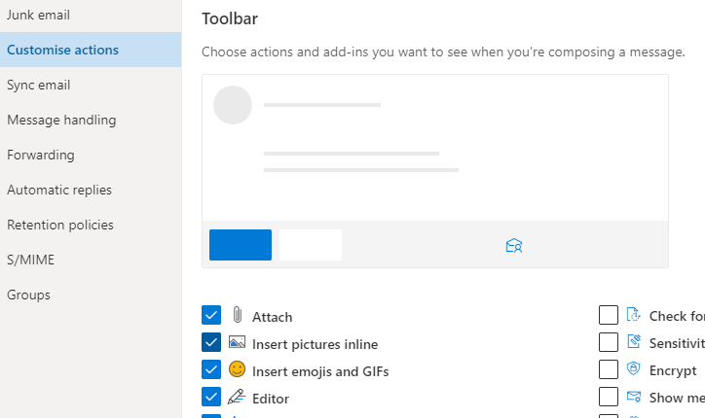

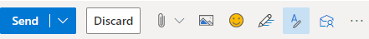
Editor here works differently. It does not display a box of suggestions but highlights errors as you type. If you click onto the word underlined, it gives you the options for improving your text.
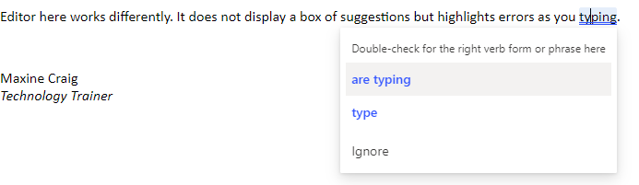
When you click on the Editor icon, you can set your controls to choose what it checks, from spelling and grammar to clarity, conciseness, inclusiveness, formality and punctuation and vocabulary.
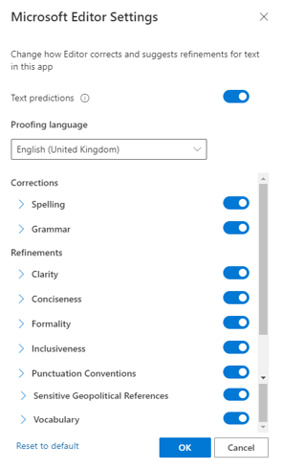

You can also turn off ‘Text predictions’ in this Editor box if you prefer not to have this function. Text prediction anticipates your next words and suggests words or phrases as you type. For example, it has added ‘than’ after the words ‘much better’ have been typed below. You can either ignore and continue to type or use the Tab key to accept the suggestion.
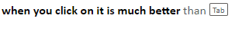

Accessibility MailTip

A MailTip in Outlook on the Web informs co-workers of your preference for accessible content. This prompt reminds them to run Accessibility Checker before sending an email to you and fix any issues that might make the content difficult for people with disabilities to consume.
Go to Settings (the cog icon in top right of Outlook Online) and choose ‘view all Outlook settings’ at the bottom of the Settings pane.
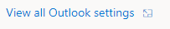

Then select General from the list of the left and then Accessibility from within the General options.
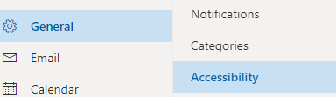

Tick the Accessible Content box.
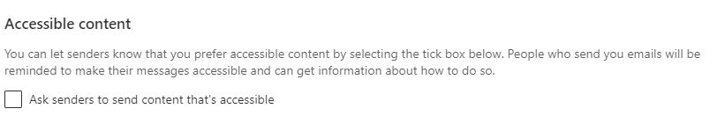

Ease of Access tools within Settings
There are a few ways you can reach the Ease of Access settings available on your Windows 10 computer/laptop.
- Press Windows logo key plus U key, which will take you straight into the Ease of Access site
OR
- Press Windows plus I key to take you to Settings, where you can then choose the Ease of Access site

If you prefer not to use shortcuts:
- Click on the Start menu in bottom left corner or press Windows logo key to access Start menu
then select Settings
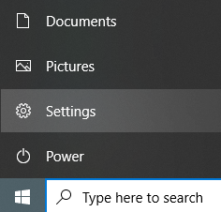
Or
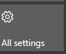
- Click onto the Notifications icon in bottom right of your screen, then select All Settings from the displayed tiles

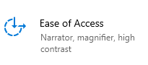
Then select Ease of Access

On the left of the Ease of Access site, you will get a list divided into Vision, Hearing, and Interaction.
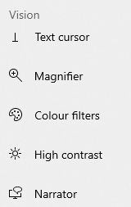
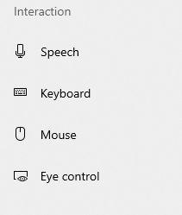

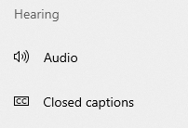

Learning
Microsoft applications for people with a learning disability and people who are
neurodiverse can help increase focus on concentration, and understanding, including tools
to improve reading and writing skills.
Learn more about tools such as Immersive Reader and Focus Assist in Windows 10.

Explore Microsoft's learning accessibility guide

If you cannot access this hyperlink, here is the full URL
https://support.microsoft.com/en-gb/windows/guide-for-people-who-have-learning-disabilities-b422a139-fab0-8047-826a-8879c23a9cb2

Windows 10 Tools

Text suggestions
Get help constructing sentences with text suggestions. Word suggestions appear and can be inserted as you type. It's a great feature for anyone who would like a little help with their writing.
To see text suggestions while you type, go into Settings and choose Devices.
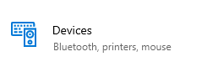

Then select Typing from the list on the left, scroll to the ‘hardware keyboard’ section and
switch across the toggle for ‘show text suggestions as I type’.
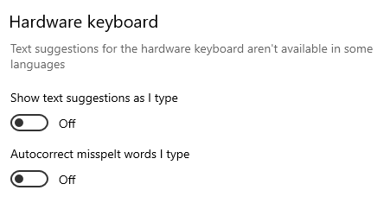

Managing distractions
There are some ways to make it easier for you to focus on your tasks.

Turn off animations
Minimise visual distractions by turning off animations.
Go into Ease of Access > Vision and choose Display.
Then choose from the different options under ‘Simplify and personalise Windows’ such as turning off animations, showing notifications for longer, hiding scroll bars.
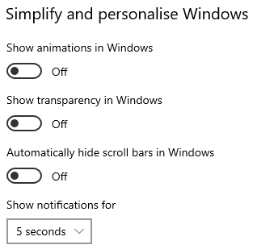

Turn off background images
Minimise visual distractions by turning off your background image.
Go into Ease of Access and select Display. Then under ‘Simplify and personalise Windows’ you can use the toggle button to show a desktop background image, or turn it off to display one colour only for easier desktop navigation.

Make notifications stick around longer
By default, Windows notifications disappear five seconds after they appear. If you want more time to read them, you can increase how long they're displayed. Maximum is 5 minutes.
To change this time, you will need to go into the Vision section of Ease of Access and choose Display.
You will see the following box where you can change the notification display time from 5 seconds to between 7 seconds or 5 minutes.
Or you can choose to hide the scroll bar on Windows applications or switch off animations in Windows.
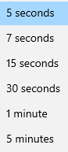
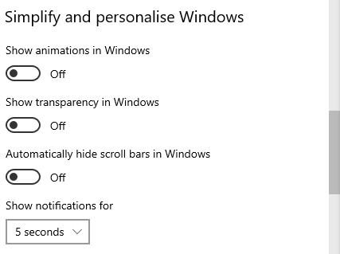

Get visual alerts for sound
If you find it difficult to hear audible alerts when you are concentrating, you can switch to visual alerts.
Go into Ease of Access and choose Audio.
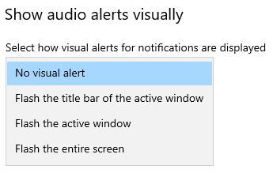
Click into the drop-down arrow and choose an option under ‘show audio alerts visually’

Clean up taskbar clutter
Your taskbar is the one that runs along the bottom of your screen. You can choose which icons appear on the taskbar and reduce the number of items in view if this is too much for you.
Go into Settings and select Personalisation.
Choose Taskbar from the list on the left.
Under ‘Notification area’, choose ‘Select which icons appear on the taskbar’.
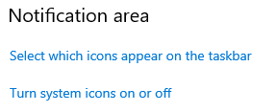
A list will appear for you to switch icons on and off, such as OneDrive, Teams, Outlook, Task Manager.

System icons can also be turned on or off by choosing the ‘turn system icons on or off’. System icons are those that appear in bottom right of your screen:
power/charging, network, volume, touch keyboard, clock/date, and action centre

Focus Assist
Focus Assist lets you to set rules that help you avoid distractions. Focus Assist blocks alerts and notifications so you can get things done without being distracted by them. Don't worry if there are some people you don't want to ignore - you can add them to a special list. And when you finish focusing, you'll get a summary of what you missed.
Go into Settings > System. On the left of System screen, you will see Focus Assist.
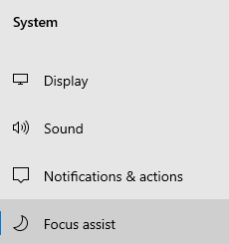
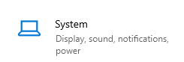

You can choose if you want to get all notifications (Focus Assist ‘Off’), priority ones only, or just alarms.
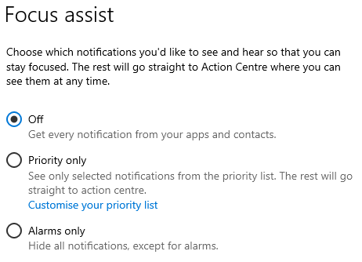

For ‘priority only’, you can customise the list and turn off incoming calls or reminders from any app.
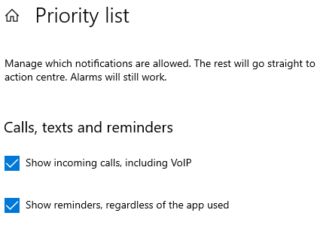

You can limit late-night notifications using the Automatic Rules section to set times and activities during which Focus Assist will turn on.
To do that, select ‘During these times’ and turn on the toggle.
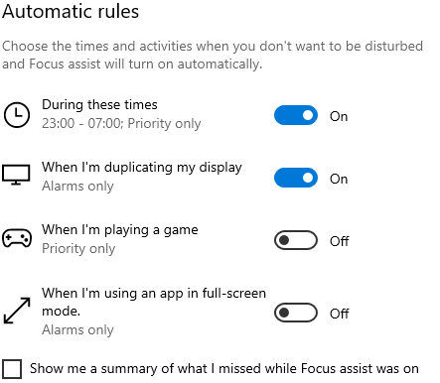

If you switch on ‘during these times’, you can click into it to set your preferred hours.
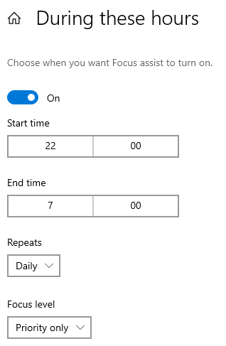
Click into Start Time or End Time to change them, then click onto the Tick icon.
You can also choose what days you want to apply the rule, and what types of notifications you'd still like to receive during the times you set.
‘Repeats’ is daily, weekdays or weekends. ‘Focus level’ is alarms only or priority only.

If you want to access Focus Assist very quickly and don’t need to set any times, select the Action Centre icon on the taskbar in the bottom right of your screen.
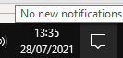
Then click once each time onto Focus Assist to cycle through the available settings: either Priority Only, Alarms Only, or Off. (If you don't see the Focus Assist tile, you may need to select Expand first.)
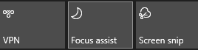

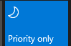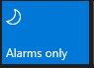

If you aren’t sure that you have Focus Assist on, hover over the notification icon and it will tell you.
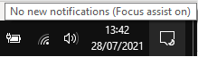

Office 365 Tools

Improve comprehension and reading with Immersive Reader
Immersive Reader improves reading comprehension and help with learning by offering tools that read text out loud, break it into syllables and increase spacing. It is designed to meet the needs of readers with dyslexia and dysgraphia or anyone who wants to make reading on their device easier.
Immersive Reader is available in these platforms: word, Outlook and Microsoft Edge and Teams.
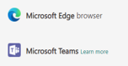
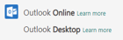
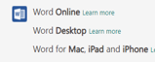
We will look at each starting with Word, then Outlook, then Edge.

Immersive Reader in Word

Accessing Immersive Reader
In Word, Immersive Reader is found under the View command group.
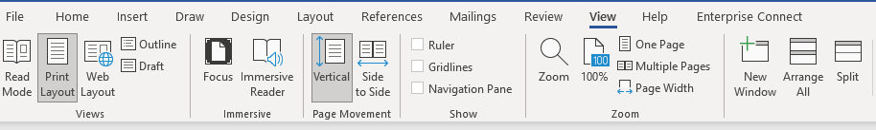
Click onto this and your document opens in Immersive Reader mode.
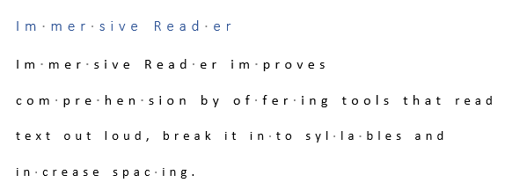

Using Immersive Reader
On the top left you have options to change how Immersive Reader works for you by changing colour, text spacing, column width, line focus and syllable break-up.
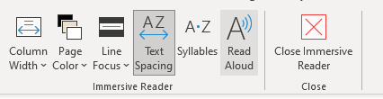
Column Width lets you choose between very narrow, narrow, moderate and wide.
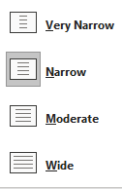

Page Colour gives you a variety of colours to display in.

Line Focus lets you choose between no line focus or one line, three lines or five lines being focused on.
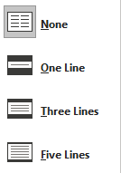

Text Spacing allows you to adjust the spacing of the words.

Read Aloud lets you listen to the text being read and with the settings icon you can change the voice or reading speed.
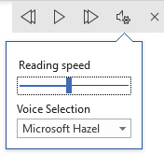

To leave Immersive Reader in Word, choose ‘close immersive reader’ at the top of the document.

Immersive Reader in Outlook Online

Accessing Immersive Reader
- Click onto the email you wish to read and a line of commands will appear along the top.
Click into the ellipsis (3 dots) and select Show in Immersive Reader’.
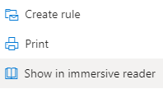

- You can also access it within your received email in the ‘message surface’ area ellipsis at top right of the email where the ‘reply’ icons are.
Click onto the ellipsis and choose View, then within the View option, choose ‘show in immersive reader’.
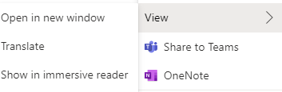

However, if you want easier access to Immersive Reader, you can add it to your message surface area on your received emails.
Go into the Settings cog in top right of Outlook online and choose ‘view all settings’. Then choose Email and Customise actions.
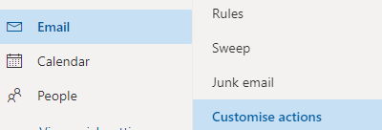

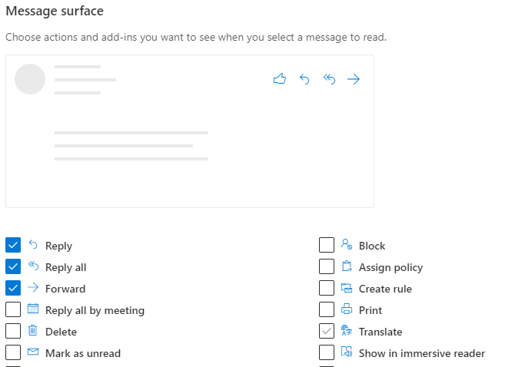
Find the section called Message Surface and tick the box for ‘show in immersive reader’.

Click Save and close settings by clicking the x in top right. Your message surface will now include the Immersive Reader icon, making it much easier for you to access.

Using Immersive Reader
Once in Immersive Reader, the email will open in it with various options for you to choose:
- Press the play button at the bottom of the display and it reads the email for you (with a choice of male or female voice and voice speed control).
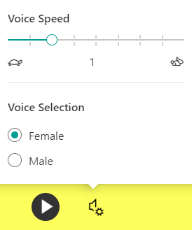

Along the top right there are three icons:

- Choose Text Preferences (the AA icon) for options for reading the text (size of font, spacing) or changes to font (including different background colours).
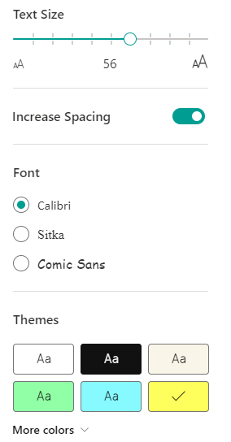

- Select Reading Preferences (the book icon), including switching languages and line focus. Line focus narrows the focus of your reading to one, three, or five lines.

- Choose Grammar Options (the lines icon) for it to help you to understand sentence structures (nouns, verbs, adjectives, adverbs).

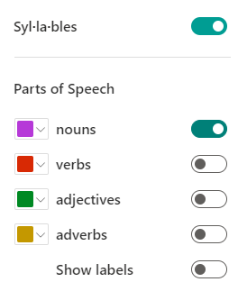

For example, with ‘nouns’ switched on, the nouns are displayed in a different colour.

To close Immersive Reader in Outlook, click onto the backward arrow in top left or press ESC.

Immersive Reader in MS Edge
Immersive Reader in Microsoft Edge simplifies a web page layout, removes clutter, and lets you customise your reading experience.

Accessing Immersive Reader
To enter reading mode, go to the website you want to read in Microsoft Edge and select ‘Enter Immersive Reader’ which is the ‘book’ icon in the address bar, or use the keyboard shortcut F9. The address bar is where the website’s ‘address’ along the top of your browser.
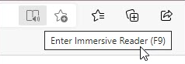

If you don’t see the Immersive Reader icon in the address bar, you can still view the text in Immersive Reader. Just select the text you want to read, right-click, and select ‘Open in Immersive Reader’ from the context menu.

Using Immersive Reader
Once you are in Immersive Reader, the bar along the top of the app will display Read Aloud options, Text preferences, Grammar tools and Reading preferences.

Read Aloud is a tool that reads the text of a web page out loud.
Select ‘Read Aloud’ from the Immersive Reader toolbar. A ribbon toolbar appears at the top of the page after you start this.
The toolbar includes the Play/Pause button, buttons to skip to the next or previous paragraph, and a button to adjust your Voice options.
Voice options allow you to select from different Microsoft voices as well as change the speed of the reader.
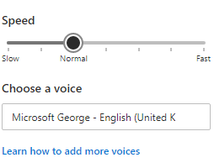
To stop listening, select the Pause button or the X to close Read Aloud.

Alternatively, you can click into the ellipsis in top right of the website page and choose Read Aloud from the content box.

Text preferences
You can choose a variety of text and colour options using Text size, Text spacing, and Page themes to enhance your reading experience in Immersive Reader.
To open the text preferences, select ‘Text preferences’ from the Immersive Reader toolbar.
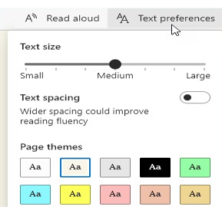

- Text size: move the slider to make the text larger or smaller.
- Text spacing: switch across the toggle to increase the spacing between lines of text.
- Page themes: Choose a theme to reduce visual distraction. There are a variety of colour options.. Click More themes to view all the available themes.

Grammar tools help with reading comprehension by breaking words into syllables and highlighting nouns, verbs, and adjectives.
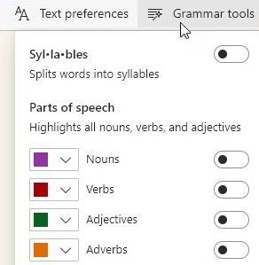
To open Grammar tools, select Grammar tools from the Immersive Reader toolbar.

Syllables: Turn on Syl·la·bles to divide words by showing small dots between the syllables.

Parts of speech: Under Parts of speech, turn on Nouns, Verbs, Adjectives, or Adverbs to highlight every noun, verb, adjective, or adverb on the page in a colour that corresponds to the colour of the label. You can customise the highlight colours and show the labels inline by turning on Show labels.

Reading preferences
You can turn on tools like Line Focus to focus on reading one, three or five lines at a time, Picture dictionary to see a picture meaning of a word or Translate to change the language of the text.
To open, select Reading preferences on the Immersive Reader toolbar.
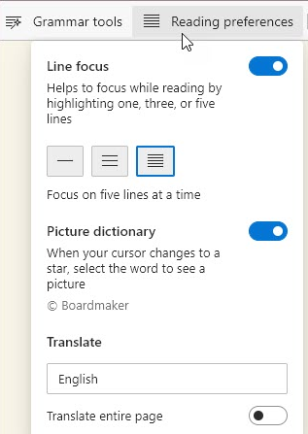

Line focus narrows the focus of your reading to one, three, or five lines in Immersive Reader. When just a portion of text highlighted, content is easier to read and comprehend.
Use the up and down arrows in Immersive Reader or up and down keys on the keyboard to move the line focus up or down on the page.
Picture dictionary: with this on, you can click on any single word and see an illustration related to the meaning.

To exit Immersive Reader in Edge, click the book icon again or press ESC.

Improve writing quality with Editor
With Editor, you can see any misspellings, grammatical mistakes and writing style issues as you type in Word and Outlook. It gives suggestions for misspellings, shows like-for-like words alongside suggestions, and can read suggestions out loud to avoid common word choice errors.
See pages 9-12 for Editor.

Read Aloud
There is a Read Aloud feature available in Outlook and Word that vocalises and highlights each word.
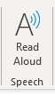
Outlook (on the far right of Home tab)

Word (Review tab)
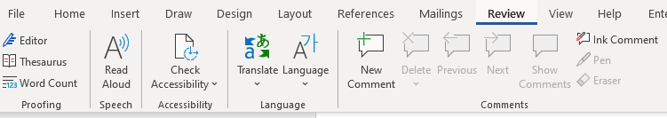

Once switched on, a small box will appear to the right of your document with play/pause, forward and backward controls. Click on the settings icon to speed up or slow down the reading voice, and to choose a male or female voice.
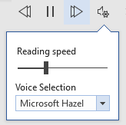

Dictate - Type with your voice
Dictate lets you use speech-to-text to ‘write’ in Word, Outlook and PowerPoint as long as you have a microphone and reliable internet connection.
The appearance of Dictate once you click onto the Dictate button is the same across all three applications.
In both Word and PowerPoint you can find the Dictate feature in the Home commands.
Click onto Dictate and the command icon will then display as ‘recording’ with a red button.
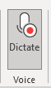
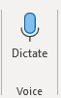

From this you can start speaking immediately and a box will display on your screen on which you can tap the mic icon to resume or pause.
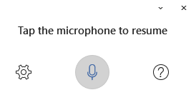
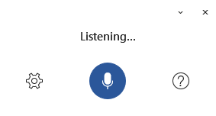

In Outlook you need to open a new email first, then Dictate sits under the Message commands.

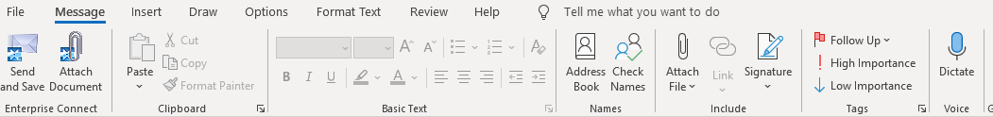

As with Word, clicking onto Dictate will open a ‘listening’ box and will change the Dictate icon to display as recording with the red button.

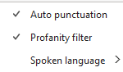
Once in Dictate, you can click onto the cog icon to set auto-punctuation and dictation language.

Creating accessible documents
Whilst you may not have accessibility needs yourself, you should always bear in mind that some of your recipients could have.

Check document accessibility
Click Review and choose Check Accessibility.
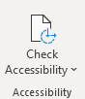

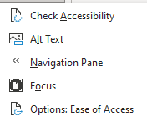
If you click onto the drop-down arrow, you’ll see the options which include Focus to display your document in a more focused way. Focus will put a black surrounding on your document and removes everything else, including the Word commands along the top. Just press ESC to remove Focus.

Results for the Check Accessibility option are presented in three types:
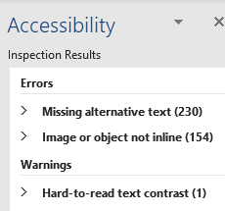

Errors – these cannot be read by screen readers
Warnings – these would be difficult to read
Tips – might cause problems

Real time presentation subtitles
You can provide translated subtitles to your presentations on the Slide Show ribbon tab by selecting Subtitle Settings.
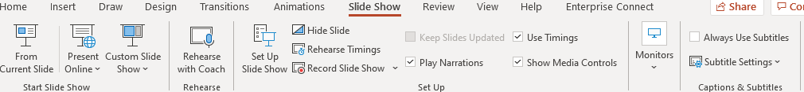
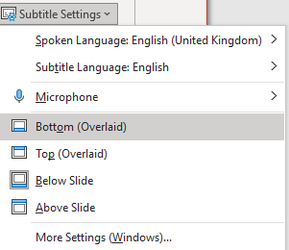
- Use Spoken Language to see the voice languages that PowerPoint can recognise and select the one you want. This is the language that you will be speaking while presenting.
- Use Subtitle Language to see which languages PowerPoint can display on-screen as captions or subtitles and select the one you want. This is the language of the text that will be shown to your audience. Choosing the same language as your Spoken Language allows you to provide closed captioning. This is especially relevant for accessibility for the deaf and hard of hearing.
You can turn subtitles on and off using the Subtitle toggle that appears in the bottom left of each slide when you are in ‘slideshow’ mode.

Glossary
Device: whatever you are using to access your work on – desktop PC, laptop or smartphone.
File Explorer: the ‘folder’ icon that displays along your bottom taskbar; the one you have been using to find your documents, downloads, pictures and desktop.
Windows Key: this is a bottom-left key on your keyboard with the Windows icon on it.
Application: the different programmes within O365 are called applications, e.g. Outlook, Word, PowerPoint, Teams. Often these are called Apps for short.
Icon: the ‘logos’ of the different applications (e.g. Word is a blue W, Excel is a green E, OneDrive is a blue cloud) or web browsers (e.g. Chrome is a coloured circle)
Desktop apps: applications that are available on your laptop/computer by clicking onto the icon. They may be on your bottom taskbar, or in your Start menu. You don’t have to be online to see and access them.
Window: In computer terms, a window is an area on the screen that displays information about a programme. You can have multiple windows open, displaying different websites, documents and applications.
Windows 10: the operating system of your device. Where Windows has a capital W, it means this system and not a window on which you can see your documents, websites, etc.
URL: short for Uniform Resource Locator, this is your web address. It shows the location of a document or website on the internet, including your OneDrive.
Microsoft 365 and Office 365: this is essentially the same thing and both names are used for the applications such as OneDrive, Outlook, Teams, Word, PowerPoint, Excel and OneNote.

