A guide to Accessibility Tools for Mental Health in Windows 10 and Office 365

Contents
About this guide three
Tools to help across the board four
Zoom feature four
Reuse files….. five
Smart Lookup seven
Editor…………. ………………………………………………………………………………………………………………eight
Accessibility MailTip twelve
Ease of Access tools within Settings thirteen
Mental Health fourteen
Windows 10 Tools fourteen
Managing distractions fourteen
Turn off animations fourteen
Turn off background images fifteen
Make notifications stick around longer fifteen
Clean up taskbar clutter sixteen
Get visual alerts for sound seventeen
Focus Assist seventeen
Night Light twenty
Office 365 Tools twenty-one
Read Aloud twenty-one
Stay on top of things to do twenty-two
Change the look of Office on your device twenty-five
Dictate - Type with your voice twenty-seven
Creating accessible documents twenty-eight
Check document accessibility twenty-eight
Real time presentation subtitles twenty-nine
Glossary thirty

About this guide
There are many tools that Microsoft has created to improve accessibility for its users. Some of these are within Windows 10 on your device, some are through Office 365 applications.
Examples of products include:
- On-Screen Keyboard: enables people to use a pointer in place of a keyboard to type text.
- Voice-recognition software: converts spoken words into typed text.
- Settings that help minimise distractions, assist your focus on tasks and declutter your screen.

The Windows 10 features are accessed via your Ease of Access site in the Settings menu. See page 13 for help with this.

Barnardo's recognises the social model of disability which means that it acknowledges that disabled people are not disabled by their impairments or conditions but by, for example, physical, environmental, attitudinal and technological barriers and structures. it is hoped that this guide helps in removing some of those barriers.

Tools to help across the board
Office 365 has some new tools that can benefit everyone. Next to each tool you will see the icon of the app(s) in which you can use the feature.
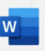
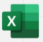
Zoom feature:
O365 Word, Excel, and PowerPoint documents have two methods of zooming to increase font size when you are reading.
Either by using the Zoom slider in bottom right of a document:
Or
Via View group along the top ribbon:
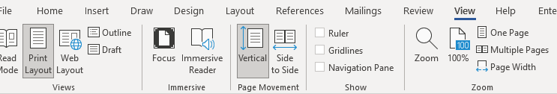
Clicking onto Page Width will adjust your Word document to the entire width of your window.
Excel and PowerPoint have less choice but you can still set your zoom percentage and customise to go larger than 200 per cent.
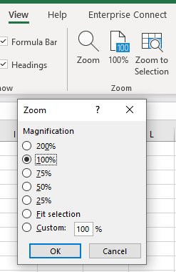

Reuse files
A useful Word tool called Reuse Files is a feature that allows you to search for documents and re-use parts of them. You can insert a block of text or other content from a different file without leaving the document you're currently working on. In PowerPoint it is ‘Reuse Slides’.
Click on Reuse Files in your Home command bar or Insert command bar.
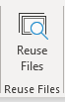

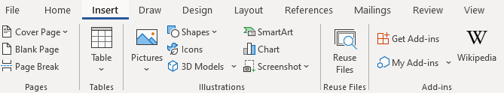

It will present a search bar plus some ‘suggestions for you’.
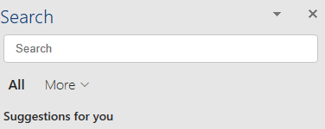
Clicking onto the More arrow allows you to narrow down the source of the information you wish to find. For example, if you only want in-house documents, choose Files; if you only want pictures, choose Media.
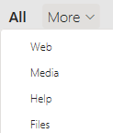
The function is intelligent enough to work out what you are working on and tries to offer results built on similarity of subject. For example, choosing Web whilst working on an accessibility document will give you various internet pages related to accessibility. Choosing Media presents you with accessibility images and logos, and Files brings up relevant documents (Word, PowerPoint, Excel) already stored on SharePoint or OneDrive.
If not relevant enough, use the Search field to look for a subject you want.
Files: If you find a file/document you wish to copy from, click into it and a plus sign will appear to ‘insert content’. Scroll to anything you wish to reuse, make sure the plus sign is over it and click. The selected text will be put into your current document.
However, you can click on the ellipsis (3 dots) next to the file’s name to choose other options:
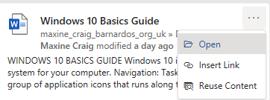
- Open: opens the document in a new window (as long as you have access to it)
- Insert link: inputs a hyperlink to the document’s location
- Reuse content: opens the file in the Search sidebar for you to scroll through content (same result as clicking into the file and using the plus sign)
Web: You can either click onto the suggested web name (in blue) or link (green) and it should open the page in a new tab on your internet window, or you can use the ellipsis (3 dots).
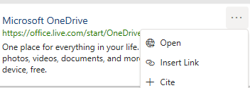
- Open: opens the webpage in a new tab if you have Chrome or Edge open
- Insert link: inserts the webpage link using its name
- Cite: inserts the webpage name plus the file path (where the page is on the internet)

Media: Select a picture you want by clicking onto the plus sign when you hover over the image.

Smart Lookup
Using the Smart Lookup pane lets you get search results without leaving the application you are in and provides definitions, topics, articles, and top related searches from the web. The Search bar at the top of your document performs the same way.
When you select a word or phrase, right-click it, then choose Smart Lookup from the menu that appears. Note: it may appear as Search “…..” instead in Word and PowerPoint but this produces the same results that are displayed in the pane that appears on the right side of the screen.
You can also get to Smart Lookup/ Search any time by going to References command bar and choosing Search or Smart Lookup (depending on what shows there).
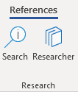
As with Reuse Files, you can narrow your search down by choosing Files, Web or Media.
Files: If you find a file/document you wish to copy from, click into it and a plus sign will appear to ‘insert content’. Scroll to anything you wish to reuse, make sure the plus sign is over it and click. If you want more or less than is being covered by the plus sign, you can also left click on your mouse and drag your cursor over what you want to select, then click the plus sign. The selected text will be put into your current document.
However, you can click on the ellipsis (3 dots) next file’s name to choose other options:
- Open: opens the document in a new window (as long as you have access to it)
- Insert link: inputs a hyperlink to the document’s location
- Reuse content: opens the file in the Search sidebar for you to scroll through content (same result as clicking into the file and using the plus sign)

Web: You can either click onto the suggested web link or name and it should open the page in a new tab on your internet window, or you can use the ellipsis (3 dots).
- Open: opens the webpage in a new tab if you have Chrome or Edge open
- Insert link: inserts the webpage link using its name
- Cite: inserts the webpage title plus the file path (where the page is on the internet)

Media: Select a picture you want by clicking onto the plus sign when you hover over the image.

Editor
Editor helps you to improve your writing in Word and Outlook Online by identifying words and phrases that might need more refinement. Editor analyses text as you type and makes suggestions when it finds misspellings and opportunities for improving.
When Editor is enabled, improved spelling and grammar suggestions will be automatically available to you. Editor is there to help you, but it will not prevent you from continuing with your document if you choose not to take its advice.

In Word, you can find Editor on the Home command bar and the Review command bar.
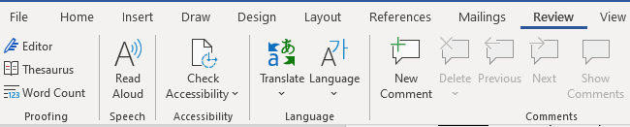
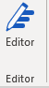

Click onto Editor and a pane will open on the right to tell you how many spelling and grammar errors there are and any refinement issues it has detected for clarity, conciseness, formality, punctuation and vocabulary.
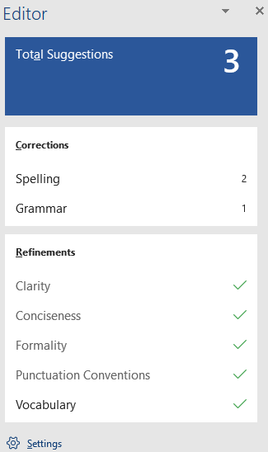
Click onto any of these sections that show a number, and Editor will give you alternatives or tell you what the correction is.

You can press onto the ‘read aloud’ icon to get the issue read to you, and if you press on the drop-down arrow in the suggestion, you can choose between ‘read aloud’ or ‘spell out’.
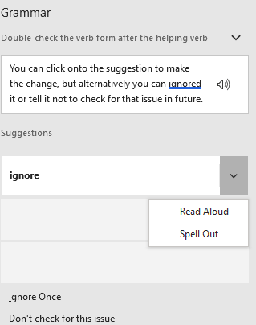
You can click onto the suggestion to make the change, but alternatively you can ignore it or tell it not to check for that issue in future.
Editor in Outlook Online
For Outlook Online, you will find Editor in the lower taskbar of a new blank email. (Unfortunately, Editor is not currently available on Outlook Desktop app.)
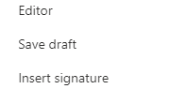
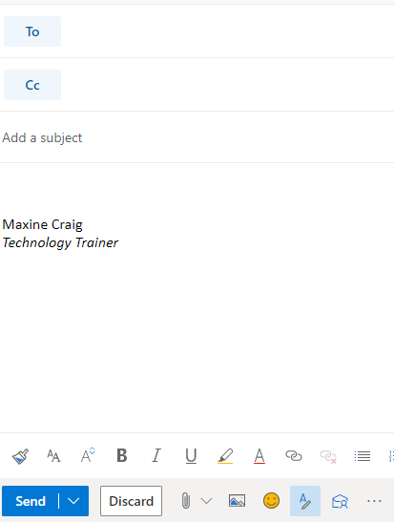

You initially have to go into the ellipsis to find it, but if you want easier access to it you can go into Settings (the cog in top right of Outlook Online), choose View all Outlook Settings > Customise actions, then scroll down to Toolbar section. Tick the Editor box to add it to the lower toolbar as displayed below.
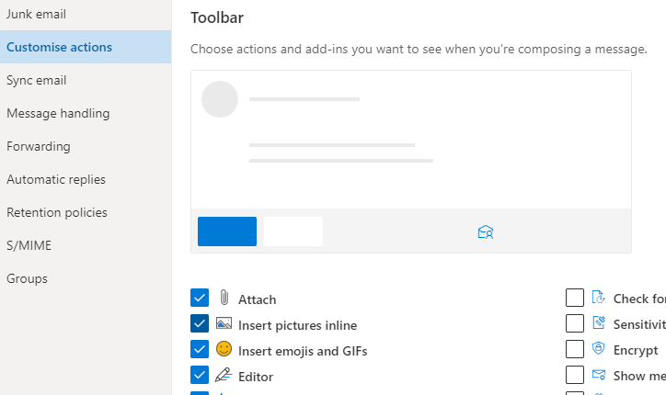

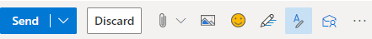
Editor here works differently. It does not display a box of suggestions but highlights errors as you type. If you click onto the word underlined, it gives you the options for improving your text.
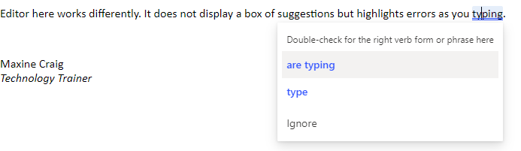
When you click on the Editor icon, you can set your controls to choose what it checks, from spelling and grammar to clarity, conciseness, inclusiveness, formality and punctuation and vocabulary.
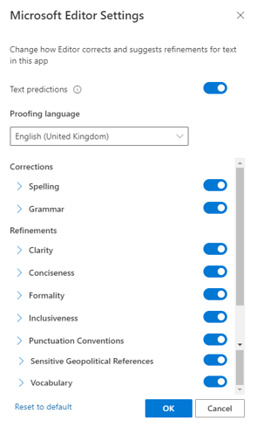

You can also turn off ‘Text predictions’ in this Editor box if you prefer not to have this function. Text prediction anticipates your next words and suggests words or phrases as you type. For example, it has added ‘than’ after the words ‘much better’ have been typed below. You can either ignore and continue to type or use the Tab key to accept the suggestion.
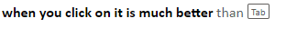

Accessibility MailTip

A MailTip in Outlook on the Web informs co-workers of your preference for accessible content. This prompt reminds them to run Accessibility Checker before sending an email to you and fix any issues that might make the content difficult for people with disabilities to consume.
Go to Settings (the cog icon in top right of Outlook Online) and choose ‘view all Outlook settings’ at the bottom of the Settings pane.
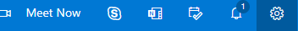
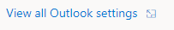

Then select General from the list of the left and then Accessibility from within the General options.
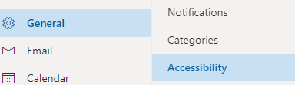

Tick the Accessible Content box.
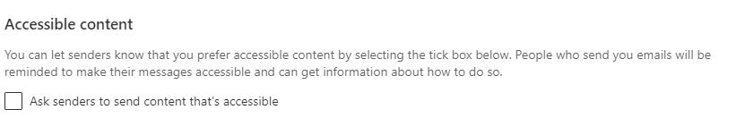

Ease of Access tools within Settings
There are a few ways you can reach the Ease of Access settings available on your Windows 10 computer/laptop.
- Press Windows logo key plus U key, which will take you straight into the Ease of Access site
OR
- Press Windows plus I key to take you to Settings, where you can then choose the Ease of Access site

If you prefer not to use shortcuts:
- Click on the Start menu in bottom left corner or press Windows logo key to access Start menu
then select Settings
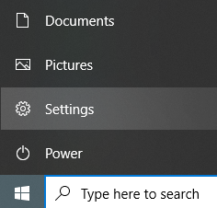
Or
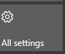
- Click onto the Notifications icon in bottom right of your screen, then select All Settings from the displayed tiles

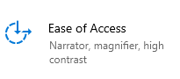
Then select Ease of Access

On the left of the Ease of Access site, you will get a list divided into Vision, Hearing, and Interaction.
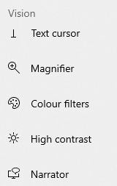
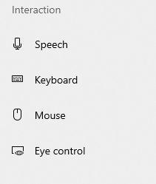

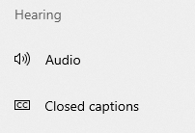

Mental Health
For people living with mental health conditions, Windows makes it easy to minimise
distractions by turning off sights and sounds.
You can also clean up taskbar clutter and manage your notifications with Focus Assist or
Use Night Light for a warmer display colour.

Windows 10 Tools

Managing distractions
There are some ways to make it easier for you to focus on your tasks. Reduce animations and background images for fewer distractions when you are concentrating. You can also clean up taskbar clutter and quieten notifications.

Turn off animations
Minimise visual distractions by turning off animations.
Go into Ease of Access > Vision and choose Display.
Then choose from the different options under ‘Simplify and personalise Windows’ such as turning off animations, showing notifications for longer, hiding scroll bars.
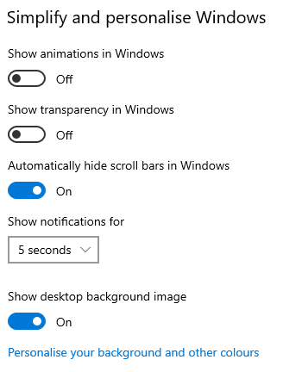

Turn off background images
Minimise visual distractions by turning off your background image.
Go into Ease of Access and select Display. Then under ‘Simplify and personalise Windows’ you can use the toggle button to show a desktop background image, or turn it off to display one colour only for easier desktop navigation.
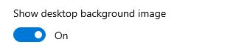

Make notifications stick around longer
By default, Windows notifications disappear five seconds after they appear. If you want more time to read them, you can increase how long they're displayed. Maximum is 5 minutes.
To change this time, you will need to go into the Vision section of Ease of Access and choose Display.
You will see the following box where you can change the notification display time from 5 seconds to between 7 seconds or 5 minutes.
Or you can choose to hide the scroll bar on Windows applications or switch off animations in Windows.
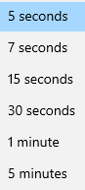
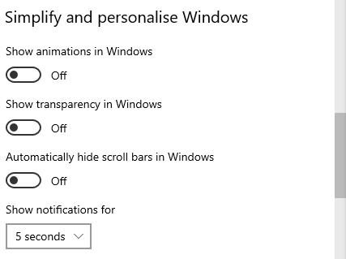

Clean up taskbar clutter
Your taskbar is the one that runs along the bottom of your screen. You can choose which icons appear on the taskbar and reduce the number of items in view if this is too much for you.
Go into Settings and select Personalisation.
Choose Taskbar from the list on the left.

Under ‘Notification area’, choose ‘Select which icons appear on the taskbar’.
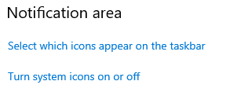

A list will appear for you to switch icons on and off, such as OneDrive, Teams, Outlook, Task Manager.
System icons can also be turned on or off by choosing the ‘turn system icons on or off’. System icons are those that appear in bottom right of your screen:
power/charging, network, volume, touch keyboard, clock/date, and action centre

Get visual alerts for sound
If you find it difficult to notice sound alerts when you are concentrating, you can switch to visual alerts.
Go into Ease of Access and choose Audio.
Click into the drop-down arrow and choose an option under ‘show audio alerts visually’.
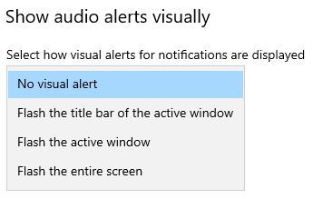

Focus Assist
Focus Assist lets you to set rules that help you avoid distractions. Focus Assist blocks alerts and notifications so you can get things done without being distracted by them. Don't worry if there are some people you don't want to ignore - you can add them to a special list. And when you finish focusing, you'll get a summary of what you missed.
Go into Settings > System. On the left of System screen, you will see Focus Assist.
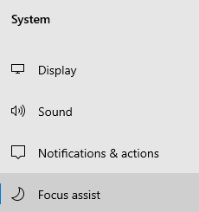
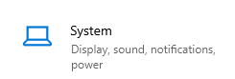

You can choose if you want to get all notifications (Focus Assist ‘Off’), priority ones only, or just alarms.
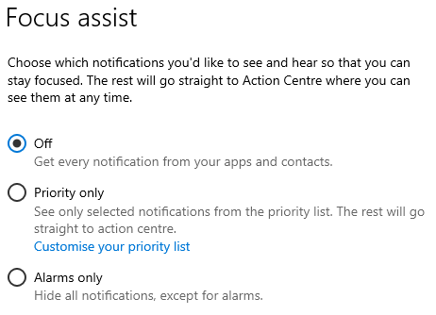
For ‘priority only’, you can customise the list and turn off incoming calls or reminders from any app.
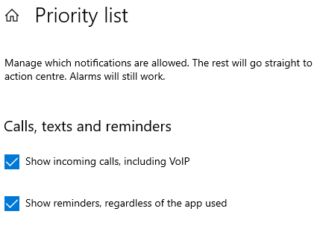

You can limit late-night notifications using the Automatic Rules section to set times and activities during which Focus Assist will turn on.
To do that, select ‘During these times’ and turn on the toggle.
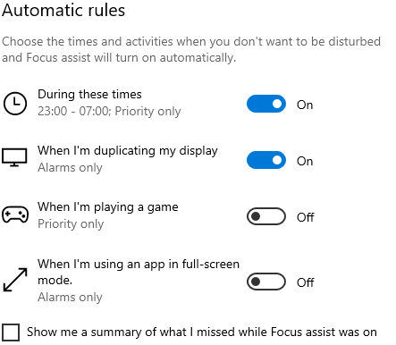
If you switch on ‘during these times’, you can click into it to set your preferred hours.
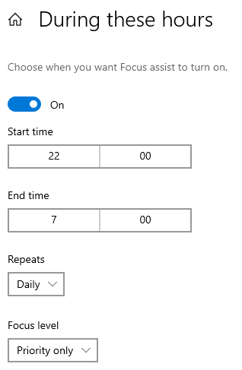

Click into Start Time or End Time to change them, then click onto the Tick icon.
You can also choose what days you want to apply the rule, and what types of notifications you'd still like to receive during the times you set.
‘Repeats’ is daily, weekdays or weekends. ‘Focus level’ is alarms only or priority only.

If you want to access Focus Assist very quickly and don’t need to set any times, select the Action Centre icon on the taskbar in the bottom right of your screen.
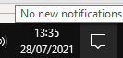

Then click once each time onto Focus Assist to cycle through the available settings: either Priority Only, Alarms Only, or Off. (If you don't see the Focus Assist tile, you may need to select Expand first.)
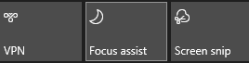

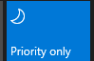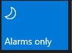

If you aren’t sure that you have Focus Assist on, hover over the notification icon and it will tell you.
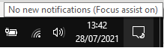

Night Light
There is a function called Night Light that allows you to set your screen display to a warmer colour than the normal ‘blue’ light, which could help you sleep better. Set the strength of the colour and click the turn on/off button.
You will find this under Vision ‘Display’ section of Ease of Access. Either click on Make Screen Brighter ‘night light’ function or use the Additional Display Settings link in top right of your screen.
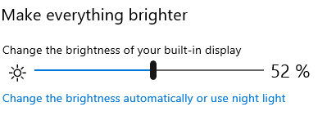
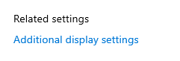

Click onto ‘use night light’ and switch the toggle button across to On.
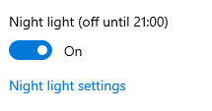

If you want night light to be darker, use the ‘night light settings’ link within the on/off box. This contains a slider to adjust night light’s strength and a schedule button.
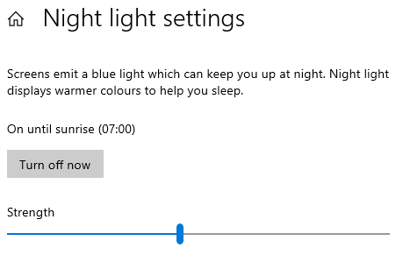

You can even schedule the function via the Schedule button, which brings up an extra box when you switch to On.
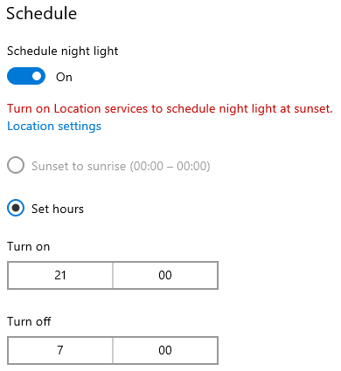

Office 365 Tools

Read Aloud
There is a Read Aloud feature available in Outlook and Word that vocalises and highlights each word.
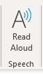
Outlook (on the far right of Home tab)

Word (Review tab)
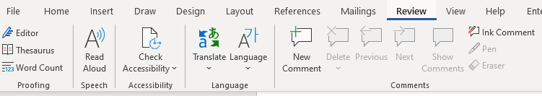

Once switched on, a small box will appear to the right of your document with forward, pause and backward controls. Click on the settings icon to speed up or slow down the reading voice, and to choose a male or female voice.
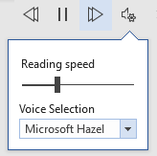

Stay on top of things to do
OneNote and Outlook work together to help you stay organised. As you take notes and plan projects in OneNote, you can manage deadlines and remember the things on your to-do list by creating Outlook tasks. Then you can view and track those tasks in Outlook and even get reminders.
Create an Outlook task in OneNote
In OneNote, select the words that you want to be your task so they are highlighted by your cursor.
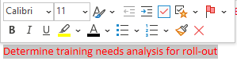
In the menu that appears, click the arrow next to the Outlook Tasks flag icon and choose a reminder.
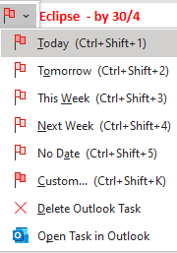
A flag appears next to your task in OneNote
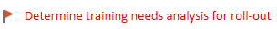
and your task is added to Outlook which you can find within your My Tasks area on Outlook.
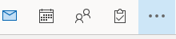
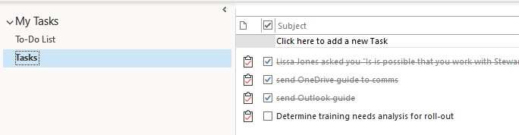

Find a task in OneNote
On the home tab in OneNote, choose ‘find tags’ and they will display in the Tags Summary pane on the right.
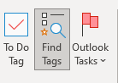
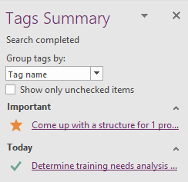

Mark a task as complete
In the Tags Summary pane in OneNote, click on the flag next to an Outlook task.
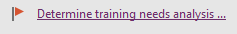
The task is marked with a green tick as completed in both the OneNote Tags Summary pane and in Outlook Tasks.
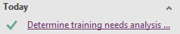
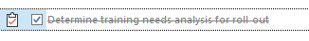

Delete a task
If you decide you don’t need a task, you can remove it. You’ve got two choices:
- delete the task from Outlook, which also removes the tag from OneNote (of course, the text itself will still be in your OneNote notes but just as normal notes)
- or remove the tag from OneNote and keep the task in Outlook.
To remove the task from Outlook:
- Right-click the tag in your OneNote notes and choose ‘deleted Outlook task’.
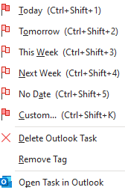
The text remains in OneNote as plain notes with no flag attached and the task is removed from Outlook.

To keep the task in Outlook and remove the flag from OneNote:
- Right-click the tag in your OneNote notes and choose ‘remove tag’ as above.
The tag/flag is removed from OneNote and the task remains in Outlook.

Change the look of Office on your device
To change the background colour and design of all your Office programs, go to File in the top left of Word and then choose Options.
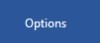
Then select the General theme and scroll to the ‘Personalise your copy of Microsoft Office’.
Use the drop-down arrow for Office Theme to set your preferred theme. You can stay with ‘colourful’ which displays Word as blue, Excel as green and PowerPoint as orange. Or you can choose dark grey, black or white.
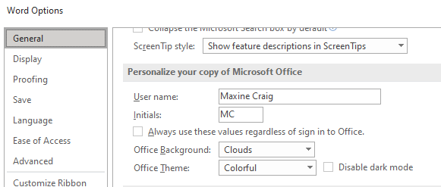
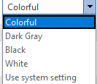

The dark grey theme is perfect for those who prefer a softer take on high-contrast visuals. Here's an example of the dark grey theme applied to PowerPoint.
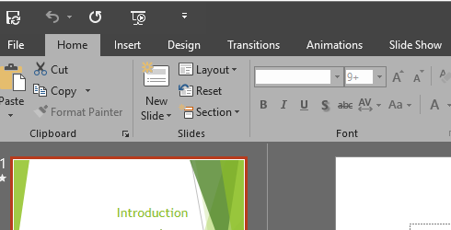

The Black theme provides the highest-contrast visual for your Office theme.
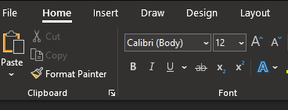

The white theme displays the classic look of Office.
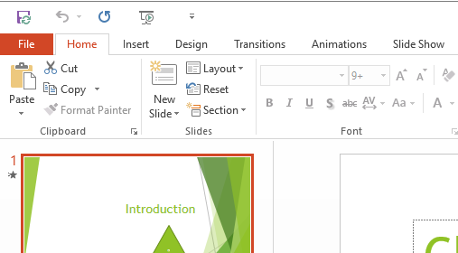

Dictate - Type with your voice
Dictate lets you use speech-to-text to ‘write’ in Word, Outlook and PowerPoint as long as you have a microphone and reliable internet connection.
The appearance of Dictate once you click onto the Dictate button is the same across all three applications.
In both Word and PowerPoint you can find the Dictate feature in the Home commands.
Click onto Dictate and the command icon will then display as ‘recording’ with a red button.
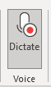
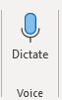

From this you can start speaking immediately and a box will display on your screen on which you can tap the mic icon to resume or pause.
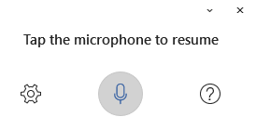
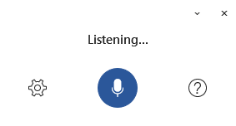

In Outlook you need to open a new email first, then Dictate sits under the Message commands.

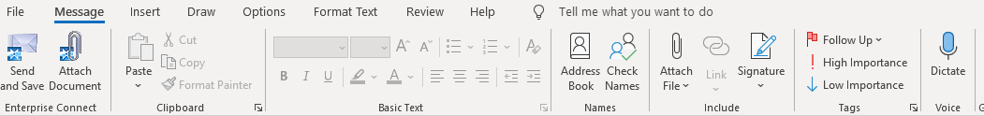

As with Word, clicking onto Dictate will open a ‘listening’ box and will change the Dictate icon to display as recording with the red button.

Once in Dictate, you can click onto the cog icon to set auto-punctuation and dictation language.

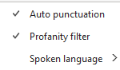

Creating accessible documents
Whilst you may not have accessibility needs yourself, you should always bear in mind that some of your recipients could have.

Check document accessibility
Click Review and choose Check Accessibility.
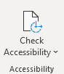

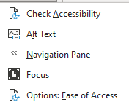
If you click onto the drop-down arrow, you’ll see the options which include Focus to display your document in a more focused way. Focus will put a black surrounding on your document and removes everything else, including the Word commands along the top. Just press ESC to remove Focus.

Results for the Check Accessibility option are presented in three types:
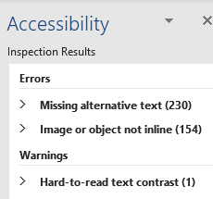

Errors – these cannot be read by screen readers
Warnings – these would be difficult to read
Tips – might cause problems

Real time presentation subtitles
You can provide translated subtitles to your presentations on the Slide Show ribbon tab by selecting Subtitle Settings.
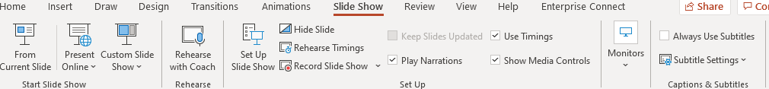
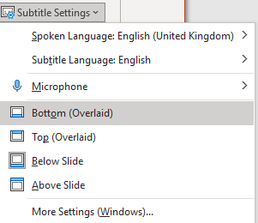
- Use Spoken Language to see the voice languages that PowerPoint can recognise and select the one you want. This is the language that you will be speaking while presenting.
- Use Subtitle Language to see which languages PowerPoint can display on-screen as captions or subtitles and select the one you want. This is the language of the text that will be shown to your audience. Choosing the same language as your Spoken Language allows you to provide closed captioning. This is especially relevant for accessibility for the deaf and hard of hearing.
You can turn subtitles on and off using the Subtitle toggle that appears in the bottom left of each slide when you are in ‘slideshow’ mode.

Glossary
Device: whatever you are using to access your work on – desktop PC, laptop or smartphone.
File Explorer: the ‘folder’ icon that displays along your bottom taskbar; the one you have been using to find your documents, downloads, pictures and desktop.
Windows Key: this is a bottom-left key on your keyboard with the Windows icon on it.
Application: the different programmes within O365 are called applications, e.g. Outlook, Word, PowerPoint, Teams. Often these are called Apps for short.
Icon: the ‘logos’ of the different applications (e.g. Word is a blue W, Excel is a green E, OneDrive is a blue cloud) or web browsers (e.g. Chrome is a coloured circle)
Desktop apps: applications that are available on your laptop/computer by clicking onto the icon. They may be on your bottom taskbar, or in your Start menu. You don’t have to be online to see and access them.
Window: In computer terms, a window is an area on the screen that displays information about a programme. You can have multiple windows open, displaying different websites, documents and applications.
Windows 10: the operating system of your device. Where Windows has a capital W, it means this system and not a window on which you can see your documents, websites, etc.
URL: short for Uniform Resource Locator, this is your web address. It shows the location of a document or website on the internet, including your OneDrive.
Microsoft 365 and Office 365: this is essentially the same thing and both names are used for the applications such as OneDrive, Outlook, Teams, Word, PowerPoint, Excel and OneNote.

