A guide to Accessibility Tools for Mobility in Windows 10 and Office 365

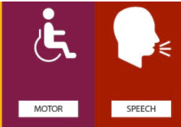

Contents
About this guide four
Tools to help across the board five
Zoom feature five
Reuse files….. six
Smart Lookup eight
Editor………….. nine
Accessibility MailTip thirteen
Ease of Access tools within Settings fourteen
Mobility (including speech) fifteen
Windows 10 Tools fifteen
Speech fifteen
Keyboard eighteen
Type without a keyboard eighteen
Sticky Keys twenty
Toggle Keys twenty
Filter Keys twenty-one
How keyboard shortcuts work twenty-two
Mouse twenty-three
Mouse Keys twenty-three
Other mouse options twenty-four
Make your mouse pointer easier to see twenty-four
Text cursor twenty-five
Eye control twenty-six
Office 365 tools twenty-six
Dictate twenty-six
Read Aloud twenty-eight
Useful keyboard shortcuts for Mobility accessibility tools twenty-nine
Creating accessible documents thirty
Check document accessibility thirty
Real time presentation subtitles thirty-one
Glossary thirty-two

About this guide
There are many tools that Microsoft has created to improve accessibility for its users. Some of these are within Windows 10 on your device, some are through Office 365 applications.
Examples of products include:
- On-Screen Keyboard: enables people to use a pointer in place of a keyboard to type text.
- Voice-recognition software: converts spoken words into typed text.
- Narrator screen reader: Narrator has a touch mode which can perform screen-reading tasks by processing touch gestures when there is no keyboard available.
- Settings that allow you to use Sticky Keys, Filter Keys and Toggle Keys.

The Windows 10 features are accessed via your Ease of Access site in the Settings menu. See page 13 for help with this.

Barnardo's recognises the social model of disability which means that it acknowledges that disabled people are not disabled by their impairments or conditions but by, for example, physical, environmental, attitudinal and technological barriers and structures. it is hoped that this guide helps in removing some of those barriers.

Tools to help across the board
Office 365 has some new tools that can benefit everyone. Next to each tool you will see the icon of the app(s) in which you can use the feature.
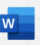
Zoom feature:
O365 Word, Excel, and PowerPoint documents have two methods of zooming to increase font size when you are reading.
Either by using the Zoom slider in bottom right of a document:
Or
Via View group along the top ribbon:
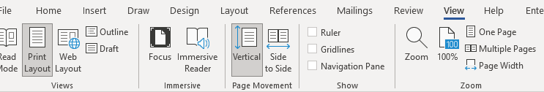
Clicking onto Page Width will adjust your Word document to the entire width of your window.
Excel and PowerPoint have less choice but you can still set your zoom percentage and customise to go larger than 200 per cent.
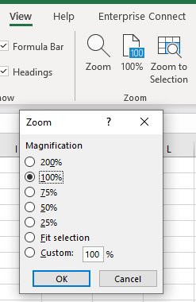

Reuse files
A useful Word tool called Reuse Files is a feature that allows you to search for documents and re-use parts of them. You can insert a block of text or other content from a different file without leaving the document you're currently working on. In PowerPoint it is ‘Reuse Slides’.
Click on Reuse Files in your Home command bar or Insert command bar.
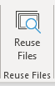

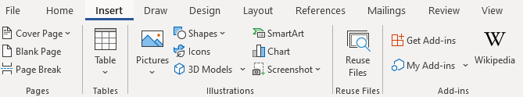

It will present a search bar plus some ‘suggestions for you’.
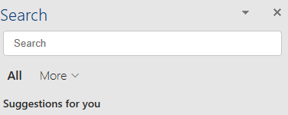
Clicking onto the More arrow allows you to narrow down the source of the information you wish to find. For example, if you only want in-house documents, choose Files; if you only want pictures, choose Media.
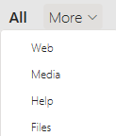

The function is intelligent enough to work out what you are working on and tries to offer results built on similarity of subject. For example, choosing Web whilst working on an accessibility document will give you various internet pages related to accessibility. Choosing Media presents you with accessibility images and logos, and Files brings up relevant documents (Word, PowerPoint, Excel) already stored on SharePoint or OneDrive.
If not relevant enough, use the Search field to look for a subject you want.
Files: If you find a file/document you wish to copy from, click into it and a plus sign will appear to ‘insert content’. Scroll to anything you wish to reuse, make sure the plus sign is over it and click. The selected text will be put into your current document.
However, you can click on the ellipsis (3 dots) next to the file’s name to choose other options:
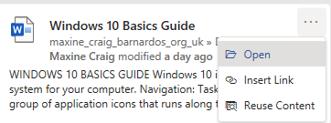
- Open: opens the document in a new window (as long as you have access to it)
- Insert link: inputs a hyperlink to the document’s location
- Reuse content: opens the file in the Search sidebar for you to scroll through content (same result as clicking into the file and using the plus sign)
Web: You can either click onto the suggested web name (in blue) or link (green) and it should open the page in a new tab on your internet window, or you can use the ellipsis (3 dots).
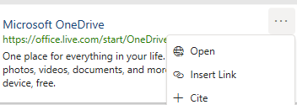
- Open: opens the webpage in a new tab if you have Chrome or Edge open
- Insert link: inserts the webpage link using its name
- Cite: inserts the webpage name plus the file path (where the page is on the internet)

Media: Select a picture you want by clicking onto the plus sign when you hover over the image.

Smart Lookup
Using the Smart Lookup pane lets you get search results without leaving the application you are in and provides definitions, topics, articles, and related searches from the web. The Search bar at the top of your document performs the same way so use that if you have no Smart Lookup.
When you select a word or phrase, right-click it, then choose Smart Lookup from the menu that appears. Note: it may appear as Search “…..” instead in Word and PowerPoint but this produces the same results that are displayed in the pane that appears on the right side of the screen.
You can also get to Smart Lookup/ Search any time by going to References command bar and choosing Search or Smart Lookup (depending on what shows there).
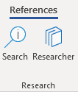

As with Reuse Files, you can narrow your search down by choosing Files, Web or Media.
Files: If you find a file/document you wish to copy from, click into it and a plus sign will appear to ‘insert content’. Scroll to anything you wish to reuse, make sure the plus sign is over it and click. If you want more or less than is being covered by the plus sign, you can also left click on your mouse and drag your cursor over what you want to select, then click the plus sign. The selected text will be put into your current document.

However, you can click on the ellipsis (3 dots) next file’s name to choose other options:
- Open: opens the document in a new window (as long as you have access to it)
- Insert link: inputs a hyperlink to the document’s location
- Reuse content: opens the file in the Search sidebar for you to scroll through content (same result as clicking into the file and using the plus sign)

Web: You can either click onto the suggested web link or name and it should open the page in a new tab on your internet window, or you can use the ellipsis (3 dots).
- Open: opens the webpage in a new tab if you have Chrome or Edge open
- Insert link: inserts the webpage link using its name
- Cite: inserts the webpage title plus the file path (where the page is on the internet)

Media: Select a picture you want by clicking onto the plus sign when you hover over the image.

Editor
Editor helps you to improve your writing in Word and Outlook Online by identifying words and phrases that might need more refinement. Editor analyses text as you type and makes suggestions when it finds misspellings and opportunities for improving.
When Editor is enabled, improved spelling and grammar suggestions will be automatically available to you. Editor is there to help you, but it will not prevent you from continuing with your document if you choose not to take its advice.

In Word, you can find Editor on the Home command bar and the Review command bar.
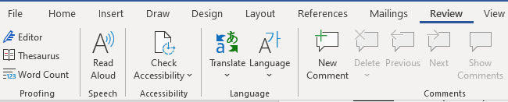
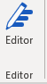

Click onto Editor and a pane will open on the right to tell you how many spelling and grammar errors there are and any refinement issues it has detected for clarity, conciseness, formality, punctuation and vocabulary.
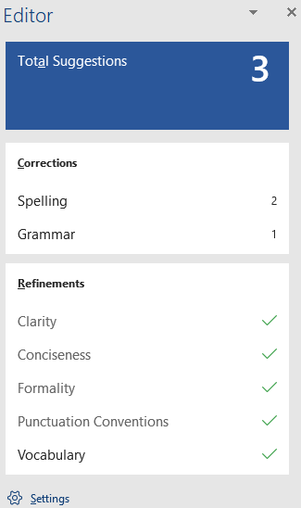
Click onto any of these sections that show a number, and Editor will give you alternatives or tell you what the correction is.
You can press onto the ‘read aloud’ icon to get the issue read to you, and if you press on the drop-down arrow in the suggestion, you can choose between ‘read aloud’ or ‘spell out’.
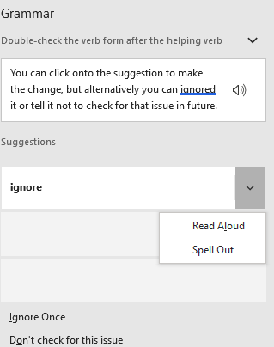

You can click onto the suggestion to make the change, but alternatively you can ignore it or tell it not to check for that issue in future.
Editor in Outlook Online
For Outlook Online, you will find Editor in the lower taskbar of a new blank email. (Unfortunately, Editor is not currently available on Outlook Desktop app.)
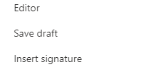
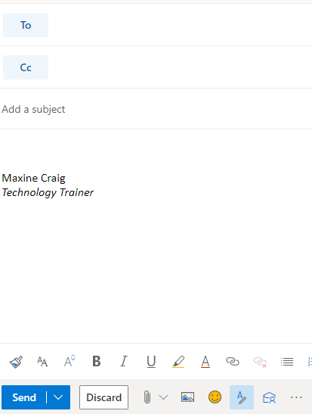
You initially have to go into the ellipsis to find it, but if you want easier access to it you can go into Settings (the cog in top right of Outlook Online), choose View all Outlook Settings > Customise actions, then scroll down to Toolbar section.
Tick the Editor box to add it to the lower toolbar as displayed below.

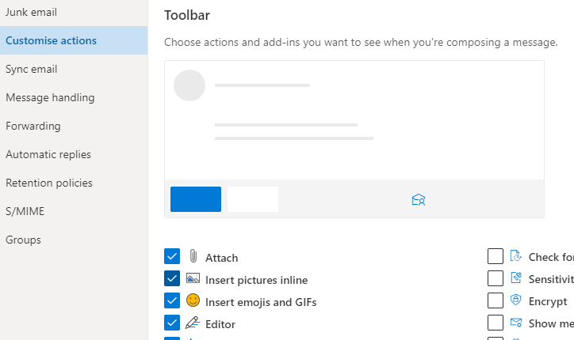
Editor here works differently. It does not display a box of suggestions but highlights errors as you type. If you click onto the word underlined, it gives you the options for improving your text.
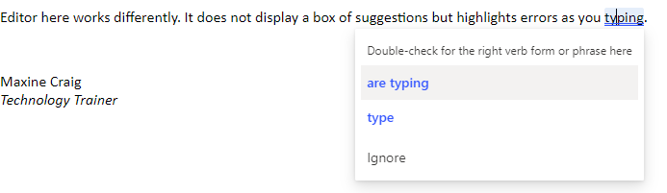
When you click on the Editor icon, you can set your controls to choose what it checks, from spelling and grammar to clarity, conciseness, inclusiveness, formality and punctuation and vocabulary.
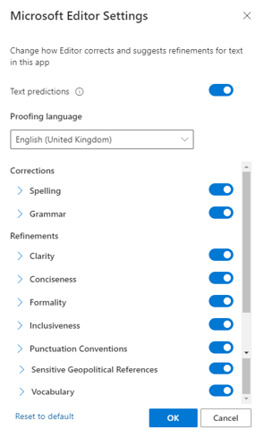

You can also turn off ‘Text predictions’ in this Editor box if you prefer not to have this function. Text prediction anticipates your next words and suggests words or phrases as you type. For example, it has added ‘than’ after the words ‘much better’ have been typed below. You can either ignore and continue to type or use the Tab key to accept the suggestion.
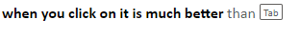

Accessibility MailTip
A MailTip in Outlook on the Web informs co-workers of your preference for accessible content. This prompt reminds them to run Accessibility Checker before sending an email to you and fix any issues that might make the content difficult for people with disabilities to consume.
Go to Settings (the cog icon in top right of Outlook Online) and choose ‘view all Outlook settings’ at the bottom of the Settings pane.

Then select General from the list of the left and then Accessibility from within the General options.
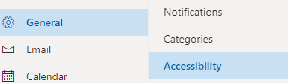

Tick the Accessible Content box.
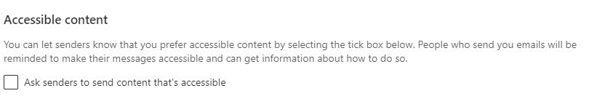

Ease of Access tools within Settings
There are a few ways you can reach the Ease of Access settings available on your Windows 10 computer/laptop.
- Press Windows logo key plus U key, which will take you straight into the Ease of Access site
OR
- Press Windows key plus I key to take you to Settings, where you can then choose the Ease of Access site

If you prefer not to use shortcuts:
- Click on the Start menu in bottom left corner or press Windows logo key to access Start menu
then select Settings
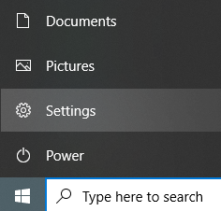
Or
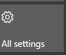
- Click onto the Notifications icon in bottom right of your screen, then select All Settings from the displayed tiles

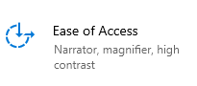
Then select Ease of Access

On the left of the Ease of Access site, you will get a list divided into Vision, Hearing, and Interaction.
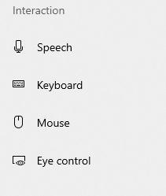

Mobility (including speech)
Microsoft has products that help people with a variety of physical or speech impairments and conditions to navigate the digital world.
Windows 10 gives you a number of options for making your mouse and keyboard easier
to use. You can change the shape and colour of the mouse pointer or use Mouse Keys to
move the mouse pointer with the numeric keypad. If you have trouble pressing two keys at
the same time, Sticky Keys lets you type commands one key at a time.

Learn more about Windows 10 features such as Eye Control, the On-Screen Keyboard, and
other assistive technology tools that can help people with mobility impairments. Use tools
such as Dictate to help you navigate around Word, Excel, PowerPoint and Outlook.

Explore Microsoft's mobility accessibility guide
If you cannot access the above link, here is the full URL:
https://support.microsoft.com/en-gb/windows/guide-for-people-who-have-low-mobility-or-dexterity-8647dc2a-93b3-6867-5081-d1e007563786

Windows 10 Tools
Within the Ease of Access site, there are four Interaction headings.
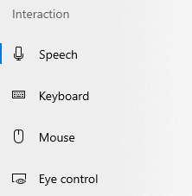

Speech
Type and navigate with your voice
Whether you're composing a document, an email, or on the internet, dictation will convert your speech to text—so you can produce words without a keyboard. And with Windows Speech Recognition you can control your PC by voice alone.
Make your device easier to use if you have limited strength or reach.

Use dictation to convert spoken words into text anywhere on your PC with Windows 10.
Dictation uses speech recognition built into Windows 10, so there's nothing you
need to download and install to use it.
To use Dictation, you device needs to be connected to the internet.
To start dictating, select a text field and press the Windows key plus H key to open the
dictation toolbar, then start speaking. To stop dictating at any time while you're dictating,
say “Stop dictation” or tap the microphone on a touch screen.

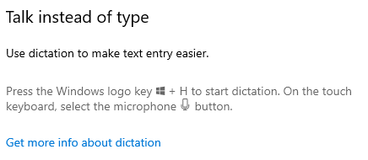

You can use Speech Recognition in Windows 10.

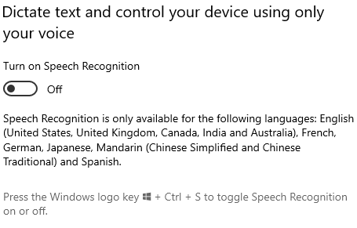

Before you set up voice recognition, make sure you have a microphone set up by going into
Settings, then Time & Language, then selecting Speech.

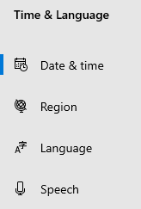
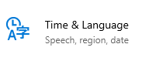

Select Microphone and choose ‘get started’
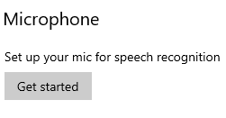
When you turn on your Speech Recognition, a box will appear.

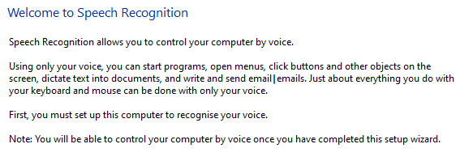

Click Next and choose the microphone type (headset, desktop or other)

Set up your mic and read the sentence that displays on your screen.
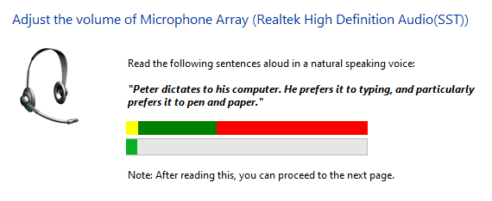
Click Next and you will see a box telling you your mic is now set up

Click Next to continue setting up Speech Recognition and follow the instructions.

To find out more about speech recognition, read Use voice recognition in Windows 10.
If you cannot access the above link, here is the full URL:
https://support.microsoft.com/en-us/windows/use-voice-recognition-in-windows-10-83ff75bd-63eb-0b6c-18d4-6fae94050571

To learn how to set up your microphone, read How to set up and test microphones in Windows 10.
If you cannot access the above link, here is the full URL:
https://support.microsoft.com/en-us/windows/how-to-set-up-and-test-microphones-in-windows-ba9a4aab-35d1-12ee-5835-cccac7ee87a4

Keyboard

Type without a keyboard
Windows has a built-in tool called the On-Screen Keyboard (OSK) that can be used instead of a physical keyboard. The On-Screen Keyboard (OSK) allows you to type with a pointing device, such as a mouse, trackball or joystick. And for those with mobility impairments or conditions, learning disabilities or cognitive impairment, the word completion and prediction tools can be helpful.
You don’t need a touchscreen to use the OSK. It displays a visual keyboard with all the standard keys, so you can use your mouse or another pointing device to select keys or use a physical single key or group of keys to cycle through the keys on the screen.
Go to Ease of Access site and choose Keyboard.
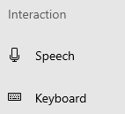
Turn on the toggle under Use the On-Screen Keyboard
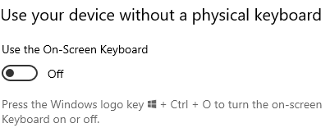
A keyboard that can be used to move around the screen and enter text will appear on the screen. The keyboard will remain on the screen until you close it.
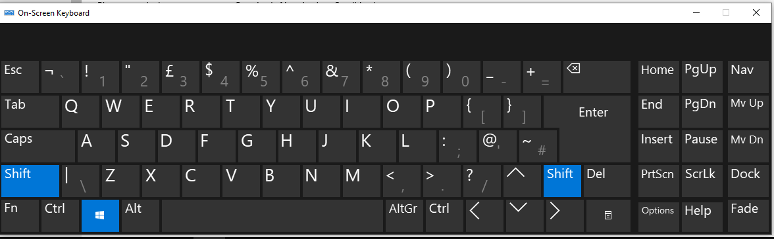

To change how info is entered into the On-Screen Keyboard, with the OSK open, select the Options key, and choose the options you want:
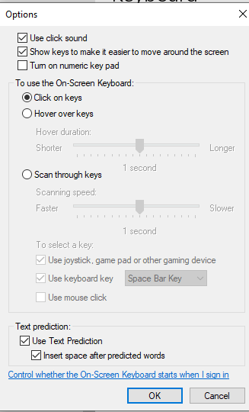

- Use click sound. Use this option if you want to hear a sound when you press a key.
- Show keys to make it easier to move around the screen. Use this option if you want the keys to light up as you type.
- Turn on numeric keypad. Use this option to expand the OSK to show a numeric keypad.
- Click on keys. Use this mode if you prefer to click or tap the on-screen keys to enter text.
- Hover over keys. Use this mode if you use a mouse or joystick to point to a key. The characters you point to are entered automatically when you point to them for a specified time.
- Scan through keys. Use this mode if you want the OSK to continually scan the keyboard. Scan mode highlights areas where you can type keyboard characters by pressing a keyboard shortcut, using a switch input device, or using a device that simulates a mouse click.
- Use Text Prediction. Use this option if you want the OSK to suggest words for you as you type so you don't need to type each complete word.

Sticky Keys
Turn on the toggle under Sticky Keys if you have trouble pressing two keys at the same time. Sticky Keys let you press commands that use multiple keys (such as Ctrl + S) one key at a time.
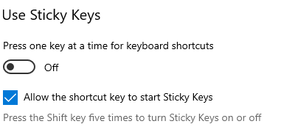
When you switch it on, some more options will be displayed under the toggle button.
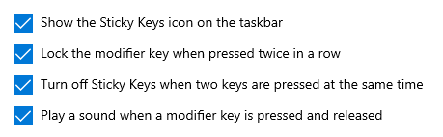

Choose whichever you feel will help.

Toggle Keys
Turn on the toggle under Toggle Keys to play a sound whenever you press the Caps Lock, Num Lock, or Scroll Lock keys.
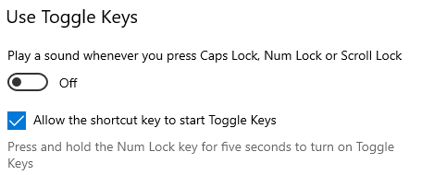

Filter Keys
Turn on the toggle under Filter Keys to set the sensitivity of the keyboard so it can ignore brief or repeated keystrokes.
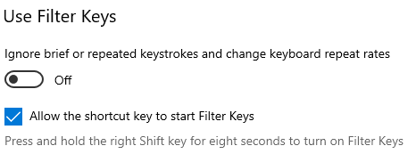
When you switch it on, some more options will display.
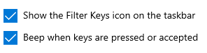

There will also be some toggle buttons for Bounce Keys, Slow Keys and Repeat Keys. Once any of these are switched on, you can chose how long your device waits before accepting keystrokes.
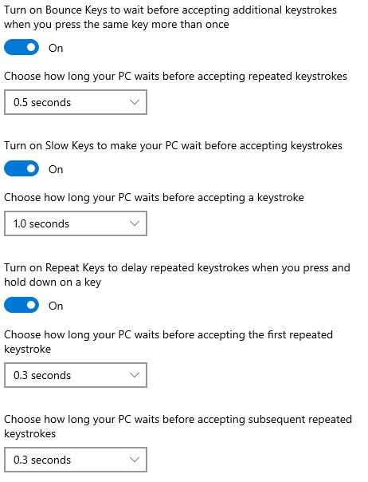

How keyboard shortcuts work
Turn on the toggle under ‘Change how keyboard shortcuts work’ to underline access keys when they're available.
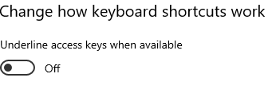
Turn on the toggle under Print Screen shortcut to use the PrtScn button to open screen snipping.
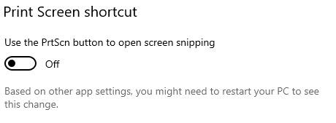
There are also a couple of settings to make it easier for you to type: show a message when turning on Sticky/Toggle/Filter Keys and make a sound when turning the same keys on or off.
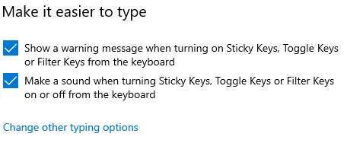
If you click onto ‘change other typing options link, you are taken to the Typing site under Devices in Settings. Here you can set some extra controls under spelling, typing, touch keyboard and hardware keyboard.
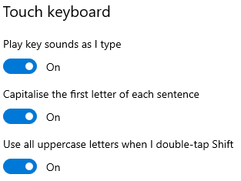
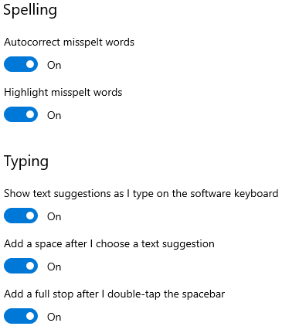

Mouse
Make it easier to see and control your mouse cursor. Go to Ease of Access and choose Mouse from list on the left.

Mouse Keys
Switch on the toggle for Mouse Keys if you want to control your mouse using a numeric keypad.
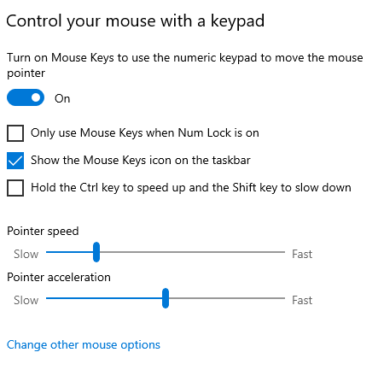

After you switch Mouse Keys on, use the following to control it:
1 | Down and to the left | 6 | right
2 | down | 7 | Up and to the left
3 | Down and to the right | 8 | up
4 | left | 9 | Up and to the right

Before you use Mouse Keys to click items on your screen, you must first select which mouse button you want to be the active button: the left button, the right one, or both.
Select the left mouse button = forward slash (/) then press 5 to perform a click.
Select the right mouse button = the minus sign (-) then press 5 to perform a click.
Select forward slash (/) and then press plus sign (+) = double click.
Press zero = drag an item.
Point to the location where you want to drop the item and press decimal point (.) = to drop an item.

Other mouse options
Use the ‘change other mouse options’ link to take you to the Mouse site under the Devices in Settings. Here you can change your mouse’s primary button to right instead of left, adjust the cursor speed, how many lines to scroll at a time with the mouse (between multiple lines or one screen at a time) or how many lines you want to scroll at a time (between 1 and 100).
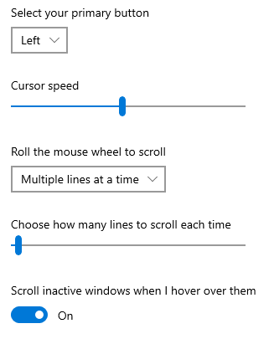

Make your mouse pointer easier to see
You can make your mouse pointer bigger or change its colour.
Go into Ease of Access and select Mouse Pointer under the Vision section on the left
Use the slider to increase/decrease the size of the mouse pointer and use the options below the slider to choose your preferred colour.
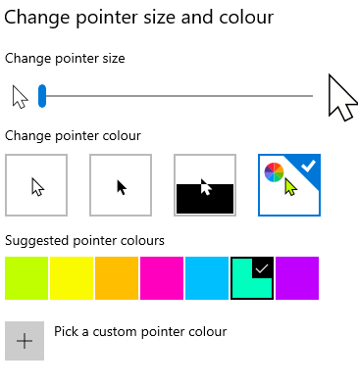
There is also a button which changes the visual feedback you get when you use a touch screen:
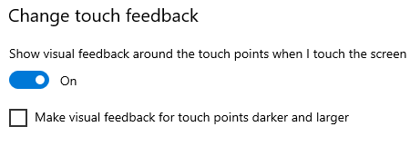

Text cursor
You can change the appearance of your Text Cursor to make it easier to follow/see where you are typing. Click Text Cursor on your Vision list on the left.
You can turn the text cursor indicator on by using the button, change the size of it by using the slider, and select a suitable colour by clicking onto the preferred choice. The sample text box will show you how your cursor will look.
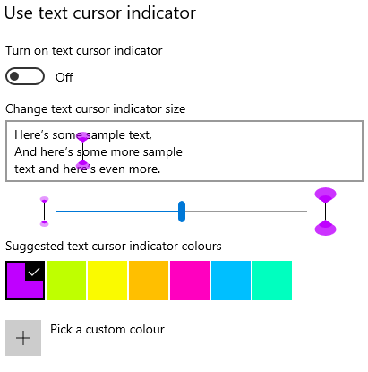

Alternatively you can use amend the thickness of your text cursor, using the slider to take it from a thin line to a thicker block.
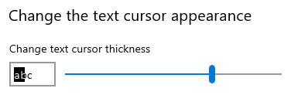

Eye control
Eye control lets you use eye-tracking technology to control the mouse, type using an on-screen keyboard, or use text-to-speech.
To use this, you need to connect a supported eye-tracking device.
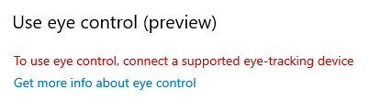

If you click onto the ‘ get more info about eye control’ above, you will reach Microsoft’s page for Getting started with eye control in Windows 10
If you cannot access this hyperlink, here is the full URL:
https://support.microsoft.com/en-us/windows/get-started-with-eye-control-in-windows-1a170a20-1083-2452-8f42-17a7d4fe89a9

Office 365 tools

Dictate
Dictate lets you use speech-to-text to ‘write’ in Word, Outlook and PowerPoint as long as you have a microphone and reliable internet connection.
The appearance of Dictate once you click onto the Dictate button is the same across all three applications
In both Word and PowerPoint you can find the Dictate feature in the Home commands.

Click onto Dictate and the command icon will then display as ‘recording’ with a red button.
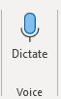
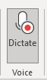
From this you can start speaking immediately and a box will display on your screen on which you can tap the mic icon to resume or pause.
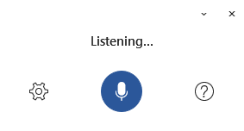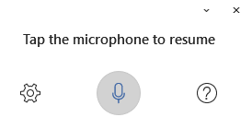

In Outlook you need to open a new email first, then Dictate sits under the Message commands.

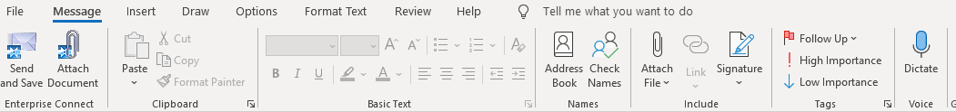

As with Word, clicking onto Dictate will open a ‘listening’ box and will change the Dictate icon to display as recording with the red button.

Once in Dictate, you can click onto the cog icon to set auto-punctuation and dictation language.

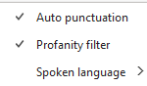

Read Aloud
There is a Read Aloud feature available in Outlook and Word that vocalises and highlights each word.
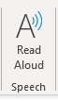
Outlook (on the far right of Home tab)

Word (Review tab)
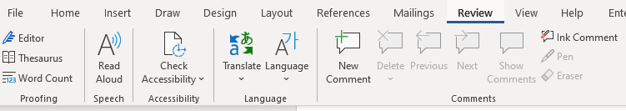

Once switched on, a small box will appear to the right of your document with play/pause, forward and backward controls. Click on the settings icon to speed up or slow down the reading voice, and to choose your preferred voice.
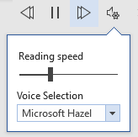

Useful keyboard shortcuts for Mobility accessibility tools

Function | Shortcut Keys
Open Ease of Access centre | Windows logo key plus U
Open Settings | Windows key plus I
Zoom in and out on text | Ctrl plus Alt plus mouse wheel
Zoom in and out | Windows plus or minus keys
Maximise a window | Windows plus Up arrow
Start dictation | Windows plus H
Turn Speech Recognition on or off | Windows plus Ctrl plus S
Turn On Screen Keyboard on or off (OSK) | Windows plus Ctrl plus O
Open Narrator | Windows plus Enter

Creating accessible documents
Whilst you may not have accessibility needs yourself, you should always bear in mind that some of your recipients could have.

Check document accessibility
Click Review and choose Check Accessibility.
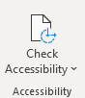

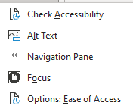
If you click onto the drop-down arrow, you’ll see the options which include Focus to display your document in a more focused way. Focus will put a black surrounding on your document and removes everything else, including the Word commands along the top. Just press ESC to remove Focus.

Results for the Check Accessibility option are presented in three types:
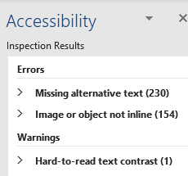

Errors – these cannot be read by screen readers
Warnings – these would be difficult to read
Tips – might cause problems

Real time presentation subtitles
You can provide translated subtitles to your presentations on the Slide Show ribbon tab by selecting Subtitle Settings.
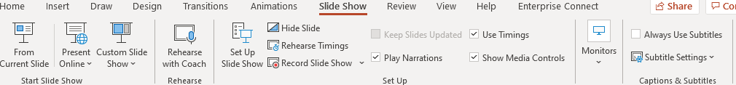
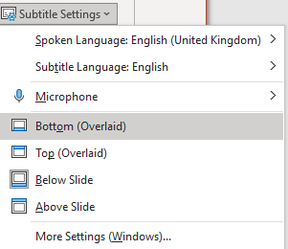
- Use Spoken Language to see the voice languages that PowerPoint can recognise and select the one you want. This is the language that you will be speaking while presenting.
- Use Subtitle Language to see which languages PowerPoint can display on-screen as captions or subtitles and select the one you want. This is the language of the text that will be shown to your audience. Choosing the same language as your Spoken Language allows you to provide closed captioning. This is especially relevant for accessibility for the deaf and hard of hearing.
You can turn subtitles on and off using the Subtitle toggle that appears in the bottom left of each slide when you are in ‘slideshow’ mode.

Glossary
Device: whatever you are using to access your work on – desktop PC, laptop or smartphone.
File Explorer: the ‘folder’ icon that displays along your bottom taskbar; the one you have been using to find your documents, downloads, pictures and desktop.
Windows Key: this is a bottom-left key on your keyboard with the Windows icon on it.
Application: the different programmes within O365 are called applications, e.g. Outlook, Word, PowerPoint, Teams. Often these are called Apps for short.
Icon: the ‘logos’ of the different applications (e.g. Word is a blue W, Excel is a green E, OneDrive is a blue cloud) or web browsers (e.g. Chrome is a coloured circle)
Desktop apps: applications that are available on your laptop/computer by clicking onto the icon. They may be on your bottom taskbar, or in your Start menu. You don’t have to be online to see and access them.
Window: In computer terms, a window is an area on the screen that displays information about a programme. You can have multiple windows open, displaying different websites, documents and applications.
Windows 10: the operating system of your device. Where Windows has a capital W, it means this system and not a window on which you can see your documents, websites, etc.
URL: short for Uniform Resource Locator, this is your web address. It shows the location of a document or website on the internet, including your OneDrive.
Microsoft 365 and Office 365: this is essentially the same thing and both names are used for the applications such as OneDrive, Outlook, Teams, Word, PowerPoint, Excel and OneNote.

