A guide to Accessibility Tools for Vision in Windows 10 and Office 365

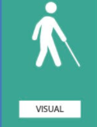

Contents
About this guide four
Tools to help across the board five
Zoom feature five
Reuse files….. six
Smart Lookup eight
Editor…………… nine
Accessibility MailTip thirteen
Ease of Access tools within Settings fourteen
Vision fifteen
Windows 10 tools fifteen
Display fifteen
Make displays bigger /brighter fifteen
Night Light seventeen
Simplify Windows eighteen
Cursors and pointers nineteen
Mouse pointer nineteen
Text cursor twenty
Magnifier twenty-one
Turn on Magnifier twenty-one
Change Magnifier view twenty-three
How to use Magnifier Reading twenty-four
Colour filters and contrast twenty-five
Colour filters twenty-five
High contrast twenty-six
Narrator twenty-eight
Start-up options twenty-nine
Personalise Narrator’s voice twenty-nine
Change what you hear when reading and interacting thirty
Change what you hear when typing thirty-one
Choose keyboard settings thirty-two
Use Narrator cursor thirty-three
Use Braille thirty-three
Office 365 tools thirty-four
Read Aloud thirty-four
Dictate - Type with your voice thirty-five
Tell Me / Search thirty-six
Useful keyboard shortcuts for Vision accessibility tools thirty-seven
Creating accessible documents thirty-eight
Check document accessibility thirty-eight
Real time presentation subtitles thirty-nine
Glossary forty

About this guide
There are many tools that Microsoft has created to improve accessibility for its users. Some of these are within Windows 10 on your device, some are through Office 365 applications.
Examples of products include:
- On-Screen Keyboard: enables people to use a pointer in place of a keyboard to type text.
- Voice-recognition software: converts spoken words into typed text.
- Narrator screen reader: Narrator has a touch mode which can perform screen-reading tasks by processing touch gestures when there is no keyboard available.
- Programs or settings that adjust the display or areas of it, such as high contrast themes, settings of the display, or the Magnifier tool.
The Windows 10 features are accessed mainly via your Ease of Access site in the Settings menu. See page 14 for help with this.
Barnardo's recognises the social model of disability which means that it acknowledges that disabled people are not disabled by their impairments or conditions but by, for example, physical, environmental, attitudinal and technological barriers and structures. it is hoped that this guide helps in removing some of those barriers.

Tools to help across the board
Office 365 has some new tools that can benefit everyone. Next to each tool you will see the icon of the app(s) in which you can use the feature.
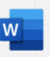
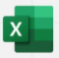
Zoom feature:
O365 Word, Excel, and PowerPoint documents have two methods of zooming to increase font size when you are reading.
Either by using the Zoom slider in bottom right of a document:
Or
Via View group along the top ribbon:
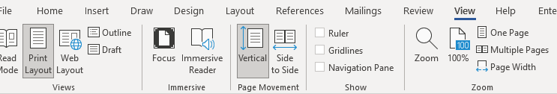
Clicking onto Page Width will adjust your Word document to the entire width of your window.
Excel and PowerPoint have less choice but you can still set your zoom percentage and customise to go larger than 200 per cent.
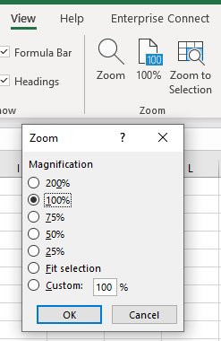

Reuse files
A useful Word tool called Reuse Files is a feature that allows you to search for documents and re-use parts of them. You can insert a block of text or other content from a different file without leaving the document you're currently working on. In PowerPoint it is ‘Reuse Slides’.
Click on Reuse Files in your Home command bar or Insert command bar.
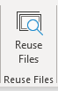

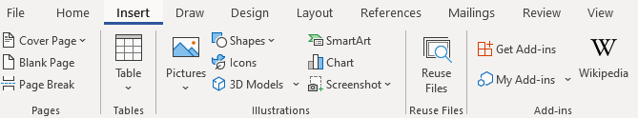

It will present a search bar plus some ‘suggestions for you’.
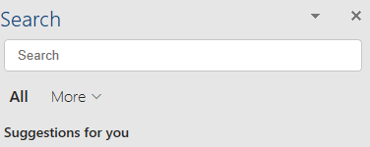

Clicking onto the More arrow allows you to narrow down the source of the information you wish to find. For example, if you only want in-house documents, choose Files; if you only want pictures, choose Media.
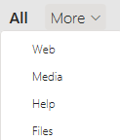

The function is intelligent enough to work out what you are working on and tries to offer results built on similarity of subject. For example, choosing Web whilst working on an accessibility document will give you various internet pages related to accessibility. Choosing Media presents you with accessibility images and logos, and Files brings up relevant documents (Word, PowerPoint, Excel) already stored on SharePoint or OneDrive.
If not relevant enough, use the Search field to look for a subject you want.
Files: If you find a document you wish to copy from, click into it and a plus sign will appear to ‘insert content’. Scroll to anything you wish to reuse, make sure the plus sign is over it and click. The selected text will be put into your current document wherever the cursor is.
However, you can click on the ellipsis (3 dots) next to the file’s name to choose other options:
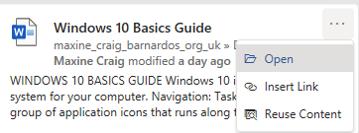
- Open: opens the document in a new window (as long as you have access to it)
- Insert link: inputs a hyperlink to the document’s location
- Reuse content: opens the file in the Search sidebar for you to scroll through content (same result as clicking into the file and using the plus sign)
Web: You can either click onto the suggested web name (in blue) or link (green) and it should open the page in a new tab on your internet window, or you can use the ellipsis (3 dots).
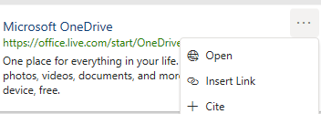
- Open: opens the webpage in a new tab if you have Chrome or Edge open
- Insert link: inserts the webpage link using its name
- Cite: inserts the webpage name plus the file path (where the page is on the internet)

Media: Select a picture you want by clicking onto the plus sign when you hover over the image.

Smart Lookup
Using the Smart Lookup pane lets you get search results without leaving the application you are in and provides definitions, topics, articles, and related searches from the web. The Search bar at the top of your document performs the same way so use that if you have no Smart Lookup.
When you select a word or phrase, right-click it, then choose Smart Lookup from the menu that appears. Note: it may appear as Search “…..” instead in Word and PowerPoint but this produces the same results that are displayed in the pane that appears on the right side of the screen.
You can also get to Smart Lookup/ Search any time by going to References command bar and choosing Search or Smart Lookup (depending on what shows there).
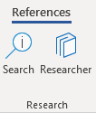
As with Reuse Files, you can narrow your search down by choosing Files, Web or Media.
Files: If you find a file/document you wish to copy from, click into it and a plus sign will appear to ‘insert content’. Scroll to anything you wish to reuse, make sure the plus sign is over it and click. If you want more or less than is being covered by the plus sign, you can also left click on your mouse and drag your cursor over what you want to select, then click the plus sign. The selected text will be put into your current document.
However, you can click on the ellipsis (3 dots) next file’s name to choose other options:
- Open: opens the document in a new window (as long as you have access to it)
- Insert link: inputs a hyperlink to the document’s location
- Reuse content: opens the file in the Search sidebar for you to scroll through content (same result as clicking into the file and using the plus sign)

Web: You can either click onto the suggested web link or name and it should open the page in a new tab on your internet window, or you can use the ellipsis (3 dots).
- Open: opens the webpage in a new tab if you have Chrome or Edge open
- Insert link: inserts the webpage link using its name
- Cite: inserts the webpage title plus the file path (where the page is on the internet)

Media: Select a picture you want by clicking onto the plus sign when you hover over the image.

Editor
Editor helps you to improve your writing in Word and Outlook Online by identifying words and phrases that might need more refinement. Editor analyses text as you type and makes suggestions when it finds misspellings and opportunities for improving.
When Editor is enabled, improved spelling and grammar suggestions will be automatically available to you. Editor is there to help you, but it will not prevent you from continuing with your document if you choose not to take its advice.

In Word, you can find Editor on both the Home command bar and the Review command bar.
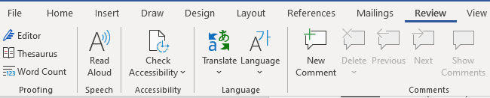
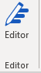

Click onto Editor and a pane will open on the right to tell you how many spelling and grammar errors there are and any refinement issues it has detected for clarity, conciseness, formality, punctuation and vocabulary.
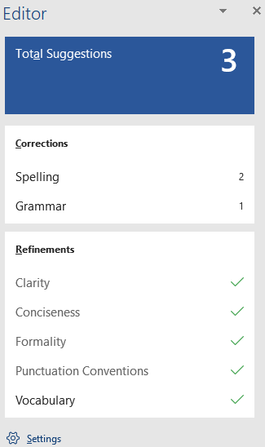
Click onto any of these sections that show a number, and Editor will give you alternatives or tell you what the correction is.
You can click onto the ‘read aloud’ icon to get the issue read to you, and if you click on the drop-down arrow in the suggestion, you can choose between ‘read aloud’ or ‘spell out’.
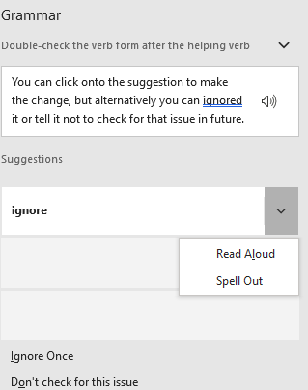

You can choose the suggestion to make the change, but alternatively you can ignore it or tell it not to check for that issue in future.
Editor in Outlook Online
For Outlook Online, you will find Editor in the lower taskbar of a new blank email. (Unfortunately, Editor is not currently available on Outlook Desktop app.)
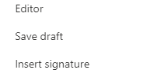
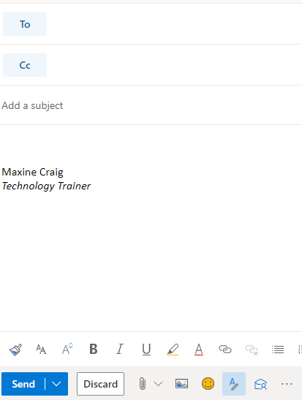

You initially have to go into the ellipsis to find it, but if you want easier access to it you can go into Settings (the cog in top right of Outlook Online), choose View all Outlook Settings, then Customise actions and scroll down to Toolbar section.
Tick the Editor box to add it to the lower toolbar as displayed below.

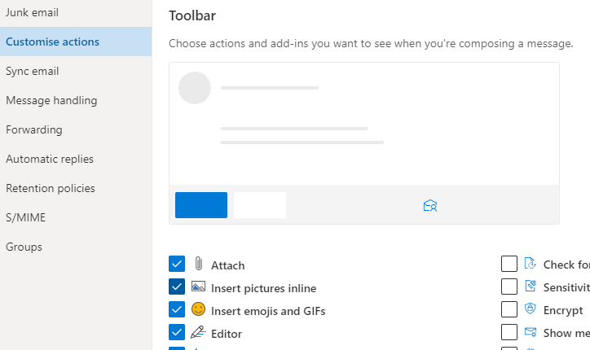
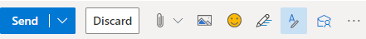
Editor here works differently. It does not display a box of suggestions but highlights errors as you type. If you click onto the word underlined, it gives you the options for improving your text.
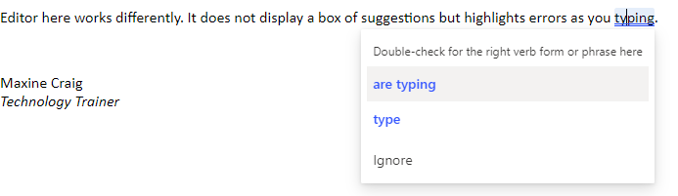
When you click on the Editor icon, you can set your controls to choose what it checks, from spelling and grammar to clarity, conciseness, inclusiveness, formality and punctuation and vocabulary.
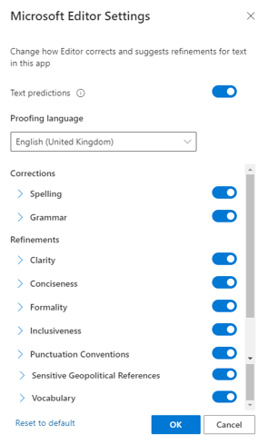

You can also turn off ‘Text predictions’ in this Editor box if you prefer not to have this function. Text prediction anticipates your next words and suggests words or phrases as you type. For example, it has added ‘than’ after the words ‘much better’ have been typed below. You can either ignore and continue to type or use the Tab key to accept the suggestion.
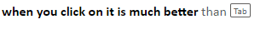

Accessibility MailTip
A MailTip in Outlook on the Web informs co-workers of your preference for accessible content. This prompt reminds them to run Accessibility Checker before sending an email to you and fix any issues that might make the content difficult for people with disabilities to consume.
Go to Settings (the cog icon in top right of Outlook Online) and choose ‘view all Outlook settings’ at the bottom of the Settings pane.
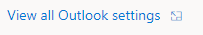

Then select General from the list of the left and then Accessibility from within the General options.
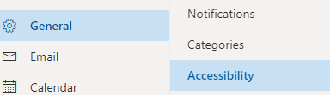

Tick the Accessible Content box.
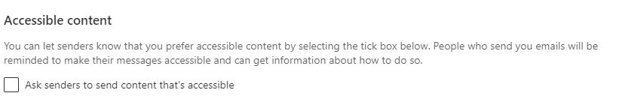

Ease of Access tools within Settings
There are a few ways you can reach the Ease of Access settings available on your Windows 10 computer/laptop.
- Press Windows logo key plus U key, which will take you straight into the Ease of Access site
OR
- Press Windows key plus I key to take you to Settings, where you can then choose the Ease of Access site

If you prefer not to use shortcuts:
- Click on the Start menu in bottom left corner or press Windows logo key to access Start menu
then select Settings
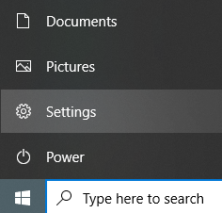
Or
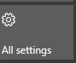
- Click onto the Notifications icon in bottom right of your screen, then select All Settings from the displayed tiles

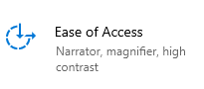
Then select Ease of Access

On the left of the Ease of Access site, you will get a list divided into Vision, Hearing, and Interaction.
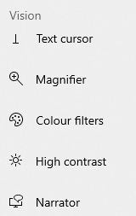

Vision
Do you need a larger display, a brighter screen, a Narrator to read text? Learn more about Narrator, Magnifier, colour filters and other assistive technology tools in Windows 10 that can assist people with visual impairments. In addition, you can better understand how to provide alternative text and use keyboard shortcuts in Word, Excel, PowerPoint, and Outlook.
Explore Microsoft's vision accessibility guide
If you cannot access the above link, here is the full URL:
https://support.microsoft.com/en-us/windows/guide-for-people-who-are-blind-or-low-vision-11c8b979-f8cd-f65e-6406-6f03b613b94b

Windows 10 tools
From the Settings ‘Ease of Access’ screen, look at the Vision group. You can see several ways of making your screen display easier to read.
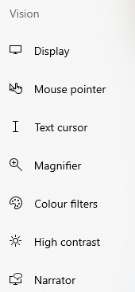

Display
There are some tools to make your computer display easier to see.

Make displays bigger /brighter
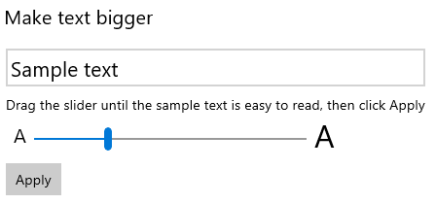

Use the slider to choose the size of your text – the Sample Text will increase or decrease in size according to the position of the slider.
Click Apply. The screen will go blue for a second, then your display will adapt to your new text size.
This will apply the changes to text across all your programmes.
In order to increase the size of your applications, such as the icons along the taskbar at the bottom of your screen, use the ‘Make everything bigger’ option. You can select 100 per cent, 150 per cent and 200 per cent.
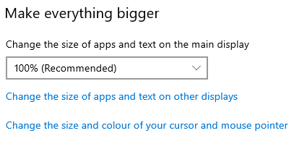

You can select ‘change the size of apps and text on other displays’ to change the scale and layout of your display to 125 percent or 150 per cent.
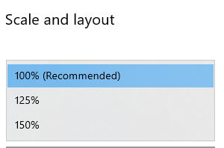

If you prefer a darker or brighter screen, you can adjust your display’s brightness using the slider.
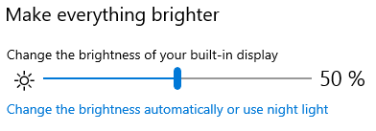

Night Light
In the ‘make everything brighter’ box, you can choose ‘use night light’ to reduce the amount of ‘blue light’ your display has because Night light displays in a warmer colour.
Click onto ‘use night light’ and switch the toggle button across to On.
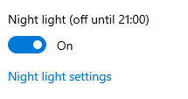

If you want night light to be darker, use the ‘night light settings’ link within the on/off box. This contains a slider to adjust night light’s strength and a schedule button.
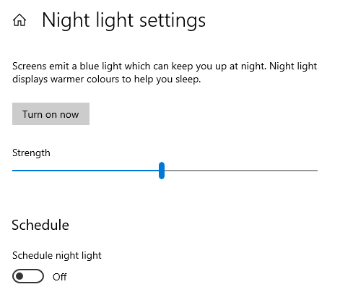

If you switch on the Schedule button, an extra box appears for you to set your schedule for night light. Set your hours to turn it on and to turn it off or choose ‘ sunset to sunrise’.
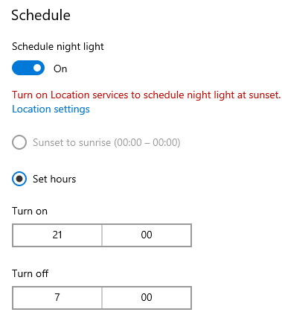

Simplify Windows
There are some functions you can amend under the ‘simplify and personalise Windows’ section.
You can choose the length of time that your notifications are displayed - the default is 5 seconds and the maximum is 5 minutes.
Or you can choose to hide the scroll bar on Windows applications or switch off animations in Windows.
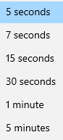
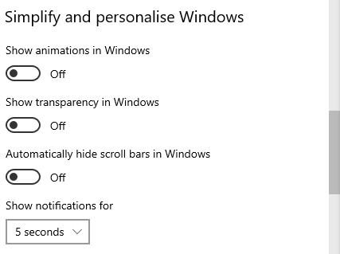

You can use the toggle button to show a desktop background image, or turn it off to display one colour only for easier desktop navigation.
Accessing the ‘personalise’ link takes you into the Background setting section for you to choose your preferred colour.

Cursors and pointers
You can make changes to the colour and size of your cursor and mouse-pointer. Either click on Mouse Pointer or Text Cursor on the Vision list or click onto ‘change the size and colour of your cursor and mouse pointer’ in the previous Make Everything Bigger section.
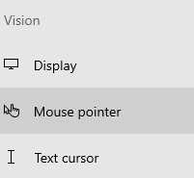

Mouse pointer
Use the slider to increase/decrease the size of the mouse pointer and use the options below the slider to choose your preferred colour.
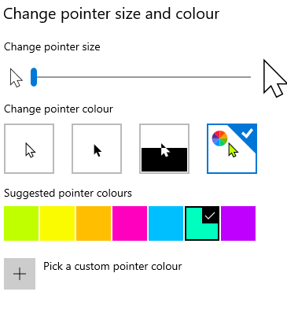

There is also a button which changes the visual feedback you get when you use a touch screen:
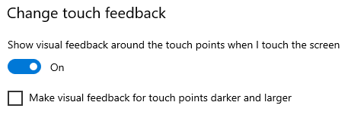

Text cursor
You can change the appearance of your Text Cursor to make it easier to follow/see where you are typing. Click Text Cursor on your Vision list on the left whilst in Display settings.
You can turn the text cursor indicator on by using the button, change the size of it by using the slider, and select a suitable colour by clicking onto the preferred choice. The sample text box will show you how your cursor will look.

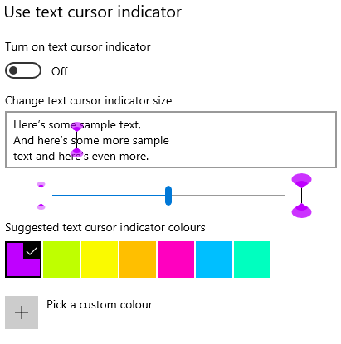

Alternatively you can use amend the thickness of your text cursor, using the slider to take it from a thin line to a thicker block.
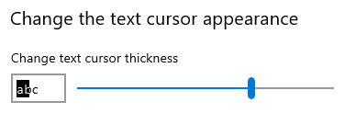

Magnifier
You can use Magnifier to zoom in on parts of your display. It can run in full screen, in a separate window or as a lens that follows your mouse pointer around the screen.
Note: If you just wish to zoom in on text in a document without using Magnifier, you can press and hold Ctrl key plus Alt key and use your mouse wheel to zoom in/out.
OR use the zoom slider in the bottom right of your document.

If you just want to zoom in on text on a website you are viewing without Magnifier, you can use the zoom function by clicking onto the ellipsis (3 dots) in the top right corner and choosing the Zoom plus or minus.

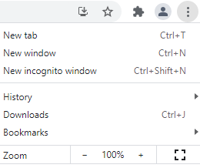

Turn on Magnifier
There are a couple of ways to turn Magnifier on:
- For full functionality, choose Magnifier from your Vision list to turn the function on.
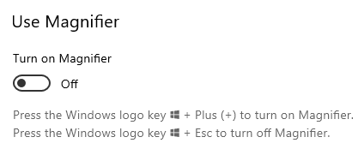

- For quick access, you can also activate Magnifier instantly by pressing the Windows key and Plus key. When you do this, a box will appear for you to change the zoom level OR use the ‘read from here’ function.
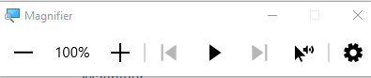

Within Magnifier screen, you can set your level of zoom from 100 per cent to 1600 per cent but can also change increments of the zoom level using the drop-down box – increments range from 5 per cent through to 400 per cent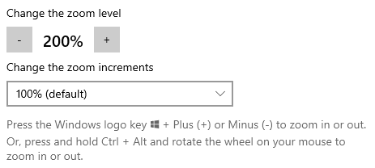

You can set Magnifier to start as soon as you sign into your device so you don’t have to keep setting it up.
You can also invert the colours of your display (so it displays as black) but make sure you have the Magnifier button switched on for this. If you just wish to use Invert Colours with no zoom, have your zoom level at 100 per cent with Magnifier turned on.
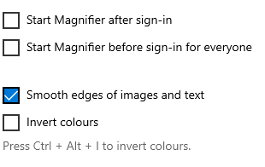

Change Magnifier view
Using the ‘choose a view’ drop-down arrow, you can set Magnifier up to magnify a full screen or magnify only what your mouse pointer is on (Lens) or put your magnified text into a separate box you can move around (Docked).
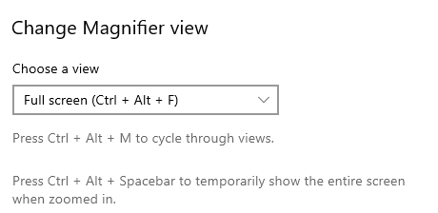
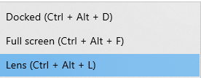

When you choose Lens view, you will get a box that lets you set the parameters of the lens – use the sliders to set the width or depth of your lens field.
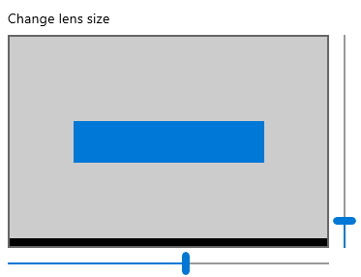
Choosing Docked view puts the magnification into a separate window and allows you to move this window around your screen by using Ctrl key plus Alt key plus Arrow keys.
If you choose Full Screen or Docked options, you can select 4 different points for Magnifier to follow:
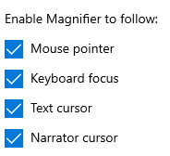
- Keyboard Focus: This setting takes advantage of the fact that in Windows 10 most of the operating system menus, links, buttons, and toggles can be navigated to using keys like Tab and the arrows. This feature is helpful to visual users who have their magnification set to a high level. With Keyboard Focus turned on, you use keystrokes to navigate certain settings and menus without having to search for certain features with the mouse.

- Text Cursor: This setting will ensure that, as you type, Magnifier will automatically move to follow the keyboard cursor if it moves out of the field of view as you type. This could be moving sideways to track with you, and it also could mean moving to the beginning of the next line as you finish typing on a given line.
- Narrator cursor: obviously, this would only need to be on if you had Narrator switched on.
With Full Screen option, you can also select where to keep the mouser pointer and/or text cursor either within the screen edges or centred on screen.
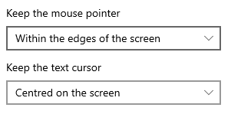

How to use Magnifier Reading
When switched On, Magnifier also has a reading aloud function. For full details click on Magnifier Reading use to reach the Microsoft page.
If this hyperlink does not work, the full URL is:
https://support.microsoft.com/en-us/windows/how-to-use-magnifier-reading-59d049ba-8434-9d04-34f2-2e00f11c5cb8

Essentially, you can set a ‘modifier’ key to start and control the reading voice.
For example, if you keep your modifier key as Control plus Alt as below, pressing Ctrl key plus Alt key plus Enter will start the reading, pause it and resume. Ctrl plus Alt plus various keys will perform other commands. You can change the Modifier key to Caps Lock or Insert key.
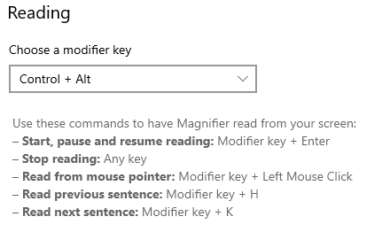

Colour filters and contrast
If you have colour-blindness, light sensitivity or a visual preference that make it hard to see what's on the screen, you can apply a colour filter. Colour filters change the colour palette on the screen and can help you distinguish between things that differ only by colour. Boost the colour contrast or get rid of colour entirely.

Colour filters
Switch on the toggle under ‘Turn on colour filters’.
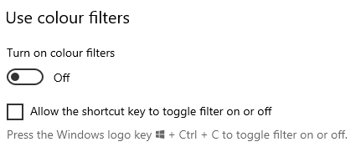
Then select a colour filter from the menu. Try each filter to see which suits you best.
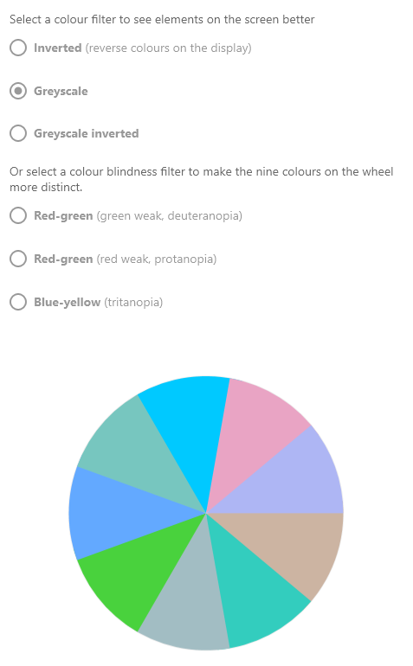

High contrast
You can make text and apps easier to see by using distinct colours. Choose High Contrast from the Vision list. Turn on high contrast using the toggle button.
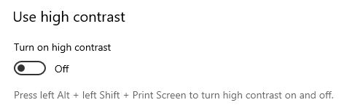

You can select between four types from the drop-down arrow
- High contrast number 1 – yellow text on black background , purple hyperlinks
- High contrast number 2 – green text on black background, purple hyperlinks
- High contrast black – white text on black background, yellow hyperlinks
- High contrast white – black text on white background, navy hyperlinks
For example, ‘high contrast black’ displays like this, with white text and a yellow link

However, even within these four options, you can customise various aspects of your display by choosing the colour you wish your hyperlinks, your text, your selected text, or your button text to display as.
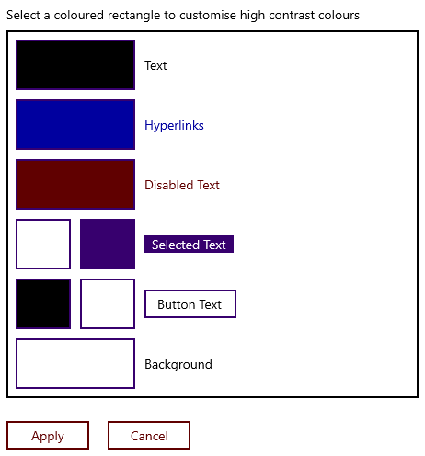
- Click on whichever you want to change (this example will change Text colour).
- Choose the preferred colour from the colour palette box that appears (this example will change text from black to pink)
- Press Done and your new colour will display in the text box.
- Click Apply and it will ask you to name and save your new theme.
- Type a name (e.g. here is ‘test theme’) and click Save.

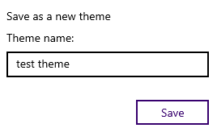

For this example, text now displays as pink across documents, websites, etc.
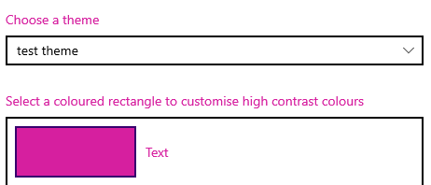

For any themes that you create yourself, you can easily delete them using the Delete button.
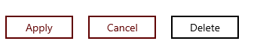

Narrator
Narrator is a screen reader that describes what is on your screen so you can use this to navigate your device. It can be controlled by keyboard, touchscreen, or mouse. It will narrate even with commands you are performing, such as cut and paste, etc. It also describes events such as notifications and calendar appointments, which lets you use your PC without a display.
View the complete Microsoft guide to Narrator
If you cannot access this link, full URL is:
https://support.microsoft.com/en-us/windows/complete-guide-to-narrator-e4397a0d-ef4f-b386-d8ae-c172f109bdb1

Find Narrator in the Vision list in Ease of Access settings.
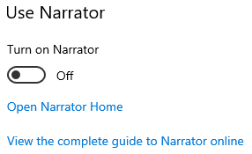

When you click onto ‘Open Narrator Home’ you get linked to Welcome to Narrator home screen. (You may get a ‘keyboard changes’ grey box first. Click OK to reach the Welcome screen – you can also tick the option not to see that box again).
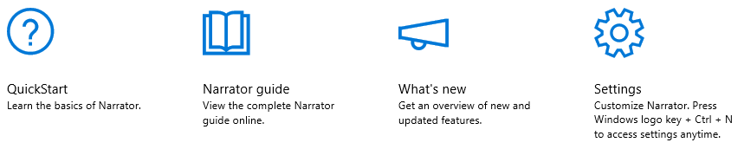

Narrator Home is where you can access settings and get help. QuickStart lets you learn the basics. Narrator Guide links you to the Complete Guide to Narrator on Microsoft’s website, which you can also access below the Use Narrator button (as above).

Start-up options
Within Ease of Access ‘Narrator’ screen, under Start-up Options you can set a few parameters and commands around the start-up of Narrator.
You can use a shortcut to open and close Narrator: Windows plus Ctrl plus Enter keys as long as the ‘allow shortcut’ option is ticked. You can set Narrator to open after you sign in.
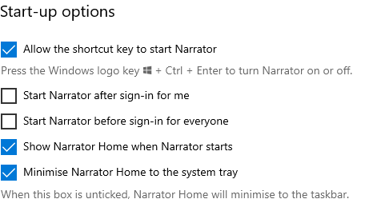

Personalise Narrator’s voice
You can change the voice or change the speed, pitch and volume of the narrating voice using the sliders.

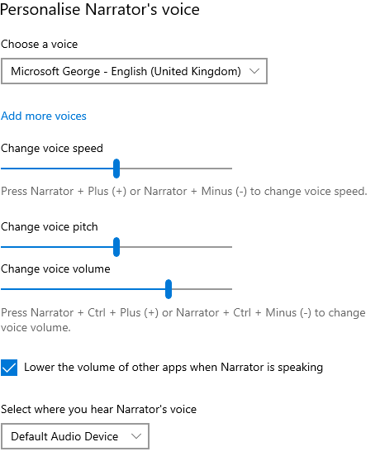

Change what you hear when reading and interacting
You can change the level of detail Narrator provides you with. Options include: Text only, Some control details, All control details, Some text details, and All text details.
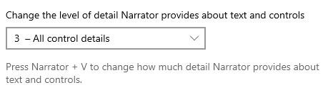

You can set how a capital letter is read. Options include: don’t announce, increase pitch, and say “cap.”
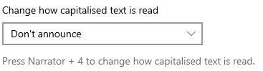

In the tick box, you can opt for Narrator’s voice to put more emphasis on formatted text, hear phonetics by character (e.g. Narrator will read letter A as ‘alpha’), or set Narrator to use punctuation.
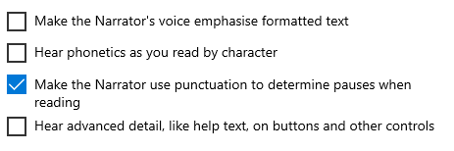

You can change the level of context: options include: No context, Sounds only, Immediate context, Immediate context name and type, Full context of new control, and Full context of old and new controls.
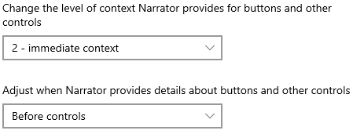

You can also set some extra controls such as hints on how to interact with buttons, hear sounds only for common actions, or have Narrator tell you why an action is not performed.
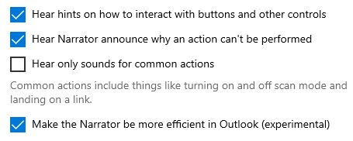

Change what you hear when typing
When typing, you can use this list to set what you hear. Characters are announced immediately after you type them. Set Narrator to read you letters, numbers, punctuation, words, function keys, navigation keys such as Tab, toggle keys such as Caps lock, or Shift, Alt, etc.
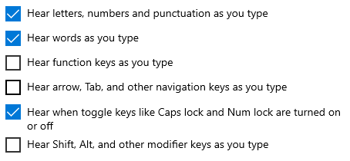

Choose keyboard settings
Select keyboard layout. Narrator’s Standard layout is more like the keyboard layouts you may have experienced in other screen readers. If you want to use Narrator’s original keyboard layout, choose the Legacy keyboard.
Select Narrator key. You can choose if you want to use Caps lock, Insert, or both keys in Narrator commands. Both the Caps lock and Insert keys serve as your Narrator key by default. You can use either of these keys in any command that uses the Narrator key.
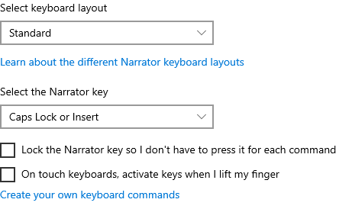
You can also create your own keyboard commands. Click on the link and an options box will appear for you to customise any of the commands.
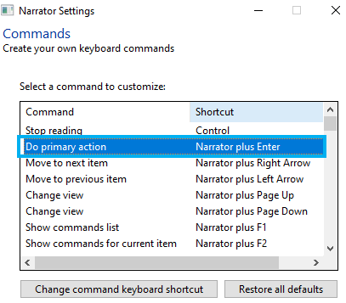
Choose the command you want to customise.
Select Change command keyboard shortcut at the bottom of the options box.
In the ‘type a keyboard’ shortcut window that appears, type the shortcut you want to use on your keyboard. Use any combination of modifier keys (Control, Shift, Alt, Caps lock, or the Windows logo key) together with a non-modifier key. Function and numeric keypad keys can be used without any modifiers.
If needed, select ‘Restore all defaults’ to return all commands back to their default settings. To find this setting, press Alt plus Tab keys after Narrator launches, select the Narrator Settings window, and choose Commands

Use Narrator cursor
Narrator cursor is where Narrator is focused on your screen. The Narrator cursor is highlighted with a blue focus box. You can set your cursor to move with the Narrator cursor or set Narrator to read what is under the mouse cursor.
For cursor navigation mode, normal is recommended and allows Narrator to move between various items such as links, tables, and other elements.
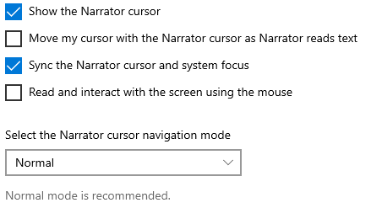

Use Braille
To use your braille display with Narrator, you will need to install software that lets your computer communicate with it. When you click on the ‘download and install braille’ button, you’ll be installing the following software:
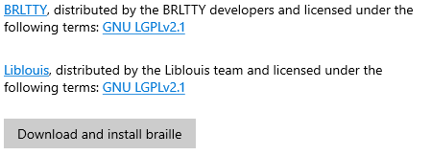

For more information, go to Microsoft Chapter 8: Using Narrator with Braille,
If you cannot access this link, the full URL is:
https://support.microsoft.com/en-us/windows/chapter-8-using-narrator-with-braille-3e5f065b-1c9d-6eb2-ec6d-1d07c9e94b20

and for a full list of supported displays, go to Microsoft Appendix C: Supported braille displays
If you cannot access this link, the full URL is:
https://support.microsoft.com/en-us/windows/appendix-c-supported-braille-displays-65c40265-8aa6-9b53-9bc8-8a7a87e5dd8a

Office 365 tools
Office 365 applications work seamlessly with screen readers and keyboards on most devices. Step-by-step guidance is available for each different Office 365 application to help you get started.
Use the Office apps with screen readers
If you cannot access the link above, the full URL is:
https://support.microsoft.com/en-gb/office/use-a-screen-reader-and-keyboard-shortcuts-with-office-apps-4aba5a56-f80c-4a6b-a584-d0f415471617?ui=en-us&rs=en-gb&ad=gb

Read Aloud
There is a Read Aloud feature available in Outlook and Word that vocalises and highlights each word.
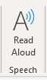
Outlook (on the far right of Home tab)

Word (Review tab)
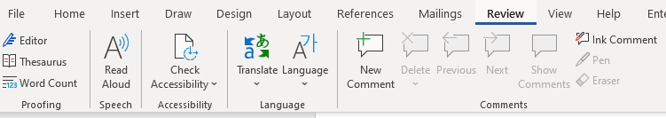

Once switched on, a small box will appear to the right of your document with play/pause, forward and backward controls. Click on the settings icon to speed up or slow down the reading voice, and to choose your preferred voice.
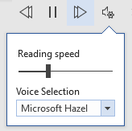

Dictate - Type with your voice

Dictate lets you use speech-to-text to ‘write’ in Word, Outlook and PowerPoint as long as you have a microphone and reliable internet connection.
The appearance of Dictate once you click onto the Dictate button is the same across all three applications.
In both Word and PowerPoint you can find the Dictate feature in the Home commands.
Click onto Dictate and the command icon will then display as ‘recording’ with a red button.
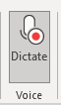
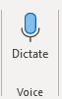

From this you can start speaking immediately and a box will display on your screen on which you can tap the mic icon to resume or pause.
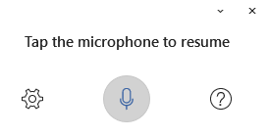
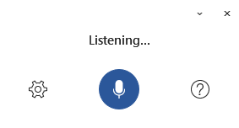

In Outlook you need to open a new email first, then Dictate sits under the Message commands.

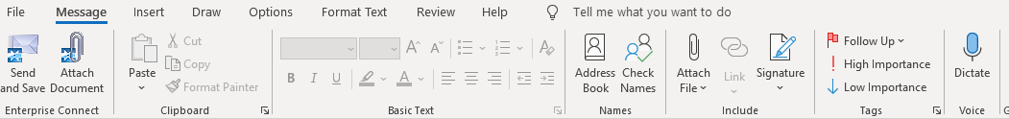

As with Word, clicking onto Dictate will open a ‘listening’ box and will change the Dictate icon to display as recording with the red button.

Once in Dictate, you can click onto the cog icon to set auto-punctuation and dictation language.

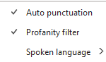

Tell Me / Search
You'll notice a text box on the ribbon in Office applications that says, ‘Tell me what you want to do’ or ‘Search’. This is a text field where you can enter words and phrases about what you want to do next and quickly get to features you want to use or actions you want to perform. You can also use Tell Me to find help about what you're looking for, or to use Smart Lookup to define the term you entered.
People
If you are currently connected to the Internet, you can type the name of anybody in your organisation into the Tell Me/Search box and Office 365 will try to find their contact information in the directory. Click onto the small arrow and you'll see their contact card as well as being able to easily share a current document with them if you are within one.
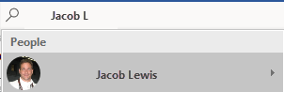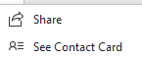

Documents
If you are currently connected to the Internet, you can type the name of any file you have stored in OneDrive or SharePoint and Office 365 will find it. Click on the small arrow you can open it separately or can share it with colleagues.
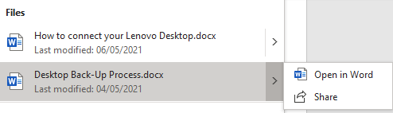

Useful keyboard shortcuts for Vision accessibility tools

Function | Shortcut keys
Open Ease of Access Centre | Windows key plus U key
Open settings | Windows key plus I key
Zoom in and out on text | Ctrl plus Alt plus mouse wheel
Zoom in and out | Windows and the Plus or Minus keys
Turn on Narrator  (make sure ‘allow shortcut to turn on Narrator’ is ticked in Ease of Access site) | Windows plus Ctrl plus Enter
Maximise a window | Windows plus Up arrow
Turn on Magnifier | Windows plus the Plus key
Turn off Magnifier | Windows plus Esc key
Magnifier plus Modifier key plus Enter | Magnifier Reading: Start, pause, and resume reading
Magnifier Reading: Stop reading | Any key
Magnifier Reading: Read from mouse pointer | Magnifier Modifier key plus Left Mouse click
Magnifier Reading: Read previous sentence | Magnifier Modifier key plus H
Magnifier Reading: Read next sentence | Magnifier Modifier key plus K

Creating accessible documents
Whilst you may not have accessibility needs yourself, you should always bear in mind that some of your recipients could have.

Check document accessibility
Click Review and choose Check Accessibility.
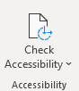

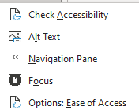
If you click onto the drop-down arrow, you’ll see the options which include Focus to display your document in a more focused way. Focus will put a black surrounding on your document and removes everything else, including the Word commands along the top. Just press ESC to remove Focus.

Results for the Check Accessibility option are presented in three types:
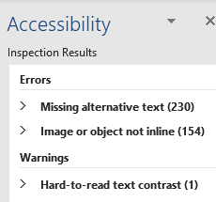

Errors – these cannot be read by screen readers
Warnings – these would be difficult to read
Tips – might cause problems

Real time presentation subtitles
You can provide translated subtitles to your presentations on the Slide Show ribbon tab by selecting Subtitle Settings.
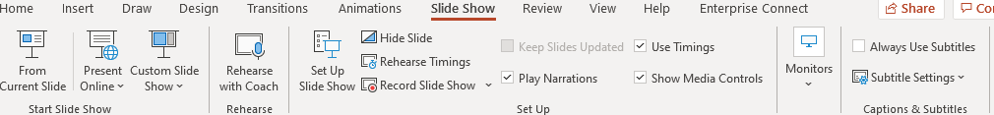

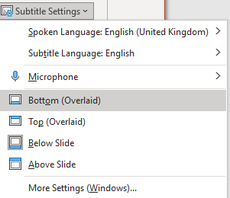
- Use Spoken Language to see the voice languages that PowerPoint can recognise and select the one you want. This is the language that you will be speaking while presenting.
- Use Subtitle Language to see which languages PowerPoint can display on-screen as captions or subtitles and select the one you want. This is the language of the text that will be shown to your audience. Choosing the same language as your Spoken Language allows you to provide closed captioning. This is especially relevant for accessibility for the deaf and hard of hearing.
You can turn subtitles on and off using the Subtitle toggle that appears in the bottom left of each slide when you are in ‘slideshow’ mode.

Glossary
Device: whatever you are using to access your work on – desktop PC, laptop or smartphone.
File Explorer: the ‘folder’ icon that displays along your bottom taskbar; the one you have been using to find your documents, downloads, pictures and desktop.
Windows Key: this is a bottom-left key on your keyboard with the Windows icon on it.
Application: the different programmes within O365 are called applications, e.g. Outlook, Word, PowerPoint, Teams. Often these are called Apps for short.
Icon: the ‘logos’ of the different applications (e.g. Word is a blue W, Excel is a green E, OneDrive is a blue cloud) or web browsers (e.g. Chrome is a coloured circle)
Desktop apps: applications that are available on your laptop/computer by clicking onto the icon. They may be on your bottom taskbar, or in your Start menu. You don’t have to be online to see and access them.
Window: In computer terms, a window is an area on the screen that displays information about a programme. You can have multiple windows open, displaying different websites, documents and applications.
Windows 10: the operating system of your device. Where Windows has a capital W, it means this system and not a window on which you can see your documents, websites, etc.
URL: short for Uniform Resource Locator, this is your web address. It shows the location of a document or website on the internet, including your OneDrive.
Microsoft 365 and Office 365: this is essentially the same thing and both names are used for the applications such as OneDrive, Outlook, Teams, Word, PowerPoint, Excel and OneNote.

