Using Microsoft 365 Translation Tools

Contents
Glossary 3
About Microsoft Translation Tools 4
Using a combination of tools 5
Dictate 6
Translate in Word and PowerPoint 8
Translate Document 8
Translate Selection 9
Language 11
Translate in Outlook 12
Using Outlook Desktop App 12
Setting your language preference 12
Translate an email you are writing 13
Translate a received email 14
Using Outlook Online 15
Setting your language preference 15
Translating a received email 16
Translate in Excel 17
Read Aloud 19
Translate in Windows 10 20
Translate in Edge Browser 23
Translate a webpage into English 23
Manually translate a webpage 24
Restore a webpage to its original language 25
Translate in Google Chrome 27
Translate websites from English 28
Translate in Microsoft Teams 30
Change the language of Teams controls 30
Translate your incoming messages 32

Glossary
Web browser: this is just what you use to get onto the internet, such as Google Chrome, Internet Explorer or Microsoft Edge.
Device: whatever you are using to access your work on – desktop PC, laptop or smartphone.
Cloud: in simple terms, the cloud is the internet. It's all of the things you can access remotely over the Internet, such as data and programmes. When something is in the cloud, it means it's stored on special internet computers (‘servers’) instead of just on your device.
Application: the different programmes within O365 are called applications, e.g. Outlook, Word, PowerPoint, Teams. Often these are called Apps for short.
Icon: the ‘logos’ of the different applications (e.g. Word is a blue W, Excel is a green E, OneDrive is a blue cloud) or web browsers (e.g. Chrome is a coloured circle)
Desktop apps: applications that are available on your laptop/computer by clicking onto the icon. They may be on your bottom taskbar, or in your Start menu. You don’t have to be online to see and access them.
Window: In computer terms, a window is an area on the screen that displays information about a programme. You can have multiple windows open, displaying different websites, documents and applications.
Windows 10: the operating system of your device. Where Windows has a capital W, it means this system and not a window on which you can see your documents, websites, etc.
Ellipsis: the 3 dots you will find next to various names and commands. An ellipsis tends to be used when there is not enough room to display all options.
Microsoft 365 and Office 365: this is essentially the same thing and both names are used in this guide. It covers Word, Excel, Outlook, Teams, PowerPoint, OneNote, Windows 10 and Microsoft Edge.
Downloading: means your computer is receiving data from the Internet. For example, if you want a document from a website, you can download it to your desktop.
Proofing language: this means that your system will spellcheck, etc against that language. Your default is English but you can also set other languages so Office 365 can check spelling and grammar and to prevent the words being underlined in red.
System tray: this is the area in bottom right of your device which displays your time and date, the weather, battery, network and volume.
File Explorer: the ‘folder’ icon that displays along your bottom taskbar; the one you have been using to find your documents, downloads, pictures and desktop.

About Microsoft Translation Tools
Microsoft 365 has some translation tools for you to use. The translations are done by Microsoft Online Translator service and, therefore, will not be perfect but will produce a useful translation in the absence of qualified interpreters and translators. Please do not use them as official translations but they could help you in your day-to-day role.
Microsoft’s icon for translation tools is always an ‘a’ alongside the Japanese A syllable so you will be able to look for that across all Microsoft applications.
To use the Translation tools, you must be connected to the internet.
The Translate feature is currently available for Word, Excel, OneNote, Outlook, and PowerPoint. You can also translate webpages on Microsoft Edge.
Languages currently supported by this online service are:
EUROPE
Albanian
Bosnian
Bulgarian
Catalan
Croatian
Czech
Danish
Dutch
English
Estonian
Finnish
French
German
Greek
Hungarian
Icelandic
Irish
Italian
Latvian
Lithuanian
Maltese
Norwegian
Polish
Portuguese
Romanian
Russian
Serbian
Slovak
Slovenian
Spanish
Swedish
Ukrainian
Welsh

SOUTH-EAST ASIA
Filipino
Hmong Daw
Indonesian
Khmer
Lao
Malay
Myanmar (Burmese)
Thai
Vietnamese

ASIA
Arabic
Armenian
Assamese
Azerbaijani
Bangla
Cantonese
Chinese (traditional and simplified)
Dari
Gujarati
Hebrew
Hindi
Japanese
Kannada
Kazakh
Korean
Kurdish
Malayalam
Marathi
Nepali
Odia
Pashto
Persian
Punjabi
Tamil
Telugu
Turkish
Urdu

OCEANIA
Fijian
Māori
Samoan
Tahitian
Tongan

THE AMERICAS
French (Canada)
Haitian Creole
Inuktitut
Portuguese (Brazil)
Queretaro Otomi
Yucatec Maya

AFRICA
Afrikaans
Amharic
Malagasy
Swahili
Tigrinya

Using a combination of tools
This guide tells you what tools are available to you, where to find them and how to use them.
- Dictate with different language options (a more limited list than Translate options)
- Translate documents and text in Word, PowerPoint, Outlook
- Translate webpages in Edge browser (and Google Chrome if preferred)
- plus a Read Aloud feature that could occasionally help
Remember that you can ‘mix and match’ these functions because they are within the Office 365 toolkit.
Full instructions are on the following pages, but examples of using translation tools are:
You are working face to face with a Polish family who speak little English and are struggling to communicate with you. (See pages 6-10 for full guidance)
  - Open a Word document and select the Dictate command
  - Set Polish as the dictation language and ask one of them to talk
  - Dictate will type in Polish as they speak
  - Once done, use the Translate button in Word to convert this text into English for you to understand
  - Then do the same yourself so the Dictate language is English and you use Translate to convert to Polish.
  - You could use the Read Aloud feature to have the Polish read out to them if their reading skills are poor. However, Read Aloud speaks in an English accent and will be difficult for native speakers to understand. This guide will be updated with further advice as soon as the process for other languages in Read Aloud is agreed.

You need to send an email to a family that only reads Urdu. (see pages 12-14 for full guidance)
  - Type your message in English into a blank email in Outlook
  - Use Translate to enable Outlook to convert your text into Urdu
  - Click the Urdu translation in the Translator pane to place it into your email instead of the English.
  - Note: if the Outlook method shown later is too complicated, you can always use Word to translate, then attach the document to your email.

You are trying to help a French-speaking young person from Congo understand how to claim housing benefit from the gov.uk website. (see pages 28-29 for full guidance)
- Open the gov.uk website
- On a separate browser tab, open Google Translate and set the ‘To’ language as French
- Paste the webpage link of gov.uk page into Google Translate and click the translate button
- Your webpage will now open in a new tab in French.

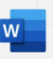
Dictate
Dictate lets you use speech to ‘write’ in Word, Outlook and PowerPoint applications as long as you have a microphone and an internet connection.
The Dictate feature has ‘spoken language’ settings that could help you with different languages.
Note: once you click on the Dictate button, the controls are the same across all three applications.

In both Word and PowerPoint you can find the Dictate feature in the Home tab.
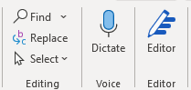
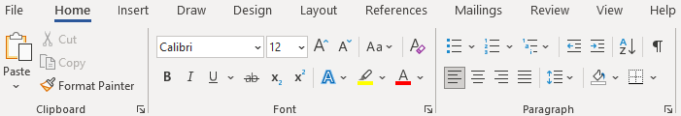
Click on Dictate and the command icon will then display as ‘recording’ with a red button.
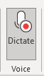
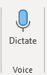

From this you can start speaking immediately and a box will display on which you can tap the mic icon to resume or pause.
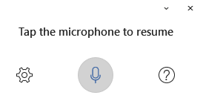
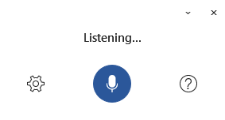

In Outlook you need to open a new email first, then Dictate sits under the Message tab.

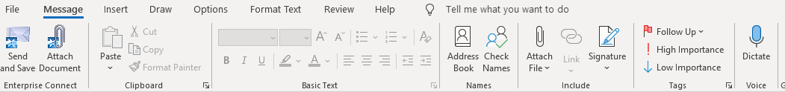

As with Word, clicking on Dictate will open a ‘listening’ box and will change the Dictate icon to display as recording with the red button.

Once in Dictate, you can click on the settings cog icon to choose the dictation language.

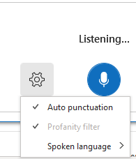

If you use Dictate, bear in mind is that the list of languages delivered by this is not nearly as extensive as those in the Translation services, which will limit its use. It’s a good idea to use this guide to familiarise yourself with the languages covered by Dictate, which are:

- Chinese, English, French, German, Italian, Spanish and Mexican Spanish

There are also ‘preview’ languages - these may have lower accuracy or limited punctuation support than those above but, of course, this is better than no translation should you need help.
- Canadian French, Danish, Dutch, Finnish, Hindi, Japanese, Korean, Norwegian, Polish, Portuguese and Brazilian Portuguese, Russian, Swedish, Thai, and Taiwanese Chinese.

You can choose one of these languages for someone to dictate in and it will type in that language for someone to read or for you translate into English. This Outlook screenshot shows an example after saying ‘Hello, how are you’ to Dictate in Spanish, French, Russian and Japanese.

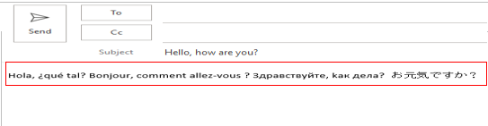

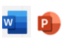
Translate in Word and PowerPoint
The Translation command can be found under the Review tab’s Language group on both Word and PowerPoint.
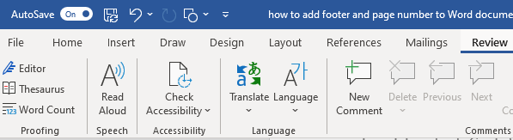

In Word, if you click on the drop-down arrow on Translate, you get a choice of ‘translate selection’ or ‘translate document’. Please note that for PowerPoint there is no ‘translate document’ choice, only text selection.
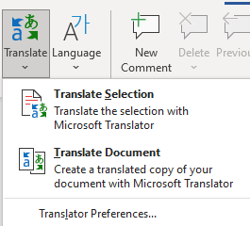

Translate Document
An excellent feature of ‘Translate Document’ in Word is that, when it translates, it opens a new document for your translation, keeping your original untouched so you don’t need to worry about losing your master copy. With a new translated copy, you can print or email it to your recipient in their own language.
When you choose ‘Translate Document’, it opens a Translator pane to the side of your document for you to select the language you want to translate into. You can also obviously change the ‘from’ language should your current document not be in English and it doesn’t auto-detect it correctly.
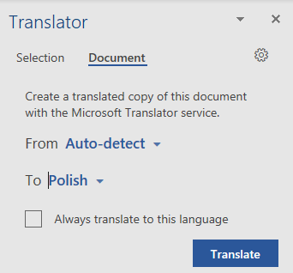
Then when you click the blue Translate button, a new Word document opens displaying the new language. The pane tells you that translation is complete.
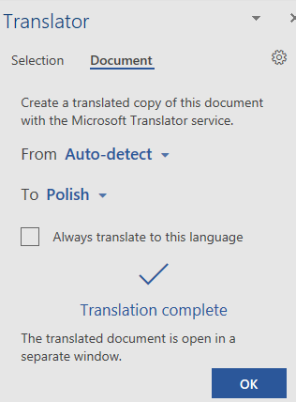
If you only ever need to translate into one language, you can set it as the go-to language by ticking the ‘always translate to this language’ box.
Click on the X to come out of Translator.

Translate Selection
Sometimes you may only need or have a section or sentence of the document in another language. To translate only a few words or part of your document, highlight the chosen text with your cursor and choose ‘Translate Selection’. In PowerPoint, just click on Translate in the Language group on the top ribbon.
A Translator pane will open to the right for you to choose your From and To languages.
Once you have done so, it displays the text both in English and, for example, Polish.
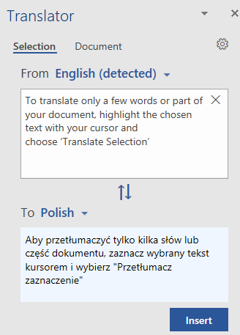
Click on Insert to transfer the translated text into your document – it will go where your cursor is.
Underneath the translation, you may get a list of different translations of a word. This is because many languages have different words for the same English word and vice versa, so the online services is trying to help you by giving examples of context. Think of the word ‘form’ in English and how many different meanings it has.
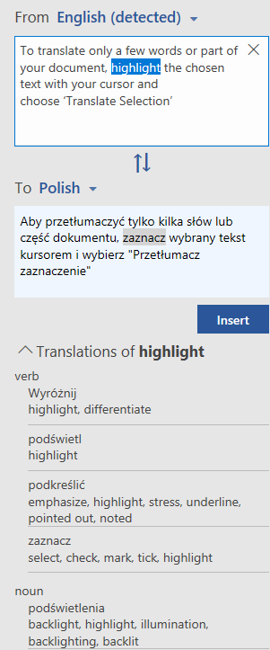

Click on the ellipsis (3 dots) next to an option to expand to show examples of usage.
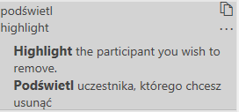
If the meaning you had in mind is a different word choice to that given in the translation, click the paper icon to copy the one you prefer. Paste that word over the one you wish to replace, using the words in bold as a guide to like-for-like.

Language
The Language command appears in both Word and PowerPoint and allows you to set a language for the proofing tools such as spell checking.
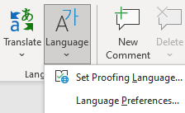
If you choose ‘set proofing language’, it displays a box to make your choice.
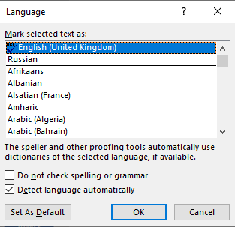

If you choose ‘language preferences’, the Word Options box appears (the same as if you go into File in top left of Word, then Options). You can set authoring and proofing languages but you may have to install the software for other languages, as is the case with Russian below.
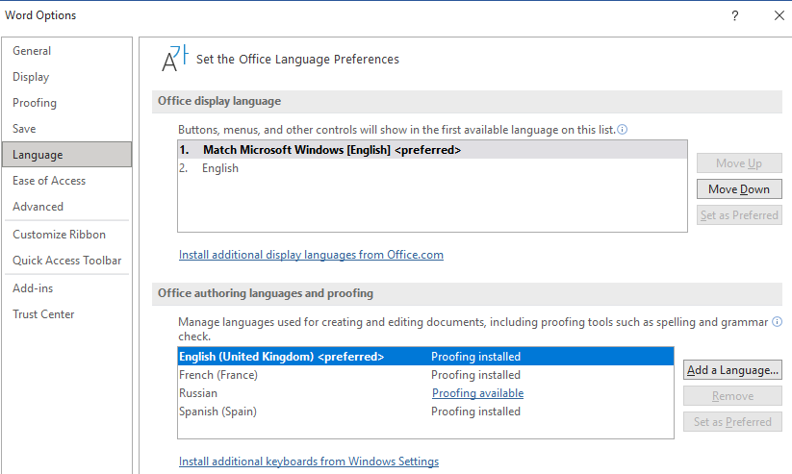

Translate in Outlook
In Outlook, you can translate words, phrases and full messages when you need them. You can also set Outlook to automatically translate messages you receive in other languages.

Using Outlook Desktop App
On Outlook desktop, Translator is found on the ribbon under the Home tab.
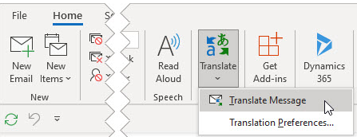
Select the received message you want to translate, then on the Home tab choose Translate and then ‘translate message’ from the drop-down arrow.
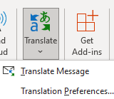

Setting your language preference
Translator in Outlook works a little differently from Word and Excel. You will need to have set your language preference first if you haven’t already done so. Click on ‘Translation Preferences’ and it will take you into Language in Outlook Options.
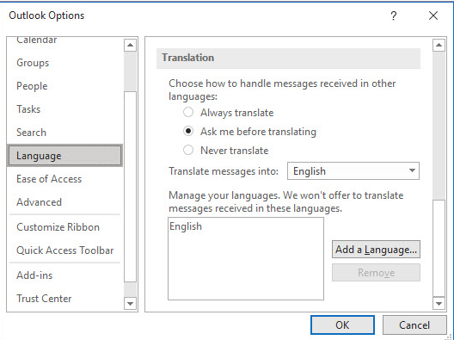
If English is not your first language and you’d prefer English messages to be translated into another language, click on the ‘translate messages into’ drop-down box to select another language.
You can also set Outlook to always translate from other languages, ask you first or never translate.
If the emails fail to translate or don’t have the ‘translate to xxx’ option, you can right-click and use Translate to do so - Translate Message will switch the email into your chosen language as long as you have set it as above.
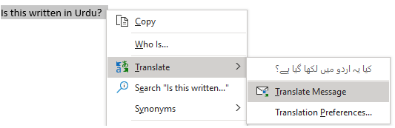
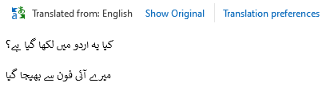

Translate an email you are writing
Once you have set your language preference (this example is for Urdu) you can select text and right-click to choose the Translate command to translate to your required language when you are writing an email. When you click on the translated text, it gets inserted into the message you're writing.
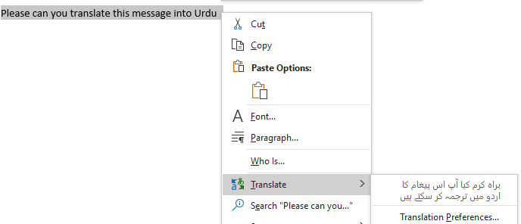
Because you have set the preference language as Urdu, Outlook will recognise it and will not perform spellcheck in English (so doesn’t underline it all in red!)
Once you have sent your translated email, you can switch your language preference back to English until you have to do an Urdu translation again. As before, you can do this in your Home tab’s Translate command.
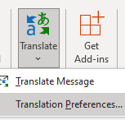

Translate a received email
For received emails, you should not have to set your language preference if you work in English. When you receive an email in another language, you'll see a prompt at the top of the message asking if you'd like Outlook to translate it into English (or whatever you have set as your preferred language).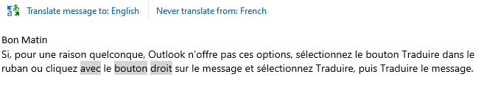
You can respond in two different ways:
- In the message, select ‘Translate message to English’. Outlook replaces the message text with translated text.
After you've translated the message, you can select ‘Show original’ to see the message in the original language or ‘Turn on automatic translation’ to always translate messages to your preferred language.
- Or select ‘Never translate from….’at the top of the email. Outlook won't ask you if you'd like to translate messages in the future. This can be used if you have a second language you are comfortable in and wish to retain the emails in that language.
If Outlook doesn't offer these options, select the Translate button from the top ribbon on the Home tab, then choose ‘Translate Message’.
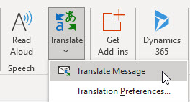

If you would like to only translate a word or phrase within your received email, you can highlight the word(s) with your cursor, then right click to select Translate. The translation will appear next to the Translate command.
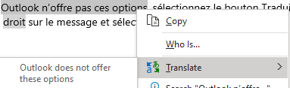

Using Outlook Online
The web version of Outlook looks a little different but the mechanics of translating are similar.

Setting your language preference
You can set your language by going into Settings (cog icon in top right) and choose ‘View all Outlook settings’ at the bottom.
Then choose Message Handling and scroll down to the Translation section. If you work in English, the ‘translate messages into this language’ box should say English (it defaults to this). 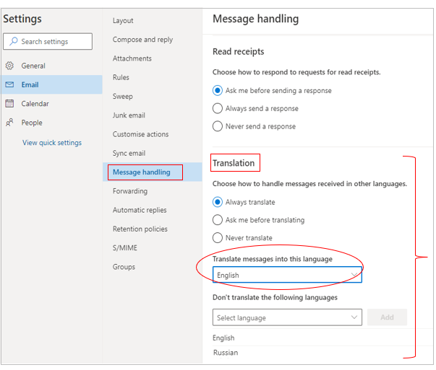
However, if English is not your first language and you’d like your messages to be translated into your native language, change this field. You can also select your language in the ‘don’t translate the following languages’ so that Outlook leaves the email in your preferred language.

Translating a received email
For messages you receive in other languages, you can choose for Outlook to always translate, ask first, or never translate.
When you receive an email in another language, Outlook will ask at the top of the email if you want to translate it into English. Click on that little link and your text will be translated within the email.
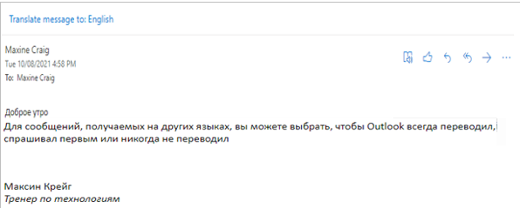

You can also go into the email’s ellipsis area (the 3 dots in top right), scroll down to View and choose ‘Translate’. The translation will take place within the email you are reading and will be into the language you have nominated in the Settings box on page 15.
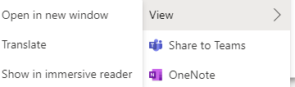

There is a ‘show original message’ link for you to return to the original language, should you need it, as with this example having been translated from English into Russian.
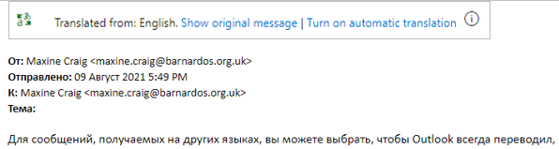
Note that for these tools to work in Outlook, you have to have Conversation mode enabled – go into Settings > View all Outlook Settings> Email > Layout. Then tick ‘show email grouped by conversation’.

Translate in Excel
The Translation command can be found under the Review tab’s Language group.
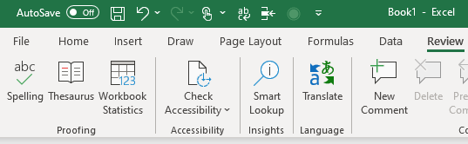
With Excel, you do not get the choice of translating selected words or translating a whole document. You just click on the Translate command and Translator pane appears on the right.
Set your To language and the translation will display. It should auto-detect the From language.
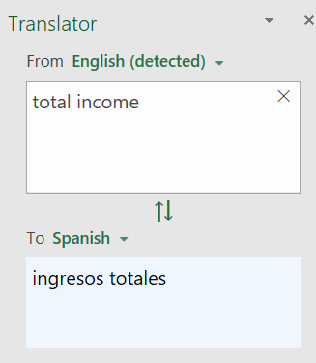
Unfortunately, for Excel there is no Insert button so you have to copy and paste the translated text into your spreadsheet.
As with Word, underneath the translation you may get a list of alternative translations of a word. This is because many languages have different words for the same English word and vice versa, so the online services is trying to help you by giving examples of context.
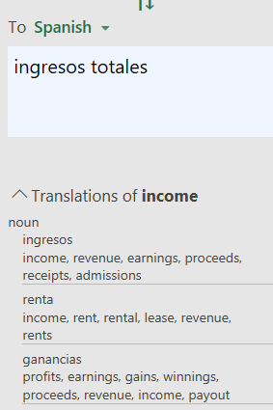
Click on the ellipsis (3 dots) next to an option to expand to show examples to help you decide which word is best.
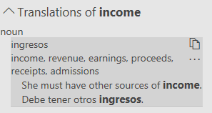
If the meaning you had in mind is a different word choice to that given in the translation, click the paper icon to copy the one you prefer. Paste that word over the one you wish to replace, using the bold words as a guide to like-for-like.

Read Aloud
There is a Read Aloud feature available in Outlook and Word that speaks and highlights each word.
You could use this to read out your translated text if you have native speakers with poor reading skills even in their own language. However, please note that it only reads the translation in an English voice, which will sound odd to them and may not be fully understood. Nevertheless, it may be worth trying in cases of low literacy.
Obviously, Read Aloud does not recognise alphabets outside of the standard Latin, such as Russian, Thai, Hindi, Japanese, etc.
Research is being done to establish how we can best set Read Aloud to work in other languages. This portion of the guide will be updated when this is established.
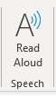
Outlook (on the far right of Home tab)

Word (Review tab)
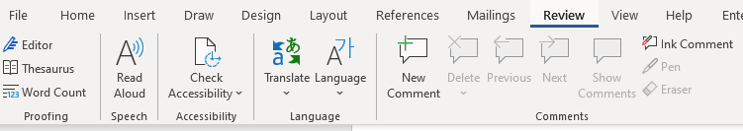
Once switched on, a small box will appear to the right of your document with play/pause, forward and rewind controls. Click on the Settings icon to speed up or slow down the reading voice, and to choose a male or female voice.
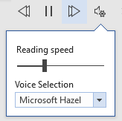

Translate in Windows 10
You can set a different language for Windows 10 so that your displays are not in English, the default language.
Go into Settings and choose Time and Language
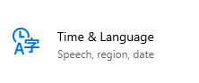
Then choose Language from the list on the left
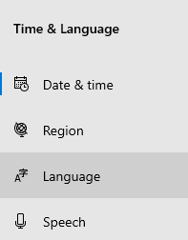
You can see which language your displays are currently in.
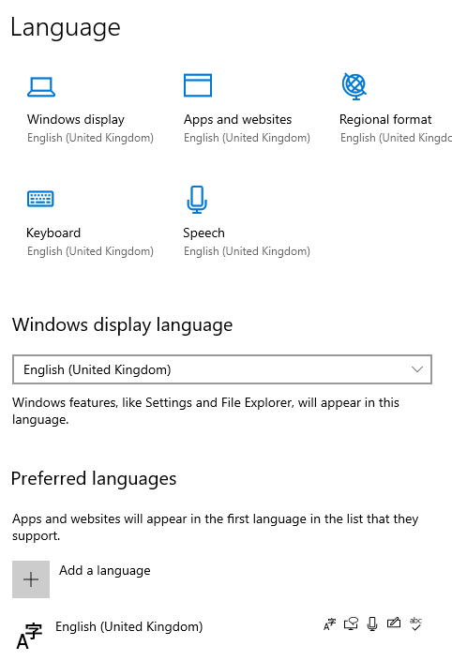
To add a language, use the Add language button and select your chosen language from the extensive list using the scrolling tool to the right of the list.
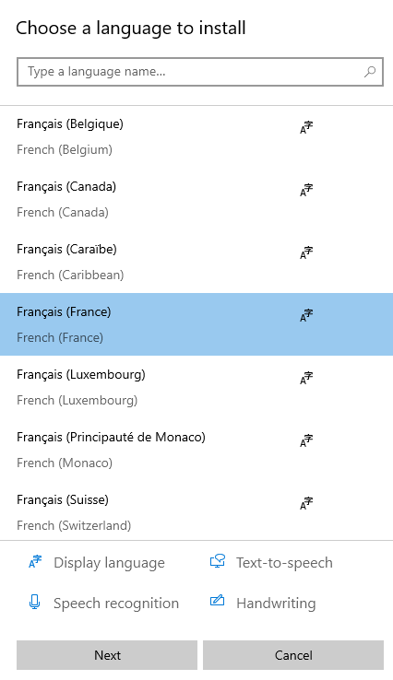
Click Next, make sure “install language pack” is ticked, then click Install.
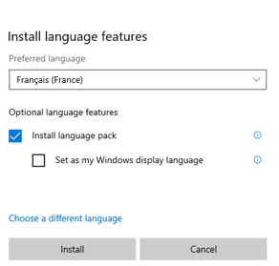
You will see it ‘pending’, then ´downloading´, as with French below.
All of your downloaded language packs will now appear in your Windows display language options box.
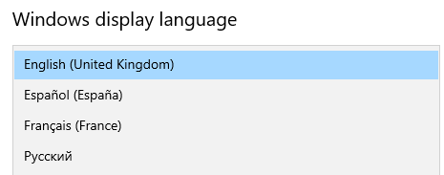

For Windows to display in another language, select it from the drop-down arrow. You will need to sign out and back in to enable this switch. Your selected language will now appear at the top of your preferred languages list.
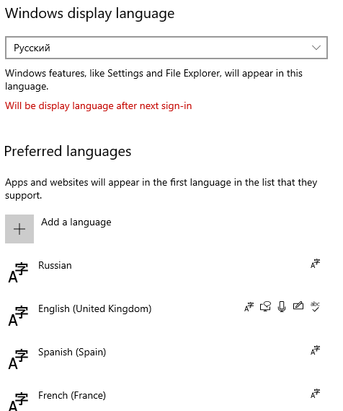
Once you have set your new language, all displays within Windows will be in that language when you next sign in. This includes Settings, Start Menu, Notifications, Taskbar and System Tray and File Explorer.
IMPORTANT: if you do change the language of your Windows 10, when you log in on your device you must select an English keyboard in bottom right of the initial log-in screen. Choose ENG to make sure your keyboard types the correct letters for your password.

Translate in Edge Browser
Microsoft Edge supports translation for more than 60 languages. The browser will automatically prompt you to translate a webpage when the page you're opening is in a language other than those listed under your preferred languages in Settings.

Translate a webpage into English
Open a webpage in Microsoft Edge. The browser detects the language of the page and a menu appears asking you to confirm that you want to translate the page.
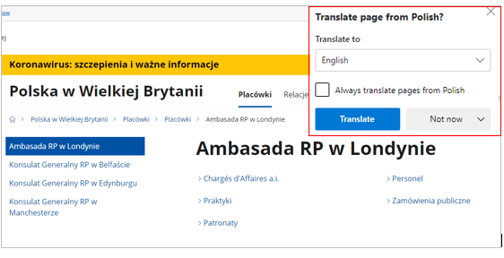
Do any of the following depending on your preference:
- In the ‘Translate to’ list, choose the language you want the webpage to display in. The default is the language you've set for Microsoft Edge, so currently English.
- To translate the page, click ‘Translate’.
- To automatically translate from the source language, tick the ‘Always translate from (language)’ box.
- To skip translation, select ‘Not now’ for no translation this time or ‘Never translate (language)’ to never have the panel appear when you view a page using that language. Even if you select ’never translate’ you can still manually change this at a later date.
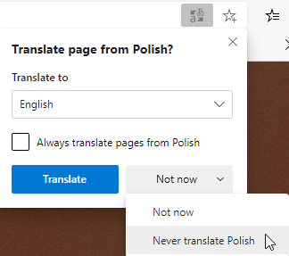
There will be a Translate icon in the address bar of this website you are viewing. The address bar is along the top where the ‘https’ details are for that website.
If you select this icon, the drop-down box that appears also shows the status of the translation.
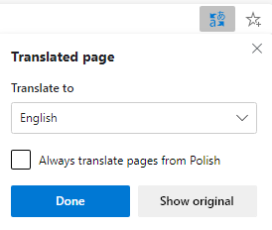

Manually translate a webpage
If you've set Edge to never translate a specific language, you'll still be able to translate it at any time. Just select the Translate icon in the address bar and the menu will appear.
After the page has been translated, you can translate the page again to a different language or to restore the page to its original language.
To translate the page again to a different language:
- On the address bar, select the Translate icon.
- In the ‘Translate to’ drop-down box, select the language you want.
- Select Translate
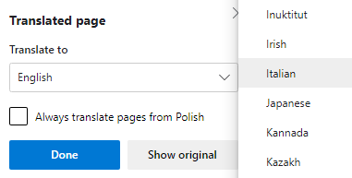
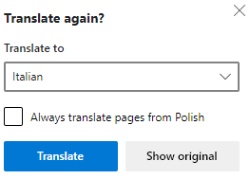

Restore a webpage to its original language
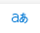
On the website’s address bar, select the Translate icon
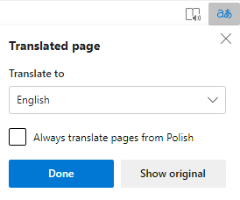
Select ‘Show original’ from the translation box.
Turn on translation in Microsoft Edge
Microsoft Edge is set to offer translation by default, but if this setting has been turned off for some reason, you'll need to set it again. To set whether Microsoft Edge offers translation:
At the top corner of the browser, select the ellipsis which is ‘Settings and more’.
Then scroll down to find Settings.
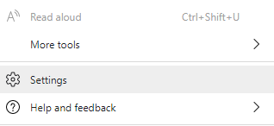
This will open your Settings page on Edge where you will find Languages in the list on the left-hand side. Click on Languages.

You will see a whole section on language settings and will need to make sure the toggle button is on for ‘offer to translate pages that aren’t in the language I read’.
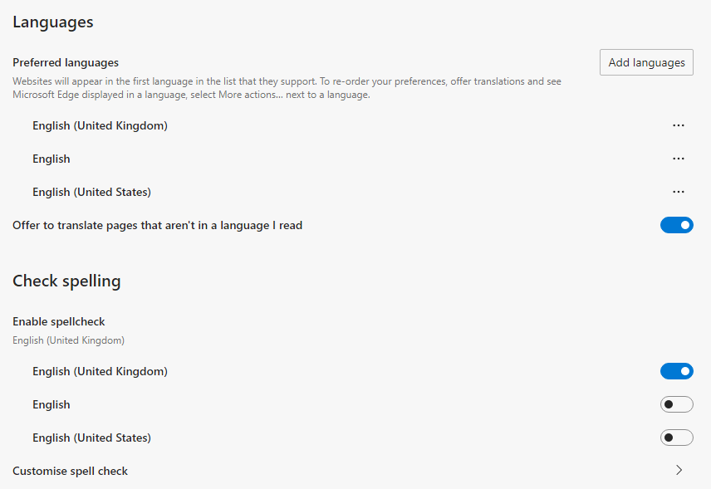

By default, Microsoft Edge uses the same language as your system. For information about how to set the language for Microsoft Edge, see Use Microsoft Edge in another language.

https://support.microsoft.com/en-us/help/4532129/microsoft-edge-use-in-another-language

Translate in Google Chrome
Whilst not part of Microsoft 365, some of you will be using Chrome as your web browser. Here is how to translate webpages in Chrome.
If you open a webpage that is not in English (or your set language), Google will ask if you want to display it in English.
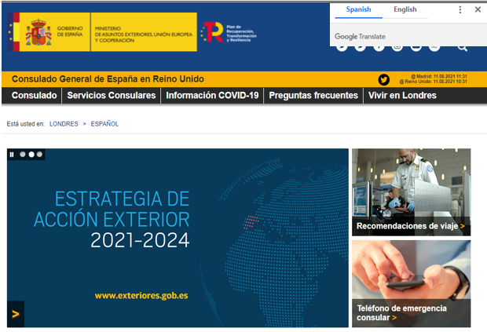
The ellipsis (3 dots) in the translate box will allow you to access other options too – choose another language instead, always translate this language, never translate this language, never translate this site.
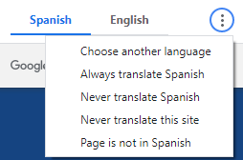
If the Translate box does not appear, you can still translate the page by using the Google Translate icon in the top right of the webpage’s address bar.

Translate websites from English
If you have an English webpage that you want translating for a service user, you can do this too in a few steps. For example, you want to translate a gov.uk webpage.
This method will work for both Edge and Chrome browsers.
Open your gov.uk webpage.
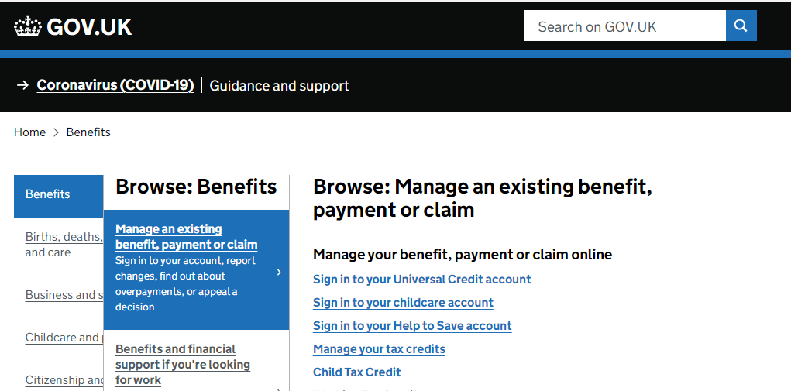

Open a new tab or window with https://translate.google.com/
Google Translate will then open for you.
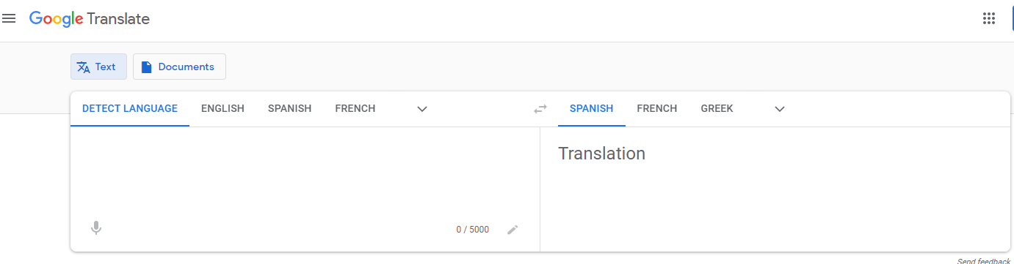

Copy the URL from your original gov.uk webpage: this is the webpage address along the top.

Choose your ‘To’ language - this example is French. You use the drop-down arrow to find other languages.
Paste the whole link into your Google Translate browser on the From side and the link will display identically in French box.
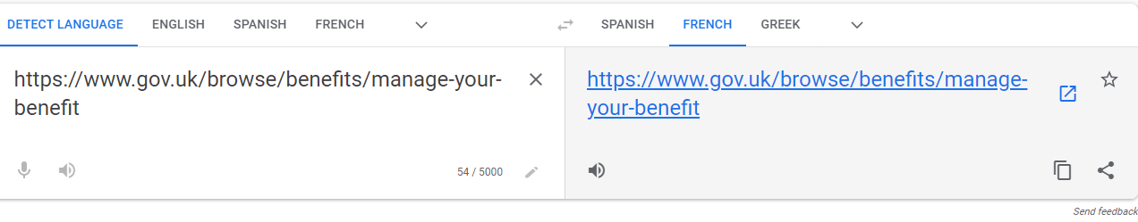
Then click onto the Translate icon
A new tab will open with your translated webpage:
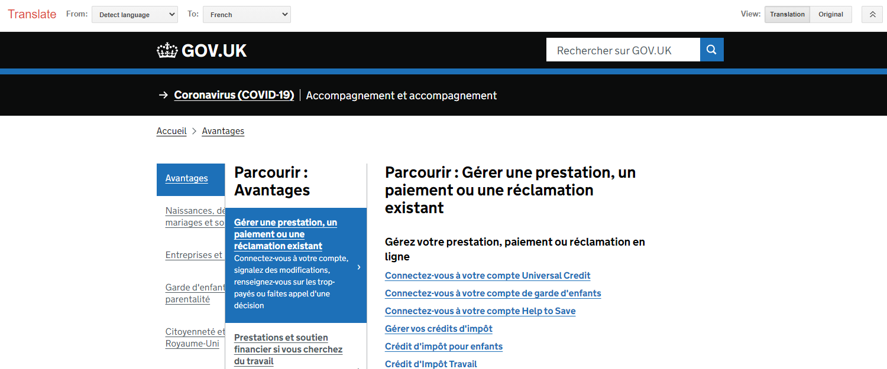
You can browse the entire website in that language by clicking links on the site — as long as you stay within the Google Translate tab. The Translate toolbar at the top enables you to do a couple of other things:
- From the To drop-down menu, you can even change the translation language again whilst staying on the website.
- Next to View, you can toggle back and forth between the translated website and the site in its original language.

Translate in Microsoft Teams

Change the language of Teams controls
You can change the language of your Teams app if English is not your first language.
When logged into Teams, go into your account at top right – click onto your initials or picture.
Choose Manage Account
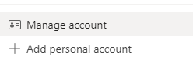
In Settings, choose General and you will see a Language section.
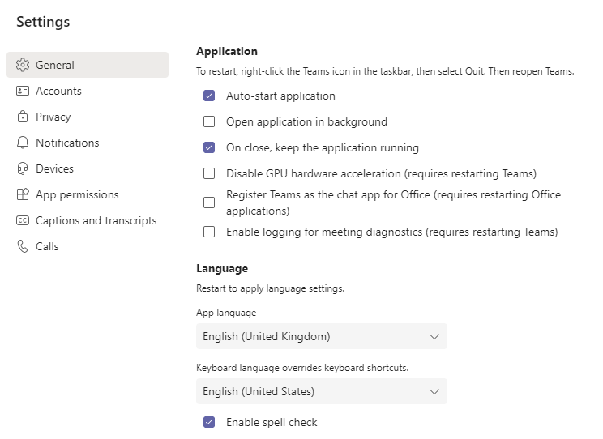
Change the ‘App language’ to the language of your choice, for example, Spanish. You will have to restart Teams (but NOT your computer) to enable this change.
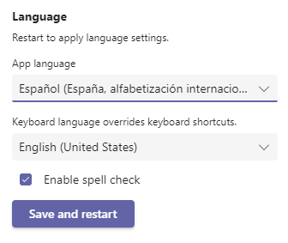
Once Teams is restarted, it will all display in Spanish or whatever language you have set. This includes:
- Your command bar and chat space -
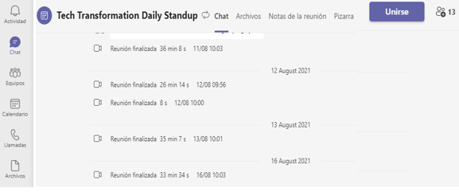
- Your meeting controls, both for joining meetings and when you are in meetings -
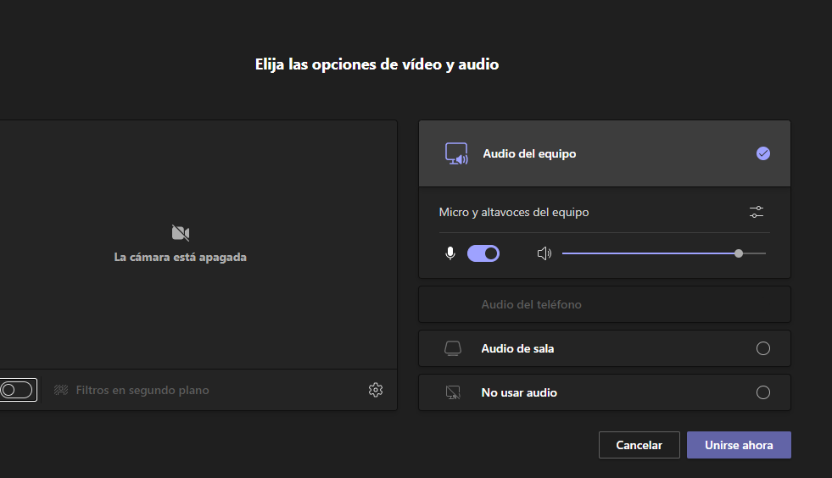
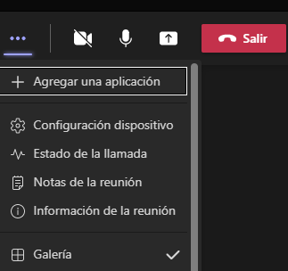

- Your whole Account area which is where you would return the language setting to English if needed -
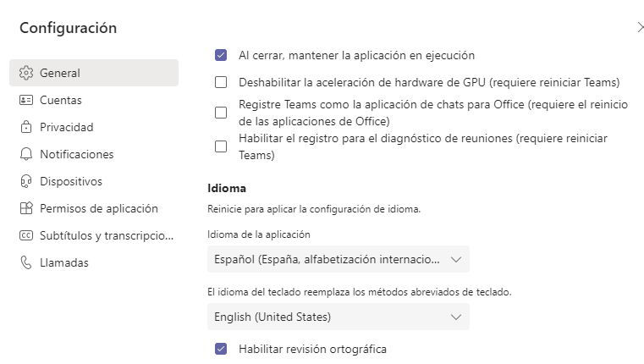

Translate your incoming messages
Your messages within the Chat spaces will be in the language they are sent, so you have to translate them yourself from English if you want them into your settings language.
You can do this easily by hovering over the message and clicking into the ellipsis (3 dots)
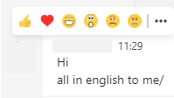
Choose Translate (obviously the word ‘translate’ will be in the language you have set) and the message will convert to, for example, Spanish.
Notice that the Microsoft translation icon now appears on the translated message.
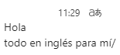

If you are working in English and receive a message in another language, click into the ellipsis on the message and select Translate to see it in English.
