This guide will help setup access to Office 365 on your existing Corporate iOS device.
A video is also available here.

Essentials
Check the version of iOS on your device to make sure it’s compatible. How to check and update your iOS version? As of September 2021 your device will need to be running a minimum of iOS 13.

My device is ready
Install the Intune Company Portal App from the Apple App Store.

My device is running an older version of iOS
You’ll still be able to access Office 365 from your device but will need to use the Web version instead. Open this link in the browser on your device. You do not need to proceed with the remaining steps in this guide.

Setup
Please note that the steps below may vary depending on the version of iOS installed.

- Open the Intune Company Portal App and select Sign in

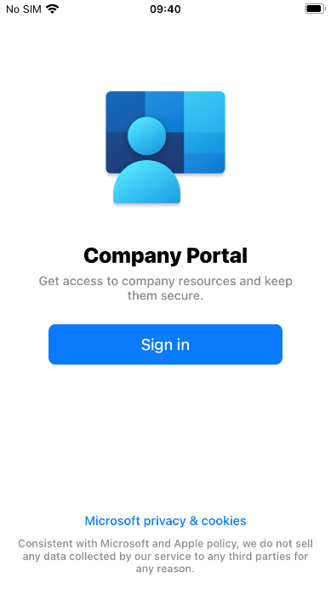

- Enter your Barnardo’s email address and select Next

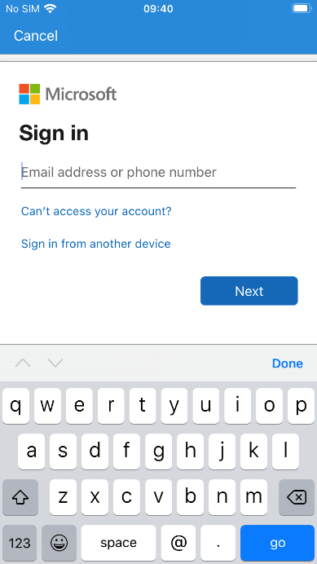

- Enter your OKTA username and password and select Sign In

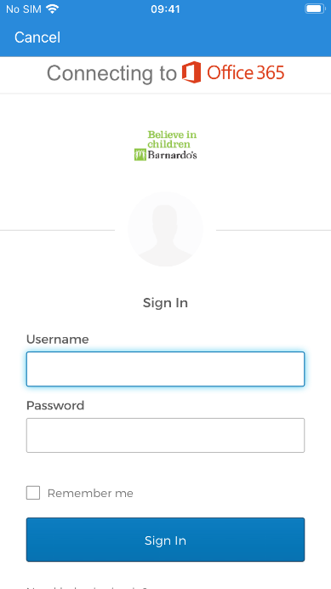

- Respond to the OKTA MFA prompt (this can be either an SMS message, phone call, push notification or code from the OKTA Verify App on your device)

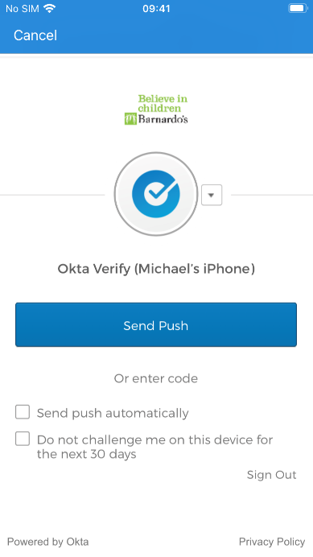

- Select Ok

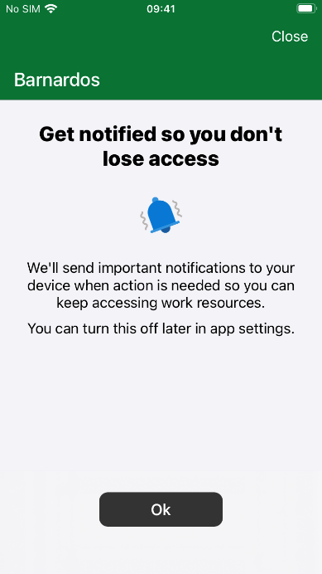

- Select Allow

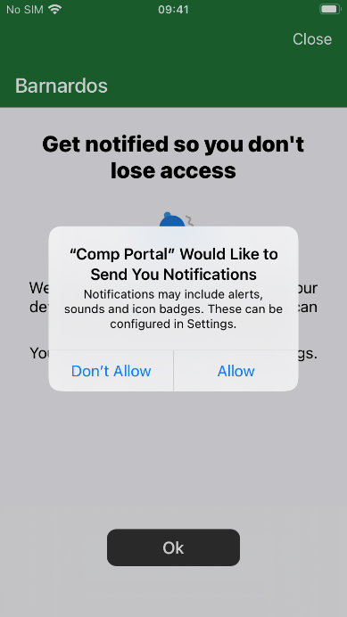

- Select Devices at the bottom of the screen

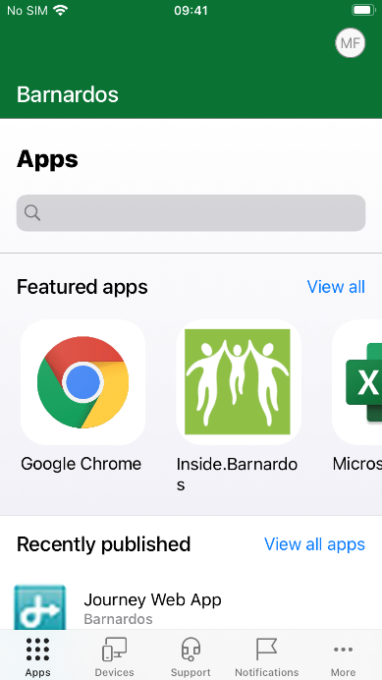

- Select your iOS device (with the description “This is the iPhone/iPad that you’re currently using.”)

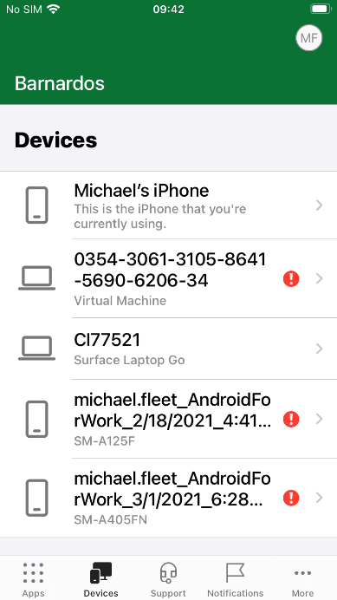

- Select Begin setup

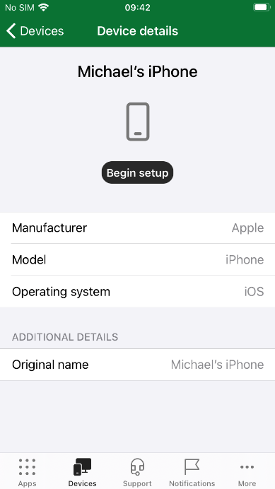

- Select Begin

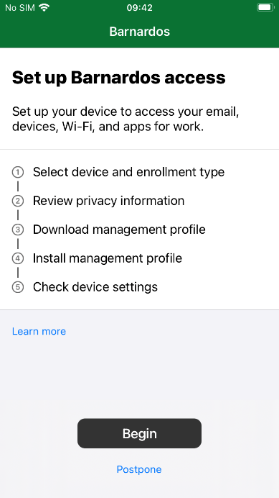

- Click ‘Barnardos owns this device’ and select Continue

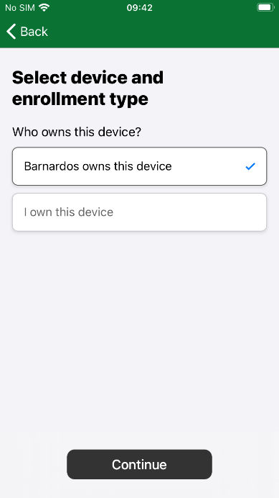

- Select Continue

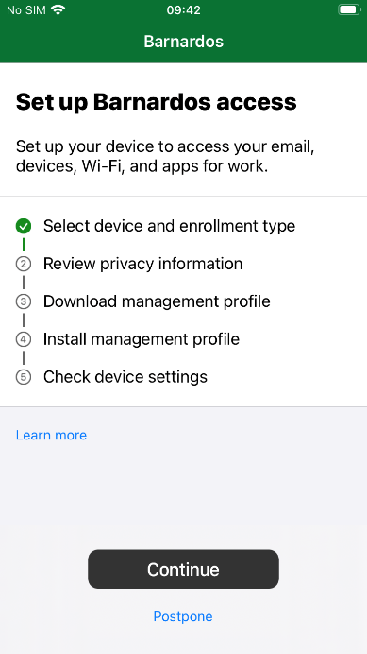

- Read the policy and select Continue

The most up-to-date version of the policy can be found at inside.barnardos.org.uk by searching for “Smart mobile device policy”.

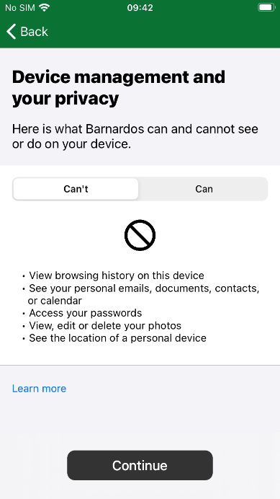

- Select Continue

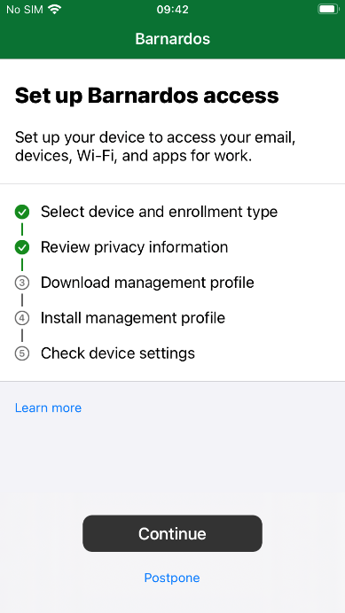

- Select Allow

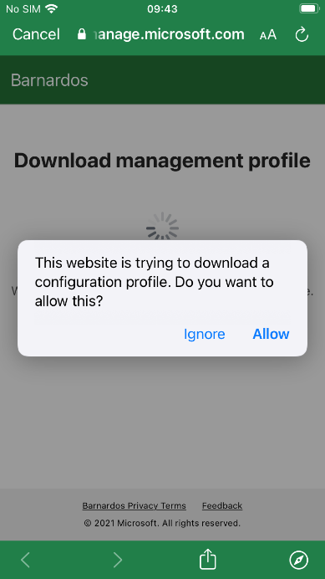

- Select Close

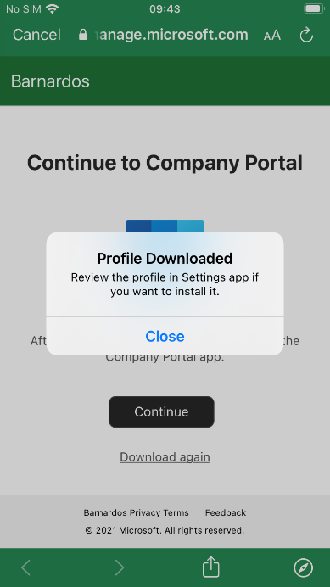

- Open the Settings App (but leave the Intune Company Portal App open) and select Profile Downloaded

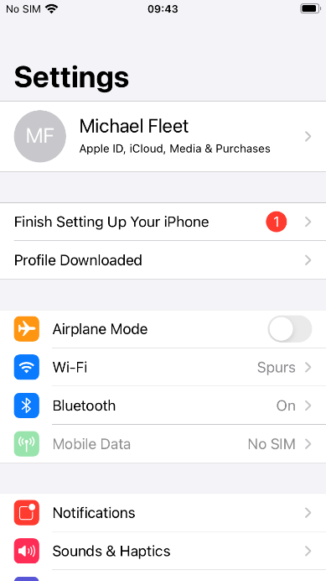

- Select Install

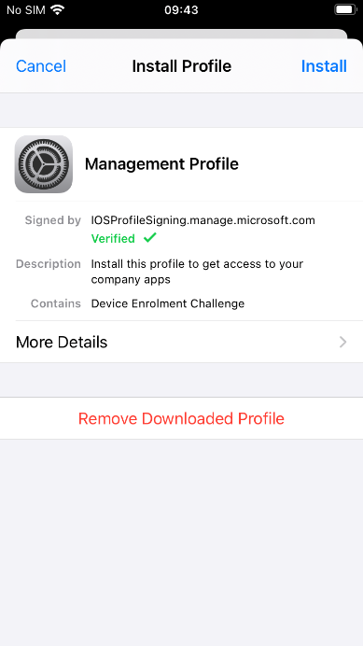

- Enter your iOS device passcode and select Done

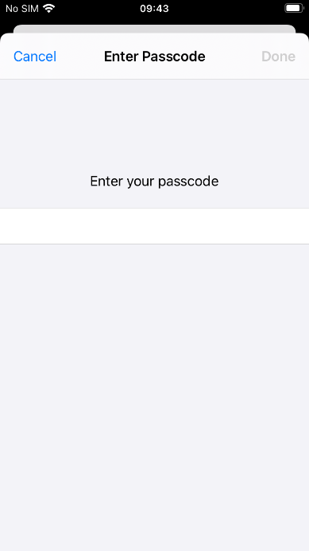

- Select Install

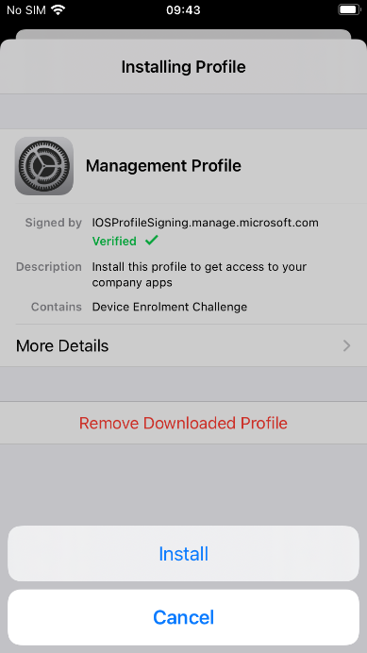

- Select Install

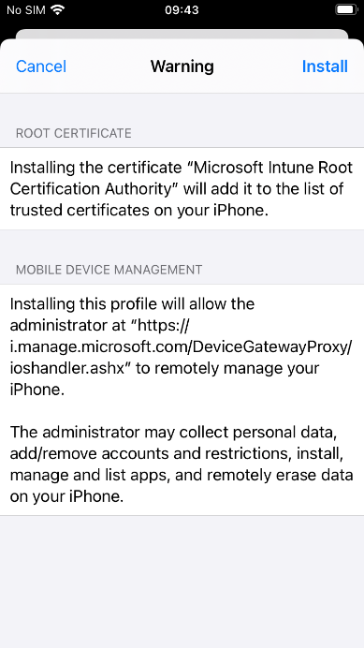

- Select Trust

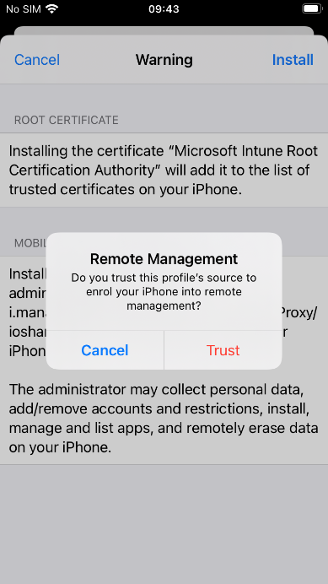

- Select Done

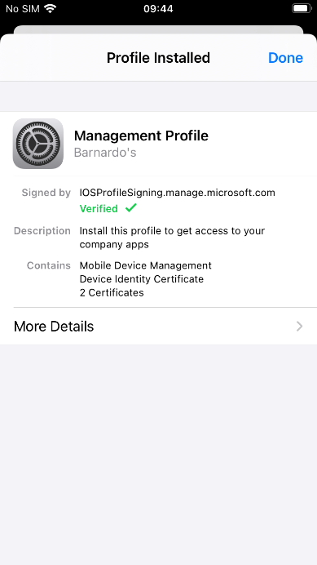

- Close the Settings App and return to the Intune Company Portal App

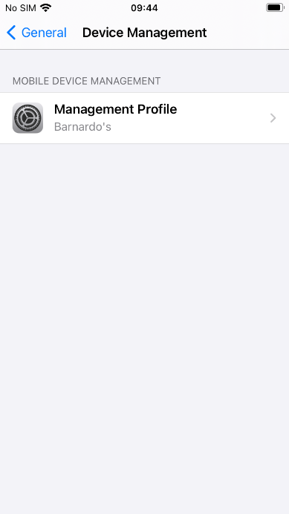

- Select Continue

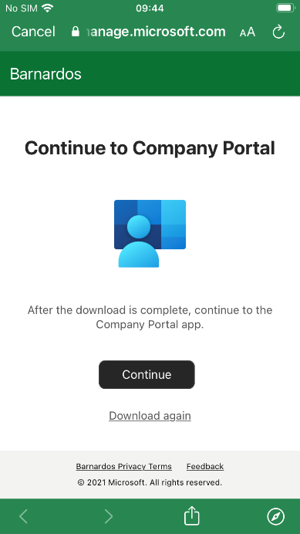

- Select Done

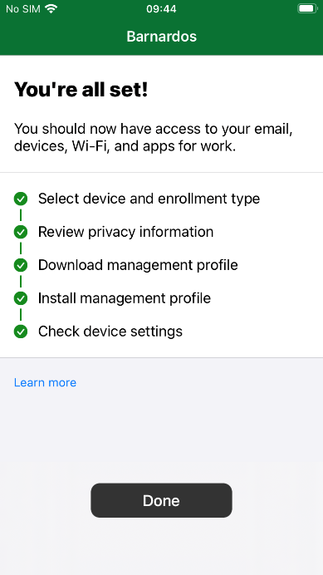

- Your device is now setup

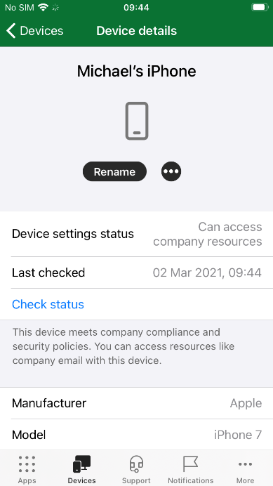

- You can install Apps e.g. Microsoft Outlook*, from the Intune Company Portal through Apps at the bottom of the screen.

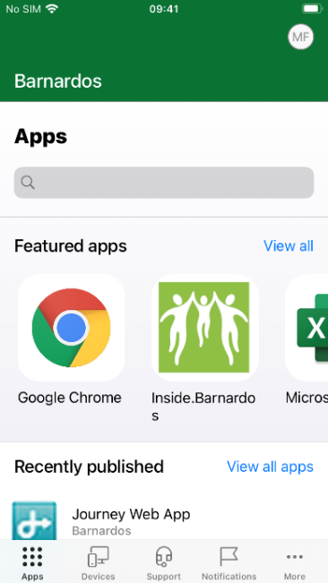

* The Office 365 Apps are supported on iOS 13+ however you can still install a shortcut and access the web version through the Company Portal – search for the Office 365 Portal App

Guidance on setting up and using Outlook is available on Inside.Barnardos here.

