Zoom Guidance
Schedule a meeting
- Login to Zoom - https://zoom.us/
- Login Details: *****
- Click Meetings
- Click Schedule a meeting
  - Add topic
  - Enter Start time and duration
  - Ensure audio is set as both and location is UK
  - If it is a large meeting ensure that mute participants on entry is selected
  - If you are recording the meetings make sure automatically record meeting and ensure that it will save locally. (After the meeting ends the file will automatically download on the hosts computer)
  - Save meeting, and copy invite information
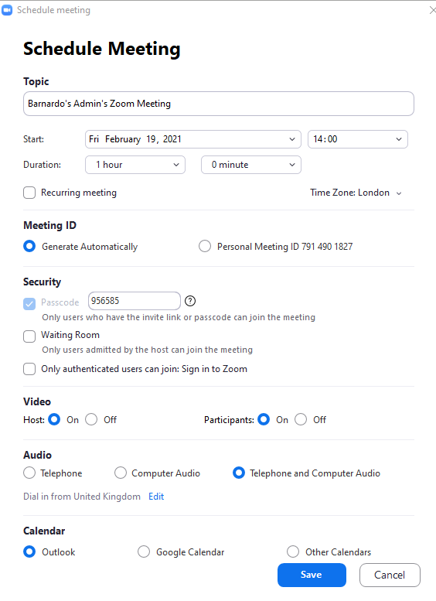

Start meeting 15 minutes before
- Check you can connect to the audio and video
  - If this doesn’t work go into meeting settings in zoom, and double check that audio is set as both and not just phone.
- Test sharing something on screen
  - If this doesn’t work, ensure you are the host.
  - If you are, click on Share settings in zoom, and all for everyone to share their screen.
- Say a few words to see if auto captions are working
  - If the captions do not work, close down zoom and start the meeting again.
- Make sure all the team have access to presentations
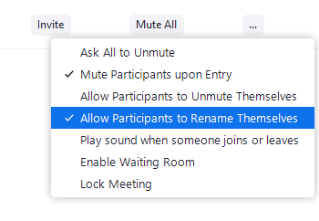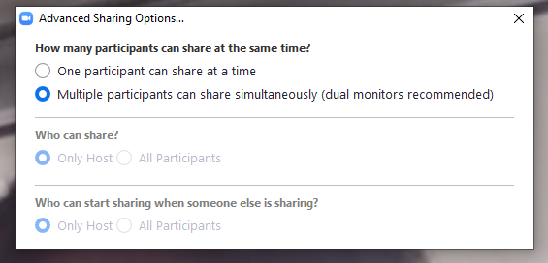During the meeting
- If you are unable to unmute someone
  - Click in the call settings and select “participants can unmute themselves”
  - Ask participant to unmute themselves
- If someone presenting can not get their camera to work.
  - Ask them to log out and log back in
- If a presenter cannot share their screen
  - Ensure the share settings are set as “anyone can share their screen”
- Dinging constantly happening during the call
  - Click on call settings and unselect “chime when new person enters”

