Policy and Process for Serious Incident Reporting to Charities Regulators

Date: 24 November 2022
Review Date: November 2025
Policy Owner: Nick Williams, Head of Legal & Company Secretary
Distribution: Internal /Non Confidential
- Purpose and Preamble

The Trustees of Barnardo’s are required to report ‘serious incidents’ promptly to the Charity’s principal charity regulator: the Charity Commission England and Wales (‘CCEW’).
The basic requirement is to report events that result in or risk significant: (i) harm to beneficiaries, staff or volunteers; (ii) loss of money or assets; (iii) damage to property; or (iv) harm to the charity’s work or reputation.
Reporting a serious incident is a regulatory requirement and a key part of demonstrating to CCEW that Trustees are discharging their wider legal duties to manage the charity, its assets and its reputation responsibly. Failure to disclose incidents and/or demonstrate compliance in a given case could lead to regulatory action.
This policy and process document sets out: (i) the regulatory reporting requirements in Barnardo’s context; and (ii) the internal process for assessing and reporting serious incidents.
- Scope of this Policy

This policy applies to Trustees, the Corporate Leadership Team and the following post holders: Company Secretary, Head of Corporate Safeguarding and Quality, Data Protection Officer, Director of Business Services Operations; Director of Strategy and External Affairs and Director of Audit and Assurance.
Note: this policy covers reporting to Charities’ regulators only; Barnardo’s will likely have disclosure requirements to other regulatory bodies or agencies in a given case; these are covered by internal processes referenced at Section D.
- Regulatory Reporting Requirements

- What is a notifiable incident?
The CCEW definition is as follows:
“A serious incident is an adverse event, whether actual or alleged, which results in or risks significant:
• harm to your charity’s beneficiaries, staff, volunteers or others who come into contact with your charity through its work [..]
• loss of your charity’s money or assets
• damage to your charity’s property
• harm to your charity’s work or reputation
For the purposes of this guidance, “significant” means significant in the context of your charity, taking account of its staff, operations, finances and/or reputation”.

Links to the full CCEW regulatory guidance documents:
CCEW SIR guidance (June 2019) see also CCEW examples table.

- Timeframe for reporting
The CCEW’s requirement is to report an actual or alleged incident “promptly”, which they define as “as soon as is reasonably possible after it happens, or immediately after your charity becomes aware of it”. Barnardo’s, in common with other large charities, has a ‘bulk reporting’ arrangement in place with CCEW which allows for quarterly reporting for incidents of lesser seriousness (see further below).
- Which Charity Commission?
Although the Scottish Charity Regulator’s guidance states that there is no need to report incidents already reported to CCEW, Barnardo’s will notify as follows:
- all notifiable incidents to CCEW wherever they occur in the UK; and
- make an additional report to OSCR for incidents occurring in Scotland.

- Barnardo’s Context

Notifiable incidents can arise in multiple contexts. This section identifies the principal reporting areas for the Charity, summarises regulatory guidance and cross references existing internal processes.

- Safeguarding-related Incidents
Summary of regulatory guidance
- incidents of abuse or of mistreatment of people resulting in or risking significant harm to them; or
- breaches of procedures or policies which put people who come into contact with it through its work at significant risk of harm.
‘People’ are defined as: (i) beneficiaries; (ii) charity’s staff and volunteers; and (iii) others who come into contact with the charity through its work.
Examples in Barnardo’s context:
- service user: inappropriate behaviour by a teaching assistant towards a pupil in a Barnardo’s school;
- retail: inappropriate conduct by a store associate towards a young person; and
- staff safeguarding: serious physical assaults on staff or volunteers by service users at a residential children’s centre.
Existing incident management protocols:
Barnardo’s safeguarding policies and detailed reporting protocols can be found here. These cover a comprehensive range of incidents and ensure necessary reports are made to other regulators/agencies, for example the relevant local authorities’ representatives, the Police, Ofsted, the Health and Safety Executive.

- Financial Crimes and Losses
Summary of regulatory guidance:
- financial crimes including fraud, theft, cyber crime and money laundering (as further defined; see additional fraud and theft checklist); no minimum loss level but this should be considered in the context of Charity’s circumstances.
- large donations from an unknown or unverifiable source, or suspicious financial activity using charity funds; suggested reporting threshold £25,000.
- other significant financial loss (where this threatens the charity’s ability to operate and serve its beneficiaries, or where the charity’s financial reserves are not sufficient to cover the loss).
Existing incident management protocols:
Barnardo’s anti-fraud policy can be found here.

- Data Breach Incidents
Summary of regulatory guidance: “a significant data breach or loss within the Charity”
As a matter of policy, Barnardo’s will report to the CCEW all data breach incidents that are reported to the Information Commissioner’s Office.
Existing Incident management protocols:
Barnardo’s data breach reporting policy can be found here.

- Other Incidents/ Reputational
Summary of regulatory guidance:
Incidents will arise outside the above listed categories, including because they pose a high risk to the Charity’s reputation. CCEW examples include the disqualification of a trustee / staff member for reason of criminal conviction; the existence of a significant police or other (non-routine) regulatory investigation; major governance problems; incidents involving a Charity’s partner.

Barnardo’s context:
The Director of Strategy and External Affairs maintains a reputational risk register to capture all ongoing incidents which may have a material reputational impact. Reputational incidents at Barnardo’s are generally linked to the categories above or (i) historic abuse; (ii) the conduct of Charity partners; or (iii) the Charity’s public positioning on equalities issues.
- Reporting Process

Roles and Responsibilities
See Appendix 1 for a summary of key roles and responsibilities;

Process
See Appendix 2 for flow charts: (i) Key Steps in Process (ii) Trustee Interface.

- Initial Review of Incidents
- When an incident occurs, the relevant SIR Lead decides whether or not the incident may qualify for CCEW reporting, consulting with the Company Secretary as needed. For incidents arising at Board level, the Trustee SIR Subgroup may take subsequent decisions directly, liaising with the CEO, CLT and the Company Secretary as appropriate.
For data breach incidents, notifications to CCEW follow the requirement to report to the Information Commissioner’s Office so there is no need to complete this review phase.
Test: does the incident result in or risk significant:
• harm to the charity’s beneficiaries, staff, volunteers or others who come into contact with the charity through its work;
• loss of the charity’s money or assets;
• damage to the charity’s property; or
• harm to your charity’s work or reputation.

- Timing for Report
Immediate Reporting
- If the incident qualifies as potentially reportable, then a decision needs to be taken as to whether an immediate report should be made to CCEW. A recommendation is agreed by the relevant SIR Leads, the CEO and the Company Secretary in consultation with relevant CLT members. If an immediate report is agreed, the SIR submission should be escalated and the submission process completed as soon as practicable.
Test: does the incident result in or risk immediate and severe harm (to beneficiary or staff/volunteer) OR immediate and severe loss/damage to the Charity.
Bulk (Quarterly) Reporting
- If the incident does not qualify for immediate reporting, the incident is included in the regular quarterly review process convened by the Company Secretariat with the SIR Leads. The review may result in one or more serious incidents being recommended for submission. The submission process should then be completed within one month of the quarterly review process. The CEO is also updated on incidents which the review team do not recommend for submission but represent borderline cases.

- Submission of reports
- In all cases, the SIR Leads and Company Secretary prepare a recommendation and draft serious incident report for review by the CEO.
- If approved, the Company Secretary shares the recommendation and draft report with the Trustee SIR Subgroup who, as appropriate, authorise the Company Secretary to submit the report and subsequent updates to CCEW via the governance@barnardos.org.uk mailbox.

- Follow up
- Board of Trustee notifications:
- all Trustees notified of immediate SIR reports within 24 hours of submission.
- the Governance and Compliance Committee receives a list of all reports on a quarterly basis; reports are shared with the full Board at quarterly meetings.
- The Company Secretary monitors CCEW responses and coordinates subsequent correspondence with the relevant SIR Lead, CLT and/or Trustees.

- Delegation
- The SIR Leads and the Company Secretary designate nominees to discharge their responsibilities should they be unavailable; they ensure that nominees receive necessary training and support.

Appendix 1: Key Roles and Responsibilities

1/ SIR Leads & CLT members: identify qualifying incidents, assist in escalation, subsequent decision making and SIR submission drafting; ensure implementation of this policy within their area of responsibility. SIR Leads consult with relevant CLT members as part of the initial decision-making process (principally: Corporate Director- Children’s Services; Corporate Director Business Services); ensure disclosures are made to other regulators/ agencies.
List of SIR leads (by area)
- Safeguarding: Corporate Head of Safeguarding and Quality
- Data Protection: Data Protection Officer
- Financial Issues: Director of Business Services Operations
- Other / Reputational: Director of Strategy and External Affairs, Director of Audit and Assurance
2/ Company Secretary: coordinates overall process and decision making; ensures timely SIR submission filing and follow up with CCEW; monitors compliance with the SIR policy and onward reporting to Board.
3/ CEO: agrees draft recommendations and draft SIR submissions for sharing with Trustee SIR Subgroup.
4/ Trustee SIR Subgroup: reviews recommendations and takes final decisions on SIR submissions on behalf of the Board. The quorum for decision making is two Subgroup members.
List of Trustee SIR Subgroup members: Board Chair, Deputy Chair, Chair of the Children and Young People’s Services Committee and Chair of the Audit and Risk Committee.

Appendix 2.1: Key Steps in Process

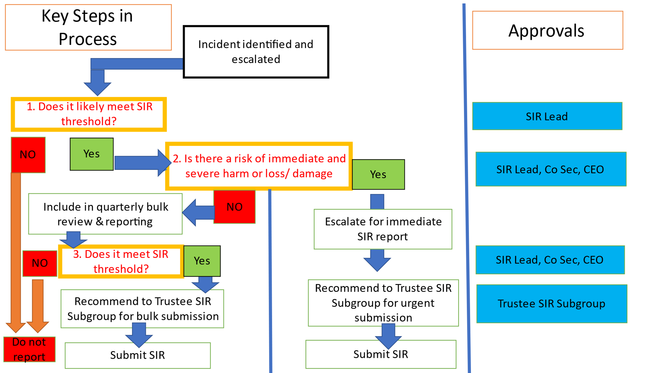

Appendix 2.2: Trustee Interface

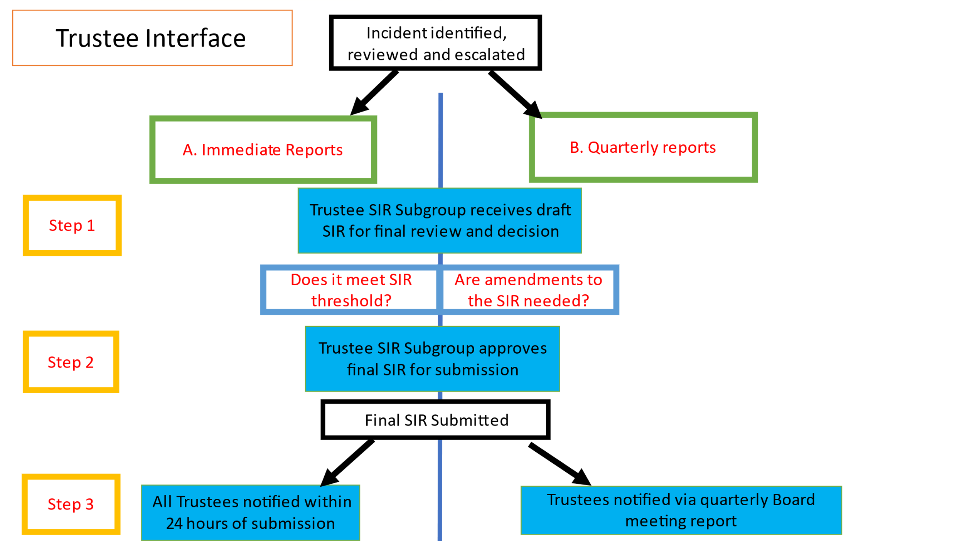

Barnardo’s is also registered with the Scottish Charity Regulator (OSCR) – see page 2 on reporting to OSCR; Barnardo’s is not registered in Northern Ireland.

