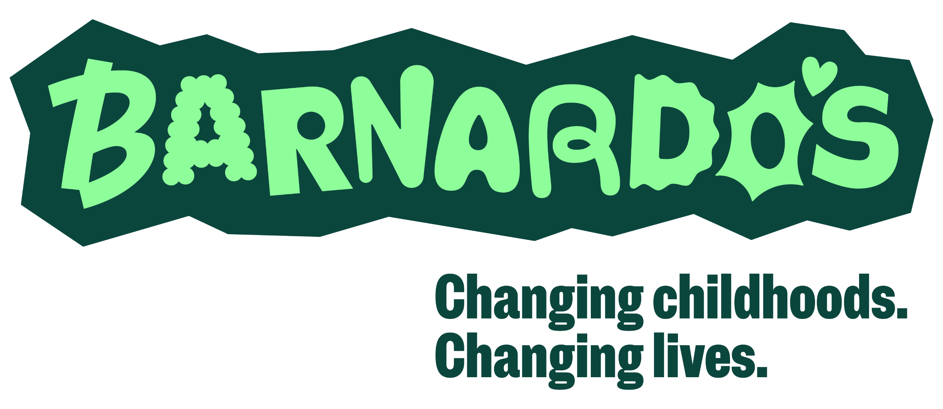
Date: 06.04.24
Review Date: 05.04.27
______________________________________________________________________________________

Support Leave - Self Certification Form (Adoption/Fostering/Maternity)

Support leave is the inclusive term that Barnardo’s uses for paternity leave. Please read and refer to our Support leave policy before completing this form.

Information detailed in this request form applies where the expected date of birth is after 6 April 2024, or the expected date of adoption placement or long-term fostering placement is on or after 6 April 2024.

If you wish to take a period of Support leave you must notify your manager, by completing this form, of your entitlement and intention to take Support leave within the specified timescales detailed below:

- your entitlement to take support leave by the 15th week before the expected week of the child’s birth; or
- your entitlement to take support leave within 7 days of the date of being notified by the adoption agency that you have been matched with a child for adoption, unless this is not possible or
- your entitlement to take support leave, within 7 days of the date of being notified by the fostering service that you have been placed with a child for long-term fostering, unless this is not possible.
- your intention to take support leave and the dates that you intend to take at least 28 days before the period of leave is due to start, unless this is not possible (e.g. the baby is born early).

Your Personal Details
Name:
Job title:
Work base:
Support Leave Application
This is to notify you that I am eligible for Support Leave on the following grounds (see ‘Eligibility’ section of the Support Leave Policy): |  | The week in which the baby is due*/date the child is expected to be placed* is:  ……………………………………………………..
I confirm that I am taking this leave for the purpose of either or both of the following:  - caring for the child  - to support the child's mother or birth parent*/main adopter or fosterer* |  | Support leave is intended to commence on  …………………………………………….…..….
A copy of the mother’s MATB1*/ adoption matching certificate*/long term’s fostering agreement* (or other documentary evidence from the adoption agency/fostering service) is: |  | (attached*/will follow*)
The date on which you were notified of being matched with a child for adoption was*:

The date on which you were notified of the long-term fostering placement was*:

I would like to take support leave in the following blocks, please select as appropriate:  (I understand that I may change my chosen start date by giving 28 day’s written notice to my line manager of the new dates). |  | 1 x week of leave *, commencing on:  …………………………………………..  2 x 2 consecutive weeks of leave*, commencing on:  ………………… and …………………..  4 x non-consecutive single weeks of leave*, commencing on:  ………………… and …………………..  ………………… and …………………..
Other Leave
I understand that I may request other leave to follow on from Support leave and must follow Barnardo’s procedures for authorising such requests. These are available on Inside.Barnardo’s, and include:  - Annual leave & bank holidays policy  - Shared parental leave policy & supporting documents  - Unpaid parental leave policy |  |  | Complete as relevant:  I am considering requesting:  Annual leave of ………………..…… weeks  Shared parental leave of …………. weeks (see policy for eligibility criteria)  Unpaid parental leave of ……….... weeks (see policy for eligibility criteria)

Please now sign your completed form and pass it to your line manager.

Signed:……………………………………… Date:…………..………………….

* delete as applicable

_____________________________________________________________________________________

Manager - Once you receive this form, please check the details and forward to your People Team for processing.

Signed ……………….……..…………..…... Date:…………..……………...….

