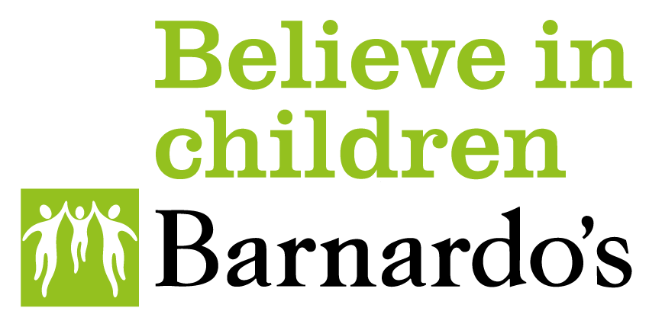

Integrated Health and Social Care
Quality Governance Strategy

© Anna Samoylova / Unsplash

Contents
Introduction
What is Quality Governance In Barnardo's?
Quality Governance Structure
Our Quality Assurance methods
Governance Framework
Appendix 1: Regulatory Organisations
Appendix 2: Action Plan

This Strategy forms part of Barnardo’s commitment to continuously improving the quality of services that we provide. We hope that this Strategy increases your understanding of and confidence in our work. We welcome feedback on this strategy from stakeholders at any time, using this link.

Introduction
Barnardo’s is working to deliver excellence across all our services. To do this, we need to develop our culture of learning and continuous improvement, empowering our staff to make professional judgements, knowing that they are supported. This includes their engagement in quality assurance activity.
We aim to maintain and enhance safe systems of working using effective evidence-based practice. Having strong clinical and quality governance means that we recognise our accountability, learning from incidents and being open and honest about our performance.
This Governance Strategy will be operationally applied across all Integrated health and social care operations using a Quality Management System (currently in the process of being enhanced) and will address:
- Clinical Governance will focus on the specific aspects relating to the quality and safety of clinical care, focusing on the practices and processes in our services which deliver health care
- Our Quality Governance arrangements and responsibilities will take a more comprehensive view ensuring that both clinical and non-clinical aspects of our services are at the highest standard
- How we will continuously improve performance and quality through engagement and learning. Learning is any activity that has a positive impact and helps us achieve the aims in our corporate strategy by equipping staff with the right qualities, skills, experience, and qualifications to deliver excellent children’s services.
- How we will continue to develop our organisation in a way which is committed to service-user safety and high-quality care.

Figure 1: The Purpose of Governance

Quality Governance is a dynamic and continuously evolving framework that operates as a circular rather than a linear approach. By constantly revisiting, reviewing, and refining practice, we can be flexible and responsive to the changing needs of service users.

What is Quality Governance in Barnardo’s?
Quality Governance across our integrated health and social care services is about the quality and safety of the services that we provide to our children and their families and carers. It encompasses everything we do as individuals and as an organisation to achieve high standards of practice and delivery of care. This starts with our systems, the management of resources, practice, and self-governance.
Research has shown that a bottom-up approach to governance is the most effective: it encourages practitioners to take real pride in their work, enabling them to introduce changes and achieve better outcomes for the children, young people and their families and carers. We conduct regular all-colleague surveys to understand what staff want and need to be able to do their jobs to the best of their abilities. The findings from these surveys are used to inform decisions and drive change, centrally and locally.
Working together on governance can stimulate team development and positive learning outcomes. However, good governance is based on the understanding that all elements of governance are important, and they should not be managed in silos. There needs to be an overarching structure to ensure joined up thinking and our Oversight Group is working to ensure this is put into practice. The principles of clinical governance are also shared with elements of effective social care governance, such as service user involvement, supervision, and risk management. Therefore, it makes sense to develop a shared strategy and management system across our integrated health and social care services.
The Social Care Institute for Excellence Social Care Group defines Quality Governance as ‘a framework for making sure that social care services provide excellent ethical standards of service and continue to improve them. Our values, behaviours, decisions, and processes are open to scrutiny as we develop safe and effective evidence-based practice.’
The Department of Health defines clinical governance as ‘A framework through which NHS organisations are accountable for continually improving the quality of their services and safeguarding high standards of care by creating and environment in which excellence in clinical care will flourish. ￼’
Many of the health services that we deliver are for and in partnership with the NHS and we aspire to the NHS’s highest standards.
The fundamental principles of a quality service are:
- Public and service user involvement.
- Safety and effectiveness.
- Robust organisational structure and processes.
- Quality of service provision.
The fundamental principles of good governance are:
- A clear focus on the organisation’s purpose and outcomes for our service users.
- Clarity around roles and functions.
- A focus on equality, diversity and inclusion.
- Managing risk and transparent decision-making.
- Stakeholder engagement.
- A well embedded culture of learning.
- Clear accountability and ownership of practice.

Quality Governance Structure

Figure 2: Key roles in Barnardo’s Quality Governance Structure
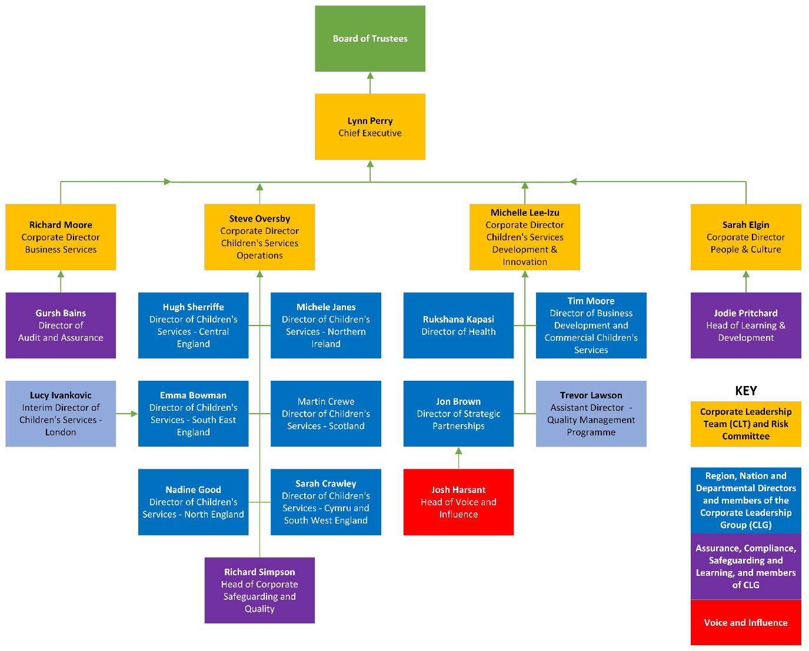
Figure 2 illustrates key roles in the strategic governance of quality within Children’s Services operations in Barnardo’s. There are also many other operational roles below those shown, in the Children’s Services management hierarchy, which ensures that quality is effectively performance-managed throughout our services. This means that commissioners, regulators and other interested parties can be confident that quality is always proactively managed.
Barnardo’s Board of Trustees
The Board has overall responsibility for the activity, integrity, and strategy of Barnardo’s and to ensure it complies with the law and is run for public benefit.
The Chief Executive
The Chief Executive has overall accountability for the governance, delegating the executive responsibility to Corporate Directors and Region and Nation Directors who in turn are responsible for reporting within the governance structure.
Corporate Directors
The Corporate Directors, who form the Corporate Leadership Team (CLT) with the Chief Executive, are accountable for a broad range of services delivered within their directorate. Having oversight of their area of responsibility, they will anticipate and consider emerging risks through their Risk Committee and provide regular and timely information to the Board.
Region, Nation, and Departmental Directors
The Directors, who form the Corporate Leadership Group (CLG) along with CLT, are accountable for the delivery of the governance agenda across their projects. It is their responsibility to ensure Quality Governance requirements are embedded in their services, and that staff have the necessary skills to understand and deliver their individual managerial and leadership responsibilities. They should be providing constructive challenge in both directions.
Assistant Directors for Children’s Services
Assistant Directors of Children's Services take responsibility for specific areas of work across our regions, or they will lead on a specific project area. They support our service managers and make sure we deliver effective services for children and young people.
Voice & Influence
Voice & Influence are key in supporting professionals working directly or indirectly with children and young people, using their voices and lived experiences to inform, shape and influence the work we do.
Compliance
Each locality/service/department should ensure compliance and year-on-year improvements need to be built into their integrated health and social care business plan.
Assurance
Children’s Service Managers should seek assurance by collating evidence, for example, outcomes data, audits, and service user feedback that their service is compliant with policy, and local and national requirements.

Our Quality Assurance methods
We are developing a Quality Management System which aims to empower our integrated health and social care services, through a robust governance structure, consistent Barnardo’s policies and procedures, and high-quality learning and development with the ability to make key organisational decisions about the approach to deliver care and services that provide better outcomes for children and young people.
It will provide a clear framework for the planning, implementation, evaluation, and reporting of outcomes to ensure continuous year on year improvements. This system will serve both as a framework for Quality Governance and a resource for specific integrated health and social care services and regulatory bodies.
Traditionally, the NHS and healthcare providers have used the 7 Pillars of Clinical Governance to provide the framework for quality management. It has been refined over the years and is readily applicable to non-health organisations. As a provider of integrated health and social care services, Barnardo’s are adopting the 7 Pillars of Clinical Governance to provide a framework for our Quality Management System.

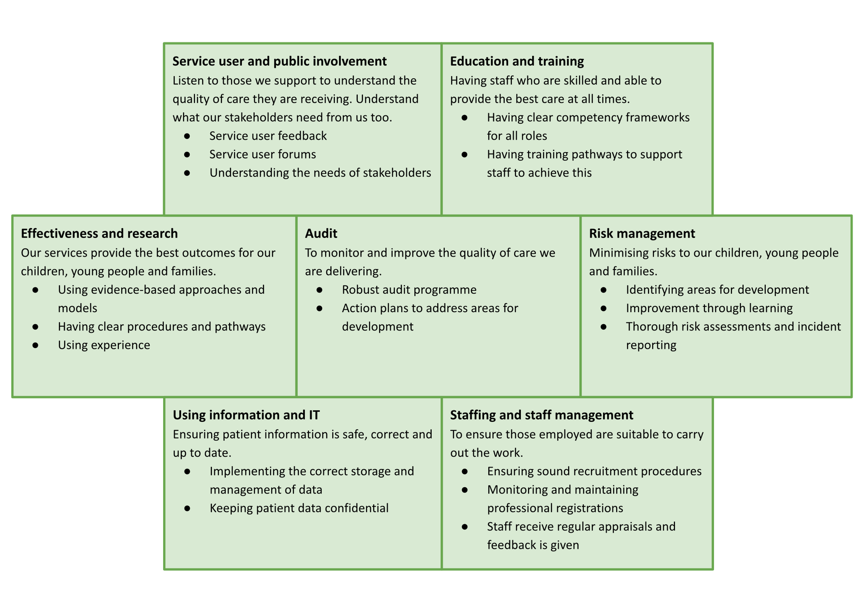
Figure 3: The 7 Pillars of Clinical Governance

Our current 7 Pillars of Clinical Governance activity

Service user and public involvement
- We have a number of projects that we are working on to co-produce services with children, young people and their families in a way that suits them, for example our current collaboration with the Institute of Health Equity
- We have a Voice and Influence Strategy that clearly lays out our vision – which is to have the voices and lived experiences of children and young people to routinely inform and influence what we say, how we work, how we make decisions, and how we seek to inform and influence externally.
- We have a central action plan based on service user feedback and complaints.
- We have a robust complaints procedure, with timeframes, that is monitored and reported.
- We have a range of processes in place to ensure staff are well supported if a complaint is made against them, from supervision through to our Employee Assistance Program.
- We work closely with our key stakeholders to understand what they want us to deliver.

Education and Training
- We have a Learning and Development Team who can support with learning and development needs of staff, providing access to a broad range of training.
- We have frameworks for learning for newly qualified staff in line with national standards, such as Assessed and Supported Year in Employment (ASYE) for Social Workers.
- All staff have a probationary period where their development is supported and monitored.
- Compliance for induction and mandatory training is monitored and reported at Corporate Leadership Group meetings.
- To support learning within the organisation, we have annual conferences, communities of practice in place, practice forums and regular lunch and learn sessions.

Effectiveness and Research
- We report on the effectiveness of our services to our commissioners and our board. We publish an annual Quality Account for our services which outlines the activity of the previous year and sets out our objectives for the coming year.
- We have a health steering group which provides steer and oversight to the development of health programmes of work.
- We have access to current evidence and research and have a dedicated team of researchers to support practitioners.
- The Barnardo’s Foundation funds work with learning partners to investigate and communicate new knowledge generated through research and evaluation.
- We have a Festival of Learning which is an opportunity to share learning and work collaboratively across the organisation.
- We hold regular learning partner events.

Audit
- We have an annual Audit and Assurance plan, which is approved by Barnardo’s Corporate Leadership Team's Risk Committee.
- There is a rolling National Action Plan that is updated with the findings of our audits. Improvements and remedial actions are agreed and delivered locally by the audit sponsor/operational lead. The actions are monitored by the Audit team and reported to the Corporate Leadership Team's Risk Committee. Our action plans demonstrate that we have learned from and made improvements to our services and are shared across our organisation to deliver systemic change.
- We can demonstrate that we have changed our practices to reflect what we are learning from audits.
- Audit and Inspection activities are triggered by:
  - Reinspection/reaudit of from a previous year.
  - Requests from senior management.
  - Corporate Leadership Group annual workshop and National Safeguarding Group.
  - Thematic reviews of practice areas or regions.
- We have a central action and learning plan from the findings of inspections by our regulators.

Risk Management
- We have robust incident reporting procedures, and we are currently developing a new app to simplify the process and enhance the response.
- Our policies are owned and approved by clearly identified, appropriate levels of governance, and have a frequency of review set.
- Risk management varies according to the service type, national legislation, and commissioner-led local procedures. They are managed by the operational lead and monitored by the Risk Committee which is a sub-group of the Trustees.
- We have a central risk register and service specific registers are being developed. These are shared via our Risk Committee.
- Serious incidents are investigated locally with support from the Safeguarding Team. Learning is shared by the Safeguarding Leads nationally.
- We are a no blame organisation; staff feel supported to report incidents knowing that it is the systems that will be investigated.
- We are developing an Early Response Identification Card (ERIC) process to enable us to identify concerns and risks earlier, to try and prevent incidents happening.
- All incidents are reported to the CEO weekly and are reviewed regularly until investigations are completed. We produce quarterly and annual dashboards of our most serious incidents which are presented to the Trustees along with quarterly case studies. Using Information and IT.
- Teams complete an annual data protection compliance audit and systems are well-embedded.
- Subject access requests are managed locally and are completed in a timely way. Staffing and Staff Management
- We have an inclusive culture, there are regular webinars with senior leaders and weekly email updates on key issues.
- We have a new People and Culture strategy.
- There is a new pay and reward framework in place, which recognises outstanding performance.
- All staff have regular Personal Development Reviews, these form part of a performance framework linked to pay progression.
- Responsible stewardship is one of our organisation's values and is reflected in the services that we deliver.
- Staff know what they are accountable for, they have a clear job description, and they know how to escalate up throughout their service.
- Training is available for all supervisors.
- We have workforce plans locally, at an individual contract level.
- There are clear recruitment, retention, and career pathways with identified training for many of our job families.
- All services have a training strategy to meet the local needs of the children, young people, and families that they support.
- We offer an in-house programme for aspiring leaders and there is an opportunity to access formal, external leadership programmes too.
- We use safe recruitment processes, checking references, DBS reviews and monitoring of registrations. Sickness and absence are managed and reported by the People Team at a local level using our recently upgraded personnel system.
- We have robust policies in place to ensure that our staff are competent and able to do their jobs, and supported when issues arise.

How we currently management governance activity
Now, governance is managed at a local level, using tailored approaches to address individual needs of services. However, recognising the potential to improve learning, quality and efficiency, our new Quality Management System will adopt a more centralised view. By doing this, we can gain better insights, standardise processes and obtain consistent data across the organisation, helping us to implement uniform quality standards.

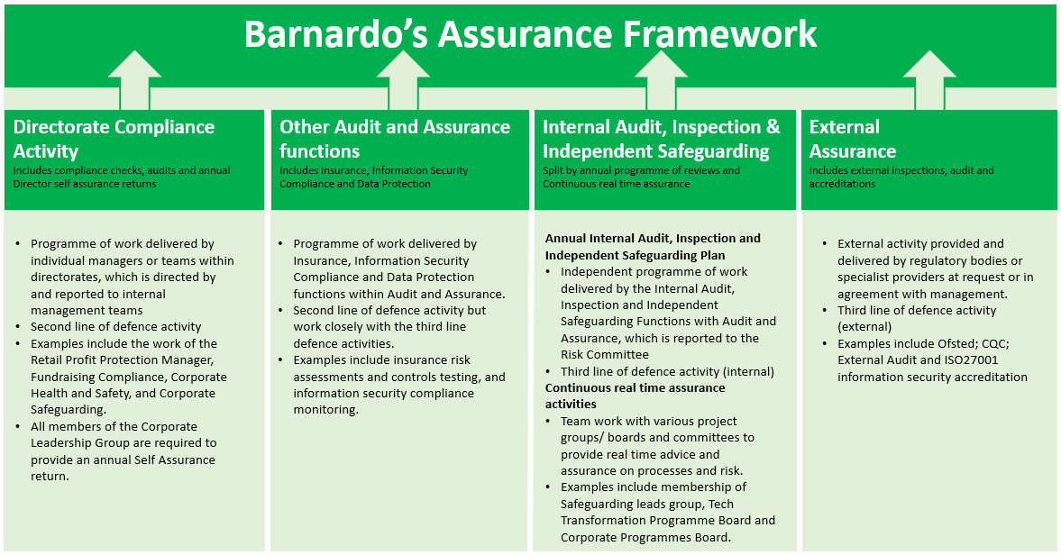

Reporting
Delivery
Learning from Incidents
Learning is collated by the Safeguarding Team
Safeguarding incidents are managed locally by Safeguarding Leads and learning is identified
Annual report is prepared on the basis of this learning and shared across integrated health and social care services
Monthly reports completed on a range of service specific quality measures completed by Children’s Service Managers
Directors receive quarterly briefing on feedback from Quality Conversation
Assistant Director submits information to Quality Conversation
Assurance provided by Audit & Assurance Team who carry out an annual programme of audit and inspections
Sign of from Assistant Director
Local protocols are developed by services based on local service specification and centralised policies

Appendix 1: Regulatory Organisations
Barnardo’s is actively providing health and social care services across the four nations of the UK: England, Ireland, Scotland, and Wales.
Each nation has an independent regulator of health and social care, and each provides a framework and a set of minimum standards that are used to register, monitor, and inspect facilities and services. The standards specify the arrangements, facilities and procedures that need to be in place and implemented to ensure the delivery of a quality service. Compliance is mandatory. The regulators take action to improve the quality and safety of services for the well-being of the people.
- England - the Care Quality Commission (CQC).
- Northern Ireland - the Regulatory and Quality Improvement Authority (RQIA).
- Scotland - The Care Inspectorate, Scottish Social Services Council (SSSC), and Healthcare Improvement Scotland.
- Wales – Care and Social Services Inspectorate Wales (CSSIW).
Other organisations with an oversight / regulatory role are:
The Charity Commission which registers and regulates charities in England and Wales to ensure that the public can support charities with confidence.
Charities in Scotland are regulated and awarded charitable status by the independent Office of the Scottish Charity Regulator (OSCR).
In England, the Department for Education (DfE) is responsible for child protection in England. It is responsible for children’s services and education and provides statutory guidance on how the child protection system should work.
Also in England, Local Safeguarding Partnerships are responsible for child protection policy, procedure, and guidance at a local level. The local safeguarding arrangements are led by three statutory safeguarding partners:
- the Local Authority
- the Integrated Care Board (ICB)
- the Police.
Ofsted is the Office for Standards in Education, Children’s Services and Skills in England. Ofsted inspects services providing education and skills for learners of all ages. It also inspects and regulates services that care for children and young people.
In Scotland, the Children and Families Directorate of the Scottish Government works across all Government departments and with delivery partners to support systems and behavioural change to improve outcomes for children, young people, and families.
In Wales, the Welsh Government’s directorates include child protection, children’s rights, safeguarding and the Improving Outcomes for Children Advisory Group.
In Northern Ireland, the Department of Health’s remit includes Children and Young People Care Services.
There is a Children's Commissioner for each country of the UK, including England, Northern Ireland, Scotland and Wales. This office promotes and protects the rights of all children in accordance with the United Nations Convention on the Rights of the Child (UNCRC).

Action Plan
There is an Action Plan linked to this Strategy that has key activities, owners and timescales identified. This will be reviewed on a regular basis.

Veenstra, G. et al, (2017) Rethinking clinical governance: healthcare professionals' views: a Delphi study, BMJ Open, 2017, Vol 7(1), PMC5253713.
SCIE (2011), Social care governance: a workbook based on practice in England, SCIE Guide 38, January 2011.

