When someone invites you to join a huddle workspace, you will receive an invitation email. The email will contain the name of the person who invited you and also the name of the workspace you are invited to join.
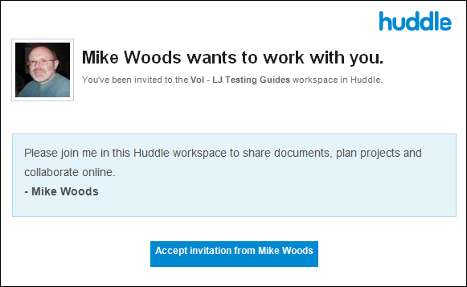
To accept the invitation:
- Click the Accept Invitation from… button.
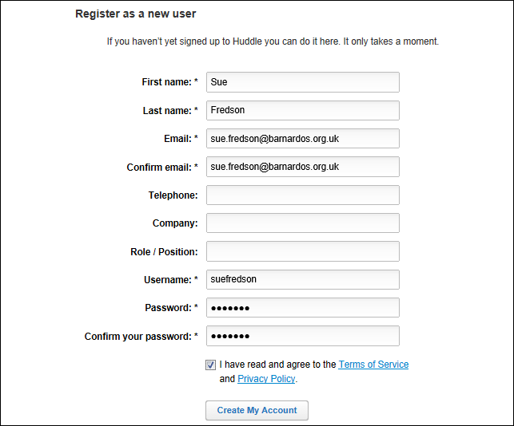
Note: If you already have a huddle login you can use the Sign In option at the top of the form. However, if you are new to huddle you will need to complete the Register as new user form.

Registering as a new user
On the registration for you must complete the fields marked with an asterisk.
The password you choose must:
- Be at least six characters
- Contain a mix of upper and lowercase characters
- Include at least one number
- Include at least one special character such as ! $ # %
Once you have completed the required fields:
- Read and accept the Terms of Service and Privacy Policy
- Click the Create My Account button.
This will log you in and take you to the workspace you have been invited to join.

Understanding the huddle workspace
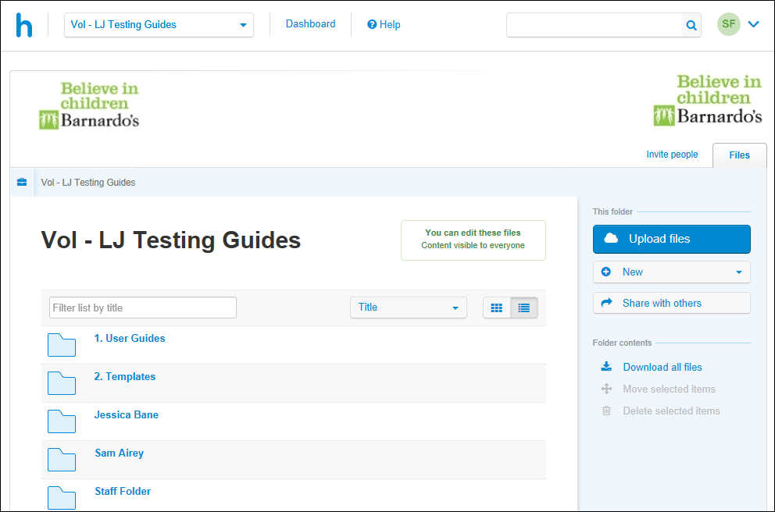
The name of the workspace is displayed prominently above the folders in the central area.
Note: If you have access to more than one workspace, always ensure you are in the correct workspace before adding or editing files. If you need to switch to a different workspace, you can do so using the drop-down list in the top-left of the screen.
Use the buttons in the block to the right to add your files and share these with your Barnardo’s contacts.
If there are folders in the workspace already these will be below the large workspace name.

What Next?
Depending on your role refer, to the other user guides user guides to be found in the huddle page on b-hive.

Signing out of huddle
For security reasons you should always sign out when you have finished working on huddle.
- Click on the drop down arrow in the top-right corner of the huddle screen.
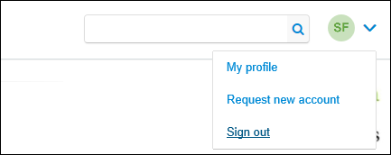
- Select Sign Out.

Tips
Once you have registered add the huddle sign in screen as an internet and/or content server favourite for quick and easy access next time you need to log in.
The web address of the huddle site is https://barnardos.huddle.net/
If you forget your password at any point use the Forgotten your password? link on the sign in screen to reset this.
To add a profile picture select My Profile from the same menu as the Sign Out option. Scroll down the profile page and use the Browse button to load a picture from your computer.

