Introduction
This guide will take you through steps of how to connect using a Wi-Fi hotspot; this is referred to as tethering.
Note: The following images have been taken from a Moto G4 Play android device, some of these images may differ slightly if using other android devices.

Set-up Wi-Fi Tethering
- Tap App Drawer >> Settings >> … More >> Tethering & mobile hotspot
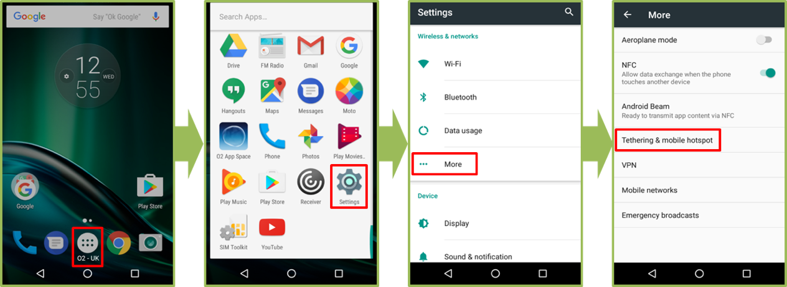
- Tap Set up Wi-Fi hotspot >> Note the Network name and enter the password >> Save >> move slider to ON for Mobile Wi-Fi hotspot
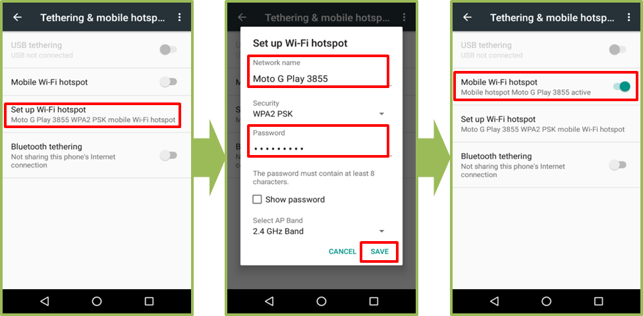
- Launch BTOne Mobile >> Tap the green Wi-Fi symbol and select Private Wi-Fi
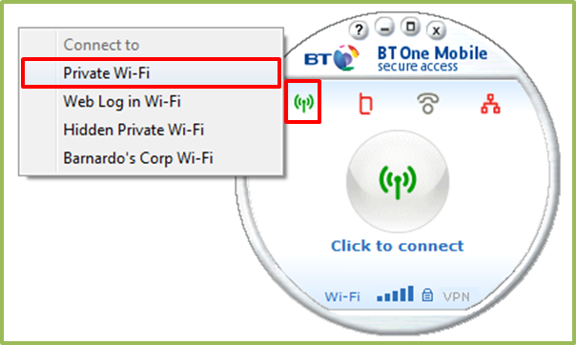
- Select the Wi-Fi network >> Enter the password

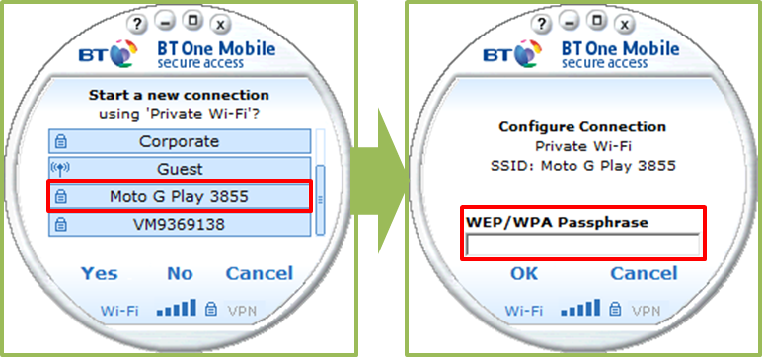

Note: The Network name and password are the same as the details added in the 2nd step of actions above.

- Enter your VPN User Name >> Enter your 4 digit PIN and password
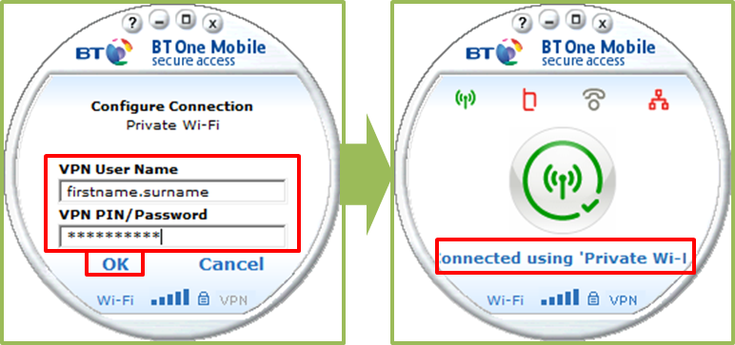
Note: This step on BT One Mobile may vary and you may only be required to enter your VPN Pin/Password.

