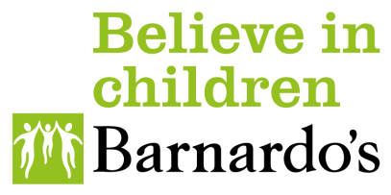

Buy Your Leave Applications

Window is open from Thursday 1 February to Sunday 3 March 2024

At Barnardo’s, we not only offer a positive, inclusive culture, where everyone can belong, grow and thrive we are also committed to providing a diverse range of benefits suited to everyone’s needs.
As part of our offering, our colleagues can purchase up to 5 days of annual leave per year. This allows colleagues to have greater flexibility over the year from time off with children in the summer holidays or to go on that once of a lifetime holiday.
Based on feedback from colleagues last year about the Buy Your Leave Scheme application window, we have opened it for longer this year. This is to ensure that there is a wider opportunity for colleagues to apply and gain approval. By giving the maximum window for applications, the closure date is not flexible given the need to process payments via the payroll.

To apply for Buy Your Leave you should familiarise yourself with the following;

- You should review the Rules and Eligibility for this scheme prior to your purchase which are covered in the FAQ’s and Line Manager Guidance
- You may purchase up to one week (5 days) full time equivalent leave.
- You are able to carry over up to one week (5 days) full time equivalent, annual leave and still participate in the BYL scheme.
- You will need to know your annual salary in order to apply (see below to support you in how to get this information).
- You will need your employee number, which can be found on Dynamics 365, or your payslip (under the identification section and labelled employee number).
- You should speak to your manager in advance of this request to get agreement before you apply.
- Your request will need to be made in hours not days, therefore ensure you calculate the total number of hours you wish to purchase based on your contracted working hours pattern.

Your annual salary

If you go to your payslip where it states, ‘Salary’ and then under ‘Amount’ this will give you the gross monthly amount. You then multiply this amount by 12 to give you your annual salary.
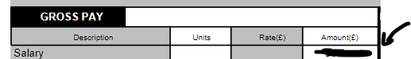

e.g., If your monthly amount states £1,500 x 12 = £18,000 per annum

Now complete the Buy Your Leave form to calculate an indicative cost for the amount you wish to purchase. *All costs should be based on your current salary.

**Please note that this indicative cost could be subject to change pending any Annual Pay Award and/or any changes you may have to your salary (e.g. change of job) between the time of completing the form and processing the payment **

When you’ve added the hours, it will show you the ‘indicative cost’ to purchase the additional leave.

When you’ve ticked the ‘I AGREE’ box, the changes to your Terms & Conditions are binding at this point.

Approval

When your line manager has approved your request the Pay & Reward Team will run some checks. They will only contact you if there is a query.

Once your line manager has approved your request you will receive a confirmation email.

Once your request has been processed it will appear in your leave allowance on Dynamics 365 as ‘BARNARDOS BOUGHT LEAVE’, under ‘Request Time off’’. Please note that this may not appear until later in April.

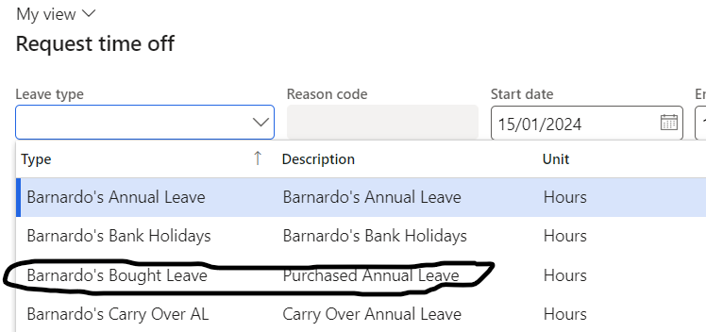

The first payment will be taken from your April 2024 pay and will continue monthly, in 12 equal instalments.

If you have any queries about the application process or difficulties applying, please raise a ticket through the Hub.

Once the closure date for applications has been, the Payroll team and Pay and Reward Team will not have the flexibility to support any post deadline requests. It’s therefore really important to apply and gain approval from your line manager by the deadline of 3 March.

