This guide will provide you with step by step instructions on how to complete the Return to Work (RTW) form.
The Return to Work form in myPlace replaces the Sickness self-certificate and paper return to work form and should be completed on the day the return to work interview is conducted.
The episode of sickness absence must have been recorded first in order for the return to work form to be completed in myPlace. See the myPlace sickness absence user guide for assistance.
Note: Once you have logged into myPlace the myPlace welcome page will be displayed. See the Logging in for the first time user guide.
To complete the Return to Work (RTW) form in myPlace:
- Log onto myPlace.
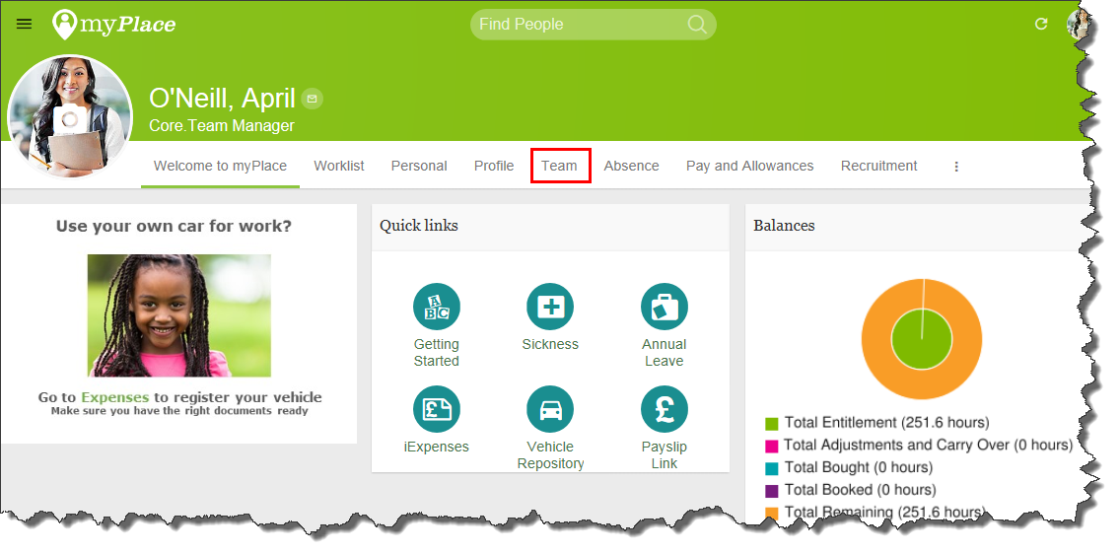
The myPlace welcome page will be displayed. As you can see myPlace has a Team menu where you can view direct reports. Within the Direct Reports menu there is an option to select Absence this is where the Return to Work form can be completed.
Completing the Return to Work form
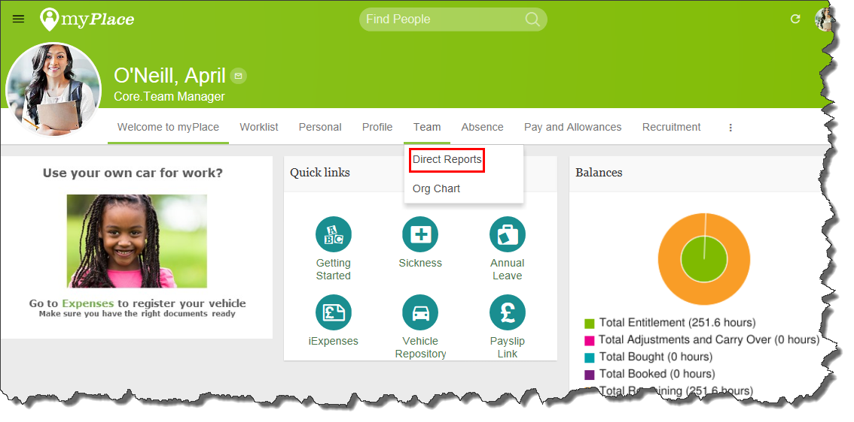
- Select Team from the myPlace menu.
- Select Direct Reports screen will open.
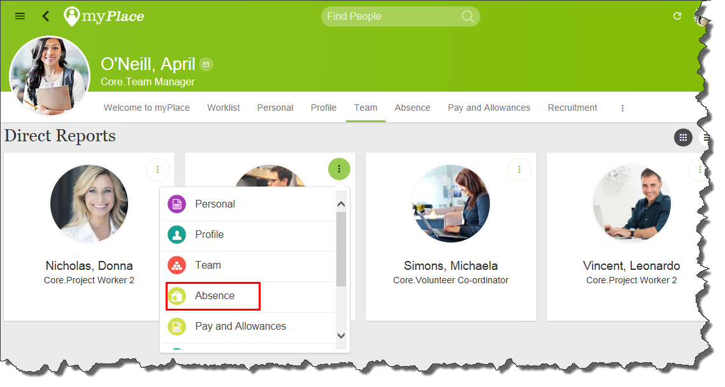
- Select the three dots on the right hand side of the person you want to complete the Return to Work form for.
- Select Absence from the menu. The Annual Leave and Bank Holidays form will open for the Direct Report.
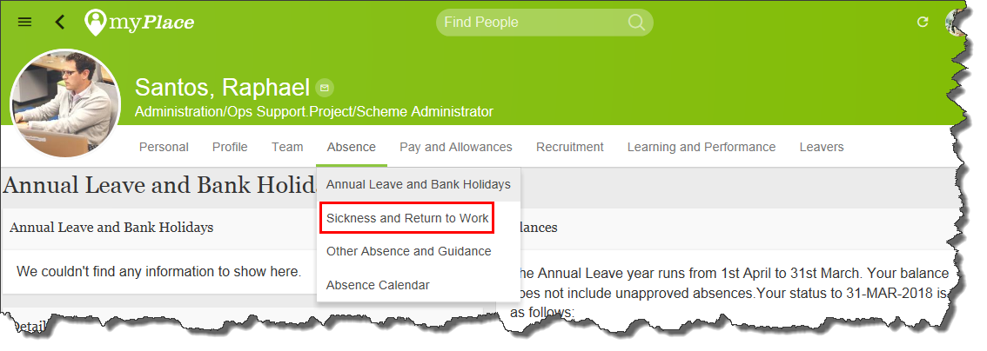
- Select Sickness and Return to Work from the Absence menu. The Sickness Absence screen will open.
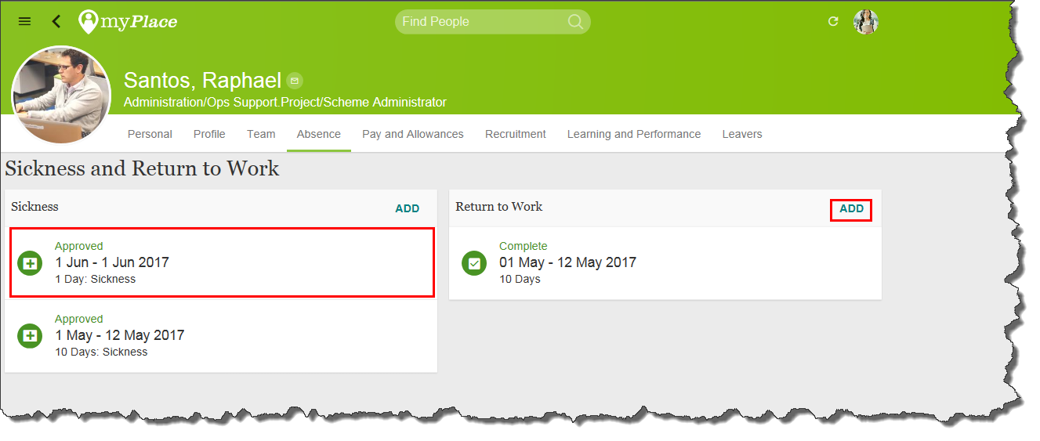
- In the Sickness Absence Area select the relevant sickness absence record
Note: Check the details of the sickness absence record are correct, for example the dates and reason for absence. If the details are incorrect log a call via Firstpoint>log ticket>myPlace.
- In the Return to Work area select the Add button.
The return to work form will open.
- In the First and Last Days of Absence field select the date from the drop down list.
Note: The date is the start and end date of the episode of sickness. This date will not be visible unless the episode of sickness has first been recorded via Direct Input.
- The Number of Days Lost field will complete automatically.
Note: The number of days lost is calculated by the start and end dates of the episode of sickness entered into either myPlace or Direct Input.
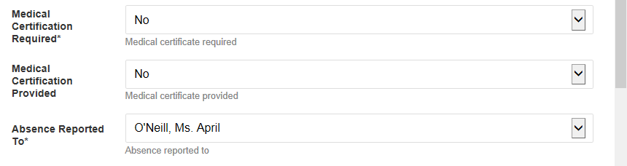
- In the Medical Certification Required field select either Yes or No.
- In the Medical Certification Provided field select either Yes or No
- The Absence Reported To field will automatically populate by default with your line manager.
Note: If the line manager is not correct it is possible to search for a different person. Search by the surname of the required person from the list of values.
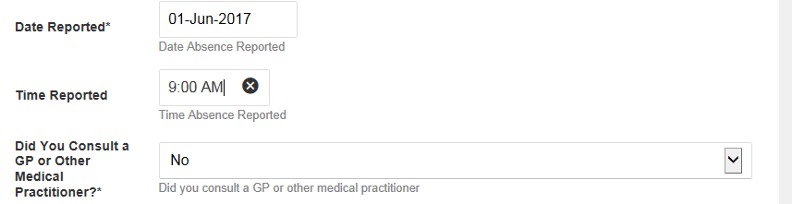
- In the Date Reported field enter the required date.
- In the Time Reported field enter the required time.
- In the Did you Consult a GP or other Medical Practitioner field select either Yes or No.
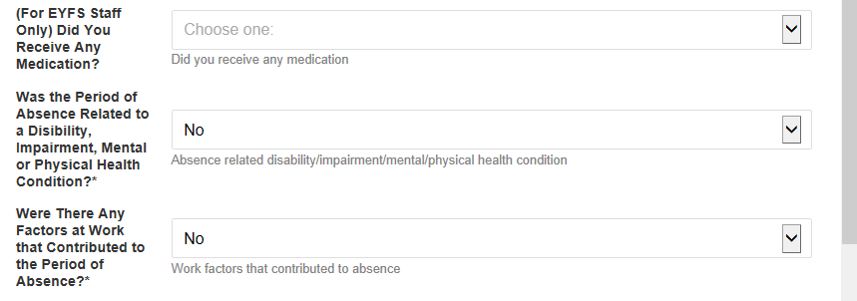
- In the (For EYFS Staff Only) Did You Receive any Medication field select either Yes or No.
Note: This question should only be completed by EYFS staff.
- In the Was the Period of Absence Related to a Disability, Impairment/Mental/Physical health condition field select either Yes or No.
- In the Were There Any Factors at Work that Contributed to the Period of absence field select either Yes or No.
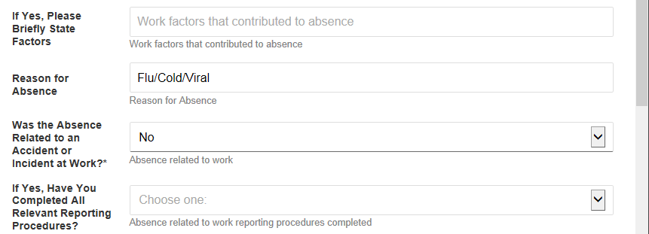
- In the If Yes, Please Briefly State Factors that contributed to absence field enter information if required.
Note: This question should only be completed if there were any factors at work that contributed to the absence.
- The Reason for Absence field will populate automatically.
Note: This is the absence reason that has been entered via myPlace or Direct Input.
- In the Was the Absence Related to an Accident or Incident at work field select either Yes or No.
- In the If Yes, Have you Completed All Relevant Reporting Procedures field select either Yes or No if required.
Note: This question should only be completed if the absence was related to an accident or incident at work.
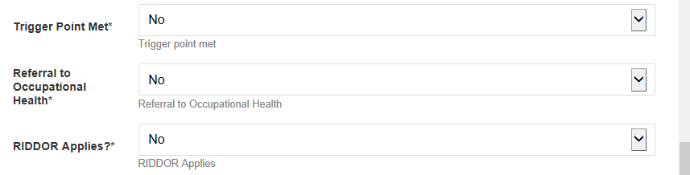
- In the Trigger Point Met field select either Yes or No.
Note: Please refer to the Sickness absence policy and procedure for further guidance.
- In the Referral to Occupational Health field select either Yes or No.
- In the RIDDOR Applies? Field select Yes or No.
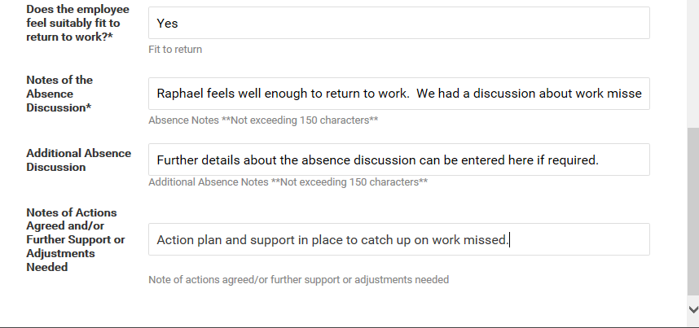
- In the Does the employee feel suitably fit to return to work field enter the required text.
- In the Notes of the Absence Discussion field enter the required text.
Note: This field is limited to 150 characters.
Tip: Type the text (up to 150 characters) into a Word document and paste it into the field in myPlace.
- The Additional Absence Discussion field can be used if you require more space to enter information.
Note: This field is limited to 150 characters.
Tip: Type the text (up to 150 characters) into a Word document and paste it into the field in myPlace.
- In the Notes of Actions Agreed and or Further Support or Adjustments field enter the required text.
Note: This field is limited to 150 characters.
Tip: Type the text (up to 150 characters) into a Word document and paste it into the field in myPlace.
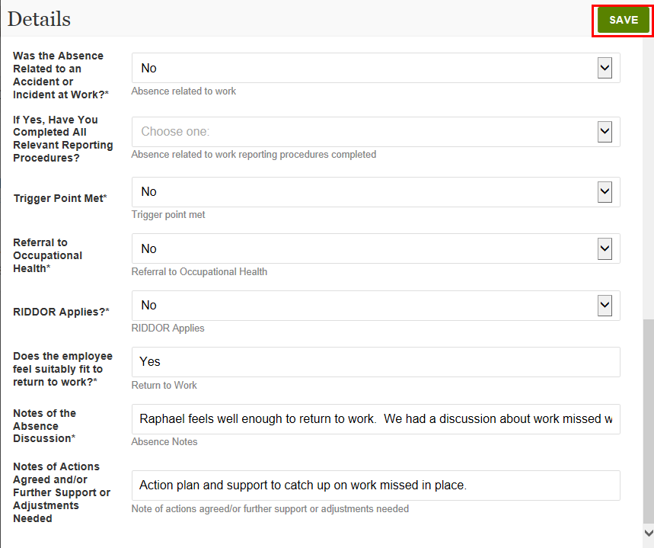
- Select the Save button.
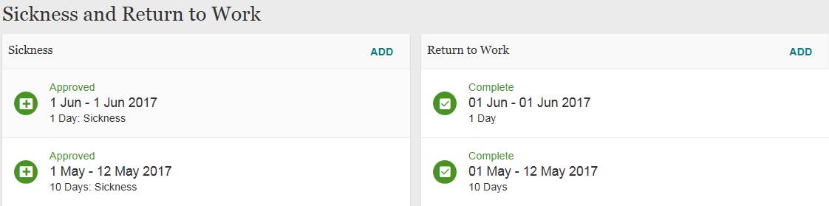
The record will display as Completed.

