To save duplication in Content Server you can add a shortcut to existing documents, forms, reports etc. To do this you first need to:
- Identify where the item you want the shortcut to lead to is located on Content Server.
- Identify where you want the shortcut to appear.
Tip: If you add the document and the location where the shortcut will appear to your favorites, the whole process will be much quicker.

Example
My region/nation maintains a list of local authority services. I want to have a link to this in my service admin folder, but don’t want to make a copy, as this will soon be out of date.
To do this I will need a shortcut in my service admin folder that points to the regional/national list. In this example I have already added the regional/national list and the service admin folder to my favorites:

Creating the Shortcut
You can create a shortcut from either end (the link location or the item location). In this case I will start from the item – the local authority service list.
- Click on the function button to the right of the item to be linked.
- Select Make Shortcut from the menu.
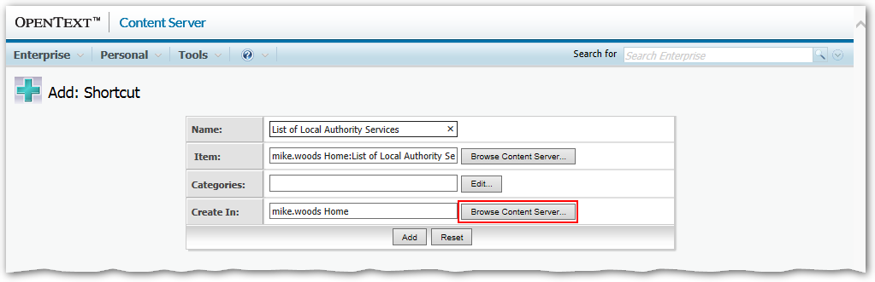
The Item field is completed for me as I started from the item.
Tip: You can change the Name at this point if needed. This will only affect the name of the shortcut, and can be useful to make it clear what the shortcut is pointing at.
I need to add the location the link will be added to:
- Click Browse Content Server for the Create In field.
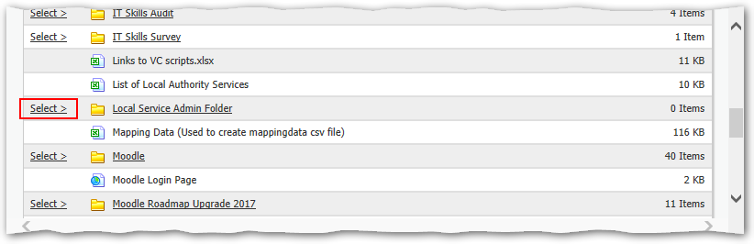
- Navigate to your favorites.
- Click the Select> link to the left of the location for the shortcut.
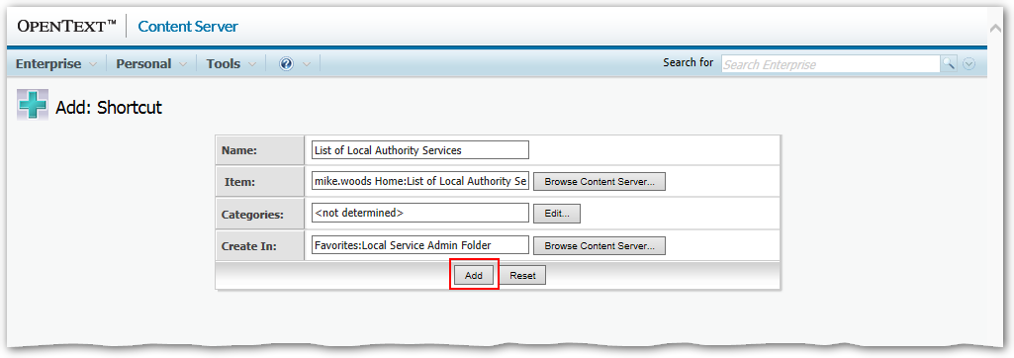
- Click the Add button.
- Complete any Category information if prompted.
This will create a shortcut in the chosen location.
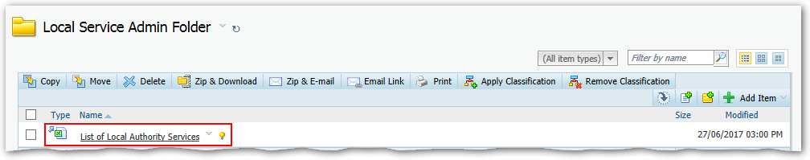
You can recognise shortcuts by the blue arrow to the left of the icon.
Note: In most cases the shortcut will behave the same as the original document. However, you do need to be careful when using the Function Button menu of the shortcut. This will have two “branches” Shortcut and Original.
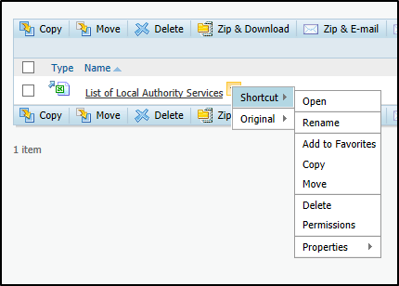 | 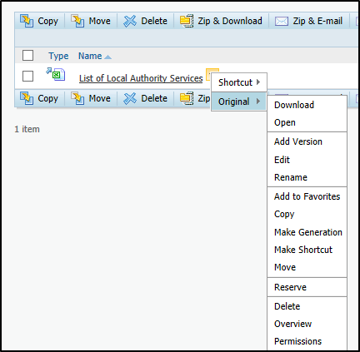
The items on the Shortcut branch will act on the shortcut, while those on the Original branch will act on the original document. This means, for example, that you must be careful when selecting Delete to be sure exactly what you are deleting!

