Email folders are created in Content Server to allow you to save emails. They are specialised folders and show you much more information about the emails than a standard folder.
There are two ways to create email folders:-
Creating email Folders in Content Server | Creating email folders in Outlook
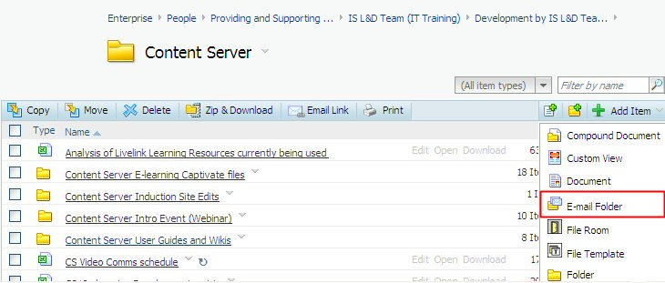 | 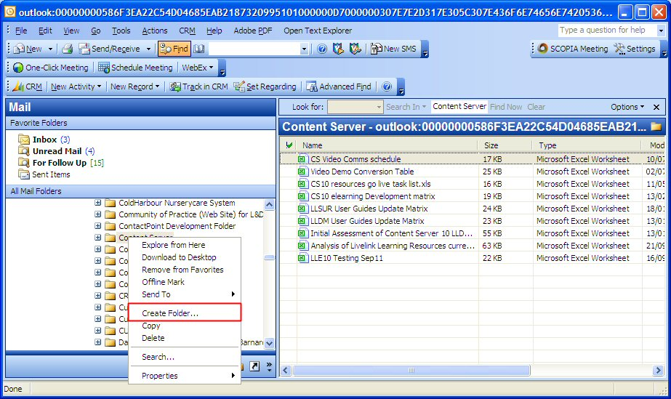

Creating Email Folders in Content Server
To create an email folder within Content Server:-
- Navigate to the relevant folder in Content Server.
- Click on the Add Item button .
- Click in the Name field and type in a sensible name.  - Click on the Add button. | 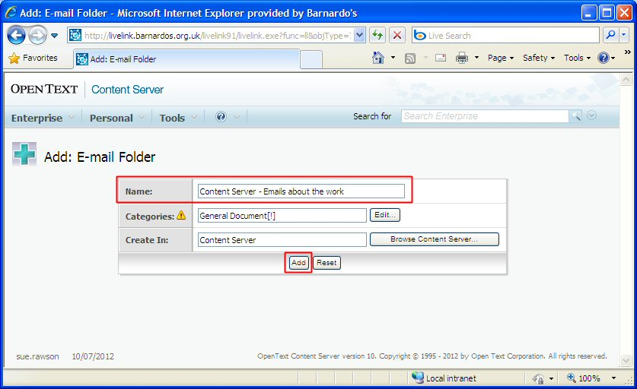
- The new email folder is created.  - Note it has a new icon to indicate it is an email folder. | 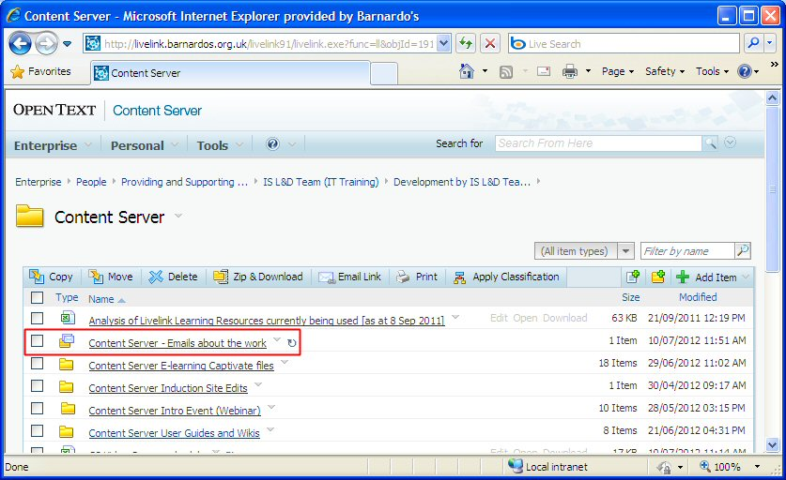
Now – why not add your new folder to your Content Server Favorites to make it easier to locate when you need it.

Creating Email Folders in Outlook
To create an email folder within Outlook:-
- Navigate to the relevant folder in Outlook by clicking on the plus to the left of each folder from Livelink onwards. | 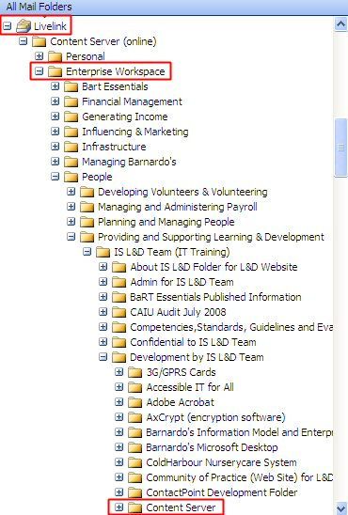
- Right click on the folder which is going to contain the new email folder.
- Select Create Folder… from the menu.
- Click in the Name field and type in a sensible name.  - Click in the E-mail folder radio button to make this new folder an email folder.  - Click on OK. | 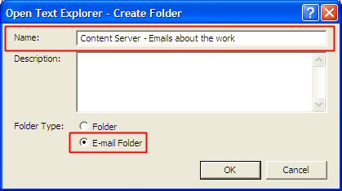
- The new email folder is created and ready to use. | 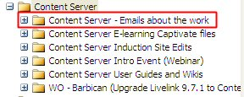
Now – why not add your new Outlook Folder to your Outlook Favorites by clicking and dragging a copy up into the Favorites area?  This will make it easier to drag and drop emails into your new folder. |  | 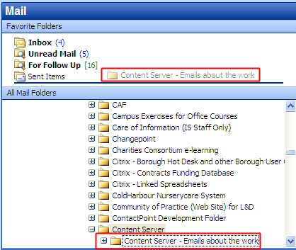

Finally, here are some helpful tips.
- Remember - you will still only be able to save emails into folders where you have permission to add items.
- Only save things into Content Server that you NEED to keep.
- Avoid having just one email folder somewhere and putting every email into it otherwise you won't ever be able to find anything! Create email folders to reflect the work you do and add mail into those - this is far more organised!
- Consider confidentiality when saving an email - remember emails added to public folders in Content Server can be viewed by anyone.
- Make sure emails regarding service users, volunteers or even members of staff, go directly into their own File.

