You can drag and drop files into most areas of Content Server (CS). This makes adding new documents to CS much quicker.

Where will this work?
Pages where you can drag and drop files have a Drag & Drop icon above the file list, next to the buttons to add documents and folders.
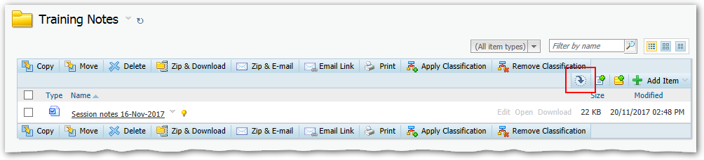
Note: The main area where Drag and Drop will NOT work is in Service User Recording File Rooms.

How does it work?
You drag a document from your desktop or My Documents on your computer onto the file list area. The whole file area will turn blue at this point and when you drop the document it will be uploaded to Content Server in this location.
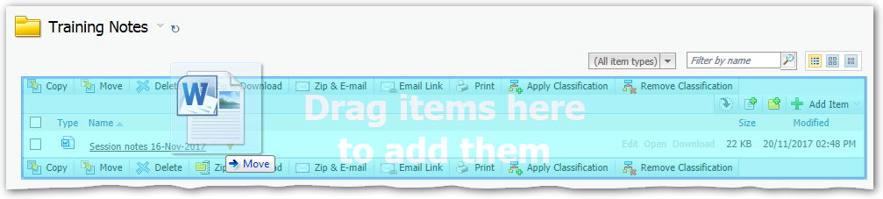

What can I drag?
Basically any file type. This could be Word, Excel or PowerPoint files, but it could also be PDFs, images or even more obscure file types, such as CAD.

Can I drag a folder of files into Content Server?
No – this will not work with Folders. However, you can drag multiple files at once. Just highlight them all as illustrated below, and drag the group of files.
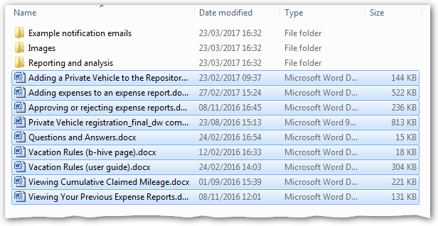
Tip: If you want to highlight a list of files as above, you can click on the first one and then shift-click on the last one. To highlight multiple files that are not next to each other, use ctrl-click.

