Exit Interview
- To access the Exit Interview form click on Special Info button in the Person and Assignment Screen. | 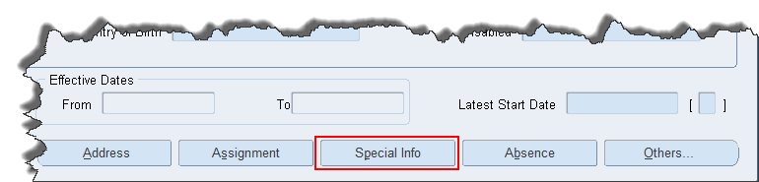
- Scroll down the top section of the form until Exit Interview appears on the list.  - Click on Exit Interview in the Name section.  - Change the Start Date as required.  - Click in the Detail field.  - Click on the Ellipse button at the end of the field. | 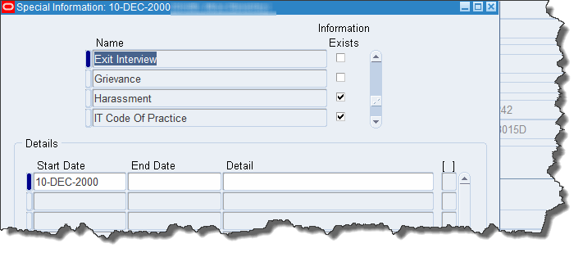
- Click in the required fields and complete with the correct information.  - Click on OK. | 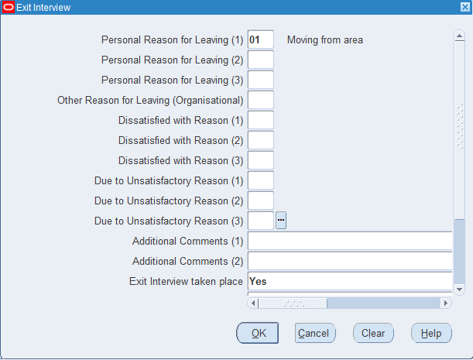
- Click on the Save button on the toolbar. | 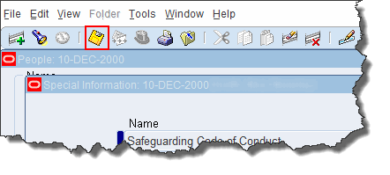
- The next time Special Information is accessed, a tick will appear in the Information Exists column.  - Click in the Exit Interview field.  - Click in the Detail field.  - Click on the Detail field again to see and update the details. | 