Barnardo’s eLearning site provides a single point of access to all eLearning resources as well as links to the Virtual Classroom schedule.

Accessing the eLearning Site
You can log onto the eLearning site from any computer with this link:
https://barnardos.clcmoodle.org
If you are on a Barnardo’s computer you can find a link to the eLearning Site in the Learning Organisation on b-hive – look in the Learning and Development section for eLearning.

Logging onto the site
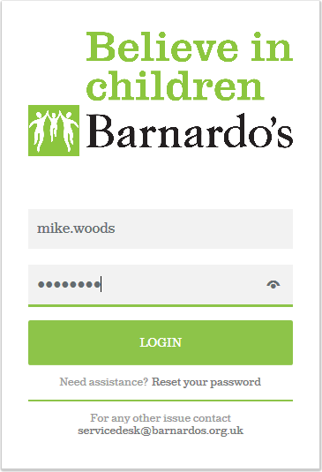 | - Your Username is your normal Barnardo’s computer login name (e.g. firstname.lastname).  - Your Password is whatever you chose at first login. New users will receive a temporary password that will expire on first login.

Tip: If you forget your password you can use the Reset your Password link to reset it.

Dashboard
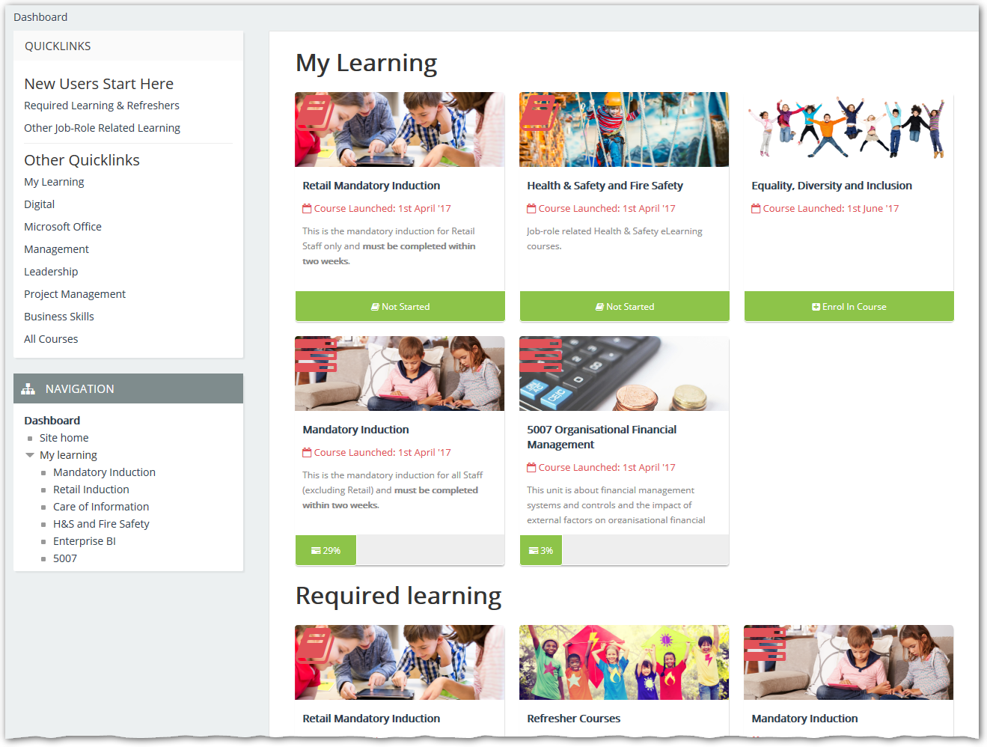
The Quicklinks panel to the left allows quick navigation to the most important courses.
The My Learning panel to the right lists the most recent courses you have accessed.

