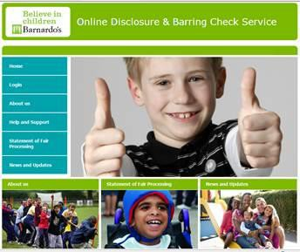

# Introduction:

This manual outlines how to use the DBS employmentcheck application system when setting up an applicant and verifying their identity.

[1 accessing the employment check system: 3](#_Toc387848327)

[1.1 The Home Page 3](#_Toc387848328)

[1.2 User access levels 4](#_Toc387848329)

[1.3 Logging onto the system 6](#_Toc387848330)

[1.4 Forgotten passwords 7](#_Toc387848331)

[1.5 Account activation / deactivation 8](#_Toc387848332)

[1.6 Editing your account details 9](#_Toc387848333)

[1.7 Logging out of the system 10](#_Toc387848334)

[1.8 Guidance on symbols used 10](#_Toc387848335)

[2 Disclosure applications: 13](#_Toc387848336)

[2.1 Adding an ID Verifier 13](#_Toc387848337)

[2.2 Adding an Applicant 15](#_Toc387848338)

[2.3 ID Verification 18](#_Toc387848340)

[2.4 Automated reminders for incomplete applications 24](#_Toc387848342)

[2.5 Putting applications on hold 24](#_Toc387848343)

[3 Disclosure results: 24](#_Toc387848348)

[3.1 Clear disclosures 24](#_Toc387848349)

[3.2 Disclosures with additional information 25](#_Toc387848350)

[4 Certificates of Good Conduct 26](#_Toc387848352)

[5 Other Administrative functionality: 28](#_Toc387848353)

[5.1 Search 28](#_Toc387848354)

# 

# 1 Accessing the employment check system:

### 1.1The Home Page



From the Home Page, you are able to:

* Log onto the system
* View information about your Registered Body’s Service
* View the Statement of Fair Processing for using the system

### User access levels

There are seven user permission levels available within the employment check system, summarised in the table below:

|  |  |
| --- | --- |
| **User type** | **User able to…** |
| Applicant | * Complete online application form * View Applicant guidance |
| ID Verifier | * Complete ID verification online for assigned applications, including entering the results of external ID checks for Route Two * Edit own account details (password and contact email) * View ID Verifier guidance * Once ID verification completed for an application, the application is removed from their “pending applications” and can no longer be viewed. |
| Admin | * Edit own account details (password and contact email) * Search and edit applications, users and ID Verifiers for all Business Units under their Registered Body * Enter receipt of a Certificate of Good Conduct * Add Applicants for all Business Units * Add ID Verifiers for all Business Units |
| BU Admin | * Edit own account details (password and contact email) * Search and edit applications, users and ID Verifiers for their own Business Unit * Limited ability to move applications to other statuses * Enter receipt of a Certificate of Good Conduct * Add Applicants for their own Business Unit * Add ID Verifiers for their own Business Unit * Access the e-Bulk menu, and view all applications for their own Business Unit * View disclosure results for their own Business Unit, including whether a disclosure has been returned with content * Run reports assigned to their Business Unit * Request standalone Barred List checks (should this functionality be enabled for the Registered Body) |
| Admin+ | * Edit own account details (password and contact email) * Search and edit applications, users and ID Verifiers for all Business Units under their Registered Body * Edit the status of an application * Request and enter the outcome for standalone Barred List checks (should this functionality be enabled for the Registered Body) * Enter receipt of a Certificate of Good Conduct * Add Applicants for all Business Units * Add ID Verifiers for all Business Units * Access the e-Bulk menu, and view all applications under their Registered Body * View disclosure results for their Registered Body, including whether a disclosure has been returned with content * Run the “Archive” and “Extract” functions * Run reports assigned to their Registered Body |
| Admincs | * Edit own account details (password and contact email) * Search and edit applications, users and ID Verifiers for all Business Units under their Registered Body * Edit the status of multiple applications * Request and enter the outcome for standalone Barred List checks (should this functionality be enabled for the Registered Body) * Enter receipt of a Certificate of Good Conduct * Add applications and Applicants for all Business Units * Add ID Verifiers for all Business Units * Access the e-Bulk menu, and view all applications under their Registered Body * Countersign and e-Bulk disclosure applications * View disclosure results for their Registered Body, including whether a disclosure has been returned with content * Run the “Archive and Extract” report * Run reports assigned to their Registered Body |
| Superadmin | * Configure Registered Body details * Manage Email Groups, Business Unit Types and Recheck Reasons * Edit own account details (password and contact email) * Configure system-generated email templates * Add Business Units * Search and edit Business Units * Add Admin/BU Admin/Admin+/Admincs users * Search and edit Admin/BU Admin/Admin+/Admincs users * Write bespoke reports using the Report Builder tool * Allocate reports to Business Units * Manage Positions, Locations and Charging Profiles * Edit the content of the login Terms & Conditions for each user level |

### Logging onto the system

To log on to the employment check system, click “Login” on the Home Page menu, and enter your username and password.

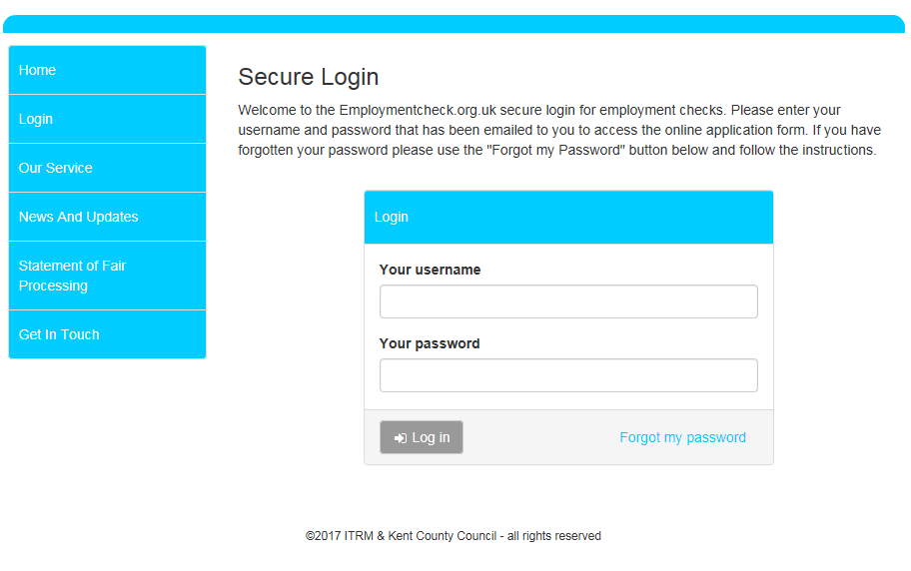

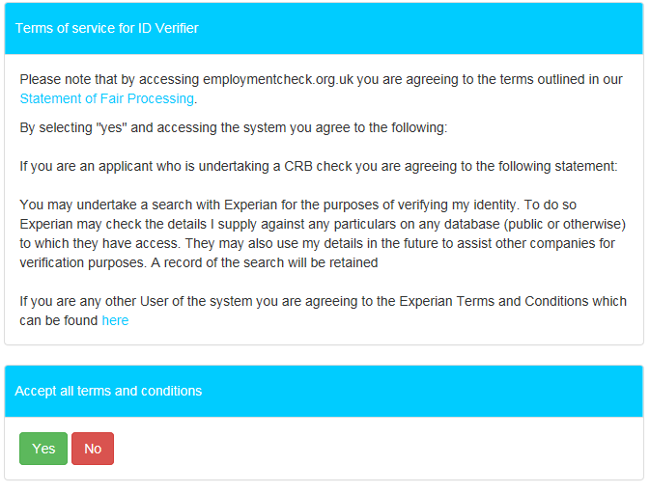

### Forgotten passwords

If you have forgotten your password, you should click the “Forgot my password” link on the Login screen. You will then be prompted to enter your username, and click on “Request a reset”. You will then receive an email with a secure link enabling you to access the system in order to change your password.

If a password is entered incorrectly three times, your access will be revoked, and you will need to use the “Forgot my password” option to generate an email to your account with a secure link to access the system to change your password.

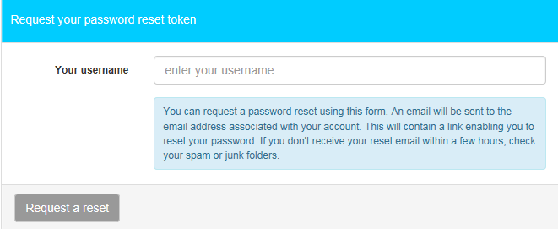

Alternatively, Admin/BU Admin/Admin+/Admincs users can also reset Applicant passwords manually, by selecting the “Manage Applications” option, searching the individuals name and clicking on the pencil icon.

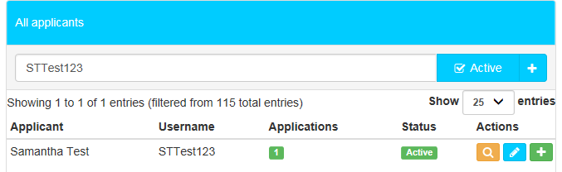

They should then amend the details as required and click on “Save”. Please note that if an Applicant has locked themselves out of their account, the administrator would also need to uncheck the “Access revoked” box at this stage.

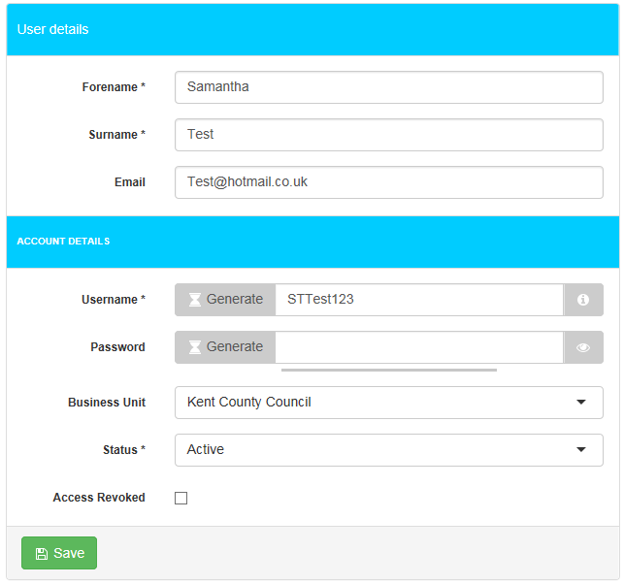

### Account activation / deactivation

User accounts (below Super Admin level) are automatically deactivated after six months of inactivity. Once an ID Verifier account becomes inactive it can only be reactivated by an Admin/BU Admin/Admin+/Admincs user. Admin/BU Admin/Admin+/Admincs level and Super Admin accounts can be reactivated by Super Admins. For users who have been deactivated, the system will automatically reactivate them when a new check is created.

User accounts may also be manually activated / deactivated by system administrators, as summarised below.

|  |  |  |
| --- | --- | --- |
| **User type** | **User types who can activate / deactivate these accounts** | **How to activate / deactivate accounts** |
| Applicant | Admin/Admin+/Admincs (for all ID Verifiers for the Registered Body)  BU Admin (for ID Verifiers for the Business Unit to which the BU Admin is attached) | Search for the applicant under the “Manage Applications” section and click the  icon. If you scroll to the bottom, you can then archive the application using the “Application status” dropdown on the edit screen. |
| ID Verifier | Admin/Admin+/Admincs (for all ID Verifiers for the Registered Body)  BU Admin (for ID Verifiers for the Business Unit to which the BU Admin is attached) | Search for the ID verifier under the “Manager ID Verifiers” section and click on the  icon to edit the account. You can tick/untick the “Access Revoked” box in order to activate/deactivate the account and then click “Save ID Verifier”. |
| Admin / BU Admin / Admin+ / Admincs / Super Admin | Super Admin | From the “Manage Admins” section, select the  icon against the individual to edit the user account and you can then tick/untick the “Access Revoked” box in order to activate/deactivate the account and then click “Save” |

### Editing your account details

All users can edit their own password and contact email address using the “Edit Details” menu.

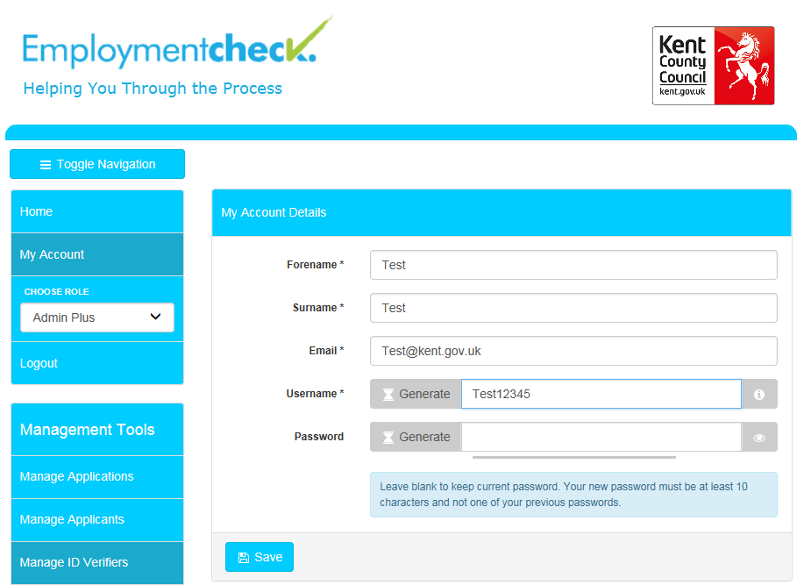

Passwords must be at least ten characters long and contain characters from three of the following four categories:

1. English uppercase characters (A through Z)

2. English lowercase characters (a through z)

3. Numeric 10 digits (0 through 9)

Separately, it is possible to set a limit on how many previous passwords can be used when resetting a password. The system default is 1, which means the system will not allow the reuse of the existing password when resetting it. There is no maximum to this value, effectively allowing you to stop the reuse of any old passwords if required, but this can be aligned with your organisations security requirements.

There is also an option to set how many days elapse before a user is forced to change their current password. The system default for this is 60 days, but this can be aligned with your organisations security requirements.

Selecting “Show Password” will display the password entered

### Logging out of the system

To log out of the system, simply click on “Logout” on the left hand menu.

### Guidance on symbols used

The following symbols are used throughout the system to denote the various statuses applications go through:

|  |  |  |
| --- | --- | --- |
| **Symbol** | **Status** | **Description of Status** |
| [https://ekhuft.employmentcheck.org.uk/images/status/waiting.png](https://ekhuft.employmentcheck.org.uk/admin/secure/?status=2) | Waiting for Applicant to Fill in Details | Once an Applicant account has been created the application status changes to “Waiting for Applicant to Fill in Details”. It remains in this status until the Applicant submits their form or the application is manually moved by a BU Admin, Admin+ or Admincs user. |
| [https://ekhuft.employmentcheck.org.uk/images/status/awaiting_id_verification.png](https://ekhuft.employmentcheck.org.uk/admin/secure/?status=12) | Awaiting ID Verification | When the Applicant finishes their section of the form an email gets sent to the assigned ID Verifier asking them to check the ID for that Applicant. Until this is completed (or the record is manually moved by a BU Admin, Admin+ or Admincs user) the application sits in Awaiting ID Verification status. |
| [https://ekhuft.employmentcheck.org.uk/images/status/completed.png](https://ekhuft.employmentcheck.org.uk/admin/secure/?status=3) | Ready for eBulk Processing | This status is used for holding applications ready for countersigning, until the Counter Signatory sends them via secure eBulk to the DBS. |
| [https://www.employmentcheck.org.uk/images/status/submitted.png](https://www.employmentcheck.org.uk/admin/secure/?status=4) | Application Submitted via eBulk | Submitted applications move into this status until a receipt confirming that the DBS have the application has been obtained at which point the status changes to Received by DBS. |
| [https://ekhuft.employmentcheck.org.uk/images/status/received_by_crb.png](https://ekhuft.employmentcheck.org.uk/admin/secure/?status=5) | Received by DBS | This status confirms that the DBS have successfully received an application. The DBS check sits in this status until the results are returned from DBS. Within this status you can track the progress of checks against the various stages of the DBS process. |
| [https://ekhuft.employmentcheck.org.uk/images/status/result_received.png](https://ekhuft.employmentcheck.org.uk/admin/secure/?status=11) | Result Received from DBS | Disclosure results are received electronically and display in this status. A paper copy of the disclosure certificate is also sent to the individual applicant. If the disclosure is clear an email is automatically generated to the manager to notify them that the disclosure has been returned.  Any disclosure with additional information will be flagged with a “**P**” and a note to say “Please wait to view applicant certificate”. |
| [https://ekhuft.employmentcheck.org.uk/images/status/archive.png](https://ekhuft.employmentcheck.org.uk/admin/secure/?status=13) | Application Archived | Once a recruitment decision has been made or a check cancelled, the application can be archived. Once done, the system will automatically purge any confidential information after 6 months in line with DBS requirements. |
| [https://ekhuft.employmentcheck.org.uk/images/status/holding.png](https://ekhuft.employmentcheck.org.uk/admin/secure/?status=19) | Holding | This status is used to pause applications for example in cases where an applicant is on long term leave and the check should be requested upon their return. Applications in this status will no longer receive any automated reminder emails. Applications can be moved here via the edit screen and eBulk menus by BU Admin, Admin+ and Admincs users. |
| [https://ekhuft.employmentcheck.org.uk/images/status/in_progress.png](https://ekhuft.employmentcheck.org.uk/admin/secure/?status=8) | In Process with DBS | This status is for hardcopy application forms where Applicants cannot get access to a PC. Applications may be placed here until the hardcopy results are returned, to ensure these records are included in reporting. |
| [https://ekhuft.employmentcheck.org.uk/images/status/error.png](https://ekhuft.employmentcheck.org.uk/admin/secure/?status=20) | Error | This status displays applications that have been rejected by the DBS. The error code describes the reason for rejection. Applications in this status generally require action from an Admincs user before the check can be resubmitted to the DBS. |

Additionally, the following symbols are used throughout the system to indicate common functions:

|  |  |
| --- | --- |
| **Symbol** | **Description** |
|  | Add/Expand |
|  | Edit |
|  | History log |
|  | Tool tip |
|  | Preview |
|  | Clone |
|  | History |
|  | Assign |
|  | Logs |
|  | View |

# 

# Disclosure applications:

All administrative users (Admin/BU Admin/Admin+/Admincs) can set up disclosure applications on the system, however BU Admin users are only able to do so for Applicants from the Business Unit to which the BU Admin is assigned. Only Admincs users are able to countersign and eBulk applications.

Logging onto the system as an administrative user will bring up the Administration Panel, as shown below. Please note that the menu options visible will reflect the permissions associated with the type of administrative user account as detailed in section 1 above.

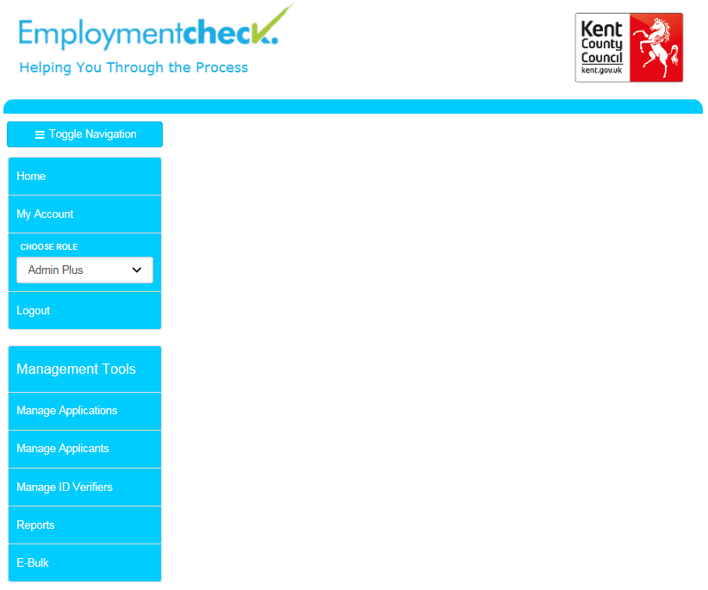

### Adding an ID Verifier

If the ID Verifier for a check is not already set up on the system they will have to be added as the first step. To check whether or not an ID Verifier has already been set up on the employment check system, click on “Manage ID Verifiers” on the main menu screen, enter the first or second name of the individual you are searching for and click enter. Please note that you can use the wildcard “%” to search for all names following an initial set of characters, and can specify whether you want the search to include inactive accounts by deselecting the “Active” tick box.

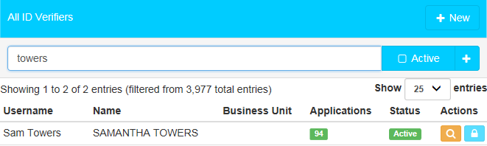

To set up an ID Verifier, click “+New” button at the top of the page. You will need to complete all of the fields marked as mandatory (denoted by an asterisk) as a minimum. Clicking on “Generate” will generate a satisfactory Username or password.

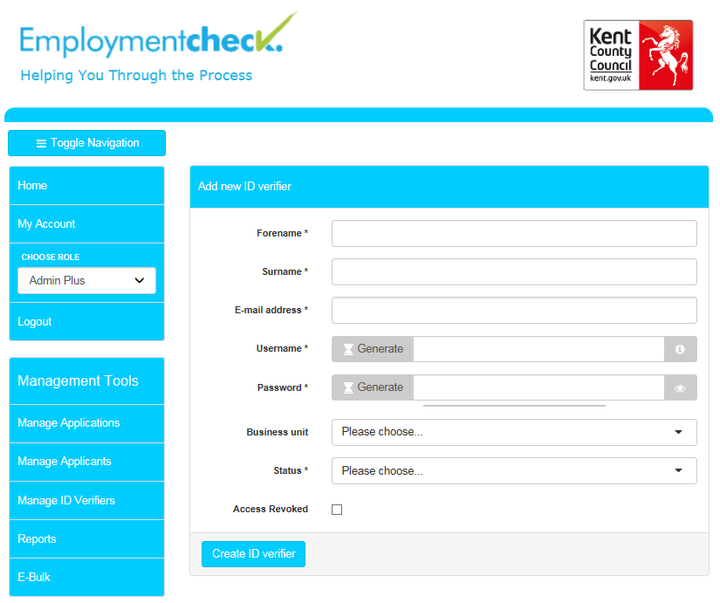

Once complete, you should click “Create ID Verifier” at the bottom. This will generate an email from the system to the ID Verifier (provided an email address has been entered) notifying them of their login details. A message will also appear on-screen to indicate that the account has been successfully set-up.

***MC900432658[1]TOP TIP – Please note that when adding an ID Verifier as an Admin/Admin+/Admincs user, you should select which business unit you would like the ID Verifier to belong to. If an ID Verifier is set up by a BU Admin user they will only be able to verify ID for checks for that specific Business Unit. Non BU admins can select “Global” for all business units to be available to that ID verifier.***

### 

### Adding an Applicant

To create a new application for an individual that has previously completed a check, search for the Applicant using the “Manage Applicants” tab on the left hand side, and then click on the 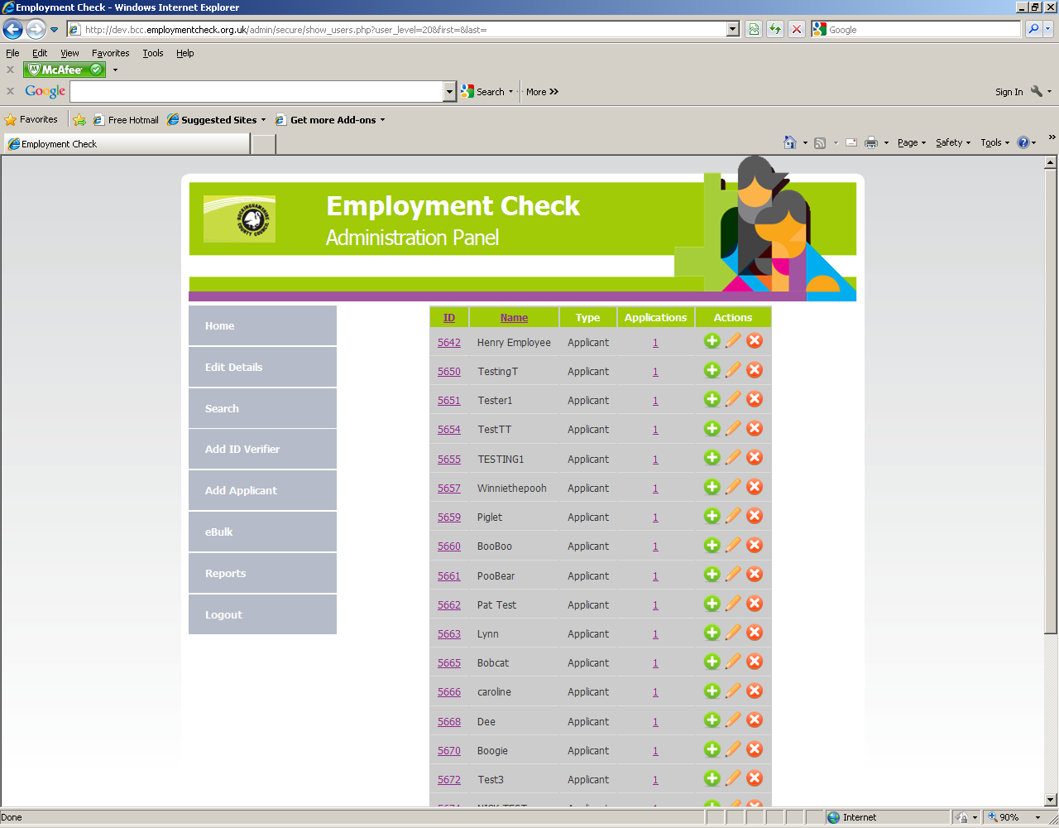 icon to add a new record for that Applicant.

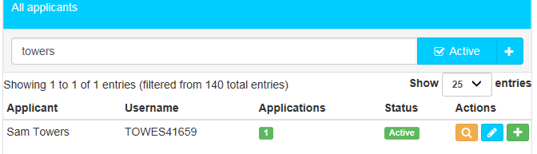

To create a new application, click the “Manage Applications” option on the left hand side, followed by the “+ New” button at the top of the page.

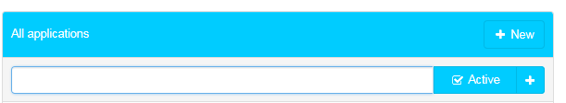

This will bring up a form as illustrated below. You need to complete all of the mandatory fields (denoted with an \*) in order for the application to be created.

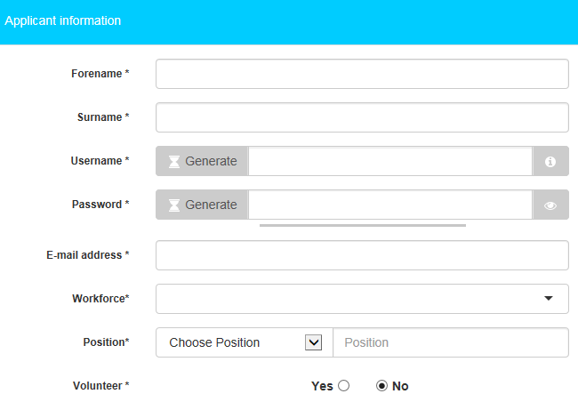

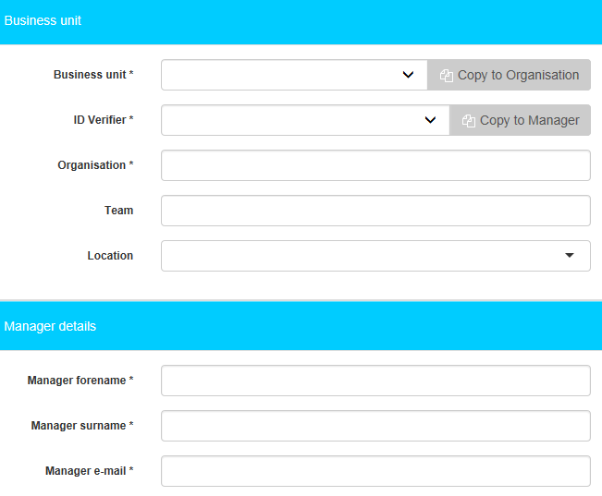

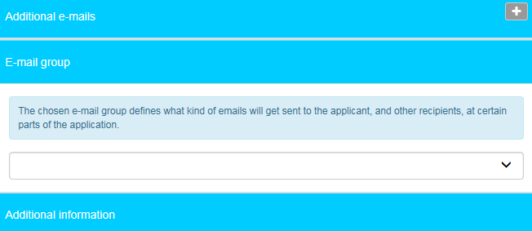

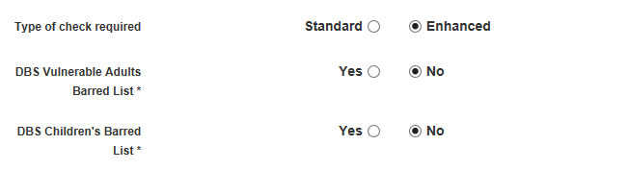

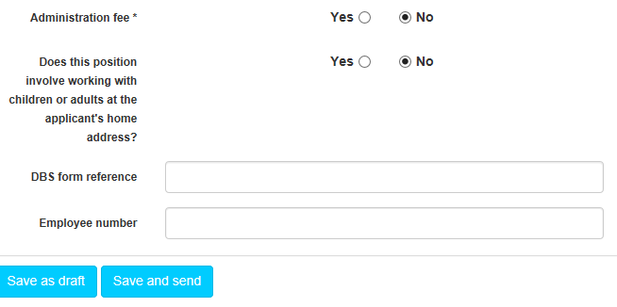

The ‘workforce’ is a mandatory pre populated drop down menu with the following options, Child Workforce, Adult Workforce, Child and Adult Workforce, Other Workforce. This entry will be added to that made in the ‘position’ field, described below, to make up the final position data submitted. This ensures the application is eligible for subscription to the DBS Update Service.

The “position” can either be selected from a drop down menu (the contents of which are set at Super Admin level) or can be manually typed in.

The “Manager Details” section details the individual who should be notified of the disclosure result. If this is the same person as the ID Verifier, you can check the box entitled “Copy to Manager”. Similarly if the “Organisation” (as it should appear on the disclosure certificate) is the same as the Business Unit, you can check the box entitled “Copy to Organisation”.

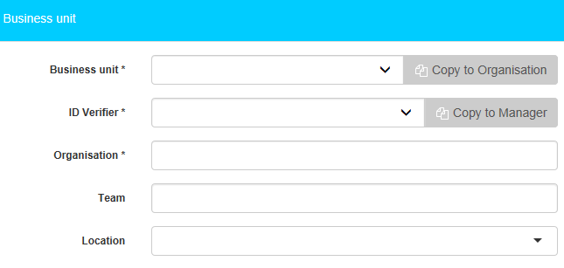

Please note that for checks set up by BU Admin users, the Business Unit will be fixed to the Business Unit to which the BU Admin is assigned, and the Team and Location fields will not be visible. The list of ID Verifiers will also be limited to those assigned to the same Business Unit as the BU Admin.

If the registered body has set a requirement for a reason to be specified against an application type, an additional, mandatory drop-down field will appear at the bottom of the application form.

The ‘working from home’ option is linked to the type of application. For standard applications this will default to ‘No’, for enhanced you must choose if the applicant is working from home.

If the check is subject to an administration fee, selecting “yes” will prompt you to provide a Cost Code to be charged.

Once all fields have been completed, click on “Save and Send”. A screen will appear to confirm that the Applicant has been successfully set up. This process will also trigger an automated e-mail to the Applicant in question, providing their log-in details.

There is also the option “Save as Draft” should you wish to come back to the application and send this at a later date.

### ID Verification

After the Applicant submits their application the ID Verifier will receive an email asking them to log on to the system and enter the ID details for the Applicant which they will either have checked and copied at interview stage or have available by completing this process with the Applicant present.

The link on the email will take them to the login screen where they will need to enter their username and password to access the system. Logging in will display the “ID Verifier Control Panel” (see below). Options available include the facility to edit their account details, view pending applications and check the ID Verifier FAQ’s. To view the list of applications requiring ID Verification, the ID Verifier should select the “Pending Applications” menu.

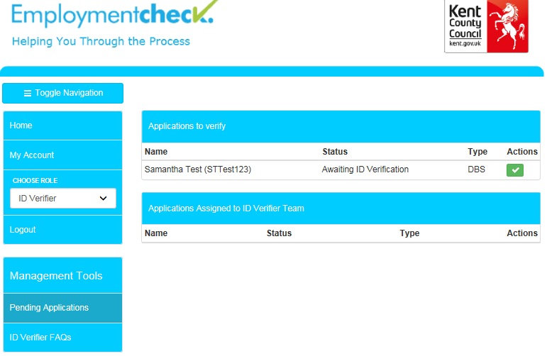

This will display a list of those Applicants for whom ID verification is outstanding. They will then need to click on “approve” (denoted by a green tick), which will then take them to the next screen to complete the ID verification.

The next screen provides a preview of the details the Applicant has already entered to allow the ID Verifier to verify the ID against this information.

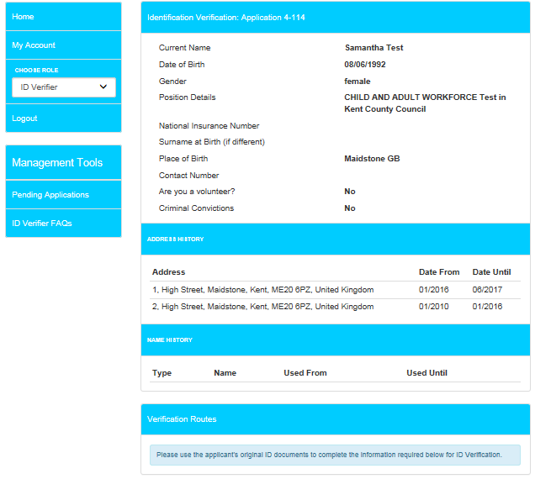

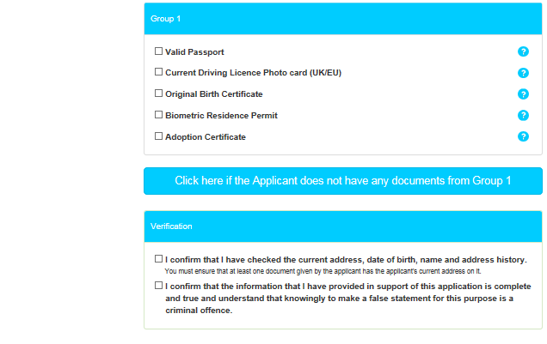

In the first instance the ID Verifier will be prompted to select ID to meet Route One from the appropriate groups. At the top of the page, you will see a banner, showing which route you are currently on and what ID combination is required for that particular route. This will change as you move through the different routes:



By clicking the tool tip () next to certain fields, it will provide additional information e.g. how old a particular document can be in order to be considered valid for ID verification purposes.

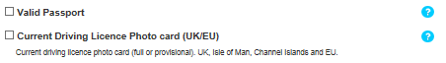

Note that for some types of ID e.g. passport, driver’s licence and birth certificates, the field will expand prompting the verifier to provide additional information e.g. date of issue, as shown below. Please note that when prompted to select a date a calendar will appear.

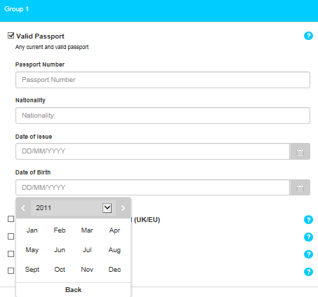

Once sufficient ID has been provided, a note will appear at the top of the documentation list confirming this and the system will grey out other options, preventing you from selecting additional ID as shown below.

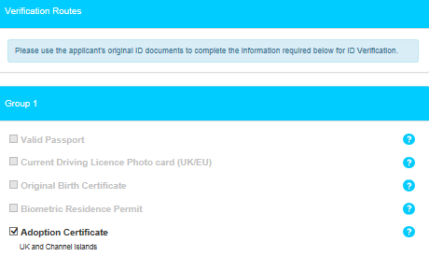

If the applicant cannot provide sufficient ID to meet Route One, the ID Verifier should select the button “Click here if the Applicant does not have any documents from Group 1”.



Upon selecting this, this will then display the relevant ID groups for Route Two.

Route Two additionally requires the ID Verifier to complete an external ID verification check, by clicking the “Verify Identity” button.

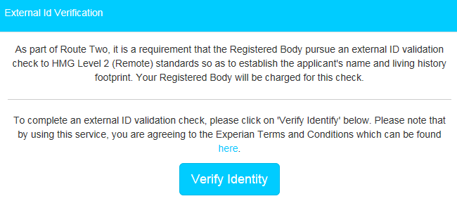

***MC900432658[1] TOP TIP – We strongly advise that you check that the applicant is able to provide sufficient ID for Route One before undertaking an external ID check.***

The ID verifier will then get a pass or fail result. If they get a pass, they will be able to proceed down route 2. In the event that they get a fail, or the applicant cannot provide enough ID for Route Two, the ID Verifier will need to move onto Route Three.

Should the ID Verifier wish to return to a previous route, they can do so by selecting the route under the current ID selection. Please note that moving to a different route will remove data entered for the previous route and that if the result of Route 2 was a fail, you will not be able to go back to this route.

Once the requirements for a particular route have been met, the ID Verifier needs to confirm that they have checked the current address of the applicant and tick the declaration to confirm that the information provided in support of the application is complete and true before being able to submit the application.

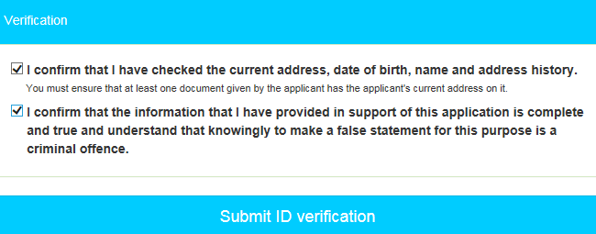

Once the ID verification has been completed, the ID Verifier should click on “Submit ID verification”. This will send the completed form to countersignatories for secure submission via e-bulk to the DBS. A message will appear onscreen to confirm this has been successful.

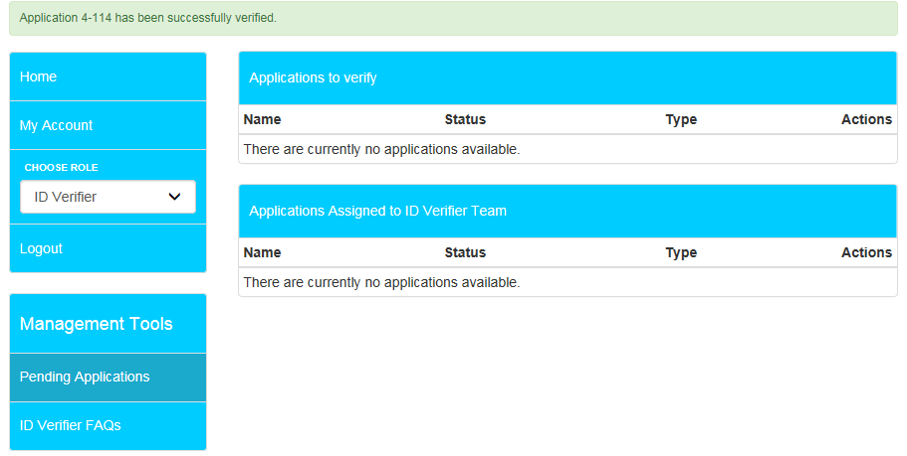

ID Verifiers are asked to complete the ID verification within a specified period. In the event that this is not completed within the stated timescales, automated reminder e-mails can be sent by the system to the ID Verifier at a frequency specified by the Registered Body at the time the system is set up.

### Automated reminders for incomplete applications

Applicants and ID Verifiers are asked to complete their respective elements of the DBS application process within a specified period.

For online Applicants, an automated reminder e-mail is sent to the Applicant at regular intervals reminding them to complete the online form, with a notification simultaneously sent to the ID Verifier. ID Verifiers are similarly issued automated reminders.

### Putting applications on hold

In cases where the completion of an application may be legitimately delayed (or where an off-system process is required), it is possible to change the status of an application to ‘Holding’ via the ‘Application Status’ dropdown on the ‘Edit Application’ screen. This will pause the application process and the automated reminder e-mails.

To view a list of applications in holding, select ‘eBulk’ from the Administrator panel, then select the holding icon ([holding](https://ekhuft.employmentcheck.org.uk/admin/secure/?status=19)).

# Disclosure results

Once checks have been completed, a disclosure number is issued by the DBS. Disclosures for online applications are received electronically and can be accessed by selecting [result_received](https://ekhuft.employmentcheck.org.uk/admin/secure/?status=11) “Result Received from DBS” from the e-bulk menu. Hardcopy disclosure certificates are received by post.

### Clear disclosures

Any clear online disclosure will be denoted with a [result_received](https://ekhuft.employmentcheck.org.uk/admin/secure/?status=11) symbol, and a confirmation that “Certificate contains no information”. A system-generated email is also automatically sent to the nominated manager(s) informing them that the DBS check has been completed for their employee, providing the disclosure number for that check. A hardcopy certificate is posted to the Applicant.

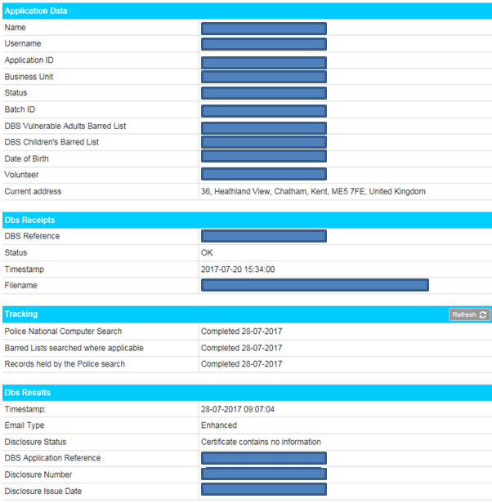

### Disclosures with additional information

Any online disclosure with additional information will be returned with a “[result_received](https://ekhuft.employmentcheck.org.uk/admin/secure/?status=11)**P**” and a note to say “Please wait to view applicant certificate”. In addition a ‘Notification of Result with Content’ email will be sent to the nominated manager(s) (set on the add application screen) informing them that they have received a result which will require them see the applicants certificate.

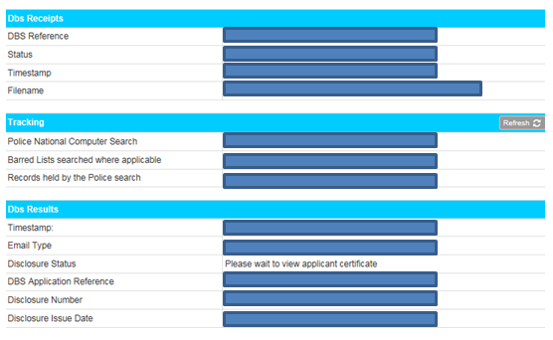

For all disclosures with additional information, the DBS records can be moved to the ‘holding’ status whilst a decision is made regarding the continuity of the Applicant’s employment.

Once an employee has been cleared to continue working, the DBS record can be archived and the manager notified of the disclosure number and issue date. Personal data is purged in line with DBS requirements 6 months after being moved to Archive status.

***MC900432658[1] TOP TIP – You can archive records in bulk via the All / None checkbox and “Archive” option on the eBulk menus. Alternatively checks can be archived individually via the “Edit Application” menu.***

# Certificates of Good Conduct

For Applicants whose five-year address history indicates that they have lived abroad for at least one period of six or more consecutive months, an automated email will be generated upon completion of ID Verification to the Applicant (copying in the manager) indicating that a Certificate of Good Conduct (CGC) is required.

An administrative user can indicate the provision of a CGC via the “Edit Application” screen. Please note that the disclosure / CGC clearance email will not be sent until both the disclosure and CGC have been received.

If an application is returned and a CGC has not been received, it will automatically be moved to the Holding status.

Once in ‘Holding’ if the CGC is logged as received in the edit application page, the application will then automatically move into the Results Received status and the ‘Notification of Result with Content CGC Received’ Email will be sent to the registered manager.

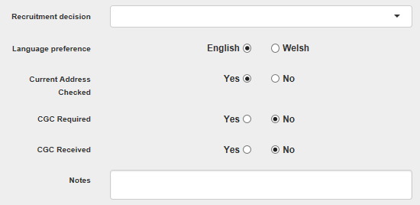

# Other Administrative functionality

### Search

You can search for applicants and ID verifiers on the system by selecting either “Manage Applications” or “Manage ID verifiers” on the left hand side and then using the search bar at the top of the next screen.

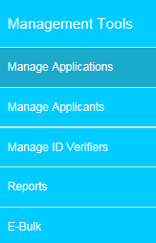

Please note that for BU Admin users, the only search results that are brought up are for accounts from the same Business Unit to which the BU Admin is assigned.

To Search for an ID Verifier click on “Manage ID Verifiers”. This will then bring up a list of ID Verifiers. To search for a specific ID verifier, you can use the search field at the top of the page and enter their forename or surname. Alternatively, you can click the  icon and the fields will expand, so that you have a few more options to search by

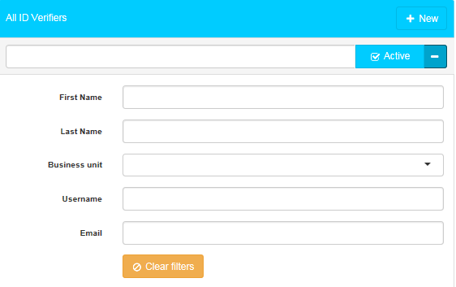

You can tick and untick the “Active” box, to be able to find active or inactive ID verifiers

To edit the ID Verifier’s account details, click on Edit ()

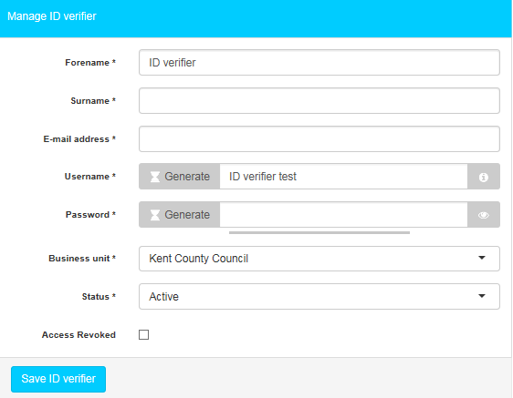

To view the history of applications to which the ID Verifier has been assigned, click the number under the “Applications” column and this will bring up all of the applications.

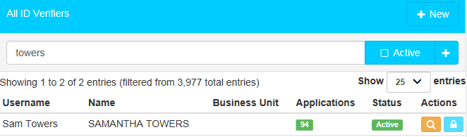

To search for an application, click on “Manage Applications”. This will bring up a list of applications. To search for a specific one, you can use the search field at the top of the page and enter their forename or surname. Alternatively, you can click the  icon and the fields will expand, so that you have a few more options to search by.

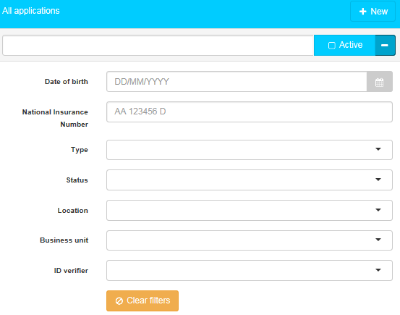

This will bring up all matching records, as illustrated in the example below:

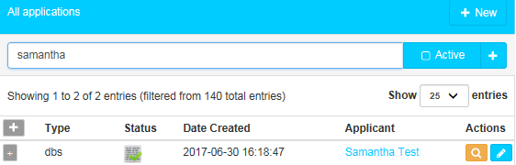

From this screen it is possible to find out / do the following:

* To edit the Applicant’s user account details click on the “Applicant Name”, followed by the pencil icon,
* The “Status” symbol indicates the current stage the application is at.
* Clicking on the magnifying glass icon under “Actions” opens up the notes page for the application in question. This provides a time and author stamped record of each time an application moves stage, a system-generated reminder email is sent out or an administrator has added a note (see below).

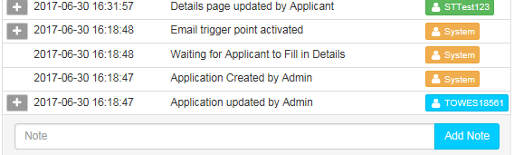

Administrators can add notes against an application using the “Add” button. This can be a useful tool for assisting in the management of an application e.g. explaining why a check was delayed or cancelled.

* Clicking on the pencil icon under “Actions” allows the administrator to open and edit the application in question. BU Admin/Admin+ and Admincs users are also able to edit the status of the application via a dropdown menu at the bottom of the page as shown below:

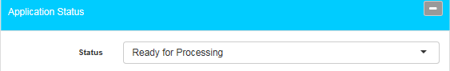

Please note that whilst Admin+ and Admincs users are able to move checks into all other statuses, **BU admins can only move checks into a limited selection of statuses depending on the current status of the application.**

Once changes have been made the administrator should click on “Update Application” at the bottom of the screen to save these.



***MC900432658[1] TOP TIP – Please note that changes will only be effective before a check has been submitted to the DBS via e-Bulk.***

***MC900432658[1] TOP TIP – Please note ID should not be verified via the “Edit Application” screen. If you have Administrative users who are also ID Verifiers they must use their ID Verifier account when verifying ID. Should they fail to do so the system will prevent the check from being submitted at the point of e-Bulk, as shown below:***

