Once the workspace has been created and you have signed up as the workspace manager you may need to invite other Barnardo’s Staff to this workspace to join huddle.
- Navigate to the huddle workspace
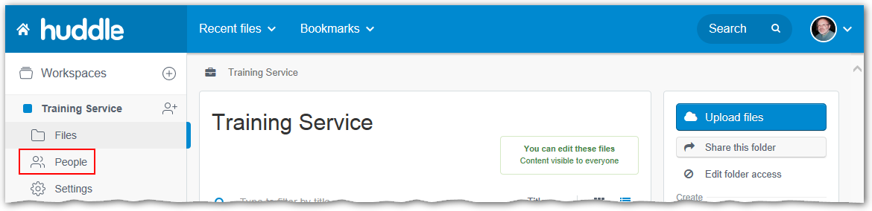
- Click on the People tab in the left-hand panel.
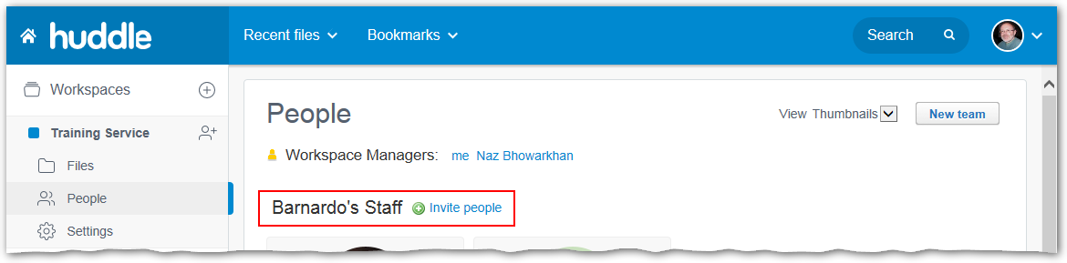
- Scroll down to the Barnardo’s Staff team.
- Click the Invite People to the right of the team name.
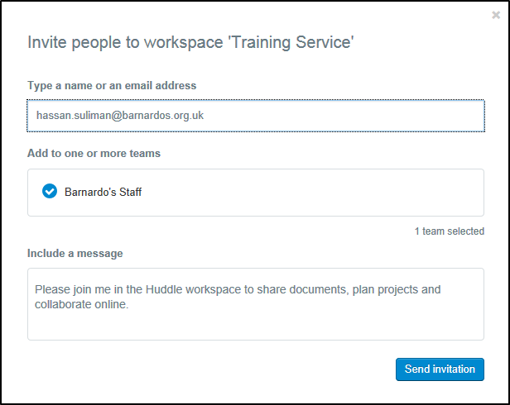
- Enter the full email address of all the staff members you are inviting into the first field.
- In the second field, Barnardo’s Staff should appear automatically. If not type it.
- Edit the Personal message if you wish
- Click the Send Invitation button.
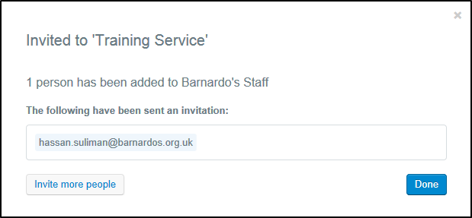
Note: If any of the people you have invited already have a huddle login, they will be added immediately, and this will be indicated on the final screen.
You can now click on the Files tab in the top-right of this panel to return to the workspace
Important: You should remove users when their access is no longer required. The details of how to do this can be found on the huddle b-hive page.

