This is the process you would use to record IT incidents, requests, suggestions or complaints.
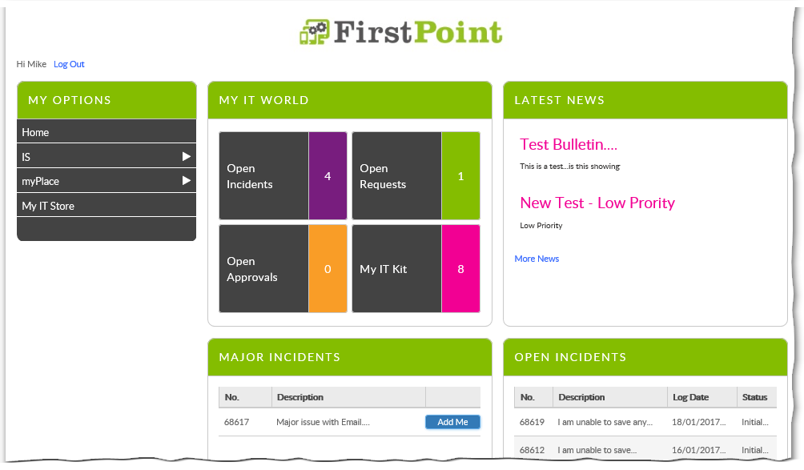
- After opening FirstPoint, you start by selecting either IS or myPlace from the My Options menu on the left, depending on what system the ticket relates to.
  - Use the myPlace option for any myPlace, iExpenses or Direct Input issues.
  - Use the IS option for any other IT related issues.
Note: The examples in this guide use the IS categories, but the same process can be used in the myPlace categories.
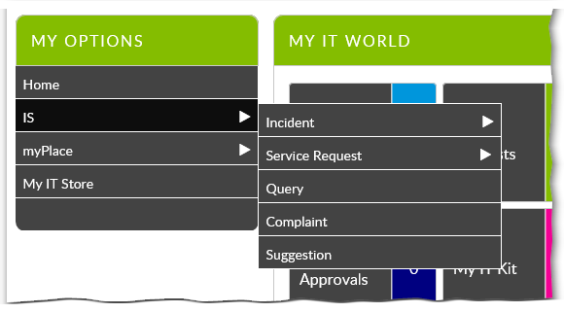
- This is where the different ticket types are displayed.
  - To log a fault with an application, a device or your connection, you would select Incident.
  - To request access to reporting, such as Discoverer, to ask for a blocked email to be released, or to request a telephone bill you should select Service Request.
  - The other options allow you to ask a question, make a complaint or make a suggestion.
- Select the appropriate category. For Incident and Service request a further submenu will appear Incident in this example).
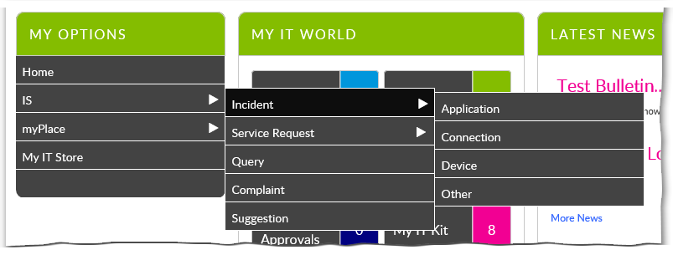
- Select the appropriate category.
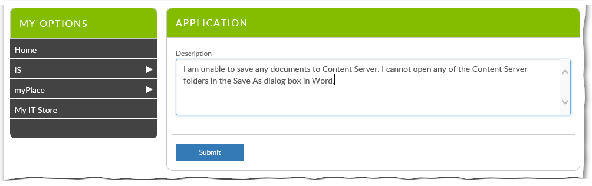
- On this screen you should enter a comprehensive description of the issue.
Note: With other ticket types you may be given specific questions at this point, related to the particulars of the request.
- Once you have completed the description, click Submit.
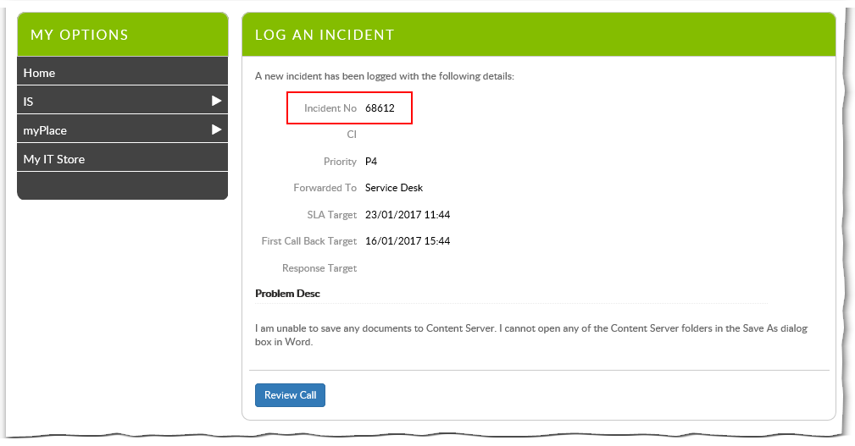
Your ticket has now been recorded and assigned an Incident Number. You will get an email confirming the details. You will also get emails whenever the ticket is updated.

