All Groups in Content Server can be assigned a Group Leader who has the right to add and remove members of staff from a group. This has the advantage of allowing people to administer access to their own Workgroups
This user guide demonstrates how a Group Leader can add or remove people from groups.
- Only one member of a group can be setup as a Group Leader.
- If the Group Leader is leaving Barnardo’s or will be on holiday, they can assign group leadership to another member of the group (“passing on Leadership”) or can unset his/her leadership.
Note: By adding a user to a group you are giving them the right to read/add/delete/edit all documents including the confidential ones in that workgroup area.
Finding the Group Leader of a Workgroup
Permission groups are named in the same or similar fashion to the main team or workgroup folder.
Examples
- For the Link Project, the permissions groups are called Link Project and Link Project Management Team, depending on whether you are part of the service’s management team.
- For the SW Finance Team, the permissions group is called SW Finance team.
There are three ways to find who the group leader for a Permission group is.

1: From the “owner-group” link in the Team folder
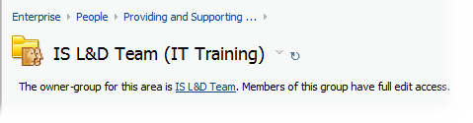
At the top of most team or workgroup folder there is a link below the folder name that leads to the list of team members.
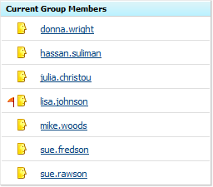
The group leader will be the name with a red flag to its right.
Note: This link will not be available for all team folders. If none of the people on the list have a red flag to their right, contact the IS Service Desk.

2: Searching for the team
If you know the name of the team you can search for it by selecting Users & Groups from the Enterprise menu in Content Server.
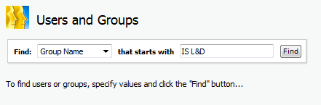
Once you have found the team, click on the View link to the right of it.
The group leader will be the name with a red flag to its right.
Note: If none of the people on the list have a red flag to their right, contact the IS Service Desk for assistance.

3: From the Group Leaders list
To find your permission group(s), look for the relevant permissions groups in the first column on this list:
Group Leaders List
The group leader is named in the second column of the list.
Note: If you cannot find your group(s) in the list, contact the IS Service Desk for assistance.

When you have found the group leader
If you are NOT the group leader for the permission group you wish to maintain, you must contact the person who is.
However, if you ARE the group leader, the remainder of this user guide explains how you can maintain membership of that group.
How to add a member of staff to a group
- Click on the Personal menu and then select My Groups
This will give you a list of all the groups that you are a member of. Any groups of which you are a Group Leader will have an “Edit” action against them; all others will have “View”.
- Select the Edit link for the group.
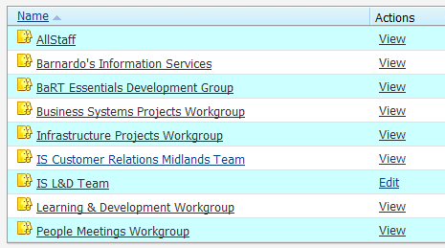
- Click on the Find & Add link (highlighted above).
- Enter the last name of the user in the Starts With field (johnson in the above example).
- Click on the Find button.
- The user information will appear – tick the Add to group tickbox for the person you wish to add
- Click on the Submit button.
Once the member has been added they will appear on the left side under the Current Group Members list.
How to remove a member from a group
To remove a member from the group:
- Click on the members name under the current group members.
- Click on the Remove from group button.
How to pass leadership onto another group member
- Click onto the member name under the current group members.
- Click on the Set as a group leader button.
You will notice that the red Flag indicator moves to the new person.
Note: only one member of the group can be set as a group leader. As Group Leader you also have the permissions to delete the group or change the name of the group. DO NOT DO THIS! Contact the Helpdesk if you believe that this may be required.

