Introduction
In order to access Barnardo’s systems from a computer remotely, you will need a RSA SecurID token. This can be either a physical device or a smartphone app.
Physical RSA SecurID Token | Smartphone RSA SecurID App
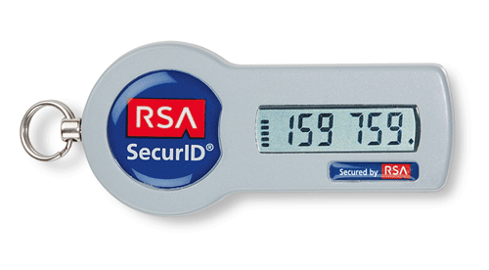 | 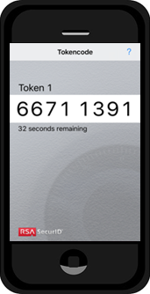

Note: Due to cost and the additional administration, the preferred method would be to download the smartphone app; where applicable.

Process
For reference the following steps will inform you of the process, from raising the request through to accessing the Barnardo’s Network.
- Raise a request in FirstPoint… My IT Store >> SecurID >> Add to Cart and proceed to checkout.
- Smartphone only: you will receive an email; this will contain a guide on how to install the RSA SecurID app.
- Smartphone or RSA physical Token: FirstPoint request completion email sent, this will have a URL to a guide for setting up a PIN and enabling access to the Barnardo’s Network. This is for both a Barnardo’s or non-Barnardo’s PC.
Note: The steps above and guides (sent separately), will take you through the process of connecting to the Barnardo’s network; either using a Barnardo’s or non-Barnardo’s PC.

