This is the process you would use order IT hardware or software, or to request new logins.
- After opening FirstPoint, you start by clicking the My IT Store option in the left-hand menu.
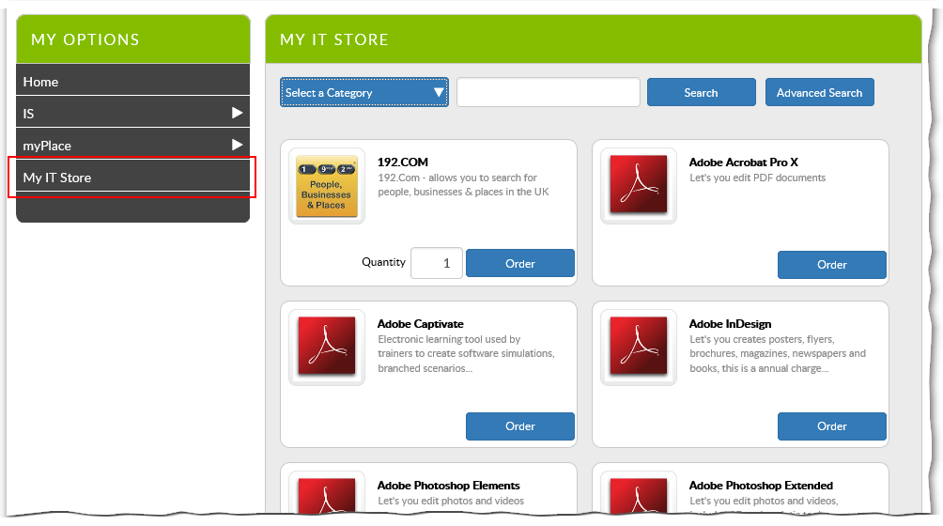
This is where the different items that I can order are displayed. This is quite a long list, so to help you find what you are looking for you can:
- Search for the item by typing part of its name in te search box at the top and clicking the Search button.
- Use the Category drop-down list to filter the list.
For example, if you are requesting a login for a new starter, you could either select New IT Login from the Category drop-down or search for login.
Many of the filter categories will have sub-categories to help you narrow down your search further.
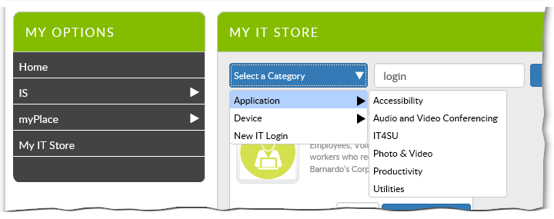
- Once you have located what you require, click on the item to display more information.
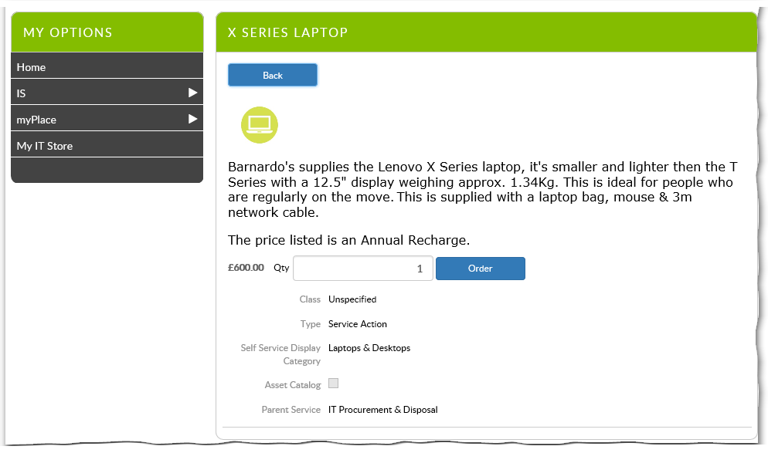
- Once you have found the item you need, enter the quantity you require and click Order.
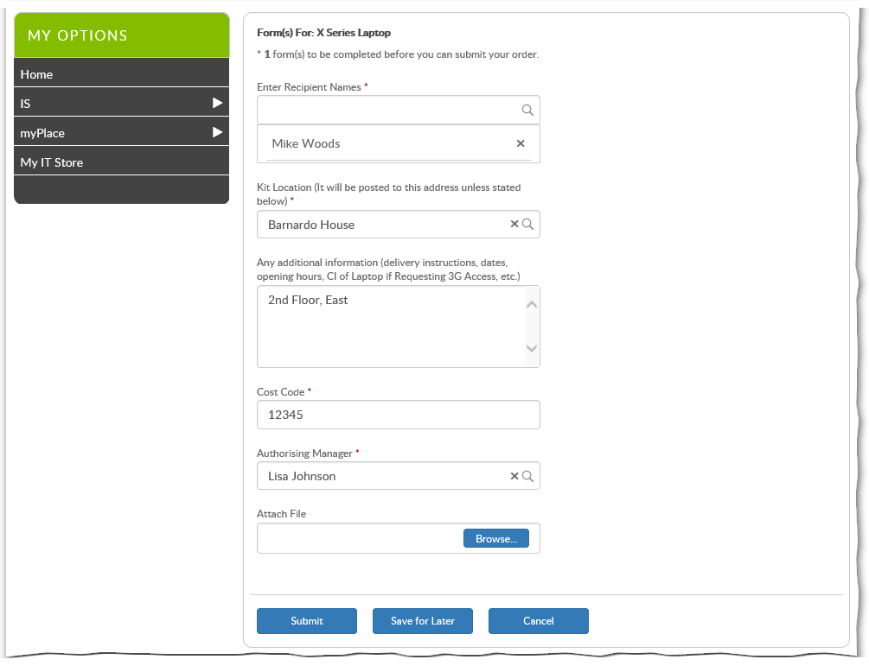
- Depending on the items you have ordered, you will now be asked to complete extra information.
Tips
The layout and fields in this form will differ, depending on what you have ordered.
If you order kit for a new starter, add yourself as the recipient for the kit and give the name of the new starter who will be the user of the kit in the additional details field.
Mandatory fields are indicated by a small red asterisk.
When completing the form, some of the fields will autocomplete as you type (e.g. Recipient Names and Locations).
Others are "free text" fields (e.g. Additional Information) allowing you to enter any information.
Most of the forms extend off the bottom of the visible screen, so take care not to miss fields lower down.
- Once you have fully completed the form, click Submit.
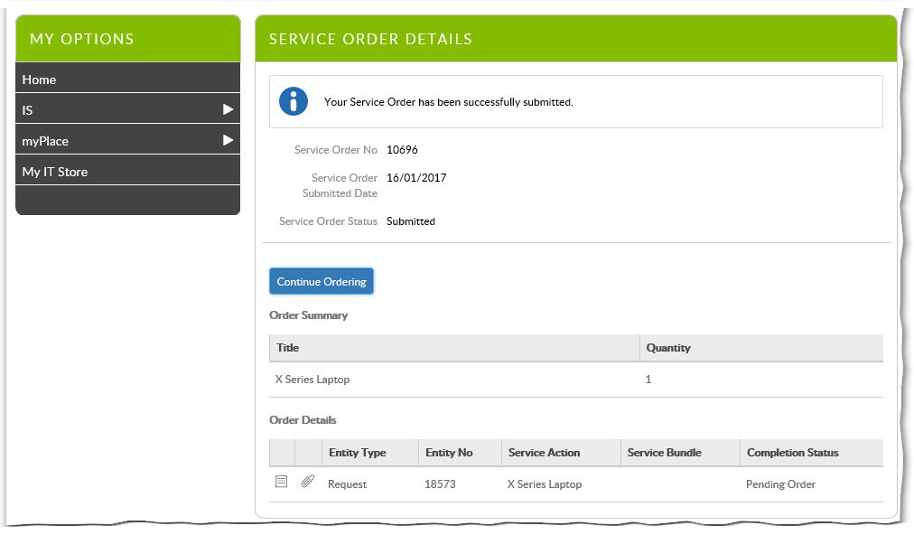
Your order is now complete. You will now get an email confirming details of the order. You will also get emails whenever the order is updated.

