Barnardo’s Volunteer
Reward &
Recognition Scheme:

A Guide for
Volunteer Managers

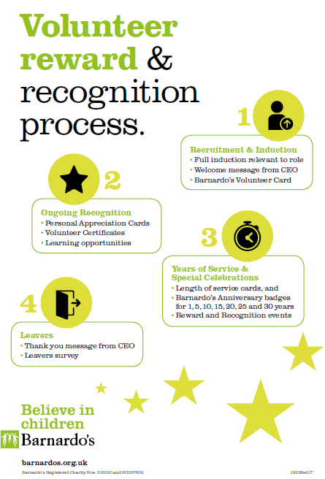
Introduction to the Barnardo’s Volunteer Reward & Recognition Scheme:
This document has been organised into the four key stages of Reward & Recognition:
- Recruitment and induction
- Ongoing recognition
- Length of Service & Special Celebrations
- Leavers
This Infographic summarises the key stages of Barnardo’s Reward and Recognition offer and can be used when inducting new volunteers to Barnardo’s.

Barnardo’s exists to transform the lives of the UK’s most vulnerable children. Our 21,000+ volunteers play such an important role in our work, supporting us in all parts of the charity, including Children’s Services, Retail, and Fundraising. Our volunteers are incredibly important to us: without them, we could not reach so many children nor make such a difference to their lives.

Barnardo’s values its volunteers highly, and seeks to reward and recognise the vital contribution they make. The purpose of this document is to explain Barnardo’s Volunteer Reward and Recognition offer, and to support volunteer managers to implement it effectively, communicating regularly with volunteers to let them know how valued they are, and hopefully increasing volunteers’ sense of satisfaction and motivation as a result.

Scope:

Barnardo’s Reward and Recognition scheme applies to all volunteers at Barnardo’s and so this document is intended for anyone who manages volunteers or is involved in their support or supervision, including Retail, Children’s Services and Fundraising i.e.: Volunteer Coordinator; Project Worker; Branch Manager; Relationship Manager; Volunteer Champion; Support Worker; Service Manager etc. These roles are collectively referred to as “Volunteer Managers” throughout this document.

Definitions:

“As and When” volunteers perform micro volunteering roles at Barnardo’s: roles which can be completed in short, discrete periods of time, but never with any regularity (e.g. not on a weekly or monthly basis). As and When volunteering roles will be identified as such on the relevant role description.

The Volunteering and Community Engagement (V&CE) Team is regularly referred to throughout this document. Each region and nation has a dedicated Volunteering & Community Engagement Adviser who can support volunteer managers with the implementation of this Reward and Recognition scheme. Please click this link for V&CE team contact details
- Recruitment and induction

Reward or Recognition initiative | What do Volunteer Managers need to do? | How is this managed? | To which volunteer roles does this apply?
Volunteer Induction | All Volunteer Managers to ensure volunteers receive an induction relevant and appropriate to their role.  This must include information about reward and recognition. | Volunteer Managers to deliver induction in accordance with V&CE induction guidelines available from Volunteer Advisers. | All
Welcome message from Chief Executive | Can be sent via email or as a hard copy letter. | Children Services: Printed/emailed by Volunteer managers.  Fundraising: Printed/emailed by Regional Relationship Managers.  Retail: The Welcome message is in the retail induction handbook which sits as part of the retail induction, which should be completed by all volunteers.  Other: Volunteer Managers to ensure new volunteers receive the Welcome message via email or letter. | All, including As and When volunteers, at the line manager’s discretion
Barnardo’s Volunteer Card | The credit card size cards will be given to volunteers by their managers after they have completed a trial period of 3 months. The cards will give a sense of membership of Barnardo’s, and will provide an awareness of the UK Volunteer Forum and discounts available to volunteers. This card will be given alongside the Fabulous offers flyer.  See Appendix 1 for image of the Barnardo’s Volunteer Card and Fabulous offers flyer.  The cards can also be used to identify volunteers eg in stores, worn with lanyards. There will also be a smaller (snap off) part that volunteers can attach as a key ring. | The central V&CE Team will send a pack of membership cards to each volunteer manager in January to be handed out to volunteers upon satisfactory completion of their 3 month trial period.  Barnardo’s Volunteer Cards to be given out alongside the Fabulous offers Flyer (see Appendix 1).  In retail, the Fabulous offers flyer should be displayed on the store noticeboard, and pointed out to new volunteers.  Click here for information on fabulous offers – discounts available to volunteers. These offers will be updated as they change. | All, apart from As and When volunteers

2. Ongoing recognition

Reward or Recognition initiative | What do Volunteer Managers need to do? | How is this managed? | Tp which volunteer roles does this apply?
Appreciation Cards | These come as a pack of 12 cards with a mixture of images. Cards are blank for the Volunteer Manager to include their own message and can be handed out to volunteers at their discretion for things such as, ‘thank you’, ‘well done’, ‘congratulations’, ‘get well soon’, etc. To be given out to volunteers throughout the year to show our volunteers how much we appreciate the everyday things that they do to keep our shops and services going. | Every January each Volunteer Manager will be sent a pack of 12 appreciation cards by the central V&CE team at Barnardo’s House. | All, including As and When volunteers, at the line manager’s discretion
Volunteer Certificates of appreciation | Certificates are available for all Volunteer Managers to use as they require throughout the year. These could be used during Volunteers’ Week, to say thank you or well done for a special piece of work, at the end of team challenges or fundraising events, etc. | Click here for a selection of Certificates to choose from | All

Barnardo’s learning opportunities | Volunteers are part of Barnardo’s learning commitment and as such we are happy to provide volunteers with learning and development opportunities relevant to their role. Examples might include a shop volunteer shadowing a Project Worker within Children’s Services; a Fundraising Volunteer Leader visiting a local store to share fundraising ideas; or a Children’s Service Volunteer participating in a taster volunteering session in a store. The time allotted for this is a maximum of three days p/year (for F/T volunteers) or pro rata. | Volunteer Managers to ask volunteers about their interests and tell them about this learning offer (e.g. during supervision sessions). If the volunteer wants to take it up, Volunteer Manager to make enquiries/ explore arrangement with colleagues. Volunteers never to be placed in unsupervised situations and/ or where they might require further screening checks (e.g. a disclosure and barring check). | All, apart from As and When volunteers
Volunteer newsletters | The V&CE Team along with the UK Volunteer Forum publishes a newsletter for all volunteers covering information and updates about volunteering across the charity, as well as new developments and success stories.  “Retail News” is a platform for retail volunteers and store staff and the wider staff team to find out more about what’s going on in other parts of the organisation. There are stories about volunteers, length of service celebrations, information about volunteer numbers and hours, etc. | Volunteer Managers to speak to local V&CE Advisers if they want something included in these newsletters (a link to contact details included on page 2 of this document). | All
Marsh Trust Awards | The Marsh Trust Awards are annual awards, where Volunteer Managers can nominate volunteers (both individuals and groups), for a variety of categories. Nominees are then judged both locally and nationally with the national award winners being invited to attend an award ceremony in London to collect their awards. | Volunteer Managers will be given details on the process each year by the V&CE team/ via line managers. | All, apart from As and When volunteers
Barnardo’s internal Awards | Barnardo’s has a range of internal staff and volunteer awards for which Volunteer Managers can nominate individuals and groups of volunteers annually. Categories include:  - The President’s Certificate  - The Founders Medal  - The Roger Singleton Award for Good Stewardship | Volunteer Managers will be given details on the process each year by the V&CE team/ via line managers. | All, apart from As and When volunteers

- Length of service (1/5/10/15/20/25/30 years) and Special celebrations

Reward or Recognition initiative | What do Volunteer Managers need to do? | How is this managed? | To which volunteer roles does this apply?
Length of Service Cards | Thank you cards to celebrate 1 year service, 5 years and every 5th year thereafter up to 30 years. Cards have been designed by children supported by Barnardo’s. The design includes a number to indicate the number of years’ service, in a large design to lend itself to being seen in a photograph for press/ social media. The card includes a standard thank you message inside about the support of children, young people and their families, with space for a personal message to be written locally.  Length of Service cards to be given along with badges (see below).  Volunteer Managers can contact their local Media and Communications Manager for support with any celebrations. | The cards will be printed and ordered in quantities to reflect data in Oracle HCM and CRM for the forthcoming year, each November, and sent to stores and services by the V&CE Team, ready for distribution throughout the following calendar year. | All, including As and When volunteers, at the line manager’s discretion

Length of service Badges | Barnardo’s Badges are available to celebrate 1 year of service, 5 years and every 5th year thereafter up to 30 years. Badges to be given along with length of service cards (see above).  To recognise length of service, lanyards can be used to display Barnardo’s Badges awarded for years of service. | The badges will be ordered in quantities to reflect data in Oracle HCM and CRM for the forthcoming year, each November, and sent to stores and services, ready for distribution throughout the following calendar year. | All, including As and When volunteers, at the line manager’s discretion
Special years’ service and anniversary celebrations | It is important to recognise these special year’s so here are some suggestions about how you can celebrate them:  - Arrange for someone to come and present the badge/certificate/card to the volunteer  - Contact your local media manager  - Take pictures and send to your local V&CE Adviser, they can be included in the newsletter and for recruitment campaigns  - Send pictures around your team/peers.  - Hold a get together in the service or store with tea, coffee and cake.  - Think creatively – ask other staff and volunteers if they would bake a cake for the celebration.  - You can highlight the anniversary of when the volunteer started with Barnardo’s, to say thank you for their contribution to the charity (send an email, write a letter, send a card etc.)  - For volunteers who achieve anniversaries not recognised by a Length of Service badge/card (e.g. 40 or 50 years) volunteer managers can arrange for an appropriate gift/ bouquet of flowers with their own managers. Cash or vouchers must never be given. | The budget for these celebrations must be discussed with your direct line Manager. Under no circumstances must money be given to individual volunteers. If it’s not possible to bring volunteers together then it’s not possible to hold an event/ the budget will not be granted. | All, including As and When volunteers, at the line manager’s discretion
Local Reward and Recognition events | There are a range of times throughout the year that Volunteer Managers can arrange an event to say thank you to volunteers. The most popular time may be Volunteers Week (1st to 7th June), after a special store anniversary, at Christmas or other key annual festival relevant to your volunteer team. It is up to the discretion of each Volunteer Manager to decide when they would like to hold a recognition event. Don’t forget the opportunity to link with other colleagues across the organisation and hold joint events to take the opportunity for your volunteers to meet other volunteers in different roles.  Volunteer Managers can contact their local Media and Communications Manager to gain media coverage about these events. | The budget for these celebrations must be discussed with your direct line Manager.  Under no circumstances must money be given to individual volunteers. If it’s not possible to bring volunteers together then it’s not possible to hold an event/ the budget will not be granted. | All, or at the Volunteer Manager’s discretion
- Leavers

Reward or Recognition initiative | What do Volunteer Managers need to do? | How is this managed? | To which volunteer roles does this apply?
Thank you message from Chief Executive and leavers’ survey | When a volunteer leaves the database must be updated by the Volunteer Manager. This will then result in an email being sent at the beginning of the following month, by the agreed Administrator in the V&CE team, signed by the Chief Executive (electronic signature). The email will include a link to the leavers’ survey.  The following criteria should be met prior to a volunteer leaver receiving this email/letter:  - The volunteer should not have been asked to leave or recorded as ‘do not re-hire’ | Leavers’ report to be run centrally.  Email: Agreed Administrator to send leavers’ email to all leavers within criteria under “detail”  Letter: Nation/region Administrators to send leavers’ letter to those without email addresses within criteria stated (see column on left). | All

Appendix 1: Barnardo’s Volunteer Card and Fabulous offers flyer
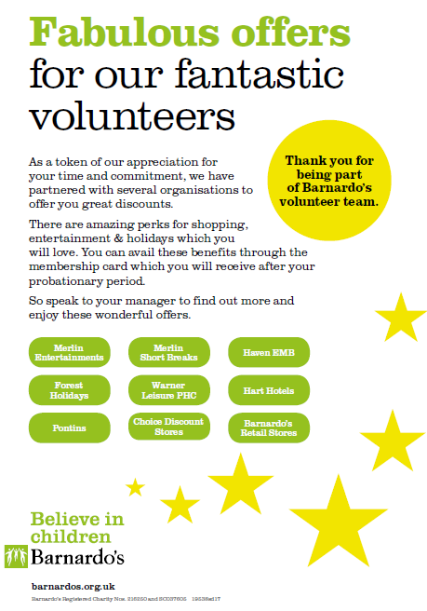
The Fabulous offers flyer is to be printed and given out to all new volunteers (or displayed on the noticeboard and referred to in stores) along with their Barnardo’s Volunteer Card.

Click here for the folder with the Fabulous offers flyer
